FINAL PROJECT REPORT
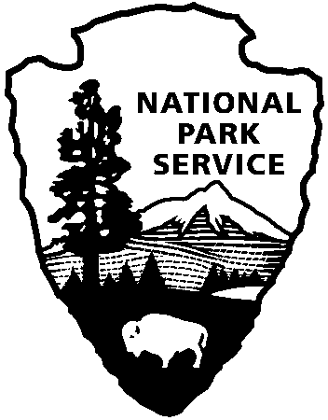
_______________________________________________________________________________________________
Japanese American Confinement
Sites Grant Program
National Park Service
U.S. Department of the Interior

Note: The Final Project Report is due within 90 days after the end date of the grant agreement or completion of the project, whichever comes first. Failure to submit a timely and acceptable Final Project Report places a grantee in noncompliance with the terms of the Grant Agreement, and will result in NPS withholding payment or possibly requiring repayment of disbursed funds.

1. Project Title: _________________________________________________ 2. NPS Grant Agreement #: ___________

3. Attach a completed FFR, Federal Financial Report (Standard Form 425), for the entire grant period.

4. Provide a brief summary of the work completed under this grant. Note any difference between the planned and actual scope of work and costs.

5. Describe the status of complying with all applicable Special Conditions in your grant agreement. These may include:
- Nonfederal matching share
- NPS concurrence with consultant selection
- NPS review of plans and specifications or other draft products
- Section 106 consultation with the State Historic Preservation Office

6. Provide a line-by-line breakdown of the planned expenditures in the approved budget and compare them to actual expenditures using the following format: (The electronic version of this form at http://www.nps.gov/history/HPS/hpg/JACS/index.html contains an embedded Excel table – double click to open.)

7. Provide a summarized list of the nonfederal matching share that was used to complete the grant-assisted work. Identify each source of match, the amount, and the type (cash, donated labor, donated materials, etc.).

8. If any publications (books, pamphlets, videotapes, etc.) were produced using federal or matching share under this grant, enclose three (3) copies with the Final Report. All publications must include acknowledgement of the grant assistance and the Federal disclaimer as required by your grant agreement.

9. Provide any relevant documentation demonstrating the completion of the project. For example, you may attach newspaper articles, press releases, copies of project-related contracts, reports, plans and specifications, or photographs or digital images showing completed grant work. Images may be printed or submitted on CD.

Signature:_________________________________________________________________________________________

Name/Title: _______________________________________________________________________________________

Date: _____________ Telephone: ____________________ Email: _________________________________________

*Please submit this form and any additional documentation by mail or private carrier to the following address:
Kara Miyagishima, Japanese American Confinement Sites Grant Program
National Park Service, Intermountain Region, 12795 W. Alameda Parkway, Lakewood, CO 80228
Phone: 303-969-2885

