BLACK BEAR INCIDENT FORM v3.11
This form is needed to manage human - black bear interactions Olympic National Park. Please use this form whenever a bear “incident” occurs (eg. bear encountered at distances < 50 yards, bear bluff charging, bear entering campsites, bear attempting to get food etc.) Data from this form enables us to keep track of where, when and what type if incidents are occurring. We use this information to direct management actions and evaluate the effectiveness of bear management in Olympic. Non –incident observations of bears (eg. bear seen at > 50 yards in an undeveloped area) can be recorded on a wildlife observation log. THANKS FOR YOU HELP!

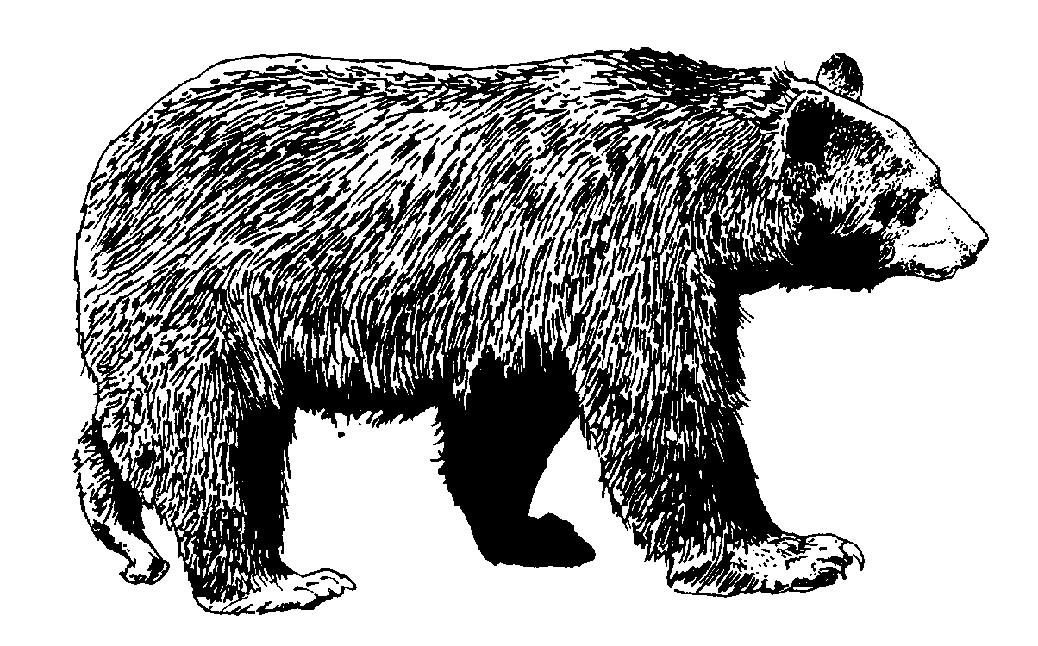
Recorder:
Duty Station:

OBSERVER INFORMATION

Name: Phone #:
Address: Email

SUMMARY OF INCIDENT/OBSERVATION

Date/Time of Observation:
Location of Observation (road, trail, site name, drainage, nearest ranger station/trailhead):

Number of animals:
Activity of person/people when bear(s) seen (hiking, driving, picnicking, etc.):

Activity of bear(s) when seen (walking, grazing, digging at log, etc.):

Did the bear(s) see the person/people?
If so, what was reaction? (ran away, sauntered away, stopped and watched, continued its previous activity bluff-charged people, etc.; please describe):

Was aversive conditioning used by person? If so, what type? (loud noise, throwing items, etc.; please describe):

How did bear(s) react? (startled/frightened and ran, or nonchalant and remained, etc.):

SUMMARY OF INCIDENT/OBSERVATION, CONTINUED

Was human food or trash available to the bear? (on ground, table, in non-bearproof canister, etc.)

If so, did the bear obtain anything?

If observer in campground or backcountry- How was food stowed?

Length of observation:

Closest distance to bear(s):

DESCRIPTION OF BEAR(S)
**Please use bottom of sheet if more space necessary for additional bear descriptions

Bear 1: Adult Cub Yearling
Bear 2: Adult Cub Yearling

Markings on bear(s) (Ear Tags, shape and size of “blaze” on chest; draw if helpful):

Condition of bear(s) (any visible injuries?):

OTHER INFORMATION

Habitat type (old growth, meadow, subalpine, etc.):
Additional notes that may help describe the incident/observation:

Thank You for your help! Please submit forms as soon as possible to either: Patti Happe, Olympic National Park Wildlife Biologist, Natural Resources Management Division (e-mail: patti_happe@nps.gov, phone: 360-565-3065). Hard Copy can be mailed to: 600 E. Park Ave, Port Angeles, WA 98362. Thanks again. pjh 2011

