MOUNTAIN GOAT INCIDENT FORM V1.11
Prompt and Accurate information on the behavior of habituated and/ or aggressive mountain goats is critical to mountain goat management in Olympic National Park. If you see or get reports of nuisance or hazardous goat-human interactions (eg. goats allowing people to approach <50 yds, following people, entering into campsite while people are present, refusing to yield the trail to hikers, exhibiting aggressive postures towards humans) please fill out this form as accurately as possible and turn in immediately to the wildlife biologist. For more information on goat biology, behavior and mountain goat management in OLYM please read the mountain goat action updated in 2011.

Recorder:
Duty Station:

OBSERVER INFORMATION

Name: Phone #:

Address:

Email:

SUMMARY OF INCIDENT/OBSERVATION

Date: Time of Observation:

Location of Observation (as exact as possible):

Total # of animals: # kids : # yearlings : # adult males:

Activity of person/people when goat(s) seen (eg. hiking, camping, picnicking.):

Activity of goats(s) when first seen (eg. walking, grazing, bedded):

Response of goat(s) to people: (eg. stood ground, approached, horn threat, pitting) please describe:

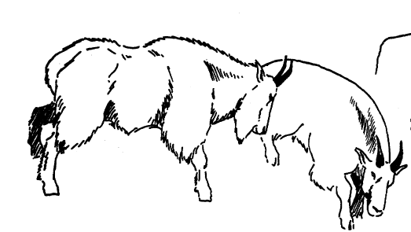

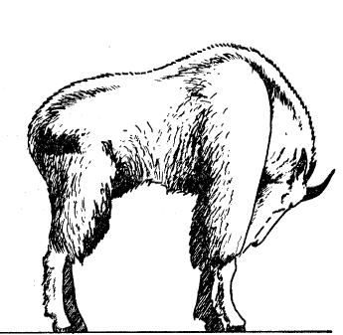

Examples: Horn Threat and Present Threat postures

Over→

SUMMARY OF INCIDENT/OBSERVATION, CONTINUED

Was aversive conditioning used by person? Yes/ No If so, what type? (eg. loud noise, throwing items):

How did goats(s) react? (eg. ran away, walked away, stood ground, aggressive posture?):

Was human salts available to the goat? If so, what form? (eg. urine on ground, sweat soaked clothing.)

If so, did the goat (s) consume it?

Length of observation:

Closest distance to goat(s):

Markings on goat(s) (Ear Tags, paint marks (color and location):

Additional notes that may help describe the incident/observation:

Incident Type: 2 (close approach but easily scared away) 3 (close or following, reluctant to leave, no aggression)
4 (persistently following, not easily shooed away, some aggressive postures) 5 (aggressively seeking salts, threat postures, only will leave with aggressive hazing) 6 attack.

Thank You for your help! Please submit forms as soon as possible to either: Patti Happe, Olympic National Park Wildlife Biologist, Natural Resources Management Division (e-mail: patti_happe@nps.gov, phone: 360-565-3065). pjh 2011

