COMMERCIAL USE AUTHORIZATION

ACTIVITY: Guided Styled Photography Instruction. THESE CONDITIONS ARE APPLICABLE TO ALL AUTHORIED ACTIVITIES and AREAS LISTED ON THIS AUTHORIZATION.

Authorized Services – The commercial activity this permits is Guided Styled Photography Instruction in Olympic National Park on approved trails within the park. This CUA is valid from October 1st through May 15th. Maximum group size is 12 people, including guides, models, and staff. All trips must remain on maintained trails and hardened surfaces. The only exception would be on beaches where there may not be designated trails. Activities must not interfere with other park visitors. No overnight backcountry camping is allowed under this authorization. No other commercial activity is permitted.

CONDITIONS OF THIS AUTHORIZATION

- False Information: The holder is prohibited from knowingly giving false information. To do so will be considered a breach of conditions and be grounds for revocation: [RE: 36 CFR 2.32(a) (3)].
- Legal Compliance: The holder shall exercise this privilege subject to the supervision of the area Superintendent. The holder shall comply with all applicable laws and regulations of the area and terms and conditions of the authorization. The holder must acquire all permits or licenses of State or local government, as applicable, necessary to provide the services described above, and, must operate in compliance with all applicable Federal, State, and local laws and regulations, including, without limitation, all applicable park area policies, procedures and regulations. All vehicles/vessels/aircraft are required to be registered and the operators are required to have the proper licenses to operate them commercially, as required by law or regulation.
- Rates: The holder shall provide commercial services under this authorization to visitors at reasonable rates satisfactory to the area Superintendent.
- Operating Conditions: The holder shall provide the authorized commercial services to visitors under operating conditions satisfactory to the area Superintendent.
- Liabilities and Claims: This authorization is issued upon the express condition that the United States, its agents and employees shall be free from all liabilities and claims for damages and/or suits for or by reason of any injury, injuries, or death to any person or persons or property of any kind whatsoever, whether to the person or property of the holder, its agents or employees, or third parties, from any cause or causes whatsoever while in or upon said premises or any part thereof during the term of this authorization or occasioned by any occupancy or use of said premises or any activity carried on by the holder in connection herewith, and the holder hereby covenants and agrees to indemnify, defend, save and hold harmless the United States, its agents, and employees from all liabilities, charges, expenses and costs on account of or by reason of any such injuries, deaths, liabilities, claims, suits or losses however occurring or damages growing out of the same.
- Insurance: Holder agrees to carry general liability insurance against claims occasioned by the action or omissions of the holder, its agents and employees in carrying out activities and operations under this authorization. The policy shall name the United States of America as additional insured. Holder agrees to have on file with the park copies of the above insurance with the proper endorsements.
- CUA Fees: At a minimum, the holder shall reimburse the park for all costs incurred by the park as a result of accepting and processing the application and managing and monitoring the authorized activity. Administrative costs for the application process must be paid when the application is submitted. Monitoring fees and any additional costs incurred by the park to support the commercial activity will be paid annually or on a more frequent basis as determined by mutual agreement between the Holder and the area Superintendent.
- Benefit: No member of, or delegate to, Congress, or Resident Commissioner shall be admitted to any share or part of this authorization or to any benefit that may arise from this authorization. This restriction shall not be construed to extend to this Contract if made with a corporation or company for its general benefit.
- Transfer: This authorization may not be transferred or assigned without the written consent of the area Superintendent.
- Termination: This authorization may be terminated upon breach of any of the conditions herein or at the discretion of the area Superintendent.
- Preference or Exclusivity: The holder is not entitled to any preference to renewal of this authorization except to the extent otherwise expressly provided by law. This authorization is not exclusive and is not a concession contract.
- Construction: The holder shall not construct any structures, fixtures or improvements in the park area. The holder shall not engage in any groundbreaking activities without the express, written approval of the area Superintendent.
- Reporting: The holder is to provide the area Superintendent upon request a statement of its gross receipts from its activities under this authorization and any other specific information related to the holder’s operations that the area Superintendent may request, including but not limited to, visitor use statistics, and resource impact assessments. The holder must submit annually the CUA Annual Report (NPS Form 10-660) and upon request the CUA Monthly Report (NPS Form 10-660A).
- Accounting: The holder is to maintain an accounting system under which its accounts can be readily identified within its system of accounts classification. This accounting system must be capable of providing the information required by this authorization. The holder grants the United States of America access to its books and records at any time for the purpose of determining compliance with the terms and conditions of this authorization.
- Visitor Acknowledgment of Risks (VAR): The holder is not permitted to require clients sign a waiver of liability statement or form, insurance disclaimer, and/or indemnification agreement waiving the client’s right to hold the CUA holder responsible for accidents or injury occurring on NPS property. The holder is permitted to request or require a client to sign a form or statement acknowledging risk and/or indicating that certain prerequisite skills may be needed to participate in the commercial activity. The holder must provide the park with the current copy of all forms and/or statements used for this purpose and obtain written approval by the park to use the form and/or statement. A sample Acknowledgment of Risk form may be obtained by contacting the CUA office at (360) 565-3028 or by going to the park CUA webpage at https://www.nps.gov/olym/getinvolved/dobusinesswithus.htm
- Intellectual Property of the National Park Service: Except with the written authorization of the Director of the National Park Service, the Holder shall not assert any legal claim that the Holder or any related entity holds a trademark, tradename, servicemark or other ownership interest in the words "National Park Service", the initials "NPS", or official name of any unit or part thereof, including but not limited to any facility, logo, distinctive natural, archaeological, cultural, or historic site, within the National Park System, or any colorable likeness thereof, or the likeness of a National Park Service official uniform, badge, logo, or insignia.
- Nondiscrimination: The holder must comply with Applicable Laws relating to nondiscrimination in providing visitor services to the public and with all equal employment opportunity provisions of Title VII of the Civil Rights Act, as amended.
- Notification of Employee Rights: The holder must comply with all provisions of Executive Order 13496 of January 30, 2009, (Notification of Employee Rights Under Federal Labor Laws) and its implementing regulations, including the applicable contract clause, codified at 29 CFR part 471, appendix A to subpart A, all of which are incorporated by reference into this authorization as if fully set forth in this authorization.

OLYMPIC NATIONAL PARK
COMMERCIAL USE AUTHORIZATION
SPECIAL PARK CONDITIONS
THESE CONDITIONS ARE APPLICABLE TO ALL AUTHORIZED ACTIVITIES and AREAS LISTED ON THIS AUTHORIZATION.

- Permits/Licenses – The holder must obtain all permits or licenses of State or local governments, as applicable, necessary to conduct the business activities specified above and must operate in compliance with all pertinent Federal, State, and local laws and regulations.

- Violations – Violation of park regulations or the terms of this permit may result in the suspension of privileges granted by this permit and could lead to citations, fines, and/or the revocation or suspension of this and future CUA’s.

- Employee/Agent Responsibility – The holder shall insure that all company employees and vehicle operators entering the park are informed of the conditions of this authorization. (The holder may be cited for any authorization violations committed by their employee and/or agent.) A copy of the entire Commercial Use Authorization (CUA) must be present and accessible at all times while conducting business in the park. A digital copy may only be used if it is stored on a tablet device with a screen size of at least 7 inches.

- Vehicle Markings – All vehicles must display company information that meets the following minimum requirements: a. Company name. b. Number issued by the Federal Motor Carrier Safety Administration (FMCSA) if applicable. c. Markings must appear on both sides of the vehicle. d. The letters must contrast sharply in color with the background on which the letters are placed. e. Markings must be legible, during daylight hours, from a distance of 50 feet when the vehicle is stationary.

- Business Operations – This authorization does not authorize the permittee to advertise, solicit business, collect any fees, or sell any goods or services on lands owned and controlled by the United States. The Authorization is for incidental business operations when there are no fixed commercial facilities within a national park area, the commercial activity originates and terminates outside the park, no money changes hands on park lands and no commercial solicitation occurs on park lands.

- Operating Plan – The holder will provide the Superintendent with an Operating Plan for approval, which will include:

- Description of proposed services to be provided;
- Copies of advertising brochures or other handouts describing trips in the park;
- Detailed itineraries for each planned trip showing their beginning and ending dates, routes with trailhead entries and exits, group sizes, and camping locations;
- Season of main period(s) of operation;
- Description of motorized equipment, watercraft, or stock use (if any);
- Environmental information provided to clients;
- Sanitation precautions/procedures that apply to your service;
- Risk Management and or Safety Plan for park activities to be filed with Superintendent;
- The holder will provide the Superintendent with a list of paid and unpaid staff working in the park.
- The holder will provide the Superintendent with a list of all medical and food handler certifications held by paid and unpaid staff working in the park. Staff members will carry certifications on their person while working in the park.

- Damages – The permittee will leave the area(s) authorized for use under this permit in substantially the same condition as it was prior to the activities authorized herein. The permittee shall pay the United States for any damage resulting from this use which would not reasonably be inherent in the use which the permittee is authorized to make of the land described in this authorization.

- Equal Employment Opportunity/Nondiscrimination – The permittee will comply with all provisions of Executive Order No. 11246 of September 24, 1965, as amended by Executive Order No. 11375 of October 13, 1967, and of the rules, regulations, and relevant orders of the Secretary of Labor.

- CUA Annual Report (NPS form 10-660)– Within sixty (60) days after the end of each year or at the end of your business season, the holder shall submit an annual report that summarizes total in-park visitor use and includes gross revenues for the year. For the purpose of this authorization, gross revenues are defined as “the total amount received, realized by, or accruing to the business operator for all sales of goods and services provided by the business operator for payment by cash, barter, or credit pursuant to the privileges granted by the authorization. This includes income from the subsidiary or other operation located outside of lands administered by the National Park Service to the extent that they support operations authorized by the authorization. A new CUA will not be issued to prior-year CUA holders until a complete and accurate Annual Report has been submitted for the prior year. The CUA Annual Report (NPS form 10-660) is available on the park’s CUA website.

- Closures/Cancellations – In the event of park closures or temporary delays this authorization does not grant the holder or clients any special privileges for entry into the park. Park staff may not be approached in the park for additional information regarding closures while performing their duties. The National Park Service reserves the right to:
- Limit the operation of authorization holders in specific areas or during specific time periods
- Schedule use of or close any trail, road, or other areas of attraction
- Information about closures can be found at: https://www.nps.gov/olym/planyourvisit/conditions.htm

- Leaders/Guides – Leaders/Guides are defined as any person paid or unpaid representing the holder during activities conducted in the park. Each group must have one person identified as the group or trip leader who will remain with the group at all times. If the party is divided into more than one group, each group will have a trip leader. The trip leader will inform the group of all park rules and regulations and has responsibility for the group. Guides must wear company clothing and/or nametags to be identifiable.

- Orientation – The trip leader must provide an orientation to clients. The orientation must include basic hiking etiquette (e.g., passing other hikers), Leave No Trace principles, a resource message explaining human impacts, park rules and regulations, safety procedures, litter, human waste, and emergencies. Each participant should be supplied with a map of the park area.

- Monitoring – The permittee is subject to monitoring of their activities by NPS personnel to ensure compliance with the terms of this agreement, federal laws, rules, requirements, policies, park regulations, and any park-specific management plans. Vehicle, operator, license, and authorization compliance inspections may occur at any time by National Park Service personnel.

- Reporting Accidents – An accident resulting in personal injury, death, or property damage shall be reported to the Superintendent as soon as possible, and no later than 24 hours after the occurrence. [36 CFR 2.33, 3.4, 4.4] All motor vehicle accidents resulting in injury, personal/government property damage, or injury to park wildlife or resources must be reported to park law enforcement immediately by dialing (360-565-3115). Commercial operators must remain on the scene until the arrival of law enforcement officers. Each group must carry a first aid kit.

- Violation Reporting – If the guide, driver, owner, company, or any other affiliated employee associated with the tour receives a citation for violating CUA conditions in the park, this citation must be reported to the Commercial Services office as soon as possible—no later than 24 hours after occurrence—at olym_cua_admin@nps.gov. Visit https://www.nps.gov/olym/getinvolved/dobusinesswithus.htm to review the CUA Suspension, Restriction, Revocation, and Application Denial Policy for Olympic National Park.

- Allocation – The National Park Service will retain the option to establish user allocation in future years in the event that the volume of use may increase to levels where specific controls or use limits must be imposed.

- Exclusive Use – The CUA holder may not reserve or attempt to exclude park visitors from any area of the park.

- CUA Use – Only one CUA may be used for each guided tour when entering the park and for permitted incidental activities.

- Rescues & Emergencies – The permittee shall notify the nearest National Park Service contact station or uniformed employee of an emergency or for lost or missing clients. The holder is responsible for providing their clients with the necessary information to locate or contact their group if they become delayed or separated. Commercial operators may not abandon their clients in the park and are solely responsible for making arrangements for their clients to rejoin and without unnecessary delay. While self-rescue is encouraged in cases where no additional resources are needed, the National Park Service retains the authority to make the determination to employ additional resources when the situation warrants. To report rescues or emergencies call (360-563-3115).

- Trails & Walkways -The CUA holder will ensure that all clients on their trip minimize impact while camping and traveling. The holder will educate its staff and clients about vulnerable subalpine and alpine plant communities in Olympic National Park and will include an outline of this “environmental education” curriculum in its Operating Plan submitted with the CUA application. Clients must travel and congregate on durable surfaces (dirt, gravel, rock, snow, forest duff, sedges and grasses); group members traveling off trails must spread themselves out to disperse impacts while hiking on vegetation and where possible, avoid walking on heather and huckleberry. Groups should make every effort to plan to camp where they know unvegetated camps exist. Groups must situate tent sites and common areas for gathering and cooking on bare ground (unvegetated surfaces such as dirt, gravel, rock, snow, or forest duff) or on resilient vegetation such as sedges or grasses if bare ground is not available. Individuals must travel between tent sites and these common areas on durable surfaces. Camping on meadows of heather (genus Phyllodoce), huckleberry (genus Vaccinium), Partridge Foot (Leutkea pectinata), lilies (genus Erythronium), Sitka Valerian (Valeriana sitchensis), or other fragile vegetation is prohibited.

- Food and Trash – All garbage, including food scraps and cigarette butts, must be removed from park areas. Feeding wildlife is prohibited, as it poses risks to both humans and wildlife. Guides must collect all trash generated on the tour and dispose of it outside the park.

- Area Use - The area(s) authorized for use under this authorization must be left in substantially the same condition as it was prior to the activities authorized herein. The holder will be liable for any damages to property of the United States resulting from the activities authorized hereunder. The CUA does not authorize priority use of park areas. The holder is prohibited from blocking access or impeding the flow of traffic along any roads, trails, walkways, or any National Parks Service (NPS) or concessioner facilities.

- Public Health - To ensure minimum standards for public health are maintained in the wilderness (backcountry) where front country standards are not achievable, the holder conducting backpacking trips is “required” to comply with the guidelines of the U.S. Public Health Service (USPHS) for Food, Potable Water, Human Waste, Vector-Borne and Zoonotic Diseases, and Illness Reporting in backcountry operations. For additional information, go to: http://www.nps.gov/public_health/info/rms/rm83f.pdf. Staff for each trip or group are “required” to be a certified food handler if they are preparing food for the clients or instructing clients on preparing food during the trip. Staff will carry a copy of their food handler’s card while guiding in the park. A food service worker training card issued by a state, county, or local health department will be accepted.

- Responding to NPS Correspondence – The permittee must respond to all correspondence from the Commercial Services Offin in accordance with the requested deadline. If there is no deadline stated, then the permittee must respond no later than three (3) business days after receiving correspondence.

OLYMPIC NATIONAL PARK
COMMERCIAL USE AUTHORIZATION
SPECIFIC ACTIVITY CONDITIONS

ACTIVITY: Guided Styled Photography Instruction. THESE CONDITIONS ARE APPLICABLE TO ALL AUTHORIED ACTIVITIES and AREAS LISTED ON THIS AUTHORIZATION.

Authorized Services – The commercial activity under this permit is Guided Styled Photography Instruction in Olympic National Park on approved trails within the park. No overnight backcountry camping is allowed under this authorization. No other commercial activity is permitted.

Authorized Dates – The commercial activity in this permit is authorized from October 1st through May 15th.

Parking and Loading/Unloading – All trips will begin and end at designated trails. Vehicles will park in designated parking spaces only.

Area Use – This authorization is applicable only for the use of the area, terms, and conditions designated herein. The area(s) authorized for use under this authorization must be left in substantially the same condition as it was prior to the activities authorized herein. Exclusive use is prohibited.

Drone use is strictly prohibited.

Time Limitations – Instruction sessions shall be limited to three-hour sessions per location to ensure visitor access.

Approved Locations/Travel – Areas of operation and permit availability may be subject to change based on park management decisions to protect wilderness character.
All trips must remain on maintained trails and hardened surfaces and must not interfere with other park visitors. Docks are not approved locations under this CUA. The utmost of care must be given to avoid the destruction of sensitive vegetation and other resources. The only exception would be on beaches where there may not be designated trails. Closed areas are not permitted. This permit does not give exclusive use to any area in the park. See attached maps and descriptions of approved locations.

Bovee Meadow: Follow Lake Crescent Rd past Lake Crescent Lodge and park in Bovee Meadow day use area.

Moments in Time Trail: Located at Lake Crescent Lodge. Park in east visitor parking lot to access trail.

Storm King Ranger Station: Grassy lawn area in front of Storm King Ranger Station. Access to the Ranger Station or the use of the Dock is not permitted as part of this CUA.

Elwha: From Maddison Falls parking lot to the wash-out on Olympic Hot Springs Road. Up to 100 feet from Olympic Hot Springs Road. Maddison Falls is not permitted for this CUA.

Fairholme Boat Launch: Boundaries are Fairholme boat launch parking lot to Fairholme Campground to foot bridge to Fairholme store.

Rialto Beach: Park in Rialto Beach parking lot and take trail to access beach.

Ruby Beach: Park in Ruby Beach parking lot and take trail to access beach.

Quinault Ranger Station: Park in Quinault Ranger Station parking lot. Area includes grassy area in front of and behind Ranger Station. Access to Ranger Station is not granted as part of this permit.

Quinault Kester Homestead and Trail: Park in Quinault Ranger Station parking lot. Area includes open spaces along trail, open fields around Kester Homestead. Access to historic buildings, vehicles and closed areas are not part of this permitted area. Do not sit on the historic fences.

Park Entrance Fee –
- Individuals participating in the activity will pay the individual per-person entrance fee.
- Annual and lifetime federal recreational land passes are accepted. These passes are good for the owner(s) of the pass plus three additional adults 16 and over who are part of the same party.
- Children under 16 are not charged.
- Individuals or groups who have previously paid the entrance fee must show proof of prior payment.
- Appropriate commercial non-road-based tour fees will be calculated and charged upon entry. The vehicle and driver/guide have free entry into the park.
- The CUA holder and/or guides may not use personal annual or lifetime federal recreational land passes to gain entry to the park for themselves or their customers when conducting business.
When entering the park each time, permittees must identify themselves; show a copy of the CUA, and state that they are transporting visitors. This will enable the entrance station personnel to verify that you are on the approved list for commercial activities and are to be charged the correct commercial fee. If the entrance station is closed, arrangements should be made to pay fees.

Resource Protection- The spreading/scattering/spraying of any item, whether edible or not, is strictly prohibited. This includes but is not limited to flower petals (both real and artificial), rice, birdseed, bubbles, and champagne.

To prevent the introduction of invasive species into the park, dried plants, including grasses are prohibited in bouquets (fresh cut flowers or fake flowers only).

The release of butterflies, doves or any other wildlife is prohibited. Harassment of wildlife is prohibited.

Altering the landscape such as removing (or adding) tree branches or vegetation or clearing an area of vegetation, rocks, etc. or disturbing the soil for any reason is prohibited.

The use of artificial light sources for purposes other than personal route-finding, that is, to light up landscapes, rock formations, water features, or other Park features, is prohibited.

Maintain a normal talking voice noise level. The use of musical instruments or amplified music is prohibited.

Permittee is responsible for site cleanup and shall dispose of all trash in authorized waste receptacles.

Employee Training and Guiding –
- Trips must be led by a designated employee who knows the park rules, regulations, and resources; is knowledgeable of the provisions of this authorization and can provide direction and instruction to participants.
- Each group must have one person identified as the group or trip leader who will remain with the group at all times and will carry a functioning two-way satellite communication device.
- If the party is divided into more than one group, each group will have a trip leader.
- Guides will ensure that each member of the group has adequate food and water for the proposed itinerary, appropriate footwear, clothing, and sun protection.
- An appropriately sized first aid kit that is adequate for the group size.
- Human waste disposal bags, or “cat hole” shovels will be carried by each group and all waste shall be disposed of properly.

Guide Qualifications – The following minimum qualifications must be met by each guide operating within Olympic National Park.
- Olympic National Park takes our visitors safety seriously. Therefore, we urge ALL Guides leading a commercial group possess a minimum Current Wilderness First Aid Certification or its equivalent and a current CPR certification. A list of guides and their certifications will be filed with the commercial services office. A copy of all current certifications must be maintained by the CUA holder base of operations and must be presented upon request from the park service within 24 hours
- Guides must be at least 18 years of age.
- Guides must provide interpretation of the park to clients that reflect the park’s interpretive themes and significance statements.
- Guides must be trained in basic safety and resource protections, Leave No Trace principles, park rules and regulations, and in the requirements of the CUA conditions.
- Guides MUST carry a copy of the following and are required to present it up on request:
- Current WFA/First Aid and CPR Certification
- Valid, signed and current CUA
- Food Handlers Certification
- Backcountry Permits

Group Size – Each front country trip will have a maximum group size of 12 persons, with includes guides, models, and staff.

Camping – This CUA does not permit overnight wilderness camping.

Violations – Violations of park regulations or the terms of this permit may result in the suspension of privileges granted by this permit and could lead to appropriate fines or citations, as well as suspension or revocation.

ATTACHMENT A
CUA Insurance Requirements

Commercial General Liability (CGL) Insurance

Liability insurance is required for all CUA holders under the terms of the authorization. Such insurance should be of sufficient scope to cover all potential risks and in an amount to cover claims that can reasonably be expected in the event of serious injury or death. The minimum commercial general liability insurance is $1,000,000. Liability insurance policies must name the United States of America as additional insured. The business or person that is providing the service must be the named insured (policy holder). Companies that provide transportation only are not required to have Commercial General Liability as long as the passengers do not disembark.

Other Required Insurance

Commercial Auto Liability Insurance is required if a CUA holder transports passengers or uses in the performance of the service in the park owned/leased/rented vehicles. If a CUA holder charters the vehicle and those chartered vehicles are owned and operated by another company, the CUA holder is not required to have Commercial Automobile Liability insurance. The minimum Commercial Auto Liability Insurance for interstate passenger transport is:

Commercial Vehicle Insurance – Passenger Transport  (bodily injury and property damage) | Minimum per Occurrence Liability Limits*
15 or fewer passengers | $1,500,000
16 or more passengers | $5,000,000

The NPS has not established standard commercial automobile liability minimums for intrastate auto use by CUA holders because each state has unique rules and regulations. Intrastate CUA holders must meet individual state requirements for Commercial Automobile Liability Insurance or the interstate requirements above, whichever are greatest.

If the CUA applicant or holder will use rented or leased vehicles in performance of the authorized service, the applicant or holder must secure appropriate insurance for that rented or leased vehicle in the amount required by the CUA application. Proof of insurance secured directly from the rental or lease company may not be available upon application submission, but applicants are required to provide proof of insurance coverage after application submission upon NPS request.

Insurance Company Minimum Standards

The NPS has established the following minimum insurance company requirements. All insurance companies must meet the following minimum standards. These standards apply to foreign insurance companies as well as domestic companies.

- All insurers for all coverages must be rated no lower than A- by the most recent edition of Best’s Key Rating Guide (Property-Casualty edition), or similar insurance rating companies (Moody’s, Standard and Poor’s, or Fitch), unless otherwise authorized by the Service.
- All insurers for all coverages must have Best’s Financial Size Category of at least VII according to the most recent edition of Best’s Key Rating Guide (Property-Casualty edition), or similar insurance rating companies (Moody’s, Standard and Poor’s, or Fitch), unless otherwise authorized by the Service
- The insurance ratings must be submitted with the CUA Application. The rating companies do not issue certificates. We require the insurance broker to note this rating in the Certificate. If the rating does not appear on the certificate, the insurance broker must provide it in another document.

Proof of Insurance Submission

Applicants must submit proof of insurance with the CUA Application. The proof of insurance must:

- Be written in English with monetary amounts reflected in USD.
- Reflect that insurance coverage is effective at time of CUA Application submission.
- Name as insured the business or person that is providing the service.
- Name the United States as additional insured.
- Reflect a General Commercial Liability Policy with the minimum coverage amount required in the CUA Application.
- Reflect required additional insurances (commercial vehicle, vessel, aircraft, etc.) with the minimum coverage amount required in the CUA Application.
- Include insurance provider rating or provide in separate document.

APPENDIX B
OLYMPIC NATIONAL PARK
COMMERCIAL USE AUTHORIZATION

FEES & PERMITS

- Application fee – The non-refundable CUA application fee will be $350, which is the NPS standardized application fee. $50 goes to NPS to maintain the online system. $300 stays in Olympic National Park to cover staff time to process and issue the CUA. Each additional CUA at Olympic National Park will be $250.00.

- Cost Recovery Fee – Monitoring fee calculated at 3% of gross receipts generated from commercial activities in the park the previous year. Paid online by CUA holders who held an active CUA in the year immediately prior.

- Entrance Fee – Paid at the entrance station by all CUA groups. $15 per person (16 and over), valid for 7 consecutive days. The CUA will cover the entrance fees for your staff members who are bringing the group into Olympic National Park. The driver is required to stop at the entrance station and show the fee collector the CUA and a list of staff working under the CUA along with a picture ID for verification. CUA clients will be required to pay the regular entrance fee or show a National Parks pass. The pass can be used to cover three other adults travelling together.

APPENDIX C
OLYMPIC NATIONAL PARK
COMMERCIAL USE AUTHORIZATION

Approved Location Maps

Bovee Meadow:
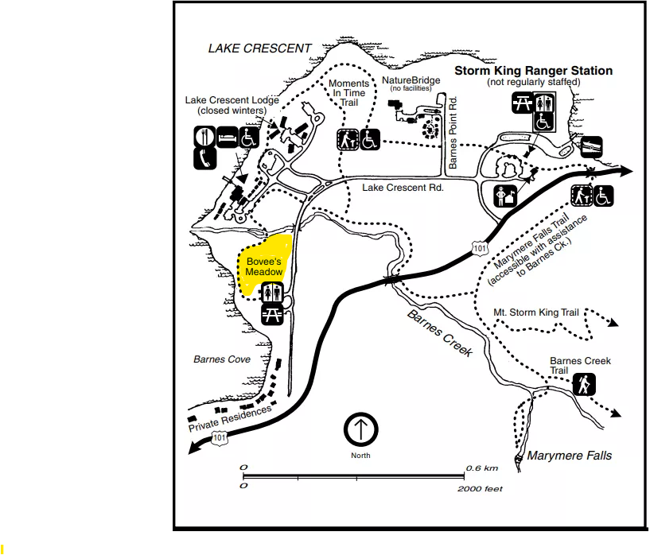

Rialto Beach:

Moments in Time Trail:

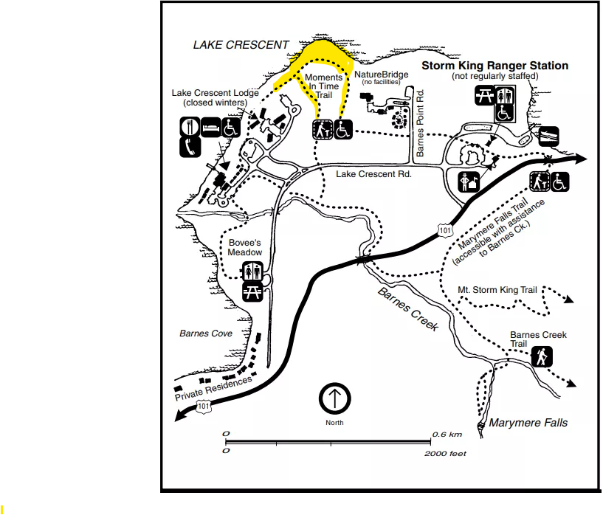
Ruby Beach:

Storm King Ranger Station:

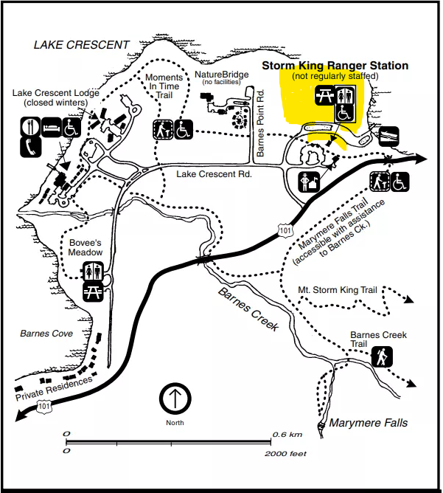

Elwha:

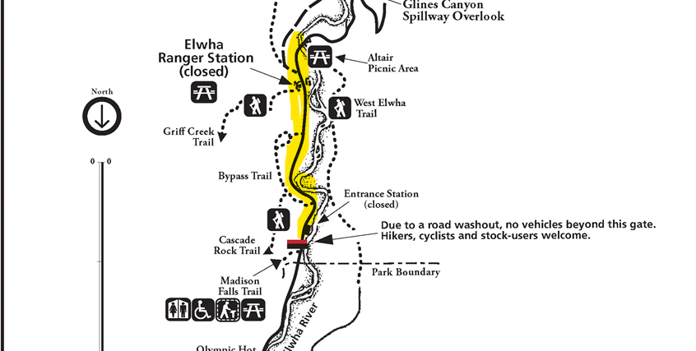

Fairholme Boat Launch:

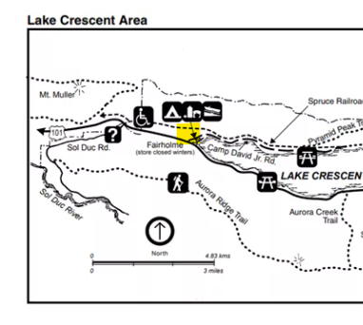

Quinault Head Quarters:

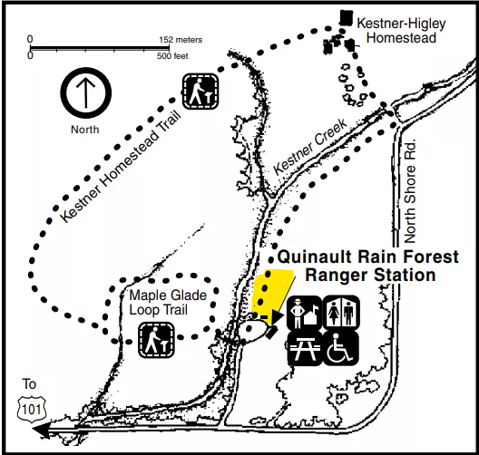

Quinault Kestner Homestead Trail:

