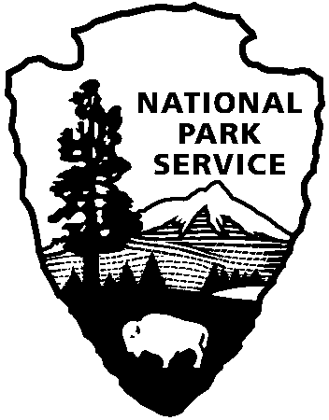
National Parks of New York Harbor
Public Affairs Office
Federal Hall National Memorial
26 Wall Street
New York, NY 10005
212-668-2251
www.nps.gov/npnh

National Park Service
U.S. Department of the Interior

Ellis Island Celebrates Hispanic Heritage Month

Ellis Island, NY/NJ - The National Park Service (NPS) joins the Nation in observing Hispanic Heritage Month, September 15 – October 15, 2007, as proclaimed by the President of the United States. During this observance, we honor the accomplishments of Hispanic Americans and recognize their extraordinary contributions to America. The national theme is “Hispanic Americans: Making a Positive Impact on American Society.”

The Statue of Liberty National Monument and Ellis Island Immigration Museum will be celebrating National Hispanic Heritage Month with an exhibit and performances. The exhibit will honor the contributions of Hispanic Americans to the United States and will be complemented by the works of Mexican-American artists Felipe Galindo and Andrea Arroyo.

Felipe Galindo has done work for The New Yorker, The New York Times, Newsday, Mad Magazine, Nickelodeon Magazine, Reader’s Digest, Crain’s, The Wall Street Journal, Advertising Age, Princeton Alumni Weekly, The Progressive, Barron’s, The National Law Journal, Time Almanac for Kids, Scholastic's Instructor, Children’s Television Workshop, Creative Classroom and TV411.

Andrea Arroyo was the official artist of the 2006 Latin Grammy Awards; her recently completed projects include: 1000sq. ft. mural at Washington Irving H.S., Faceted-glass art, Metropolitan Transportation Authority, NYC. Art commission for the Florida’s Art in State Buildings Program, Tampa, Florida.

On September 15, 16, 22, 23, from 11:00 am to 4:00 pm there will be musical performances by Agua Clara, playing music of the Andes Mountains of Columbia, Ecuador, Peru, Chile, and Argentina. The band members represent these countries and they have performed at the United Nations and throughout the country.

For more information, please contact Noemi Ghazala at (212) 363-3206 Ext. 134.

- NPS -

FOR IMMEDIATE RELEASE
Date: September 13, 2007

Contact: Darren Boch – (212) 668-2251

Statue of Liberty National Monument and
Ellis Island News Release

