Ninety Six National Historic Site
National Park Service
U.S. Department of the Interior
HISTORY OF THE LOGAN LOG HOUSE

The Logan Log House at Ninety Six National Historic Site was originally built as an early settler cabin. The cabin is the oldest house in Greenwood County. It was built during the 1700s possibly by Andrew Logan. Later the cabin was bought by William Blake after Logan died. Blake owned the cabin from 1795-1875 when he died. After Blake’s death the cabin was bought by W.J. Wells. Wells’ family lived in the cabin for 82 years. 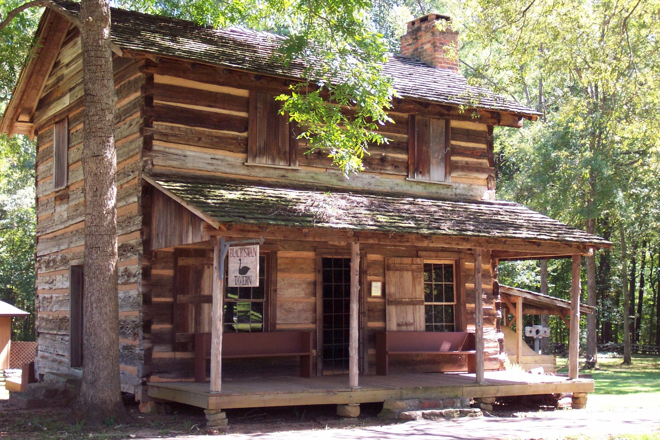¹ Over the decades the original cabin had new sections added to it. By 1967 when the house was owned by Mrs. Thomason the original cabin had been enclosed in a modern home. The cabin was revealed during demolition of the modern home.
The cabin was saved from demolition and preserved by the Greenwood Historical Society. It was moved to Lander University in 1967. In 1971 the cabin was moved from Lander University to the site that would become Ninety Six National Historic Site. The cabin was first used as the visitor center. Later the cabin was name Black Swan Tavern for the park’s living history program and is still being used in that way. The cabin is set up like a tavern with cabin and chairs on the main floor. Here, especially during living history programs, one can imagine early settlers passing by coming here looking for food, drink, local news, and a place to sleep. Taverns were used as local meeting places where men could have social gatherings. 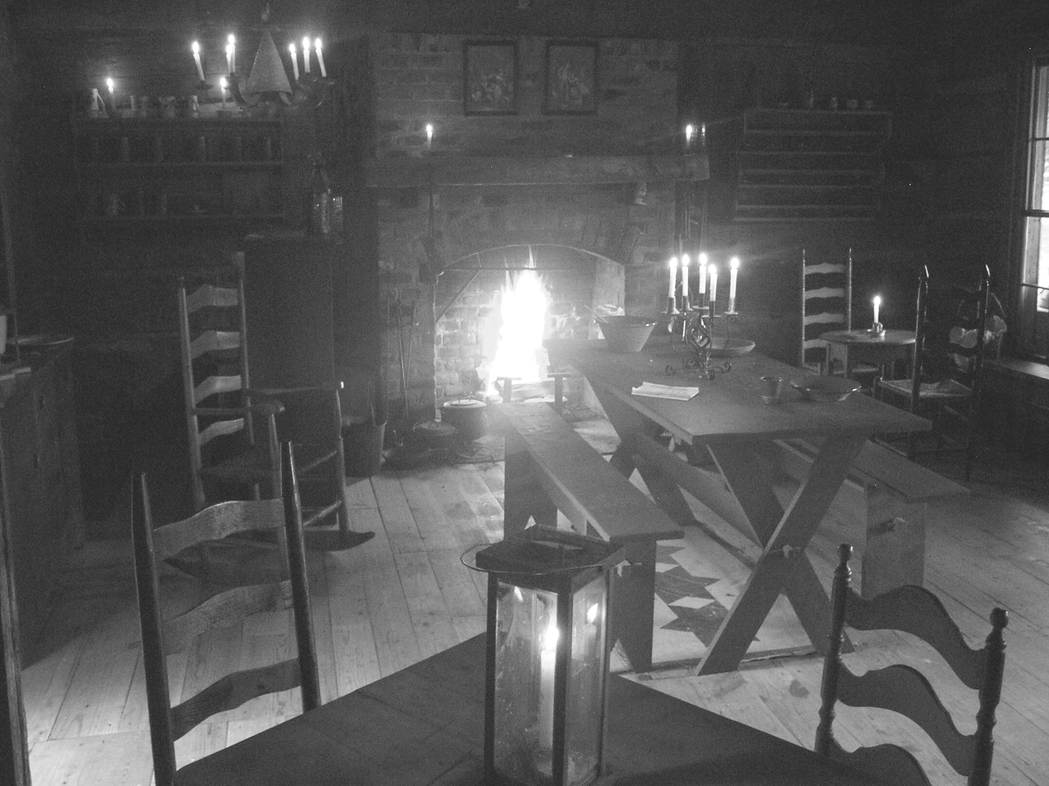²
The Black Swan Tavern here at Ninety Six was originally built as a home for early settlers. Throughout the decades it fulfilled that purpose and was added on to so that bigger families could live inside it. Now the cabin is a portal to another time and lifestyle for visitors who come to Ninety Six.

Margaret Watson, Greenwood County Sketches; Old Roads and Early Families, 156-157.
“Index Journal”, Greenwood, SC. Dec 8, 1966.
“Index Journal”, Greenwood, SC. Jan 19, 1967 ¹ Picture supplied from Ninety Six NHS Photo files ² Picture supplied from Ninety Six NHS Photo files Compiled by Samantha Taylor

