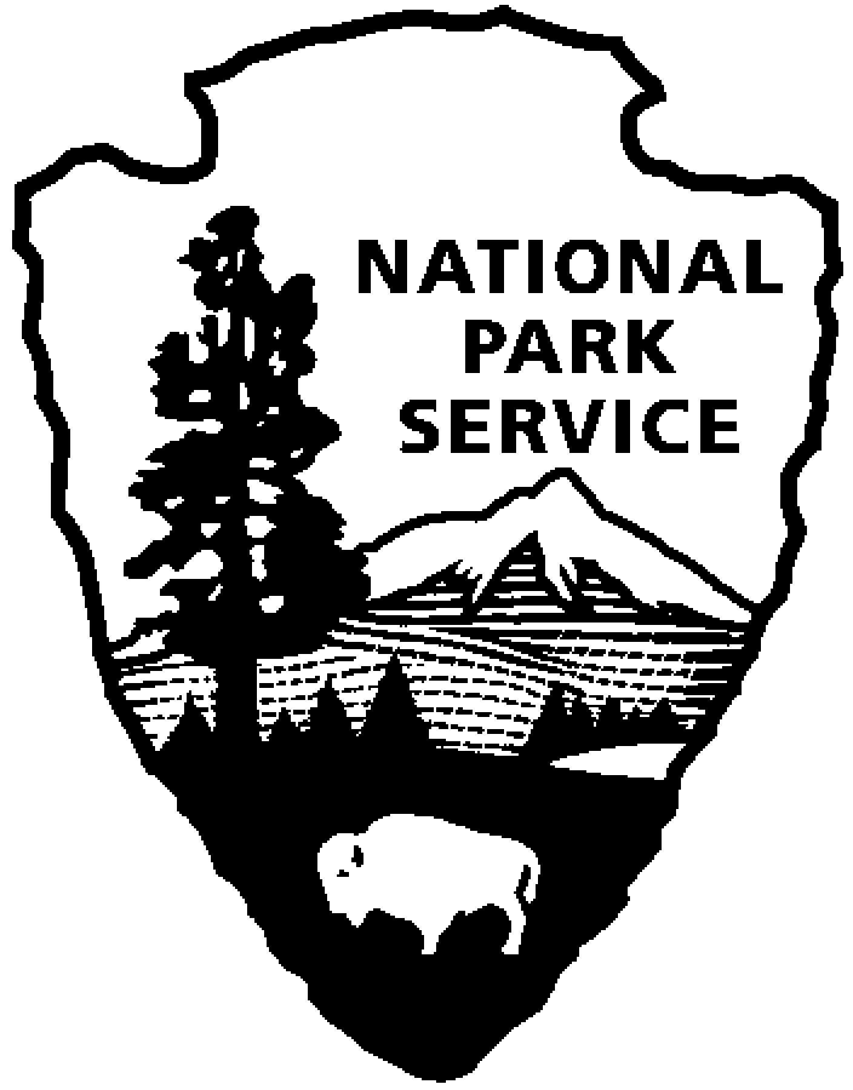  National Park Service  U.S. Department of the Interior  Superintendent’s Compendium  Of Designations, Closures, Permit Requirements and Other Restrictions Imposed Under Discretionary Authority.  Approved:  “Signature on File” Date: August 16, 2014 __  Angela Wetz, Superintendent | NICODEMUS NATIONAL HISTORIC SITE |  | 510 Washington Avenue B1  Nicodemus, KS 67625  785-839-4321 phone  785-839-4325 fax

A. INTRODUCTION

Superintendent’s Compendium Described

The Superintendent’s Compendium is the summary of park specific rules implemented under 36 Code of Federal Regulations (36 CFR). It serves as public notice, identifies areas closed for public use, provides a list of activities requiring either a special use permit or reservation, and elaborates on public use and resource protection regulations pertaining specifically to the administration of the park. The Superintendent’s Compendium does not repeat regulations found in 36 CFR and other United States Code and CFR Titles, which are enforced without further elaboration at the park level.

The regulations contained in 36 CFR, Parts 1-7, are the basic mechanism used by the National Park Service (NPS) to preserve and protect the natural and cultural resources of the park and to protect visitors and property within the park. Parts 1 through 6 are general regulations applicable to all areas of the National Park system, and Part 7 contains special regulations specific to individual parks. Each of these Parts has many sections and subsections articulating specific provisions. Within some of these Part 1-7 sections and subsections, the Superintendent is granted discretionary authority to develop local rules to be responsive to the needs of a specific park resource or activity, park plan, program, and/or special needs of the general public.

As an example, 36 CFR 1.5(a) Closures and Public Use Limits provides the Superintendent certain discretion in allowing or disallowing certain activities. The authority granted by the Section, however, requires the Superintendent to comply with the Administrative Procedures Act (6 USC Section 551), which requires public notice on actions with major impact on visitor use patterns, park resources or those that are highly controversial in nature.

Another example is 36 CFR 1.6 Permits, which allows the Superintendent to require a permit for certain uses and activities in the park. This Section, however, requires that a list of activities needing a permit (and a fee schedule for the various types of permits) be maintained by the park.

A final example is 36 CFR 2.1(c) (1) Preservation of Natural, Cultural and Archeological Resources, which provides the Superintendent the authority to designate certain fruits, nuts, berries or unoccupied seashells which may be gathered by hand for personal use or consumption. This activity can occur, however, only if a written determination shows that the allowed activity does not adversely affect park wildlife, the reproductive potential of a plant species, or otherwise adversely affect park resources.

This Compendium should be used in conjunction with Title 36 CFR, Parts 1-7, to more fully understand the regulations governing the use and enjoyment of all the areas of the national Park System.

A copy of Title 36, CFR, can be purchased from the U.S. Government Printing Office at:

Superintendent of Documents

P.O. Box 371954

Pittsburgh, PA 15250-7954

The CFR is also available on the Internet at:

http://www.access.gpo.gov/nara/cfr/waisidx_05/36cfrv1_05.html

2. Laws and Policies Allowing the Superintendent to Develop This Compendium

The National Park Service (NPS) is granted broad statutory authority under 16 United States Code (U.S.C.) Section 1 et.seq. (Organic Act of 1916, as amended) to “…regulate the use of the Federal areas known as national parks, monuments, and reservations…by such means and measures as conform to the fundamental purposes of the said parks…which purpose is to conserve the scenery and the natural and historic objects and the wildlife therein and to provide for the enjoyment of the same in such manner and by such means as will leave them unimpaired for the enjoyment for future generations” (16 U.S.C. Section 1). In addition, the NPS Organic Act allows the NPS, through the Secretary of the Interior, to “make and publish such rules and regulations as he may deem necessary or proper for the use and management of the parks, monuments, and reservations under the jurisdiction of the National Park Service” (16 U.S.C. Section 3).

In 1970, Congress amended the NPS Organic Act to clarify its intentions as to the overall mission of the NPS. Through the General Authorities Act of 1970 (16 U.S.C. Sections 1a1-1a8), Congress brought all areas administered by the NPS into one National Park System and directed the NPS to manage all areas under its administration consistent with the Organic Act of 1916.

In 1978, Congress amended the General Authorities Act of 1970 and reasserted System-wide the high standard of protection defined in the original Organic Act by stating “Congress further reaffirms, declares, and directs that the promotion and regulation of the various areas of the National Park System, as defined by Section 1 of this Title, shall be consistent with and founded in the purpose established by Section 1 of this Title, to the common benefit of all people of the United States.”

16 U.S.C. Section 1c defines the National Park System as”…any areas of land and water now or hereafter administered by the Secretary of the Interior through the National Park Service for park, monument, historic, parkway, recreational, or other purposes.”

In addition to the above statutory authority, the Superintendent is guided by established NPS policy as found in the NPS Management Policies (2006). The Superintendent is also guided by more specific policies promulgated by the Director, National Park Service, in the form of Director’s Orders. As stated in the Management Policies, the primary responsibility of the NPS is to protect and preserve our national natural and cultural resources while providing for the enjoyment of these resources by visitor and other users, as long as use does not impair specific park resources or overall visitor experience. The appropriateness of any particular visitor use or recreational experience is resource-based and will vary from park to park; therefore, a use or activity that is appropriate in one park area may not be appropriate in another. The Superintendent is directed to analyze overall park use and determine if any particular use is appropriate. Where conflict arises between use and resource protection, where the Superintendent has a reasonable basis to believe a resource is or would become impaired, than that Superintendent is obliged to place limitations on public use.

3. Consistency of This Compendium with Applicable Federal Law and Requirements

The Superintendent’s Compendium is not considered a significant rule requiring review by the Office of Management and Budget under Executive Order 12866. In addition, this Compendium will not have a significant economic effect on a number of small entities nor impose a significant cost on any local, state or tribal government or private organization, and therefore does not fall under the requirements of either the Regulatory Flexibility Act or the Unfunded Mandates Reform Act.

The actions and requirements described in this Compendium are found to be categorically excluded from further compliance with the procedural requirements of the National Environmental Policy Act (NEPA) in Department of the Interior (DOI) Guidelines 516 DM 6 and as such, an Environmental Assessment will not be prepared.

4. Development of the Requirements of the Superintendent’s Compendium

As outlined above, the NPS has broad authority and responsibility to determine what types of uses and activities are appropriate in any particular National Park System area. The requirements of the Superintendent’s Compendium are developed through an analysis and determination process. The decision criteria used during this process are:

- Is there use or activity consistent with the NPS Organic Act and NPS policy?
- Is the use or activity consistent and compatible with the park’s enabling legislation, management objectives, and corresponding management plans?
- Will the use or activity damage the park’s protected natural and cultural resources and other protected values?
- Will the use or activity disturb or be in conflict with wildlife, vegetation, and environmental protection actions and values?
- Will the use or activity conflict with or be incompatible with traditional park uses and activities?
- Will the use or activity compromise employee or public safety?

5. Applicability of the Compendium

The rules contained in this Compendium apply to all persons entering, using, visiting or otherwise present on Federally owned lands, including submerged lands, and waters administered by the NPS within the legislative boundaries of the park. This includes all waters subject to the jurisdiction of the United States, including all navigable waters.

6. Enforcement of Compendium Requirements

NPS Law Enforcement Park Rangers enforce the requirements of the United State Code, 36 CFR, and this Superintendent’s Compendium.

7. Penalties for Not Adhering to the Compendium Requirements

A person who violates any provision of the regulations found in 36 CFR, Parts 1-7, or provisions of this Compendium, is subject to a fine as provided by law (18 U.S.C. 3571) up to $5,000 for individuals and $10,000 for organizations, or by imprisonment not exceeding six months (18 U.S.C. 3559), or both, and shall be adjudged to pay all court costs associated with any court proceedings. You may receive a list of fines associated with any particular provision by contacting the Chief Ranger at the park address found below.

8. Comments on the Compendium

The Compendium is reviewed annually and revised as necessary. The park welcomes comments about its program and activities at any time.

Written comments on the Compendium may be submitted to:

Superintendent
510 Washington Ave, Suite B1
Nicodemus, KS 67625-3015
9. Effective Date of the Superintendent Compendium

The Superintendent’s Compendium is effective on the approval date listed on the first page of this document, and remains in effect until revised for a period up to one year.

10. Additional Information

Some of the terms used in this Compendium may have specific meaning defined in 36 CFR 1.4 Definitions.

11. Availability

Copies of the Compendium are available at 510 Washington Avenue, Nicodemus, KS 67625. It may also be found at www.nps.gov/nico.

B. SUPERINTENDENT’S COMPENDIUM

In accordance with regulations and the delegated authority provided in Title 36, Code of Federal Regulations (“36 CFR”), Chapter 1, Parts 1-7, authorized by Title 16 United States Code, Section 3, the following provisions apply to all lands administered by the National Park Service, within the boundaries of Nicodemus National Historic Site. Unless otherwise stated, these regulatory provisions apply in addition to the requirements contained in 36 CFR, Chapter 1, Parts 1-7.

Written determinations, which explain the reasoning behind the Superintendent’s use of discretionary authority, as required by Section 1.5(c), appear in this document identified by italicized print.

I. 36 CFR §1.5 – VISITING HOURS, PUBLIC USE LIMITS, CLOSURES, AND AREA DESIGNATIONS FOR SPECIFIC USE OR ACTIVITIES

(a)(1) The following visiting hours and public use limits are established for all or for the listed portions of the park, and the following closures are established for all or a portion of the park to all public use or to a certain use or activity:

Visiting Hours:

The Visitor Center and AME Church Foyer are open to the public from 9:00 am until 4:30 pm daily May-August. The Visitor Center is open to the public from 9:00 am until 4:30 pm Monday-Saturday September-April except for all federal holidays.

Public Use Limits:
- The Visitor Center has a 300 person occupancy maximum.

Determination: For reasons of fire safety and public safety.

Closures:
- AME Church Interior– Visitors are allowed in foyer only.

Determination: For reasons of public safety. Floors are dilapidated and some sections are open to the ground.

- St. Francis Hotel, First Baptist Church, District No.1 School

Determination: For reasons of public safety and respect of private property owners’ rights.

Closures:

- Launching, landing, or operating an unmanned aircraft from or on lands and waters administered by the National Park Service within the boundaries of Nicodemus National Historic Site is prohibited except as approved in writing by the superintendent.

Definition: The term “unmanned aircraft” means a device that is used or intended to be used for flight in the air without the possibility of direct human intervention from within or on the device, and the associated operational elements and components that are required for the pilot or system operator in command to operate or control the device (such as cameras, sensors, communication links.) This term includes all types of devices that meet this definition (e.g. model airplanes, quadcopters, drones) that are used for any purpose, including for recreation or commerce.

Determination: Protection of Cultural Resources.

II. 36 CFR §1.6 – ACTIVITIES THAT REQUIRE A PERMIT

                - (f) The following is a compilation of those activities for which a permit from the superintendent is required:

- §1.5(d) The following activities related to Public Use Limits:
    - Special events may require a written permit from the Superintendent.

- §5.5 Commercial Photography/Filming:
    - (a) Commercial filming of motion pictures or television involving the use of professional casts, settings or crews, other than bona fide newsreel or news television
    - (b) Still photography of vehicles, or other articles of commerce or models for the purpose of commercial advertising.

For permit information and applications, contact the Park Superintendent, 510 Washington Avenue, Unit 1B, Nicodemus, KS 67625 or call 785-839-4321.

III. GENERAL REGULATIONS

36 CFR §2.1 – PRESERVATION OF NATURAL, CULTURAL AND ARCHEOLOGICAL RESOURCES

(a)(5) The following conditions are in effect for walking, climbing, entering, ascending or traversing the listed archeological or cultural resource, monuments or statues:
- Public use is restricted to the grounds of the Visitor Center.
- Park visitors are not permitted access to any structures within the park boundary with the exception of the Township Hall which serves as the Park Visitor Center, and the foyer of the AME church.
- Visitors will not access privately owned property: St. Francis Hotel, First Baptist Church, District No.1 Schoolhouse.

Determination: Visitors are to respect private property owners’ rights.

36 CFR §2.15 – PETS

(a)(1) The following structures and/or areas are closed to the possession of pets:
- Visitor Center, AME Church

Determination: Potential for injury due to close contact of animals with other Park Visitors. This restriction does not apply to guide dogs for the visually or hearing impaired or those suffering from seizures.

(a)(5) Pet excrement must be disposed of in accordance with the following conditions:
- Immediately bagged and disposed in refuse containers.

Determination: Animal waste is a threat to visitor health.

36 CFR §2.21 – SMOKING

(a) The following portions of the park, or all or portions of buildings, structures or facilities are closed to smoking as noted:
- Inside the Visitor Center, Foyer of the AME church

Determination: Smoking is prohibited to protect park resources, reduce the risk of fire or prevent conflicts among visitor use activities. [2.12(a)]

