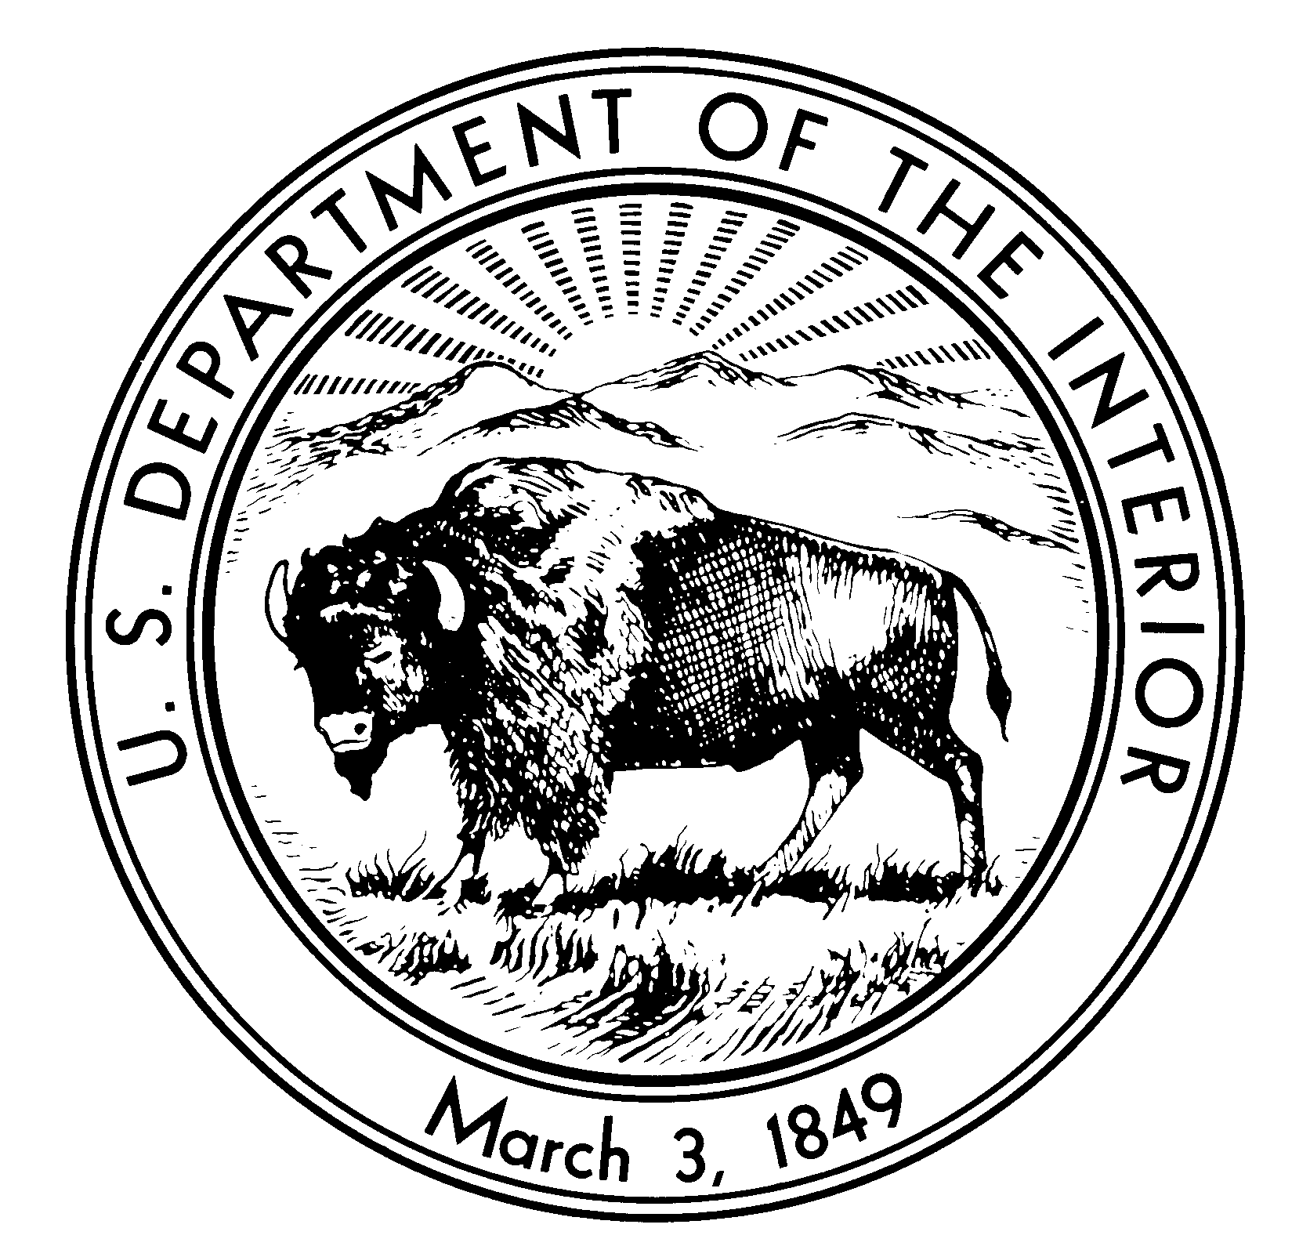
I
United States Department of the Interior
NATIONAL PARK SERVICE
Nicodemus National Historic Site
510 Washington Avenue B1
Nicodemus, Kansas 67625

IN REPLY REFER TO:

Thank you for your interest in the Nicodemus Traveling Trunk. Please fill out the information below and mail this form to Nicodemus National Historic Site 510 Washington Avenue B1
Nicodemus, Kansas 67625 or fax to785-839-4325. The trunk may be checked out at no charge, except for shipping to its next destination or return to the Park via FEDEX, UPS or Post Office. The length trunk maybe checked out will be due to availably. For more information contact our education coordinator at

Nicodemus National Historic Site
510 B1 Washington Avenue
Nicodemus, Kansas 67625

785-839-4233 phone
785-839-4325 fax
_________________________________________________________________________

Contact and Shipping Information:

Name: _____________________________________

School: _____________________________________

Address: ____________________________________

City: ______________________ State: _____________________ Zip Code:____________

Email Address: _______________________________

Phone:_______________________________________

Number of Students or Users of the Trunk:____________________________

Experience Your America: The National Park Service cares for the special places saved by the American people so that all may experience our heritage.

