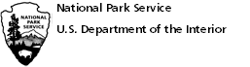 | Nez Perce National Historical Park

Full Name:
 | Last | First | M.I.

Address:
 | Street Address | Apartment/Unit #

 | City | State | ZIP Code

Home Phone: |  | Email:

Photo identification | ID/ Photo #  : (photo name) Avian Species Location Title Date Taken

Ex. DCIM 3456, Roseate Spoonbill, Ding Darling NWR, Roseate Spoonbill In Flight, 3/23/2018

1
2
3
4
5

Signature (can be typed):
I have read and agree to the Rules and Regulations: |  | (place “x” here)

