Virtual Junior Ranger Program!
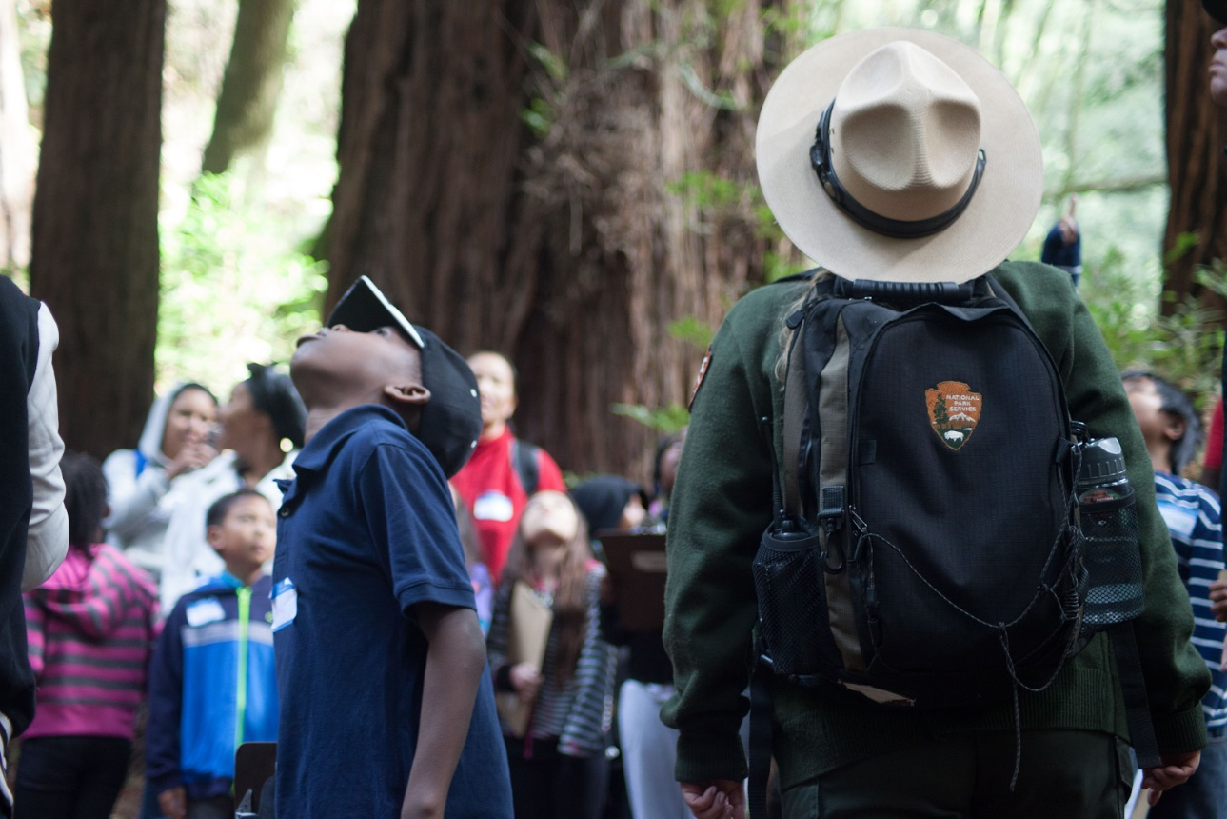
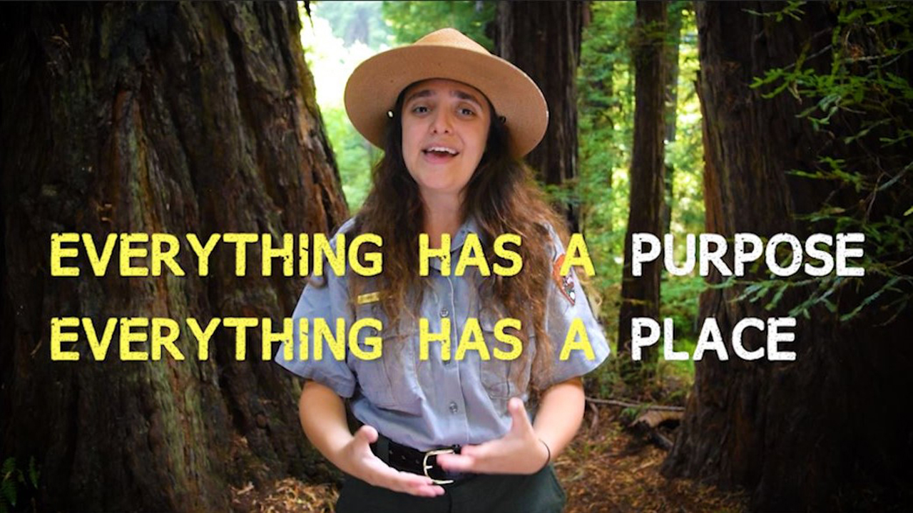
While you watch the redwood forest puppet show, fill out this virtual Junior Ranger packet!
Image Description: A drawing of a black tailed deer says, “What is an ecosystem?”
Answer the deer’s question:
What do you think lives in the redwood forest? Please draw a picture below:

Image Description: A drawing of a fog cloud says, “What is one reason you like where you live?”
Draw your home, school or park and write a reason you like it:

Image Description: A drawing of a squirrel says, “How would it make you feel to live in the canopy?”

Close your eyes. Imagine yourself up in the canopy. Now draw yourself in the canopy and write how you feel:

Image Description: A drawing of fire says, “What is one of your superpowers?”

Answer the fire’s question:

Draw yourself as a forest superhero!
Image Description: The redwood forest with a white square surrounded by comic book style words like “wow” “zap” “poof” “cool” “OMG” “yeah”.

How can your superpower help the forest?
How can your superpower help your community?

Image Description: a drawing of a burl and fire scar says, “What is unique about you?”
Answer the burl’s question:

How decomposition works:
Image Description: A drawing of a tree is surrounded by dead leaves, banana slugs and mushrooms. Arrows point from the dead material to the decomposers and then to the soil and back up to the tree. The text on the image reads “Dead leaves and other dead material have nutrients inside. Decomposers such as banana slugs and fungus break down the dead material, making rich soil. Trees and other plants can now take up those nutrients through the soil and use them for growth.”
Image Description: A drawing of a banana slug saying, “What is something small but important to you?”
Draw it and write about it below:

Underground, a redwood tree has roots. Underground, a mushroom has mycelium. Roots and mycelium weave together in the dirt. They form a web, or network, under the forest floor. Mushrooms get food and energy from tree roots. Trees get nutrients from mycelium. Roots and mycelium also connect trees to other trees. Through this connection, trees communicate, share, and support each other. This connection is a mycorrhizal network.

Image Description: Three redwood trees and mushrooms are connected underground through their roots and mycelium.
Image Description: A drawing of three mushrooms says, “How do you support other people?”
Answer the mushroom’s question:
Image Description: A drawing of a coho salmon says, “What role do you play in your community?”

Answer the coho salmon’s question:
There are so many different organisms in the redwood forest. They all live together, work together, and thrive together!

Image Description: A drawing of a wren says, “What is diversity?”
Answer the wren’s question:

How does diversity make this forest stronger?
How does diversity make your community stronger?
Celebrate the story and diversity of your community!

