Superintendent’s Compendium

Of designations, Closures, Permit Requirements and Other Restrictions
Imposed Under Discretionary Authority

National Park Service
U.S. Department of the Interior

Morristown National Historical Park
30 Washington Place
Morristown, NJ 07960

Approved by Thomas E. Ross, Superintendent – 02/26/21
Signature is on file at the park

A. INTRODUCTION
1. Superintendent's Compendium Described

The Superintendent's Compendium is the summary of park specific rules implemented under 36 Code of Federal Regulations (36 CFR). It serves as public notice, identifies areas closed for public use, provides a list of activities requiring either a special use permit or reservation, and elaborates on public use and resource protection regulations pertaining specifically to the administration of the park. The Superintendent's Compendium does not repeat regulations found in 36 CFR and other United States Code and CFR Titles, which are enforced without further elaboration at the park level.
The regulations contained in 36 CFR, Parts 1-7, are the basic mechanism used by the National Park Service (NPS) to preserve and protect the natural and cultural resources of the park and to protect visitors and property within the park. Parts I through 6 are general regulations applicable to all areas of the National Park system, and Part 7 contains special regulations specific to individual parks. Each of these Parts has many sections and subsections articulating specific provisions. Within some of these Part 1-7 sections and subsections, the Superintendent is granted discretionary authority to develop local rules to be responsive to the needs of a specific park resource or activity, park plan, program, and/or special needs of the general public.
As an example, 36 CFR 1.5(a) Closures and Public Use Limits provide the Superintendent certain discretion in allowing or disallowing certain activities. The authority granted by the Section, however, requires the Superintendent to comply with the Administrative Procedures Act (6 USC Section 551 ), which requires public notice on actions with major impact on visitor use patterns, park resources or those that are highly controversial in nature.
Another example is 36 CFR 1.6 Permits, which allows the Superintendent to require a permit for certain uses and activities in the park. This Section, however, requires that a list of activities needing a permit (and a fee schedule for the various types of permits) be maintained by the park.
A final example is 36 CFR 2.1 (c) (1) Preservation of Natural, Cultural and Archeological Resources, which provides the Superintendent the authority to designate certain fruits, nuts, berries or unoccupied seashells which may be gathered by hand for personal use or consumption. This activity can occur, however, only if a written determination shows that the allowed activity does not adversely affect park wildlife, the reproductive potential of a plant species, or otherwise adversely affect park resources.
This Compendium should be used in conjunction with Title 36 CFR, Parts 1-7, to more fully understand the regulations governing the use and enjoyment of all the areas of the national Park System.
A copy of Title 36, CFR, can be purchased from the U.S. Government Printing Office at:
Superintendent of Documents
P.O. Box 371954
Pittsburgh, PA 15250-7954
The CFR is also available on the Internet at:
http://www.access.gpo.gov/nara/cfr/waisidx_05/36cfrvI_05.html
2. Laws and Policies Allowing the Superintendent to Develop This Compendium
The National Park Service (NPS) is granted broad statutory authority under 16 United States
Code (U.S.C.) Section 1 et.seq. (Organic Act of 1916, as amended) to regulate the use of the Federal areas known as national parks, monuments, and reservations. by such means and measures as conform to the fundamental purposes of the said parks... which purpose is to conserve the scenery and the natural and historic objects and the wildlife therein and to provide for the enjoyment of the same in such manner and by such means as will leave them unimpaired for the enjoyment for future generations" (16 U.S.C. Section 1). In addition, the NPS Organic Act allows the NPS, through the Secretary of the Interior, to "make and publish such rules and regulations as he may deem necessary or proper for the use and management of the parks, monuments, and reservations under the jurisdiction of the National Park Service" (16 U.S.C. Section 3).
In 1970, Congress amended the NPS Organic Act to clarify its intentions as to the overall mission of the NPS. Through the General Authorities Act of 1970 (54 USC Subtitle I), Congress brought all areas administered by the NPS into one National Park System and directed the NPS to manage all areas under its administration consistent with the Organic Act of 1916.
In 1978, Congress amended the General Authorities Act of 1970 and reasserted System-wide the high standard of protection defined in the original Organic Act by stating "Congress further reaffirms, declares, and directs that the promotion and regulation of the various areas of the National Park System, as defined by Section 1 of this Title, shall be consistent with and founded in the purpose established by Section I of this Title, to the common benefit of all people of the United States."
54 USC Subtitle I defines the National Park System as"... any area of land and water administered by the Secretary, acting through the Director, for park, monument, historic, parkway, recreational, or other purposes."
In addition to the above statutory authority, the Superintendent is guided by established NPS policy as found in the NPS Management Policies (2006). The Superintendent is also guided by more specific policies promulgated by the Director, National Park Service, in the form of Director's Orders. As stated in the Management Policies, the primary responsibility of the NPS is to protect and preserve our national natural and cultural resources while providing for the enjoyment of these resources by visitor and other users, as long as use does not impair specific park resources or overall visitor experience. The appropriateness of any particular visitor use or recreational experience is resource-based and will vary from park to park; therefore, a use or activity that is appropriate in one park area may not be appropriate in another. The Superintendent is directed to analyze overall park use and determine if any particular use is appropriate. Where conflict arises between use and resource protection, where the Superintendent has a reasonable basis to believe a resource is or would become impaired, than that Superintendent is obliged to place limitations on public use.
- Consistency of This Compendium with Applicable Federal Law and Requirements
The Superintendent's Compendium is not considered a significant rule requiring review by the Office of Management and Budget under Executive Order 12866. In addition, this Compendium will not have a significant economic effect on a number Of small entities nor impose a significant cost on any local, state or tribal government or private organization, and therefore does not fall under the requirements of either the Regulatory Flexibility Act or the Unfunded Mandates Reform Act.
The actions and requirements described in this Compendium are found to be categorically excluded from further compliance with the procedural requirements of the National Environmental Policy Act (NEPA) in Department of the Interior (DOI) Guidelines 516 DM 6 and as such, an Environmental Assessment will not be prepared.
- Development of the Requirements of the Superintendent's Compendium
As outlined above, the NPS has broad authority and responsibility to determine what types of uses and activities are appropriate in any particular National Park System area. The requirements of the Superintendent's Compendium are developed through an analysis and determination process. The decision criteria used during this process are:
    - Is there use or activity consistent with the NPS Organic Act and NPS policy?
    - Is the use or activity consistent and compatible with the park's enabling legislation, management objectives, and corresponding management plans?
    - Will the use or activity damage the park's protected natural and cultural resources and other protected values?
    - Will the use or activity disturb or be in conflict with wildlife, vegetation, and environmental protection actions and values?
    - Will the use or activity conflict with or be incompatible with traditional park uses and activities?
    - Will the use or activity compromise employee or public safety?
- Applicability of the Compendium
The rules contained in this Compendium apply to all persons entering, using, visiting or otherwise present on federally owned lands, including submerged lands, and waters administered by the NPS within the legislative boundaries of the park. This includes all waters subject to the jurisdiction of the United States, including all navigable waters.
- Enforcement of Compendium Requirements
NPS Law Enforcement Park Rangers enforce the requirements of the United State Code, 36 CFR, and this Superintendent's Compendium.
- Penalties for Not Adhering to the Compendium Requirements
A person who violates any provision of the regulations found in 36 CFR, Parts 1-7, or provisions of this Compendium, is subject to a fine as provided by law (18 U.S.C. 3571) up to $5,000 for individuals and $10,000 for organizations, or by imprisonment not exceeding six months (18
U.S.C. 3559), or both, and shall be adjudged to pay all court costs associated with any court proceedings. You may receive a list of fines associated with any particular provision by contacting the Chief Ranger at the park address found below.
- Comments on the Compendium
The Compendium is reviewed annually and revised as necessary. The park welcomes comments about its program and activities at any time.
- Effective Date of the Superintendent Compendium
The Superintendent's Compendium is effective on the approval date listed on the first page of this document, and remains in effect until revised for a period up to one year.
- Additional Information
Some of the terms used in this Compendium may have specific meaning defined in 36 CFR 1.4 Definitions.
Il. Availability
Copies of the Compendium are available at:

30 Washington Place
Morristown, New Jersey 07960.

It may also be found at https://www.nps.gov/morr/learn/management/lawsandpolicies.htm

B. SUPERINTENDENT'S COMPENDIUM
In accordance with regulations and the delegated authority provided in Title 36, Code of Federal Regulations ("36 CFR"), Chapter I , Parts 1-7, authorized by Title 16 United States Code, Section 3, the following provisions apply to all lands and waters administered by the National Park Service, within the boundaries of Morristown National Historical Park. Unless otherwise stated, these regulatory provisions apply in addition to the requirements contained in 36 CFR, Chapter I, and Parts 1-7.
Written determinations, which explain the reasoning behind the Superintendent's use of discretionary authority, as required by Section I .5(c), appear in this document identified by italicized print.

I. 36 CFR §1.5 – VISITING HOURS. PUBLIC USE LIMITS. CLOSURES AND AREA DESIGNATIONS FOR SPECIFIC USE OR ACTIVITIES
(a)(l) The following visiting hours and public use limits are established for all or for the listed portions of the park, and the following closures are established for all or a portion of the park to all public use or to a certain use or activity:
Note: Due to seasonal budgetary consideration and Special Events/permits hours may vary, especially in the winter. The most current hours are posted on-line at https://www.nps.qov/morr/index.htm, bulletin boards, and any Morristown NPS contact station when open. Road and trail hours are posted at the entrance to each unit of the park.

Visiting Hours
Headquarters/Museum
  - Walks and Trails Park hours as posted
  - Parking Lots Park hours as posted
  - Museum/ Ford Mansion September-June: 10am-4pm: Wednesday-
Sunday, Except Thanksgiving, Christmas and New Year’s Day
July and August: 10am-5pm daily

Fort Nonsense Park hours as posted

Jockey Hollow
- Trails Park hours as posted
- Parking Lots Park hours as posted
- Tour Road/Restrooms Closed 30 min prior to posted park hours
- Visitor Center and Wick House September-June: 10am-4pm: Wednesday-
Sunday, Except Thanksgiving, Christmas and New Year’s Day
July and August: 10am-5pm daily

New Jersey Brigade/Çross Estate Area Park hours as posted

Park hours posted will vary by the time of year, per the following schedule (+1-2 weeks)

Time From Through

8am – 5pm EST First Sunday in November First Saturday in February
8am – 6pm EST First Sunday in February First Saturday in March
8am – 7pm EDT First Sunday in March First Saturday in April
8am – 8pm EDT First Sunday in April First Saturday in September
8am – 7pm EDT First Sunday in September First Saturday in October
8am – 6pm EDT First Sunday in October First Saturday in November

Whenever park hours as posted vary, the hours posted take precedence over the above times.
Determination: The above visiting hours are based upon a determination that such hours are necessary for the maintenance of public health and safety, the protection of natural and cultural resources, and the implementation of management responsibilities.
Closures
- Entering or remaining in the park outside of posted hours is prohibited.
- Severe weather conditions or other operational constraints may require delayed opening or non-opening of park roads or visitor use buildings.
- The following park areas are closed to the public:
  - Wick farm barn and corral in Jockey Hollow
  - Yards immediately adjacent to permanent housing.
  - The Jockey Hollow maintenance area.
  - All areas signed or posted as "Closed", "area closed", "Restricted Access", "Staff Only",
"Employee Only", or "Authorized Vehicles/Personnel Only"
- The following park buildings or portions of park buildings are closed to the public (except as specifically authorized and/or escorted by park staff):
  - All buildings within the park are closed to public use except for regularly scheduled and conducted activities, reservations, or as allowed by a permit.
  - All areas signed or posted as "Closed", "area closed", "Restricted Access", "Staff Only",
"Employee Only", or "Authorized Vehicles/Personnel Only"
Determination: The Superintendent has determined that these closures are necessary for the safety of park visitors, the protection of natural and cultural resources, maintaining historical view sheds, and to maintain residents' privacy.
- Recreational sledding, inner tubing, ice skating, and tobogganing are prohibited within the park
The following park areas are closed to picnicking:
- The open field adjacent to the Soldier Huts (west of the Tour Road and north of the Sugarloaf Road exit).
- The area immediately adjacent to the Wick House.
- On the Ford Mansion lawn.

Determination: The Superintendent has determined that the above-described activities conflict with the historical scene at the locations specified.
Public Use Limits
- Tours of the historic Ford Mansion are limited to groups of 20 people or less.
The following restrictions and/or conditions are in effect for the specific uses or activities noted:
- Launching, landing, or operating an unmanned aircraft (drone, model airplane, quadcopters, etc) from or on lands and waters administered by the National Park Service within the boundaries of Morristown National Historical Park is prohibited except for administrative use, or as approved in writing by the superintendent.
- Vehicles:
Washing, repair, or maintenance of vehicles belonging to visitors in public parking areas is prohibited. (Other than short-term emergency repairs)
Parking is limited to parking lots and designated pull-outs.
Parking along roadway shoulders or on grass areas are prohibited.
- Hiking and Pedestrian Use:

Hiking and pedestrian use is restricted to the park's trails and roadways.

Leaving a trial or roadway to shortcut between portions of the same trail or roadway, or to shortcut between portions of the same trail or roadway is prohibited.
Determination: The above designations are based upon a determination that such conditions are necessary for the maintenance of public health and safety, protection of environmental and cultural values, protection of natural or cultural resources and the equitable allocation and use of the park.

CCTV Policy Statement
In accordance with National Park Service Law Enforcement Reference Manual 9 (RM-9), notice is hereby given that Morristown NHP uses Closed Circuit Television (CCTV) security camera monitoring

The park's use of Closed Circuit Television (CCTV) for law enforcement and security purposes will only be to visually monitor public park areas and public activities where no constitutionally protected reasonable expectation of privacy exists. Such CCTV use — which will have adequate privacy and First Amendment safeguards — will be to help ensure public safety and security; facilitate the detection, investigation, prevention, and deterrence of terrorist attack and crime; help ensure the safety of citizens and officers; help assist in the proper allocation and deployment of law enforcement and public safety resources; and help facilitate the protection of the innocent and the apprehension and prosecution of criminals. (RM-9, 26. I)
This policy does not restrict the official use of CCTV in government administrative areas, including administrative buildings, jail holding facilities (RM-9, 26.37), revenue collection sites, etc., where the government may record/monitor its facilities. For example, the government may perform unrestricted video/audio recording at revenue collection points (entrance stations, visitor center counters, etc.). This policy does not restrict the use of an Audio/Visual Recording Device (AVRD) in patrol vehicles or officer worn recording devices used by commissioned rangers. (RM-9, 26.1).
Operation of CCTV cameras, maintenance of recorded images and use of recorded images will be in accordance with NPS and Department policy and applicable laws and regulations. (RM-9, 26.1-26.4) No person will be targeted or monitored merely because of race, religion, gender, sex, disability, national origin, or political affiliation or views. (RM-9, 26.4.2)
Nothing in this policy statement is intended to create any rights, privileges, or benefits not otherwise recognized by law.
COVID-19 Mask Usage

Masks must cover the nose and mouth and fit snugly around the nose and chin with no large gaps around the sides of the face. Masks not designed to be protective, masks with ventilation valves, and face shields do not meet the requirement. Individuals over the age of two years must wear masks, except when actively eating or drinking, in the following locations:
  - All common areas and shared workspaces in buildings owned, rented or leased by the National Park Service, including, but not limited to, park visitor centers, administrative offices, museums, gift shops, and comfort stations.
  - In outdoor areas, when others are present and physical distancing (staying at least six feet apart) cannot reasonably be maintained such as:
    - Crowded trailheads, overlooks, parking lots, bulletin boards, information panels, soldier huts, formal garden areas, and other areas of interest that draw large groups of visitors.
    - All trails, paths and paved surfaces less than 8’ wide
      - The physical configuration of some trails, paths, and surfaces in the park are too narrow to safely accommodate bi-directional traffic with a minimum of six feet between visitors. This also reduces potential resource damage from off-trail use.
    - Standing adjacent to outdoor restrooms if congregating or waiting in line.
      - The outdoor restrooms may experience high visitor traffic, creating a line that can extend outside the restroom entrance and into/on the adjacent walkways or parking areas. This policy is to ensure the safety of those waiting in line for the restroom and/or using adjacent walkways/parking areas.
In addition to physical distancing and hand washing, masks are a critical step to help prevent people from getting and spreading COVID-19. When you wear a mask, you protect others as well as yourself. COVID-19 spreads mainly from person to person through respiratory droplets. Masks are a simple barrier to help prevent respiratory droplets from reaching others.
CDC guidance recognizes that masks should not be worn by children under age two or anyone who has trouble breathing. Wearing masks may be difficult for some people with sensory, cognitive, or behavioral issues. If a visitor is unable to wear a mask properly or cannot tolerate a mask, they should not wear one and may be asked to leave any location where masks are required to be worn. Visitors may be asked to lower their masks briefly for identification purposes in compliance with safety and security requirements.
Filming Activities

The following types of filming activities may occur in areas open to the public without a permit and without advance notice to the NPS:
- Outdoor filming activities involving five persons or less and equipment that will be carried at all times, except for small tripods used to hold cameras.
The organizer of any other type of filming activity must provide written notice to the Superintendent at least 10 days prior to the start of the proposed activity. Based upon the information provided, the Superintendent may require the organizer to apply for and obtain a permit if necessary, to:

  - Maintain public health and safety
  - Protect environmental or scenic values
  - Protect natural or cultural resources
  - Allow for equitable allocation and use of facilities
  - Avoid conflict among visitor use activities.
If the Superintendent determines that the terms and conditions of a permit could not mitigate the concerns identified above in an acceptable manner, the Superintendent may deny a filming request without issuing a permit. The Superintendent will provide the basis for denial in writing upon request.
The NPS will consider requests and process permit applications in a timely manner. Processing times will vary depending on the complexity of the proposed activity. If the organizer provides the required 10-day advance notice to the NPS and has not received a written response from the NPS that a permit is required prior to the first day of production, the proposed filming activities may occur without a permit.
The following are prohibited:
- Engaging in a filming activity without providing advance notice to the Superintendent when required.
- Engaging in a filming activity without a permit if the Superintendent has notified the organizer in writing that a permit is required.
- Engaging in a filming activity without a permit in an area that is closed to the public. This includes filming on park grounds during times in which the park is closed to the public.
- Violating a term and condition of a permit issued under this action.
Violating a term or condition of a permit issued under to this action may also result in the suspension and revocation of the permit by the Superintendent.

II. 36 CFR§1 .6 - ACTIVITIES THAT REQUIRE A PERMIT

(f) The following is a compilation of those activities for which a permit from the superintendent is required:
§1.5(d) The following activities related to Public Use Limits
Use of unmanned aircrafts
Use of park buildings and structures except for regularly scheduled and conducted activities
§2.4(d) Carrying or possessing a weapon, trap, or net
§2.5(a) Specimen collecting (plant, fish, wildlife, rocks, or minerals)
§2.12 Audio Disturbances:
(a)(2) Operating a chain saw in developed areas
(a)(3) Operation of any type of portable motor or engine, or device powered by a portable motor or engine in non-developed areas
(a)(4) Operation of a public address system in connection with a public gathering or special event for which a permit has been issued pursuant to §2.50 or §2.51
§2.17 Aircraft & Air Delivery:
(a)(3) Delivery or retrieval of a person or object by parachute, helicopter or other airborne means
(c)(l) Removal of a downed aircraft
§2.17 Soliciting or demanding gifts, money goods, or services (Pursuant to the terms and conditions of a permit issued under §2.50, §2.51 , or §2.52)
§2.38 Explosives:
Use, possess, store, transport explosives, blasting agents
Use or possess fireworks
§2.50(a) Conduct of a sports event, pageant, regatta, public spectator attraction, entertainment,
ceremony, and similar events
§2.51 (a) Public assemblies, meetings, gatherings, demonstrations, parades and other public
expressions of views involving more than 25 people.
§2.52 (c) Sale or distribution of printed matter involving more than 25 people.
§2.60 (b) Livestock use
§2.61 (a) Residing on federal lands
§2.62 Memorialization.
(a) Erection of monuments (Requires approval from Regional Director)
(b) Scattering ashes from human cremation
§4.11 (a) Exceeding of established vehicle load, weight and size limits
§5.1 Advertisements - (Display, posting or distribution.)
§5.3 Engaging in or soliciting any business
§5.5 Commercial Photography/Filming (see also 43 CFR 5.1)
- For filming see 36 CFR §1.5 Filming Activities
- Still photography of vehicles, or other articles of commerce or models for the purpose of commercial advertising (use of models, sets, or props)
§5.6(c) Use of commercial vehicles on park area
§5.7 Construction of buildings, facilities, trails, roads, boat docks, path, structure, etc.
Applications for permits can be obtained by contacting the Permit Manager:
Morristown NHP
c/o Permit Office
30 Washington Place
Morristown, NJ 7960 973-539-2016 x201 www.nps.gov/morr
III. GENERAL REGULATIONS

36 CFR §2.1 - PRESERVATION OF NATURAL. CULTURAL AND ARCHEOLOGICAL RESOURCES

(a)(4) Using or possessing wood gathered from within the park area is prohibited, except that dead wood on the ground may be collected for use as fuel for campfires within the park in the following areas:
- The Superintendent has not designated any areas where dead wood on the ground may be collected, therefore this is not allowed
(a)(5) Walking on, climbing, entering, ascending, descending, or traversing an archeological or cultural resource, monument, or statue is prohibited, except in the following areas and/or under the following conditions.

- No conditions/areas designated
Under, I(a) collecting natural materials from the park is generally prohibited. However, pursuant to §2.1 (c), the following fruits, nuts, berries or unoccupied seashells may be gathered by hand for personal use or consumption, in accordance with the noted size, quantity, collection sites and/or possession and consumption restrictions:

- Wine Berries, 1 (DRY) quart per person, per day

Determination: The Superintendent has determined that the limited use of these renewable resources will not adversely affect park wildlife, the reproduction of any plant species or other park resources. The authorizations of this consumptive use recognize an existing condition but is meant to prohibit any largescale collection of natural products for private gain through sale, storing, preserving of other purpose not closely related to the park experience.

36 CFR §2.2 - WILDLIFE PROTECTION
(b) Hunting and trapping is prohibited.
(d) Transporting lawfully taken wildlife through the park is prohibited except on Tempe Wick Road or under the following conditions and procedures:
- Carcass must be tagged in accordance with state and federal law
- Game must be kept out of sight as much as practical
- No other route/road is available to the final destination
- Deer legally taken outside of the park, but ran into a park area, may be removed by park law enforcement staff and returned to the hunter provided that:
I) park law enforcement staff are notified in advance and accompany the hunter while present on parkland
2) There is clear indisputable evidence indicating that the deer was originally taken outside of the park.
Determination: The regulation allows for the legal transportation of wildlife so long as it is harvested or collected in accordance with New Jersey State hunting regulations.
(e)(i). Use of artificial light to view wildlife is prohibited except in research studies authorized by the Superintendent.
Determination: The Park is closed to the public at sunset. Except for authorized researched activities, viewing wildlife with artificial light is a technique associated with hunting and is commonly referred to as "spotlighting". The use of artificial light to view wildlife negatively impacts the animals in their natural environment.

36 CFR §2.3 - FISHING
Fishing is allowed in waters within the boundary of Morristown National Historical Park in accordance with State of New Jersey Division of Fish, Game and Wildlife regulations. Indian Brook and the Passaic River are designated by the State of New Jersey as "Wild Trout Streams" and state fishing regulations are more stringent at those locations.

36 CFR §2.4 - WEAPONS. TRAPS. AND NETS
Pursuant to 18 USC §930, firearms are prohibited in federal facilities. Federal facilities are marked with signs at public entrances.
Pursuant to 16 US §1a-7b, park visitors may carry firearms in the park if they are otherwise in compliance with federal, state, and local laws.
(e) Traps and nets are prohibited except under a permit issued by the Superintendent.

36 CFR §2.5 - RESEARCH SPECIMENS
Taking plants, fish, wildlife, rocks, or minerals is prohibited except in accordance with 36 CFR chapter I or the terms and conditions of a specimen collection permit pursuant to §2.5(a)

36 CFR §2.10 - CAMPING and FOOD STORAGE
Camping is defined as erecting a tent or shelter of natural or synthetic material, preparing a sleeping bag or other material for use, parking a motor vehicle, motorhome or trailer, or mooring a vessel for the apparent purpose of overnight occupancy.
(a) Camping is prohibited in Morristown National Historical Park
(d) No food storage conditions designated
36 CFR §2.11 - PICNICKING
Certain areas have been closed to picnicking and are listed in section 1.5(a)(I) "Closures"

36 CFR §2.12 - AUDIO DISTURBANCES
(a)(2) Operating a power saw in developed areas is prohibited, except pursuant to the terms and conditions of a permit.
(a)(3) Operating any type of portable motor or engine, or device powered by a portable motor or engine in non-developed areas is prohibited, except pursuant to the terms and conditions of a permit.
(a)(4) Operating a public address system is prohibited, except in connection with a public gathering or special event for which a permit has been issued pursuant to §2.50 or §2.51.

36 CFR § 2.13 - FIRES
(a)(l) The lighting or maintaining of fires is generally prohibited, except as provided for in the following designated areas and/or receptacles, and under the conditions noted:
Designated Areas.
• Wick House fire pit conducted by Park employees or properly training volunteers, for interpretive purposes only.

36 CFR §2.14 - SANITATION and REFUSE
(a)(2) Using park refuse receptacles or facilities for dumping household, commercial, or industrial refuse is prohibited.
(a)(7) Disposing of fish remains on land or in waters within 200 feet of boat docks or swimming beaches or within developed areas is prohibited.
(a)(8) In developed areas, the disposal of human body waste is prohibited, except at the following designated locations or fixtures provided for that purpose:
- Jockey Hollow Visitor Center
- New York Brigade comfort station
- Washington's Headquarters Museum

36 CFR §2.15 - PETS
"Pet" means dogs, cats, or any animal that has been domesticated. [36 CFR §1.4]
(a)(l) Possessing pets in public buildings, public transportation vehicles, swimming beaches, and the following structures and/or areas is prohibited:
- Wick Farm Barn & Corral
- Within Park Headquarters/Museum
- Within the Ford Mansion
- Within the Wick House
NOTE: This subparagraph does not apply to service animals
(a)(3) Leaving a pet unattended and tied to an Object is prohibited.
(a)(5) Pet excrement must be disposed of in accordance with the following conditions.
- All pet excrement must be removed no matter the location (road, paths, trail, open field, or around buildings) and disposed of in established refuse containers,
(e) Pets may be kept by park residents under the following conditions:
• In accordance with the park's approved Housing Management Plan.

36 CFR §2.16 - HORSES and PACK ANIMALS
- The following animals are designated as pack animals for purposes of transporting equipment • Horses, mules, burros, llamas, and goats
- The use of horses or pack animals is prohibited except for the following trails, routes or areas designated for their use:
White Blaze Trail (Grand Loop)
Blue Blaze Trail (NY Brigade)
Mt Kemble Loop Trail
Old Army Camp Road
Mendham Road Trail
South portion of Aqueduct loop trail (Green Blaze)
Trail spurs to access parking area
(d) Free-trailing or loose-herding of horses or pack animals on trails is prohibited.
(g) Other conditions concerning the use of horses or pack animals:
- Manure deposited by horses at parking areas where they are unloaded/loaded into trailers must be removed by the owner.
- Groups of riders using six or more horses must obtain a Special Use Permit at least 48 hours prior to arrival at the park.
- Halter and lead rope must be carried or be on the horse or pack animal at all times.
Determination: Consistent with public health, protection of environmental values and natural resources and avoidance of conflict among visitor use activities, the Superintendent has determined that some regulation of horse use is necessary.

36 CFR §2.17 - AIRCRAFT AIR DELIVERY
(a)(3) Delivering or retrieving a person or object by parachute, helicopter, or other airborne means is prohibited, except in emergencies involving public safety or serious property loss or pursuant to the terms and conditions of a permit.
(c)(l) The removal of a downed aircraft, components, or parts thereof is subject to procedures established by the Superintendent.

36 CFR §2.19 - WINTER ACTIVITIES
(a) Skiing, snowshoeing, ice skating, sledding, inner tubing, tobogganing, and similar winter sports are prohibited on park roads and in parking areas open to motor vehicle traffic.
• Pursuant to 1.5(f)- closures- Ice skating, sledding, tobogganing, and inner tubing are prohibited park-wide.

36 CFR §2.20 - SKATING. SKATEBOARDS end SIMILAR DEVICES
Using roller skates, skateboards, roller skis, coasting vehicles or similar devices is prohibited throughout the park.
36 CFR §2.21 - SMOKING
(a) The following portions of the park, or all or portions of buildings, structures or facilities are closed to smoking as noted:
• Any park building, housing, government vehicle, or within 20 feet of any building entrance.
Smoking, including all tobacco products, electronic smoking devices (such as electronic cigarettes), handheld vaporizers and items covered by the Controlled Substances Act, Title Il of the Comprehensive Drug Abuse Prevention and Control Act of 1970 (to include for medical use) is prohibited in all other areas and buildings to protect park resources and reduce the risk of fire.
Per-Policy Memorandum 15-03: Effective immediately, use of Electronic Nicotine Delivery System (ENDS) will be treated as tobacco smoking. All provisions of Director's Order #50D—including in particular sections 4.1. I and 4.1.2—will apply to ENDS use. ENDS use will not be permitted within any Government-owned or -leased vehicle, including heavy equipment, watercraft or aircraft.
36 CFR §2.22 - PROPERTY
(a) Leaving property unattended for periods longer than 24 hours is prohibited, except with the permission of the Superintendent.

36 CFR §2.23 - RECREATION FEES
(a) Recreation fees, and/or a permit, in accordance with 36 CFR part 71, are established for the following entrance fee areas, and/or the use of the following specialized sites, facilities, equipment or services, or for participation in the following group activity, recreation events, or specialized recreation uses:
Entrance Fee Areas
- There are no entrance fees for Morristown NHP
Special Recreation Permit Fee (Such as but not limited to. group activities. recreation events. and the use of motorized recreation vehicles):
- Special Use Permit Application Fee- $75

36 CFR §2.37 - NONCOMMERCIAL SOLICITING
Soliciting or demanding gifts, money, goods, or services is prohibited except pursuant to the terms and conditions of a permit that has been issued under §2.50, §2.51 , or 9.52.

36 CFR §2.38 - EXPLOSIVES
- Using, possessing, storing, or transporting explosives, blasting agents or explosive materials is prohibited, except pursuant to the terms and conditions of a permit.
- Using or possessing fireworks and firecrackers is prohibited, except pursuant to the terms and conditions of a permit, and in accordance with applicable State Law.

36 CFR §2.50 - SPECIAL EVENTS
(a) Sports events, pageants, regattas, public spectator attractions, entertainments, ceremonies, and similar events are allowed, provided there is a meaningful association between the park area and the events, and the observance contributes to visitor understanding of the significance of the park area, and a permit therefor has been issued by the superintendent.

36 CFR §2.51 DEMONSTRATIONS
(b) Demonstrations of more than 25 people are allowed within park areas designated as available under paragraph (c)(l) when the superintendent has issued a permit for the activity.
NOTE: Demonstrations involving 25 persons or fewer may be held without a permit in designated park areas, provided that the requirements in 9.51 (b) are met. The 25 person maximum for the small group permit exception may be reduced pursuant to §2.51(b)(3)
(c)(l) The following locations are designated as available for demonstrations:
- Jockey Hollow VC Flag Pole
- New Jersey Brigade Trailhead
- New York Brigade Comfort Station Island
- Fort Nonsense Picnic Area
- Washington's Headquarters — grassy area behind Caretakers Cottage *See attached Map for details
Determination: These designated locations are based upon a determination that such locations will not negatively impact park resources, unreasonably interfere with park operations, impair public facility use, create a danger to public health and safety, or unreasonably impair the atmosphere of peace and tranquility maintained in the historic zones.
These locations are available for any group without a permit, provided they are fulfilling the small group exception of less than 25 people.

36 CFR §2.52 SALE OR DISTRIBUTION OF PRINTED MATERIAL
(b) The sale or distribution of printed matter by more than 25 persons is allowed within park areas designated as available under §2.51 ) (see above) when the superintendent has issued a permit.

36 CFR§2.60 LIVESTOCK USE AND AGRICULTURE

(a) Livestock are generally prohibited in any park area. They are only permitted in park areas pursuant to the exceptions provided for in 2.6 (a) and only pursuant to the terms and conditions of a license, permit, or lease.

36 CFR §2.61 - RESIDING ON FEDERAL LANDS
(a) Residing in park areas, other than on privately owned lands, is prohibited except pursuant to the terms and conditions of a permit, lease, or contract.

36 CFR §2.62 - MEMORIALIZATION
- The installation of a monument, memorial, tablet, structure, or other commemorative installation in a park area without the authorization of the Director is prohibited.
- The scattering of human ashes from cremation is prohibited, except pursuant to the terms and conditions of a permit.

36 CFR §4.21 - SPEED LIMITS
(b) The following speed limits are established for the routes/roads indicated:

Jockey Hollow Road 20 mph
Cemetery Road 20 mph
Grand Parade Road 20 mph
Sugarloaf Road 25 mph
Fort Nonsense 20 mph
Cross Estate Access 15 mph

36 CFR §4.30 - BICYCLES
- The use of a bicycle is prohibited except on park roads and in parking areas.
(h)(4) Riding a bicycle abreast of another rider is prohibited
The term “e-bike” means a two- or three-wheeled cycle with fully operable pedals and an electric motor of less than 750 watts (1 h.p.).
E-bikes are allowed in Morristown National Historical Park where traditional bicycles are allowed.
E-bikes are prohibited where traditional bicycles are prohibited. Except where use of motor vehicles by the public is allowed, using the electric motor to move an e-bike without pedaling is prohibited.
A person operating an e-bike is subject to the following sections of 36 CFR part 4 that apply to the use of traditional bicycles: sections 4.12, 4.13, 4.20, 4.21, 4.22, 4.23, and 4.30(h)(2)-(5).
Except as specified in this Compendium, the use of an e-bike within Morristown National Historical Park is governed by State law, which is adopted and made a part of this Compendium. Any violation of State law adopted by this paragraph is prohibited.

36 CFR §4.31 - HITCHHIKING
Hitchhiking or soliciting transportation is prohibited

36 CFR §5.1 - ADVERTISEMENTS
Commercial notices or advertisements shall not be displayed, posted, or distributed on federally owned or controlled lands within a park area unless prior written permission has been given by the Superintendent.

36 CFR § 5.3 BUSINESS OPERATIONS
Engaging in or soliciting any business in park areas, except in accordance with the provisions of a permit, contract, or other written agreement with the United States, except as such may be specifically authorized under special regulations applicable to a park area, is prohibited.

36 CFR§ 5.6 - COMMERCIAL VEHICLES
(b) & (c) Using commercial vehicles on government roads within park areas when such use is in no way connected with the operation of the park is generally prohibited, and requires permission or a permit issued by the Superintendent.

36 CFR §5.7 - CONSTRUCTION OF BUILDINÇS OR OTHER FACILITIES
Such activities are prohibited, except in accordance with the provisions of a valid permit, contract, or other written agreement with the Unites States.

- END OF DOCUMENT -

Designated Demonstration Areas
(36 CFR 2.51, 2.52)
New Jersey Brigade Trailhead
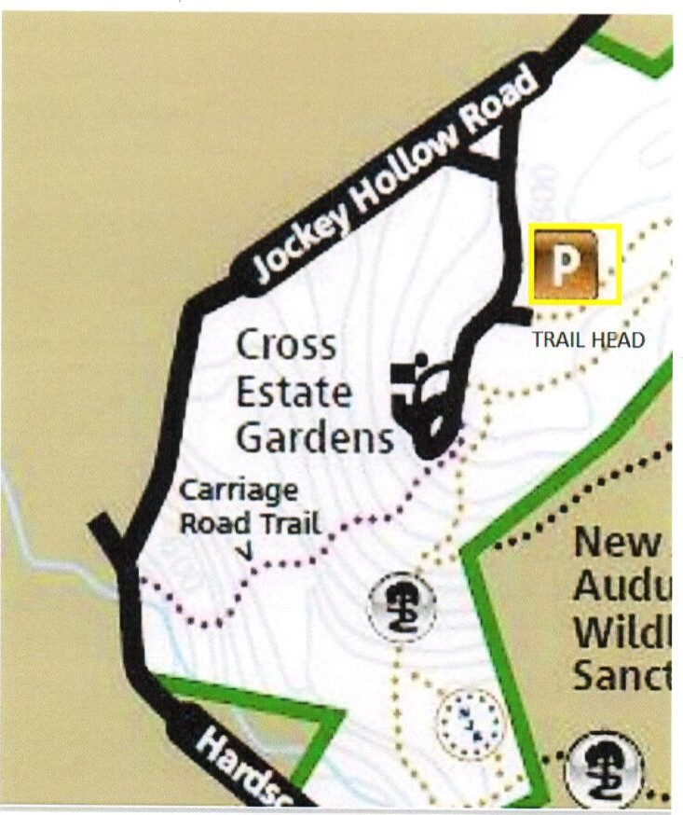
Jockey Hollow VC- Flag Pole
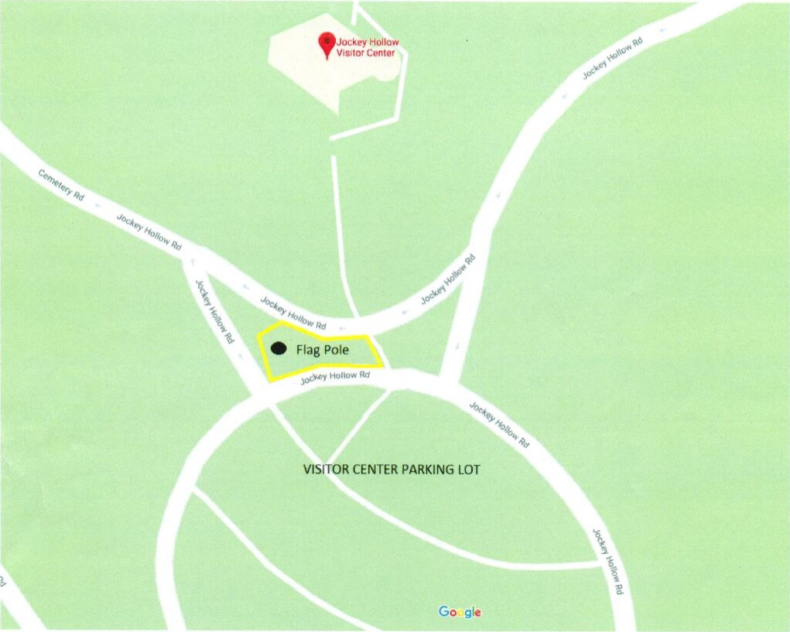
Jockey Hollow New York Brigade- Comfort Station Island
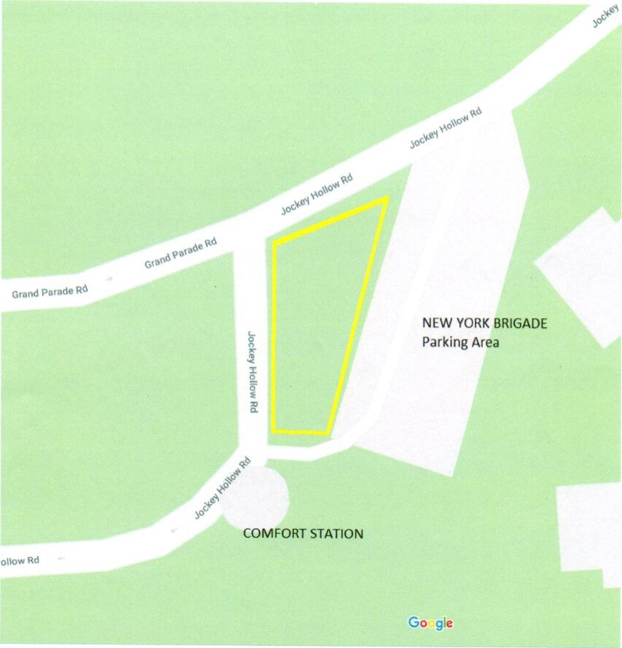
Fort Nonsense- Picnic Area
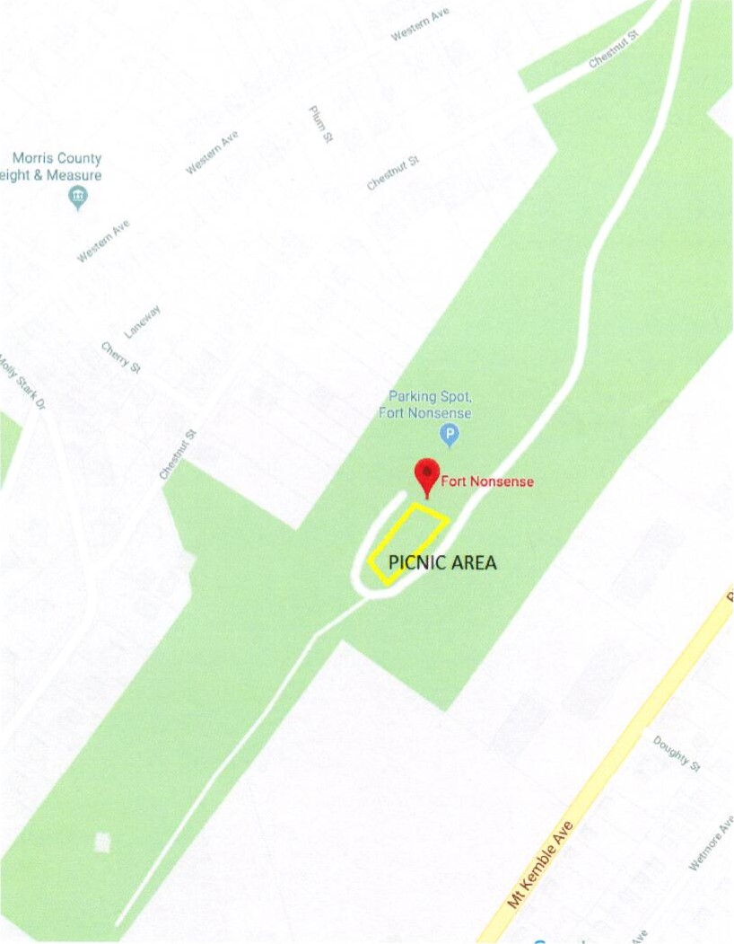
Washington's Headquarters- Behind Caretakers Cottage
