Junior Ranger

EXPLORE LEARN PROTECT

Morristown National Historical Park

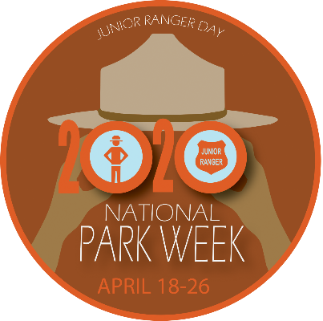

Junior Ranger Pledge:

I promise to learn all that I can about Morristown National Historical Park and to share my knowledge with others. I also promise to enjoy and protect all National Parks

Image of a badge with the words Junior Ranger and Morristown NHP. It has an image of a stetson styled hat

_________________________ _______________

Junior Ranger Name Date