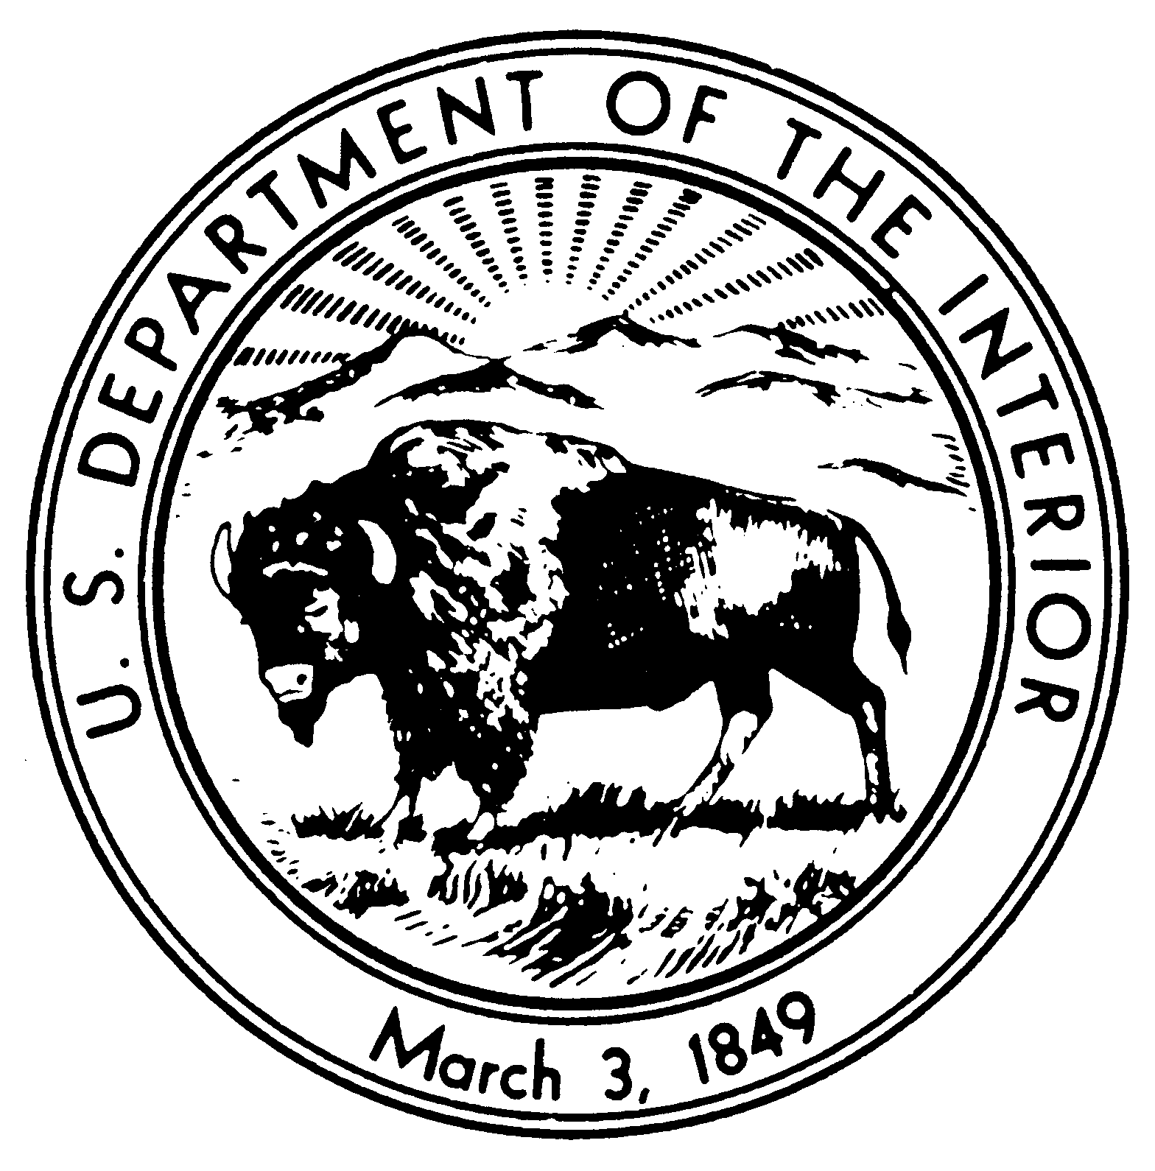

United States Department of the Interior

NATIONAL PARK SERVICE

Morristown National Historical Park

30 Washington Place

Morristown, New Jersey 07960-4299

Dear Educator:

Please review carefully the following materials that are needed for you to prepare yourself and your students for your educational program(s) at Morristown National Historical Park.

Please confirm the dates, number of students and the names of the teacher(s) supervising for each date you have reserved programs.

We are very pleased to inform you that the Ford Mansion is reopening, and it is expected that a tour of the historic house where General Washington headquartered from December 1779 to June 1780 is planned to be included in your visit. unless there are unforeseen circumstances.   No more than twenty students can be part of a tour, so groups greater than twenty students will have to alternate.

Due to staffing, it may be necessary for you or another adult to supervise the activity in the Museum auditorium—see attachments.  The procedures for these activities are written mainly in "script" form to make it as easy to you as possible—just read them to the students as you begin that given activity. If you wish, you can review the activities with the students before your visit, but that is up to you.

It is important that you read all the attachments included in this email-- please get back to me with any questions.

If at all possible, please show at least one of the following videos in your classroom in preparation for your visit:

The Remarkable Story of American Perseverance at Morristown National Historical Park

https://findyourpark.com/get-inspired/revolutionary-story-morristown

Morristown: Where America Survived

https://www.youtube.com/watch?v=lx5YkyHuPvQ

Please note that Ford Mansion is not currently considered accessible—there is no elevator in the 18th century building,

Make sure your driver(s) is/are instructed as to the location of the drop-off point and the proper area to park the vehicle.

We look forward to your visit(s)--we want your students to have an enjoyable learning experience.  Let me know if I can help in any way. You can call me at your convenience--see work cell number below.

Best wishes,

Tom Winslow

Park Ranger/Education Specialist

Morristown National Historical Park

Morristown, NJ 07960

thomas_winslow@nps.gov

work cell number 973 518 1526