National Park Service
U.S. Department of the Interior
Morristown National Historical Park

Morristown

EXPERIENCE YOUR AMERICA™

EXPERIENCE YOUR AMERICA™

MORRISTOWN NHP EDUCATION PROGRAM--SCHOOL YEAR 2023-24

Thank you for your interest in Morristown NHP educational programs!
- The program will take place only at the Washington's Headquarters section of the park
- Programs will take place on Wednesdays only--one program per day.
- There is a limit of forty students per program

Requests must be submitted via email ONLY to thomas_winslow@nps.gov and will be reviewed in the order of their reception.
The email requesting a program reservation must include the following:

- The date you are proposing for you visit—please also provide alternative dates.
- The number of students you intend to bring.
- The grade of the students
- The name and location of your school
- Your name (or if different) the name of the educator(s) that will supervise the group.
- The email address to where the confirmation of the reservation should be sent.
- Any information about the students that park staff should know about the group in preparation for the program. (i.e. special needs)

The education programs (one per day) will take place on Wednesdays from October 18 through December 20, 2023 and February 28--May 29, 2024 at the Washington's Headquarters section of the park. The program is FREE.
Groups must include a minimum of four/maximum of six adults--this includes teachers.
The program will take place from 10 AM to 12 noon and includes a tour of the Ford Mansion and activities in the Washington's Headquarters Museum—information about the activities will be sent with the confirmation of the reservation. Groups with over twenty participants will be divided, with each half of the group (students and adults) alternating between buildings. If the group is divided, there must be at least two adults with the section of the group visiting the Museum and at least one adult with the section of the group visiting the Ford Mansion.

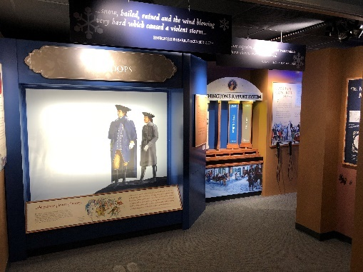
The time allotted in the Museum is for the students to participate in a teacher-led activity with replica 18th century items. Involvement by the adult supervisors is critical to the program’s success. The program includes a opportunity to explore the newest exhibit area—the Discover History Center, with touchscreens and interactive displays.

The park has no facilities for purchasing or eating snacks or lunch. Food consumption is not allowed in the buildings.

If the supervisors permit, the students (approximately 10 at a time) can purchase items in the museum sales area. Let the staff know if you wish to use the sales area before your visit.
Discover History Center

Please note that the Ford Mansion is not considered accessible with a staired front porch at the entrance and narrow stairs connecting the first and second floors that are steeper than modern buildings.

Questions? Contact the Park Ranger/Education Specialist
Tom Winslow thomas_winslow@nps.gov

