AH_large_BW_b.tif

National Park Service

U.S. Department of the Interior

Morristown National Historical Park

Morristown

EXPERIENCE YOUR AMERICA™

EXPERIENCE YOUR AMERICA™

**MORRISTOWN NHP EDUCATION PROGRAM--SCHOOL YEAR 2025-26**

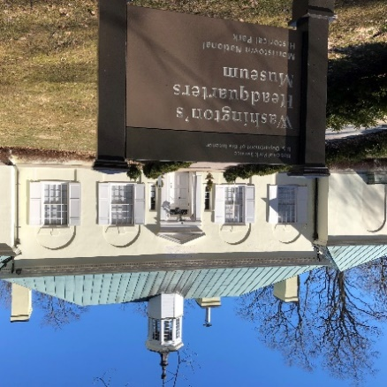Thank you for your interest in Morristown NHP educational programs!

* The program will take place **only** at the Washington's Headquarters section of the park
* Programs will take place **on Wednesdays only**--one program per day.
* There is a limit of **forty** students per program.

The first day email requests will be accepted will be on **September (date to be determined)** Requests must be submitted via **email ONLY** to thomas\_winslow@nps.gov and will be reviewed in the order of their reception. Since the number of programs available are limited, do not delay in making your emailed request to have a chance of receiving the date(s) you want, as demand is great..

The email requesting a program reservation must include the following:

* The date you are proposing for you visit—please also provide alternative dates.
* The number of students you intend to bring.
* The grade of the students
* The name and location of your school
* Your name (or if different) the name of the educator(s) that will supervise the group.
* The email address to where the confirmation of the reservation should be sent.
* Any information about the students that park staff should know about the group in preparation for the program. (i.e. special needs)

The education programs (one per day) will take place on **Wednesdays** from **mid**-**October through December 2025** and **mid-February 26 through May 2026** at the **Washington's Headquarters section** of the park. The program is **FREE**.

Groups must include a minimum of four adult chaperones for supervision--this includes teachers.

The program will take place from **10 AM to 12 noon** with activities in the Washington's Headquarters Museum—information about the activities will be sent with the confirmation of the reservation. When renovations are complete, the program will include a tour of the Ford Mansion.  Groups with over twenty participants will be divided, with each half of the group (students and adults) alternating between activities.  If the group is divided, there must be at least three adults with each half.

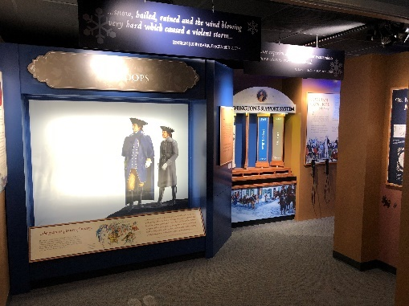The time allotted in the Museum is for the students to participate in a **teacher-led** activity with replica 18th century items and also explore the newest exhibit area—the **Discover History Center**, with touchscreens and interactive displays. Details about the program are sent to teachers after the program reservation is made.

The park has no facilities for purchasing or eating snacks or lunch.  Food consumption is not allowed in the buildings.

If the supervisors permit, the students (approximately 10 at a time) can purchase items in the museum sales area. Let the staff know if you wish to use the sales area before your visit.

Discover History Center

Questions?

Contact the Park Ranger/Education Specialist

Tom Winslow thomas\_winslow@nps.gov