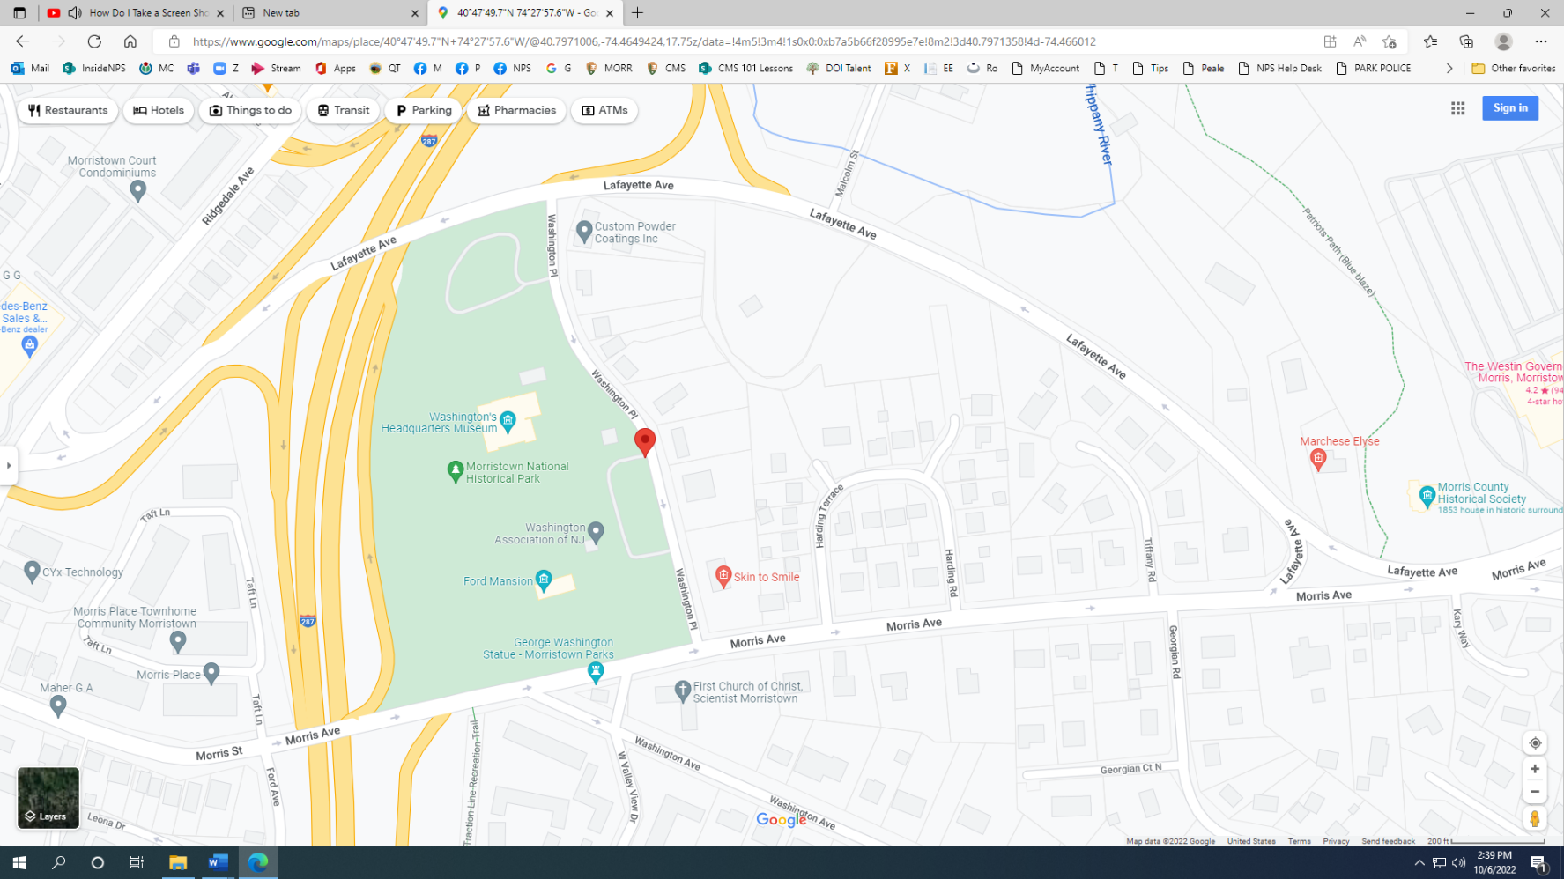**Morristown NHP educational program—drop off and parking information**

Lower Lot

Washington’s HQ Museum

Upper Lot—Drop off

**Drop off group at Upper Parking Lot**

**Red pin** 40.7971358, -74.4660120 shows the location of the entrance to the **Upper Parking Lot**, just past a brown house on the right (22 Washington Place, Morristown NJ) Pull into this lot to drop off the students/adults.

**Buses park at Lower Parking Lot**

**Buses cannot park in the upper lot**—they must park in the Lower Parking Lot at the beginning of Washington Place, behind the Washington’s Headquarters Museum.

Because of the one-way streets, the driver must turn right after leaving the upper lot and then turn left onto Morris Avenue, then circle back (via Lafayette Avenue) to Washington Place. Turn left onto Washington Place and make the next right into the Lower Parking Lot, behind the Washington’s Headquarters Museum.

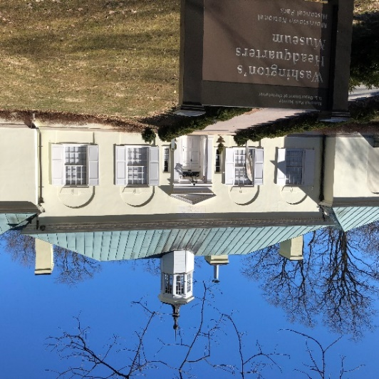After the students and adults are dropped off, they follow a path that begins near the bulletin board and walk to the Washington’s Headquarters Museum (see photo on left)

When the program is concluded and the group is ready to leave , the bus can return to the Upper Parking Lot to pick up the group.