Chinook Salmon

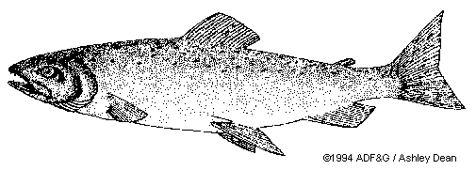
Chinook Salmon, also called King Salmon, inhabit the White River. Construction of the flood-protection structure Mud Mountain Dam formed a barrier to natural upriver migration of salmon species. However, the U.S. Army Corps of Engineers transports them around the dam. The present condition of White River salmon populations within park boundaries is unknown. In 2006, water temperatures and sediment levels exceeded state water quality standards in the upper White River drainages near and within the park.

Impact:
Increased frequency and severity of floods and other high precipitation events stress juvenile fish and destroy incubating
eggs by washing them downstream.

Impact:
Higher winter stream temperatures accelerate development of embryos and cause premature birth of fry before their food
source (insects) hatch. Increasing water temperatures affect the availability of dissolved oxygen for respiration and
decrease salmon health. Furthermore, non-native fish species such as small-mouth bass are better adapted to warmer
temperatures and may outcompete cold water adapted salmon species for resources.

Impact:
Retreating glaciers expose sediments that wash downstream during peak flow, burying salmon nests (called redds). The
combination of warmer temperatures, less water, bark beetle infestation and longer frost-free seasons results in a longer
and more robust wildfire season. Fire impacted areas are more prone to erosion, also leading to an increase of sediment in
the rivers. Increases in fine sediments decrease the transport of dissolved oxygen through gravels, suffocating incubating eggs. Sediments also irritate the gills of adult fish.

Impact:
In the Pacific Northwest, streams are experiencing drastic changes in flow patterns, such as higher stream flow in March,
reduced stream flow in summer, increased winter runoff, and earlier snowmelt-derived peaks in stream flow. Decreasing
stream flow in the summer restricts spawning salmon from swimming upstream or traps juvenile fish in shallow pools.
Maximum stream flow may not correspond to the developmental timing of juvenile downstream migration to salt water
and/or upstream migration for spawning. For example, Chum, Coho, Pink and Chinook species are all known to migrate
upstream in the late summer to early fall – a period with low stream flow.

Impact:
Hotter and dryer summer months require more irrigation of farmland, sometimes requiring extraction of water from
streams with already depleted stream flow. This causes a conflict between environmental needs of maintaining and
protecting spawning salmon populations and the economic needs of farmers and consumers.

Impact:
Lower stream flow is also less able to dilute urban runoff, leading to a greater percentage of contaminants in streams and
lakes. Some contaminants, such as endocrine disrupters found in many household chemicals, can lead to genetic mutations
in fish and amphibians. In addition, other chemical pollutants such as pesticides can become stored in the muscle tissue of
fish and transfer to humans and other animals when the fish are consumed.

Impact:
Reduced salmon populations effect food resources for other animals such as black bears and predatory birds who feed on
spawning salmon. Furthermore, salmon once served as an important food source of many Native American groups
and continues to be a centerpiece of tribal traditions and culture. Reductions in wild salmon populations impact the
number of salmon available for harvest and cause conflict between Native Americans and recreational and commercial
fishermen.

