National Park Service  U.S. Department of the Interior | Missouri National Recreational River |  | 508 E. Second Street  Yankton, SD 57078  605-665-0209
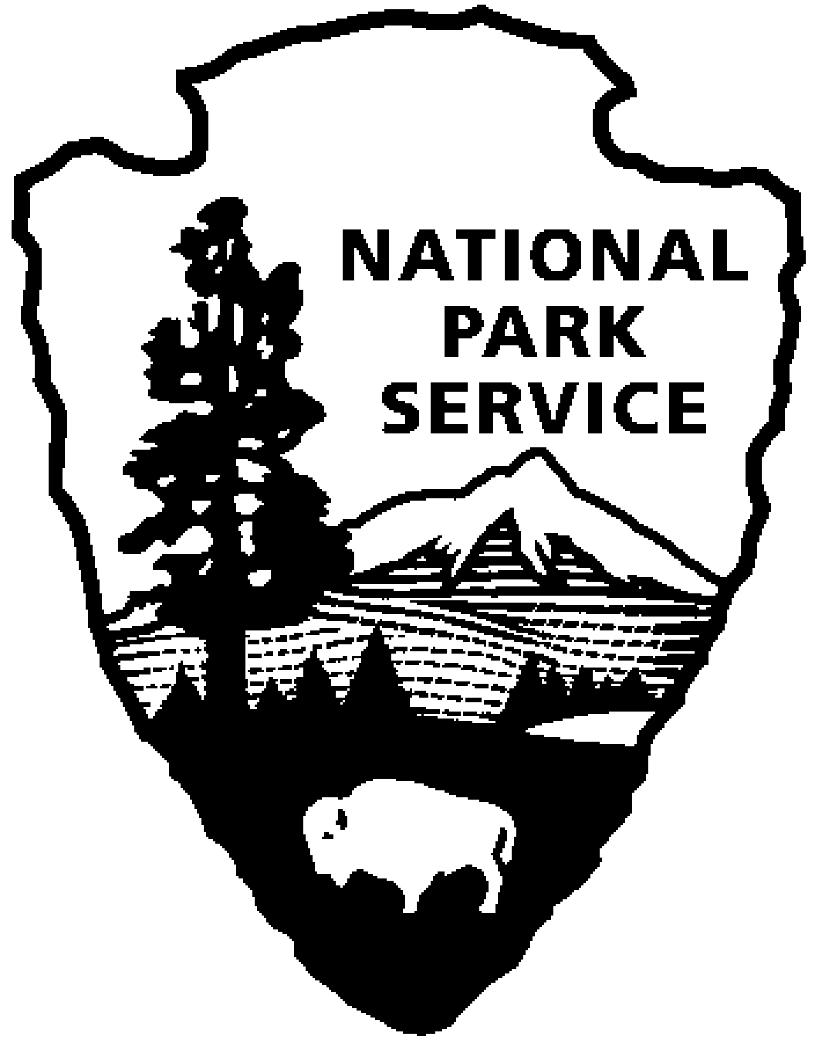
November 29, 2012
For Immediate Release
Contact: Park Headquarters, 605-665-0209 x29

Law Enforcement Rangers from Mt. Rushmore Help Protect
Missouri National Recreational River
Recent unlawful activity at National Park Service properties along the Missouri River including trespass by motorized vehicles, property destruction, and violation of park service hunting regulations will be addressed by law enforcement rangers from Mt. Rushmore National Monument in upcoming months starting this weekend. Rangers will make contact with visitors to educate them about park rules and regulations and issue citations as appropriate to protect resources and provide for the safe enjoyment of the properties by all visitors.
Bow Creek Recreation Area, (http://www.nps.gov/mnrr/planyourvisit/bow-creek-recreation-area.htm) near Wynot, NE, is owned and managed by the NPS. This property is open to the public for a variety of recreation activities including hunting and fishing. The following rules were developed to ensure equal access for all visitors, provide a safe environment for recreation and protect resources for present and future generations to enjoy:
- No trespassing on adjacent private property
- Foot traffic only – horses and motorized vehicles prohibited
- Primitive camping only – no trenching and no campfires
- Do not leave trash or litter – Pack It In, Pack It Out
- All natural and cultural features are protected by law – do not damage or remove
- Nebraska State as well as Federal hunting and fishing regulations apply
- Non-toxic shot is required for all shotgun hunting
- Trapping is prohibited
- Do not abandon property or leave property unattended for longer than 24 hours including waterfowl hunting blinds and associated personal property such as decoys.

  - Tree-stand limitation
    - Permanent tree stands and climbing devices are prohibited
    - Portable tree stands and climbing devices that do not use nails, wire, or bolts for attachment are allowed during Nebraska deer hunting season
    - Screw-in steps only
    - No more than one portable tree stand per licensed hunter
    - Name, address, and phone number of the owner or user must be on the stand and be legible and visible from the ground
    - Other blinds or elevated platforms not attached to a tree must also conform to the specified dates and labeling requirement

For the safety of our visitors, Mulberry Bend Overlook is closed to hunting. If you have any questions, please contact NPS Yankton headquarters at (605) 665-0209.

