**Wee Wonders**

***Weather Journal***

***Begin the Adventure***

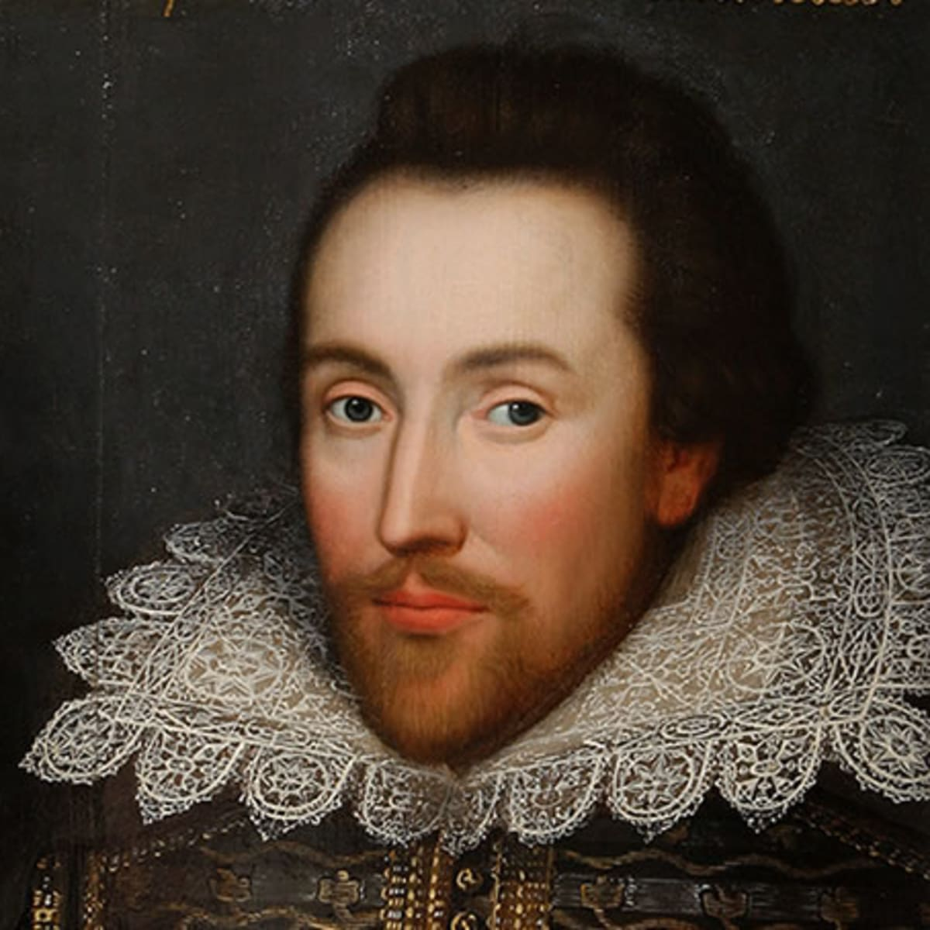

***“I call for pen and ink,***

***and write my mind”***

*William Shakespeare*

William Shakespeare, Shakespeare Birthplace Trust.

William Shakespeare became famous 200 years before Martin Van Buren was born. His poems, stories and plays are still read by people all over the world.

Martin Van Buren would have read Shakespeare and seen performances of his plays.

Shakespeare’s often mentioned the weather in his stories and plays, just like the author of the book you will hear read to you!

We hope you enjoy the story and your weather adventure guided by the famous

William Shakespeare.