Materials needed:
- A cup (any kind)
- Soil
- A seed or a bean
- Water

1. Fill the cup a little more than half- way full of soil.
2. Place the seed or bean on top of the soil.
3. Place a small amount of soil over the seed or bean to lightly cover it.
4. Sprinkle some water on top of the soil to lightly wet it.
5. Place it on a window sill or somewhere it will receive some sun light.
6. Choose one song to play or sing to it – choose a different one each week.
7. Keep track of the songs you choose by making a plant playlist.

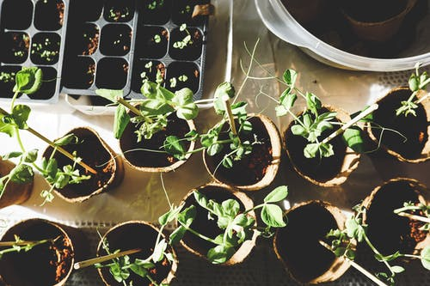
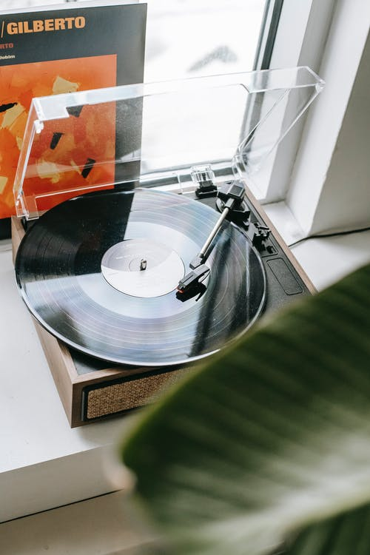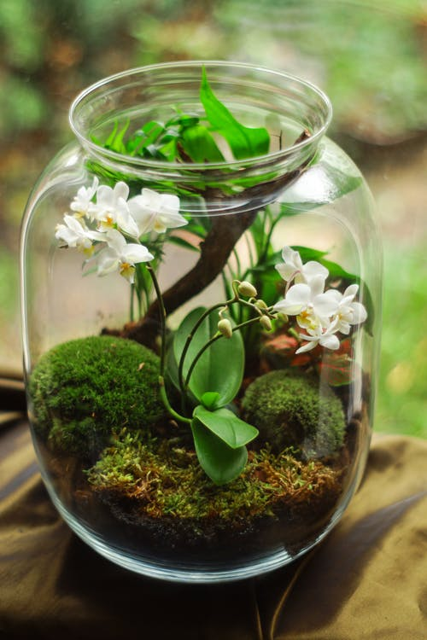

My Plant
PLaylist
Week 1: ___________________________________________

Week 2: ___________________________________________

Week 3: ___________________________________________

Week 4: ___________________________________________

Week 5: ____________________________________________

