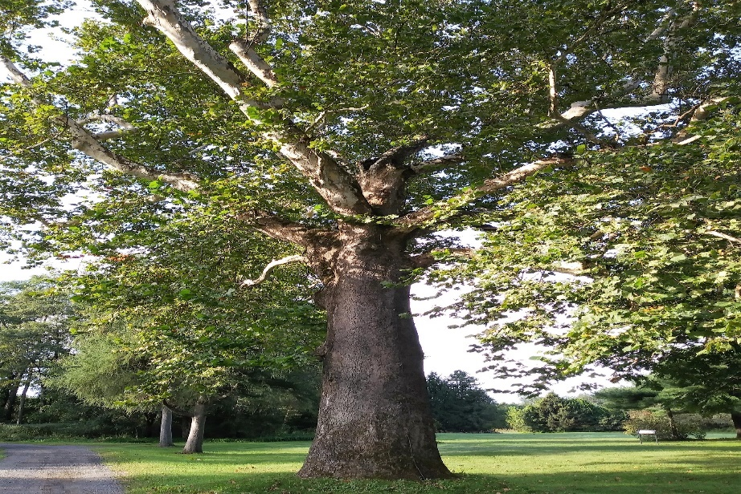
How Many “Yous”
Equal the circumference of a tree?

Circumference (Pronounced: Sir-come- fur-ince) means the distance around something.
Measure the circumference of a tree’s trunk and compare it to your height. How many of “you” equals its circumference?
How to:
1) Take a ball of string and walk around the tree one time.
2) Cut the string.
3) Measure the length of your string. How long is it? ________________
4) Measure how tall you are. I am ________ inches tall.
5) Compare your height (Pronounced: Hi-t. Meaning: How tall something is) to the tree’s circumference.
6) How many of “you” does it take to equal the tree’s circumference?
This many of “me”: ________________.

