**The End:** Exhibits and other public displays of art or objects are for us to enjoy.

Can you imagine someone ruining this interesting piece because they refused to follow directions?

Let’s all make sure children and adults continue to enjoy objects and works of art on display by respecting rules.

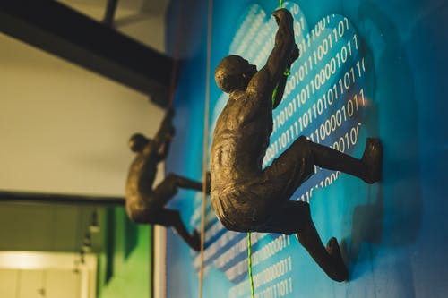[1]

1. Brett Sayles. “Man Climbing On Wall” 11 May 2019, *Pexels* accessed 14 November 202, <https://www.pexels.com/photo/man-climbing-on-wall-2380614/>