Summer
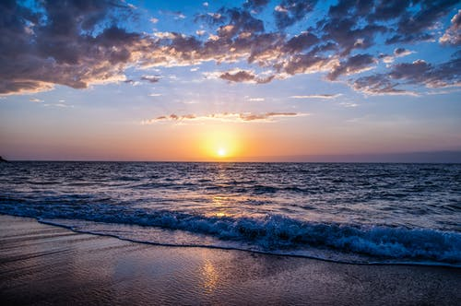
Summer usually makes you think of no school, loads of ice cream, the hot sun, and swimming.
Summer is also the perfect time to go to the beach!
Have you ever swum in the ocean?
Yes, swum, because ‘swimmed’ is not an actual word.
Did you float or sink while swimming in the ocean? Do you know why?
Beach During Sunset by: B. White
Let’s conduct an experiment to find out!
You will need: 2 small bowls of water 1 cup of Salt 2 eggs (uncooked)
1. Dump the salt in a bowl and stir it up. (Taste it. It tastes like ocean water)
2. Once the water settles, gently rest one egg in the salt water.
3. Next, gently rest the second egg in the bowl of water without salt.
Did the egg float in the saltwater or in the bowl of freshwater? ____________
Do you know why this happened?
If you were to rest on a pile of feathers and then rest on a thick mattress, which one would you sink into easier?
You would sink into the feathers easier because feathers are light and thin. The mattress is dense, (Means: thick) so it will hold you up easier.
The ocean is made of saltwater. The salt makes the water dense. This is why it is easier to float in the ocean than in a lake – which is made of freshwater.
Marco Photography of Black Sunglasses on Sand by: Y. Koppens
Why is the Ocean Salty?
Find out by watching this excellently explained video with the same title by Mystery Doug at:
https://www.youtube.com/watch?v=FGPFzHw-NDo

Summer is a wonderful time of year. The warm weather makes it possible to be outdoors nearly all season long!
What are some of your favorite things to do in Summer? Write down three in the space below:
_____________________________________________________________________________________

_____________________________________________________________________________________

_____________________________________________________________________________________

