Winter
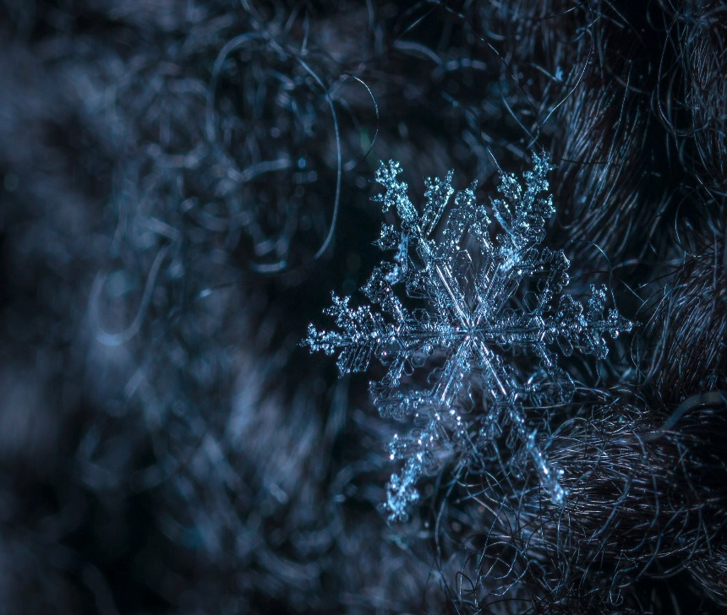
Winter is the time of year when temperatures are the coldest. Winter begins in mid-December and runs through mid-March.
Some places around the world will even get snow!
Rain and snow come from the same thing: water! Snow is just frozen water falling from the sky.
Close-up of a snowflake
What do YOU and SNOWFLAKES have in common?
- No two snowflakes are alike!
- Each snowflake that falls from the sky looks a little bit different from all the rest.
    - Just like you and your friends!
- Temperature and humidity can change the look of each snowflake that falls to ground.
- Scientists, people who study stuff about science, counted at least 39 different shapes of snowflakes!

To learn how snowflakes are made and how they turn into their own special shape, we invite you to watch the video below:
https://www.youtube.com/watch?v=7AeiwLhFuFQ
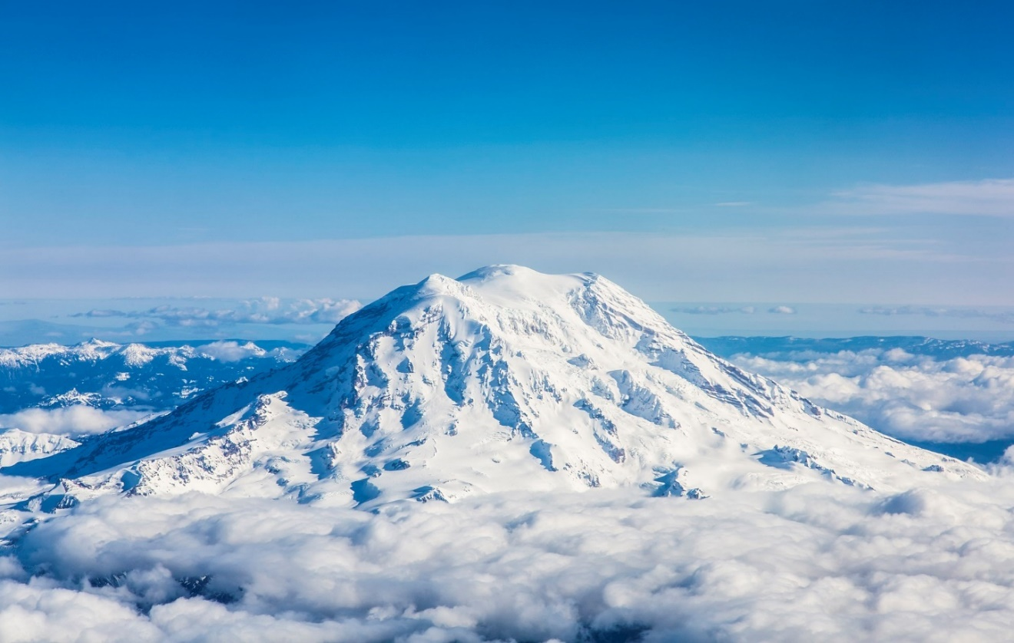
Mount Rainier from 30,000 feet. Photo by raduranga. Washington, USA.
Did you know that the places in the United States that get the most snow each year are Mount Rainier and Mount Baker in Washington State?
- They each get about 645 inches of snow each year! That is like stacking over 10,700 pennies on top of each other!
Winter weather brings a chance to do things you can’t do other times of the year like ice skating, skiing, or having a snowball fight!
What are some of your favorite things to do in the Winter? Write down three in the space below:

_____________________________________________________________________________________

_____________________________________________________________________________________

_____________________________________________________________________________________

