Fishing: A Sport for Every Season –
In Fresh or Ocean Water
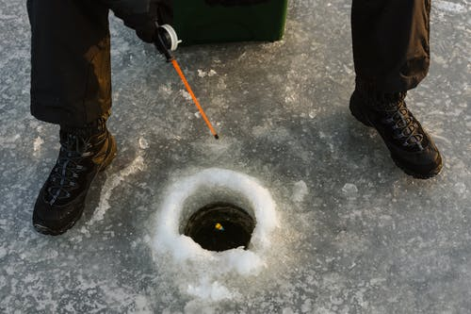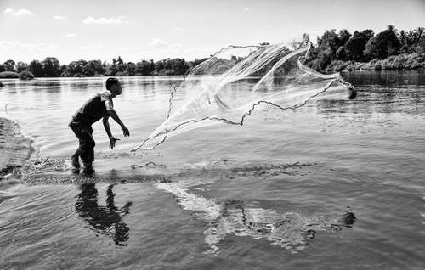
T. Miroshniche D. Pahntham

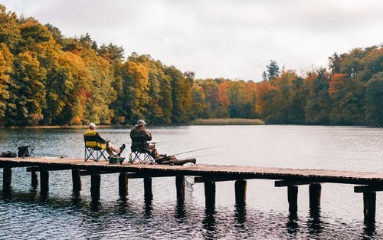 T. Filipek

It took several thousand years before fishing moved from being the way people survived, eating the fish they caught, to becoming a sport many people find very relaxing.

One of the first articles on fishing was by a woman and appeared one hundred eleven years before the first English colony settled in America (Jamestown, Virginia - 1607).

Fishing as a sport became popular during the middle of the 1600s, when more English began to settle in the American colonies.

Today fishing is enjoyed during all four seasons, both in freshwater and on the ocean. Have you ever been fishing? Did you catch fish?

Catch of the Day.
President Van Buren really enjoyed fishing. He had two man-made ponds dug on his farm in order to fish whenever he wanted. He paid men to continually fill it with Perch, Pike and Trout which he often caught for his breakfast.
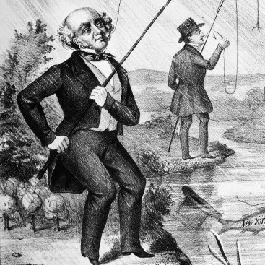
1. Perch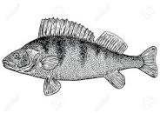 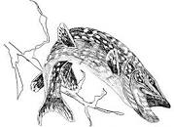 2.Pike 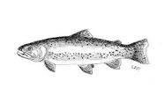3. Trout
What kind of fish would you place in his pond? Be creative and funny! ___________________________

