
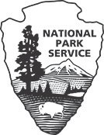
BUSINESS ORGANIZATION INFORMATION
Individual* or Sole Proprietorship

Note: Either a Form 10-353 or Form 10-354 is completed for each proposal, depending on the nature of ownership of the company.

Complete separate form for the submitting business entity and any and all parent entities.
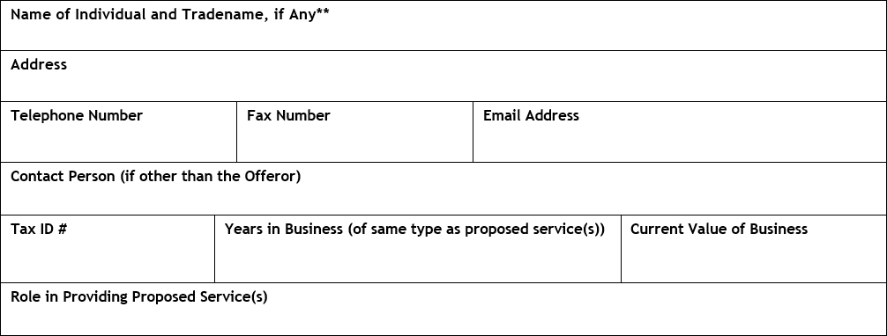

* Due to difficulties determining authority to act and ownership, the Service will not accept a proposal from spouses jointly as a purported business entity. Either one individual must serve as the Offeror or the spouses must form a corporation, partnership, or limited liability company to serve as Offeror.

** If the sole proprietorship acts under a name other than that of its owner (i.e., does business as “company name”), also add the jurisdiction where the company’s trade name is registered, if any.

NOTICES

PRIVACY ACT STATEMENT

Authority: 54 U.S. Code Chapter 1021—Privileges and Leases; 54 U.S. Code § 306121—Lease or exchange.

Purpose: The purposes of the system are (1) to assist NPS employees in managing the NPS Leasing program allowing for residential and commercial uses within a unit of the National Park System to ensure that business activities are conducted in a manner that complies with Federal laws and regulations; (2) to monitor resources that are or may be affected by the authorized residential and/or commercial uses within a unit of the National Park System; (3) to track applicants and holders of leases who are planning to conduct or are conducting business within units of the National Park System; and (4) to provide to the public the description and contact information for businesses that provide services in national parks.

Routine Uses: In addition to those disclosures generally permitted under 5 U.S.C.552a(b) of the Privacy Act, records or information contained in this system may be disclosed outside DOI as a routine use pursuant to 5 U.S.C. 552a(b)(3) to other Federal, state and local governments, tribal organizations, and members of the general public upon request for names, addresses and phone numbers of lease holders conducting business within units of the National Park System for the purpose of informing the public of the availability of the services offered by the lease holder. In addition, records or information contained in this system may be disclosed outside DOI based on an authorized routine use when the disclosure is compatible with the purpose for which the records were compiled as described under the system of records notice for this system.

Disclosure: Voluntary, however, failure to provide the requested information may impede our ability to 1) manage the National Park Service (NPS) Leasing Program allowing for residential and/or commercial uses within a unit of the NPS, 2) monitor resources that are or may be affected by the authorized residential and/or commercial uses, and 3) provide the public the description and contact information for businesses that provide services in national parks.

PAPERWORK REDUCTION ACT STATEMENT

We collect this information under the authority of 54 U.S.C. Chapter 1021. We use this information to evaluate a lease proposal. Your response is required to obtain or retain a benefit. We may not collect or sponsor and you are not required to respond to a collection of information unless it displays a currently valid OMB control number. OMB has approved this collection of information and assigned Control No. 1024-0233.

ESTIMATED BURDEN STATEMENT

We estimate that it will take no more than 1 hour to complete this form, including time to review instructions, gather and maintain data, and complete and review the form. You may send comments on the burden estimate or any aspect of this form to the Information Collection Clearance Officer, National Park Service, 1201 Oakridge Drive, Fort Collins, CO 80525. Please do not send your completed form to this address.

