United States Department of the Interior

National Capital Parks-East

NATIONAL PARK SERVICE

Interior Region 1- National Capital Region

1900 Anacostia Drive, S.E.

Washington, D.C. 20020

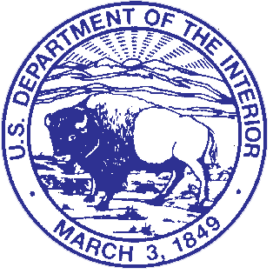

In Reply Refer to:

**Mary McLeod Bethune Federal Advisory Commission Meeting**

**Members Agenda**

**January 24-25, 2024**

**January 24th**

**Location:**  **National Capital Parks- East (NACE) Headquarters**

**1900 Anacostia Drive, S.E. Washington, DC**

**10:00-10:45am** **Special Government Employee (SGE) training**

All SGE designated Commission members are required to complete this training on an annual basis.

*SGE members: Dr. Clark-Lewis, Dr. Gardner, Dr. Hobson, Dr. Huyck, Dr. Jones, Dr. Lopez, Dr. Phillips*

**10:45am** **Remaining members arrive**

*Representative members: Ms. Adams, Dr. Daley, Ms. Dunn, Dr. Jones, Dr. Flemming-Hunter, Ms. Lawson, Ms. Mathis, Dr. Taylor*

**11:00-11:45am** **Welcome and Introductions**

**11:45am-12:30pm**  **Lunch**

Menus will be provided for ordering and delivery.

**12**:**30 –1:15pm**  **History of the Commission and Review of the Act**

**1:15 –2:30pm** **Site Update and Improvements**

**2:30- 3:30pm** **How an Advisory Commission Functions**

**Election of Chair and Vice Chair**

**3:30-4:30pm**  **NPS Expectations and Priorities**

**January 25th**

**9:00am** **Arrive at NACE and depart for Museum Resource Center**

**Van transportation provided for all members**

**9:30-11:00am** **Visit MRCE location of the National Archives for Black Women’s History**

**11:00-11:30am** **Travel to Mary McLeod Bethune Council House National Historic Site**

**11:30-12:30pm** **Mary McLeod Bethune Council House NHS visit**

**12:30-1:00pm**  **Return to NACE**

**1:00–1:45pm** **Lunch**

**1:45 –2:00pm** **Recap NACE Priorities**

**2:00pm-3:00pm**  **Advisory Commission Expectations**

**Important Driving Instructions:**

Please enter the address to United States Park Police (USPP) in your GPS as entering the NACE HQ address directs people to the wrong side of Anacostia Park.

USPP- **1901 Anacostia Drive, S.E. Washington, D.C. 20020** is the white building on the other side of the NACE HQ parking lot.

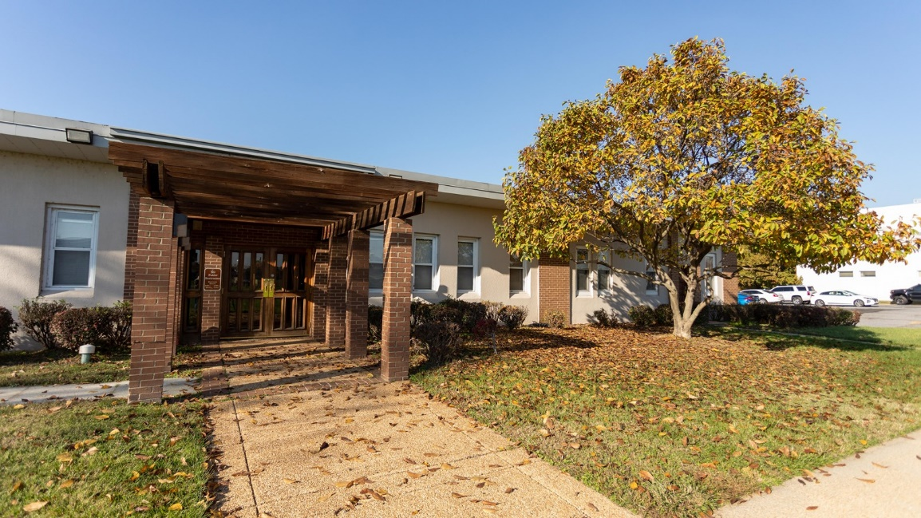

NACE Headquarters. There are three parking lots available.