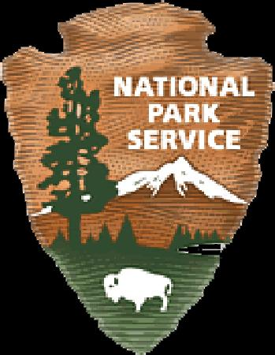
Volunteer Position Description Thank you for volunteering!
Marsh Billings Rockefeller National Historical Park

Special Event Volunteer

Tasks undertaken by special event volunteers range very widely and will be discussed with individuals as they arise. Most of our special events take place on weekends, so if you can volunteer an occasional weekend day, this might be your niche!

We also welcome volunteers with a special skill to share, who might be able to contribute to the program during a special event, e.g. lead a yoga session or share specialized historic knowledge in costume!
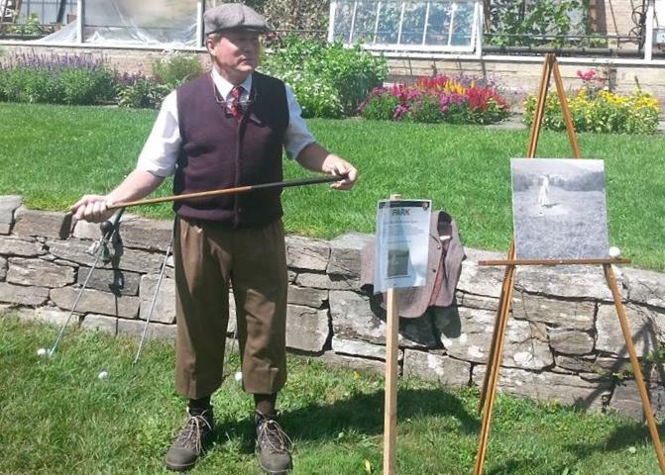
Tasks may include set up and break down of tents and exhibition stands; setting out signposts and flags; roving trails to ensure visitors find their way around special events; assisting with art and craft projects, or with children’s activities; scooping ice cream; playing music; trail work, or staffing a welcome desk to hand out brochures and give information.

Even occasional volunteers are ambassadors for the park and the National Park Service; they can help promote the mission of the park service, which is to preserve special places that tell the story if this country, and to help people understand their significance and enjoy them safely.

Requirements of this job:
- Willingness to learn and understand the assigned task/s;
- Willingness to learn and understand the story and significance of the park;
- Willingness to attend trainings as agreed, and possibly to use two-way radio;
- Review volunteer job hazards and safety protocol with Volunteer Coordinator and agree to abide by park safety procedures;
- Report volunteer hours to Volunteer Coordinator.

Supervisor:
Volunteer Coordinator/Chief of Interpretation

Equipment Provided by NPS: Clothing and equipment will be provided as needed.

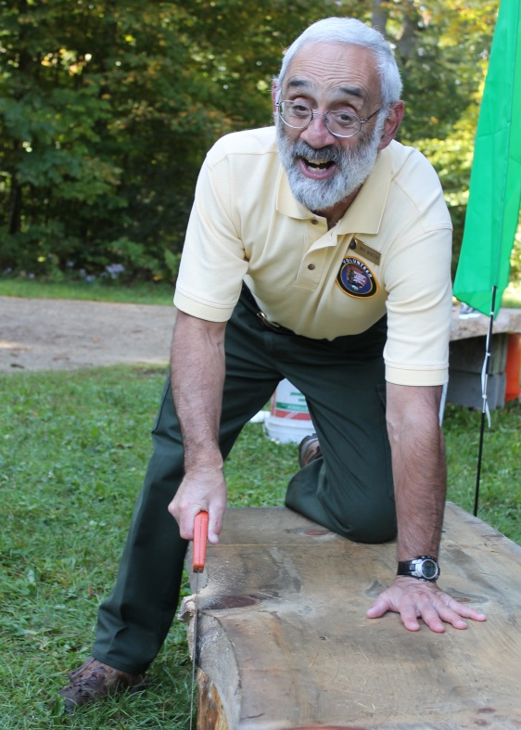
Training Provided by NPS: General NPS orientation training will be offered to new volunteers individually or in small groups, by arrangement. Additional training will be provided to help volunteers learn the specific duties and procedures of special event tasks as the need arises.

Estimated Length of Commitment, if determined: To be determined by volunteer and coordinator.

Work Conditions (location, weather, physical needs, etc.): These volunteers are likely to be working outdoors.

rev. 4/4/2016 jfl

