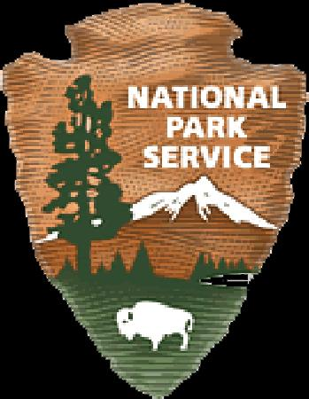
Volunteer Position Description Thank you for volunteering!
Marsh Billings Rockefeller National Historical Park

Roving Trail Ambassador: on foot or horseback

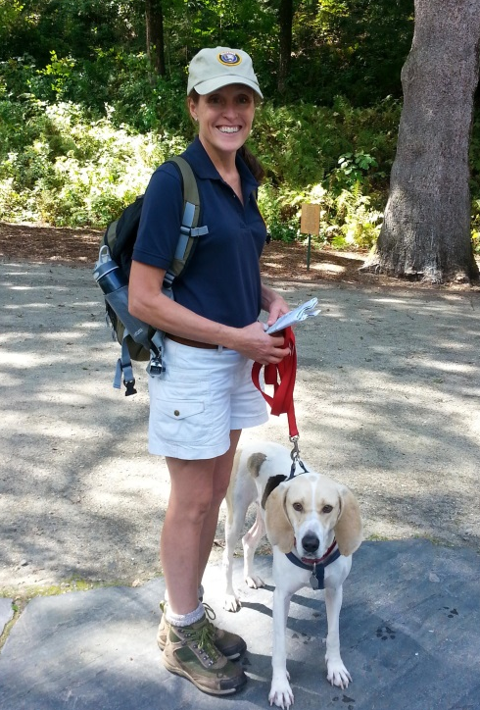
Requirements of this job
- Ability to communicate clearly with a wide variety of people;
- Interest in working with people;
- Desire to be outdoors;
- Ability to recognize and facilitate actions and conversations that assist park visitors to have a positive experience in their park and to acquire a deeper understanding and appreciation of the missions of the NPS and this park;
- An understanding of park regulations;
- Ability to travel comfortably and safely on the park trails under variable trail and weather conditions;
- Own horse and trailer (if necessary) if mounted rover;
- Willingness to attend trainings as agreed, and to use two-way radio;
- Review volunteer job hazards and safety protocol with Volunteer Coordinator and agree to abide by park safety procedures;
- Report volunteer hours to Volunteer Coordinator.

Routine Duties
- Check in and out at with Visitor Center desk (ext 222) at beginning and end of shift;
- Rove well-used pedestrian and equestrian routes in the park with the intention of engaging with visitors;
- Assist visitors with wayfinding;
- Share maps and general park information;
- Orient, inform and interpret for visitors according to own abilities;
- Represent the NPS warmly and professionally in interacting with park visitors;
- Assist in orientation of visitors to activity locations during special events;
- Observe and monitor trail conditions and promptly ;report conditions and hazards;
- Always carry a park radio when on patrol;
- Report any safety hazards spotted during rove.

Commitment
- A minimum of four hours per month is desired;
- Hours and days are by individual arrangement;
- Volunteers are asked to give adequate notice, if possible, should they need to change a shift;
- We ask for a total commitment of at least 30 hours in a year;
- The park will provide training, and some identifying uniform items;
- The National Park Service issues an annual pass for free admission to all federal recreation lands to volunteers who complete 250 hours of service.

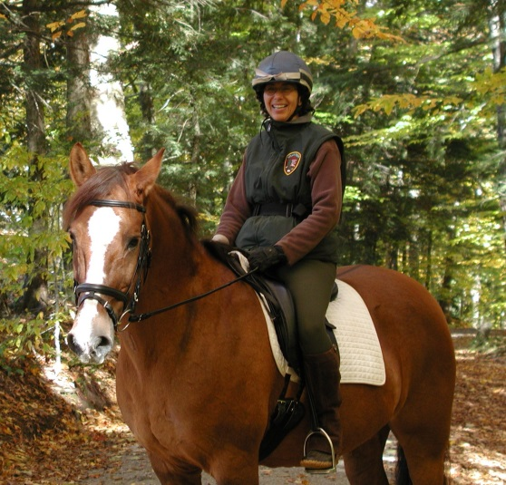
Supervisor
Volunteer Coordinator. Field supervision may be provided by other NPS staff or cooperators as needed.

Equipment Provided by NPS
Volunteer uniform shirt and hat, and a name tag will be provided to volunteers who make a commitment to fulfill 30 hours of volunteer service within a year.

Training Provided by NPS: Orientation training is offered to new volunteers individually or in groups as convenient. Additional training will be provided to help the volunteer learn the specific duties and procedures of the position.

Estimated Length of Commitment, if determined: To be determined by volunteer and coordinator.

Work Conditions (location, weather, physical needs, etc.): This work involves walking or riding on carriage roads and forest trails with frequent changes in elevation. Surfaces may be uneven, and weather conditions may be mildly unclement, although roving is not required in bad weather! Interaction with the general public is required.

Thank you for volunteering. We look forward to working with you!

Rev 4/4/2016, jfl

