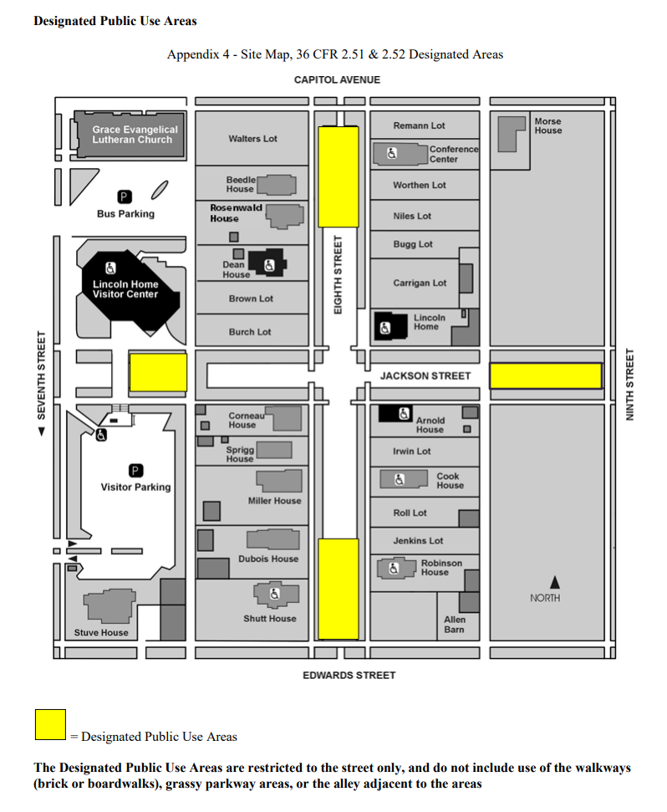

Aerial Map of Lincoln Home NHS with designated public use areas highlighted: Northern third of 8th street, southern third of 8th street, area of Jackson Street southeast of Visitor Center between Visitor Center and parking lot, and the Eastern edge of Jackson street closest to 9th street.