DIVE Authorization
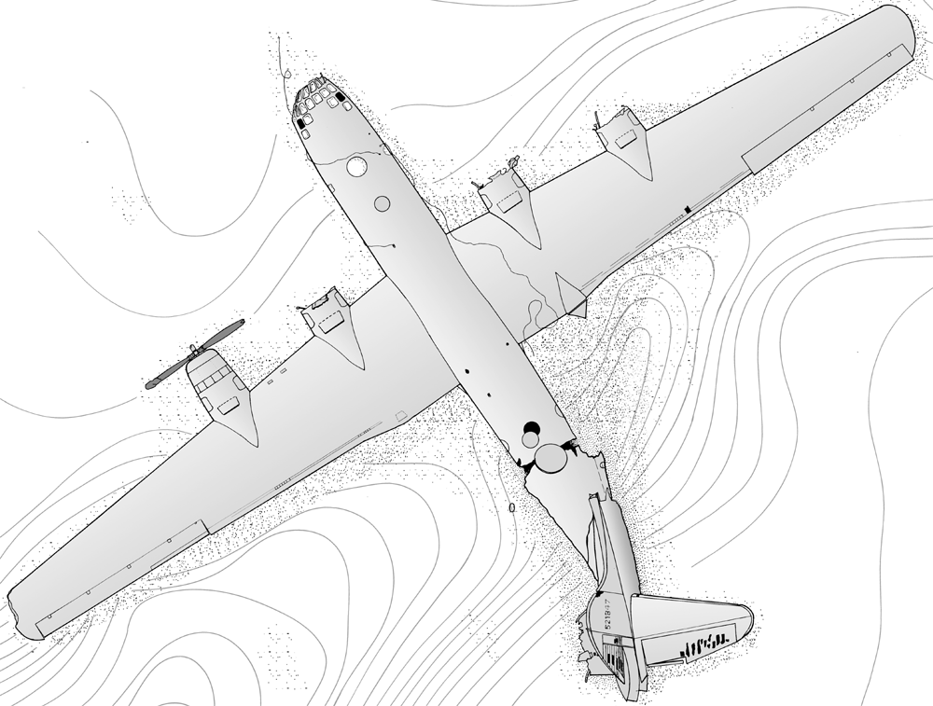

LAKE MEAD B-29
Lake Mead National Recreational Area
601 Nevada Highway, Boulder City, Nevada 89005

Name (Please Print)

DIVES

PROPOSED ACTUAL

Dive Date Location Dive Date Location

1__________________________________

2__________________________________

3__________________________________

1________________________________

2________________________________

3________________________________

_____ As a recreational diver at Lake Mead I acknowledge that there are risks inherent to conducting deep dives and dives requiring specialized equipment and/or breathing gasses. I have sufficient training and experience for the dive I am about to undertake and I understand and that the National Park Service may not have the capability to perform property or body recovery.

_____ I understand that disturbing or removing archeological or cultural materials, including materials from the B-29, is a violation of federal law and that this activity will result in my prosecution and may jeopardize the dive boat’s charter license at Lake Mead.

_____ I have watched the National Park Service orientation video and I understand that the B-29 control surfaces are covered with delicate fabric and that portions of the fuselage are thin aluminum. I will do everything possible to maintain neutral buoyancy and leave the B-29 as I found it so that others may enjoy the same dive I am about to complete. I also understand that I am not to enter or attempt to enter the plane.

Sport divers have helped manage the resources at Lake Mead by offering information on observed changes over time. These changes, whether environmental or human caused, provide information that assists with our monitoring efforts. We encourage you to help by providing the National Park Service with feedback about your diving experience, observations and suggestions for future improvements.

SIGNATURE DATE
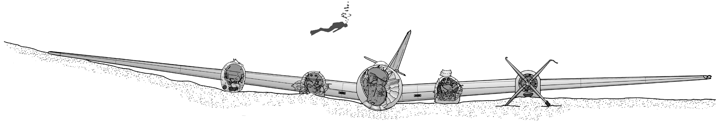

DIVE PERMIT
LAKE MEAD B-29
Lake Mead National Recreational Area
601 Nevada Highway, Boulder City, Nevada 89005

The Overton B-29 offers an exciting and unique scuba diving opportunity. In order to enjoy and preserve this special recreational experience with this wilderness setting, we ask that you please observe the following regulations pertaining to diving on the site. The National Park Service was created to conserve America’s precious historical and natural resources unimpaired for future generations. Please join with us and help keep this site special for those who will come after us.

- Each diver is required to watch the orientation video and complete a diving permit for the B-29 site before diving.

- Completed permits should be turned into your dive boat operator.

- Removal or disturbance of underwater cultural materials from the B-29 site is prohibited and will be prosecuted under relevant federal laws. Prosecution may involve fines, forfeiture of equipment and/or incarceration.

- Impacts to the aircraft caused by divers will affect the number of divers that are allowed on the site in the future. Severe impacts may jeopardize the dive boat’s charter license. Please be considerate and think about how your actions will affect others who would like to share this experience.

- The following are prohibited without an NPS Special Use Permit: Metal detectors, side scan sonar, sub-bottom profilers. Remotely operated vehicles (ROVs) require a NPS Special Use Permit for the Overton B-29. Spear guns are prohibited on the Overton B-29 site.

- Contact Lake Mead dispatch (marine radio channel 16 or cell phone) for emergency assistance. Please report diving accidents, safety issues, unauthorized diving activities or problems to Park Service personnel or to Lake Mead Dispatch 911 or (702) 293-8998.

- Please share your thoughts and ideas for improving the dive site, protecting it better for the future or other issues that the National Park Service should be aware of:

