Jacob Riis Workshop-Lesson(s)
Carrie Karvakko and Traci Welch

Day 1
Title of Lesson: Investigating the Photos of Jacob Riis
Course(s): World History or U.S. History
Grade Level: 9-12
Time frame: 1- 1 ½ class periods
Lesson Overview:

This lesson uses the photographs of Jacob Riis to explore the struggles of immigrants during the Industrial Revolution in New York City.

Students will analyze and discuss, in small groups, Riis’s photographs using the “Save the Last Word for Me teaching strategy from Teaching Tolerance. Students will also come together at the end of the activity to discuss as a class what they learned about immigrant life in the late 1800s and compare it to today’s immigrants.
Objectives:
After completing the lesson, students will be able to:
- Identify ways of how immigrants struggled during the Industrial Revolution and
subsequent urbanization
- Analyze photographs and relate these struggles to different time periods in history
Michigan Course Content Expectations:
- World History 6.2.3: Industrialization : compare and contrast the causes and consequences of industrialization around the world, including social, economic, and environmental impacts
- World History CG1: Population (relationship of the population changes to global interactions, and their impact on different regions of the world)
- U.S. History 6.1.1: Factors in the American Second Industrial Revolution – Analyze the factors that enabled the United States to become a major industrial power
- U.S. History 6.1.3: Urbanization – Explain the causes and consequences of urbanization
- U.S. History: P1 Reading and Communication – Read and Communicate Effectively
- U.S. History: P2 Inquiry, Research, and Analysis
- U.S. History: P3 Public Discourse and Decision Making
- U.S. History: P4 Citizen Involvement
Materials:
- Various photographs from Jacob Riis (7 are provided but below are links to others)
  - icp.org Archive Constituents Jacob Riis
  - Library of Congress Jacob Riis Photographer
  - MCNY Collections Highlights Jacob Riis
- Save the the Last Word for Me- instructions from Teaching Tolerance.org
Activity: Students will analyze and discuss in small groups the Jacob Riis photos.
Assessment: Students responses in class, student discussion
Citations:
Granger, H., Lawrence R. H. and Riis, J. (1895). “Well dressed man being thrown into jail”. Museum of the City of New York. Retrieved 23 July 2019 from “Well dressed man being thrown into jail”
Riis, J. (1890). “Lodgers in a crowded Bayard Street tenement - "Five cents a spot." Museum of the City of New York. Retrieved 23 July 2019 from
“Lodgers in a crowded Bayard Street tenement - "Five cents a spot."

Riis, J. (1890). “Street Arabs in sleeping quarters”. Museum of the City of New York. Retrieved 23 July 2019 from “Street Arabs in sleeping quarters."
Riis, J. (1890). “Pietro learning to write”. Museum of the City of New York. Retrieved 23 July 2019 from “Pietro learning to write”.
Riis, J. (1890). “Saluting the Flag in the Mott Street Industrial School.” Museum of the City of New York. Retrieved 23 July 2019 from “Saluting the Flag in the Mott Street Industrial School.”
Riis, J. (1890). “In a Sweat Shop.” Museum of the City of New York. Retrieved 23 July 2019 from “In a Sweat Shop.”
Riis, J. (1994). “Poverty Gap Transformed -- the spot where Young Healey was murdered is now a playground. “Museum of the City of New York. Retrieved 23 July 2019 from “Poverty Gap Transformed -- the spot where Young Healey was murdered is now a playground. "
"Save the Last Word for Me". Teaching Tolerance. Retrieved 14 August 2019.

Procedure for Day 1:
- Hand out article "What immigrants think about life in the United States" to read for homework the night before the lesson.
- Begin the lesson by dividing students into small groups of 4-5.
*the teacher should pick the groups so that all of the different student groups are integrated.
3. Pass out 4-6 Jacob Riis photographs for each group.
4. Have each student choose one of the pictures they want to talk about. They can chose the pictures based off of any idea they want, such as what speaks to them, something striking about it, etc.
5. One student will show the picture that they chose. Each group member will comment on the picture with their ideas and thoughts. This will happen until the last group member had a chance to comment. Remind students not to engage in cross-talk.
6. After everyone has commented, the first student elaborates on why they chose that photo. That student gets “the last word.”
7. Monitor the discussion as students take turns discussing the photos, listening to the group’s responses and explaining their reasons for choosing those photos. Repeat the process until all students have shared.
8. Wrap up with a whole group discussion by asking questions such as: What did you observe about the conditions that immigrants lived or worked in? What kind of life do you think they lived? How do you think it compares with the life of immigrants today?
9. Exit ticket assessment
TEACHING STRATEGY
Save the Last Word for Me
Community Inquiry

CCSS RL.3-5.2, RI.3-5.2, SL.3-5.1
What?
Save the Last Word for Me is a comprehension strategy that builds speaking and listening skills by structuring a text-based discussion for students. Students highlight two to three of the most important sentences of the central text, then discuss their text-based responses in small groups.

When?
During and after reading

Why?
Save the Last World for Me builds active reading, speaking and listening skills. Giving students a task to complete while reading engages them with the text, and the structured format draws all students into the discussion. Students with stronger comprehension model their process for others, and all students benefit from hearing the alternative viewpoints and different interpretations of the text.

How?
- Choose a central text for students to read independently
- After reading, instruct students to determine the text's main idea. Ask them to summarize it in their own words in two or three complete sentences and record the summary in a place they can easily reference during the rest of the activity.
- Ask students to choose two to three sentences from the text that they think are important, keeping their main idea summary in mind.
- Put students in small groups to share their selections. Group size may vary.
- Have the first student begin by reading her first quote to the group without making any disclaimers or comments about the quote.
- Prompt each member of the group to respond briefly to the quote until everyone has had a chance to comment. Remind students not to engage in cross-talk.
- After everyone has commented, the first student elaborates on why she chose that phrase or sentence as important to the central text. That student gets “the last word.”
- Monitor the discussion as students take turns reading their quotes, listening to the group’s responses and explaining their reasons for choosing those quotes. Repeat the process until all students have shared.

English language learners
Pre-writing tasks build confidence for students to express their thoughts and ideas. Encourage English language learners to make connections to their own lives and diverse experiences when selecting quotes. The Common Core emphasizes that English language learners enrich the school and society by building on their cultural practices and perspectives.

English language learners also benefit from Save the Last Word for Me because there is no right or wrong answer; all students have the opportunity to share without judgment. Modify this strategy for less proficient students by having them highlight pieces of text they find confusing or unclear. This not only aids comprehension and provides practice speaking with peers, but also gives other children the opportunity to teach, support and offer feedback.

Connection to anti-bias education
The strategy creates the structured conditions necessary for equitable classroom discussion. Students who are typically reluctant to speak up and those who tend to dominate discussions both get to practice appropriate speaking and listening habits. Students practice sharing their own thoughts in a low-stress situation, building confidence to speak in larger groups.

What Immigrants Say About Life in the United States

MAY 1, 2003
By Steve Farkas
The values and sentiments of immigrants — whether they are Latin American, East Asian, Caribbean, or European — mirror those of native-born Americans, according to new research carried out by the nonprofit, nonpartisan research group Public Agenda.
The New York-based group conducted a comprehensive study of 1,002 randomly selected immigrants to the United States. Some of the key findings from the study, entitled "Now That I'm Here: What America's Immigrants Have to Say About Life in the U.S. Today," are reported below.
Learning English Called Essential
One of the most surprising findings from the research is how insistent immigrants are that learning English is critical for their success. Focus group discussions made it clear that this conviction is driven by pragmatism and the desire to be understood. Fully 85 percent say it is hard to get a good job or do well in this country without learning English; only 12 percent say it is easy. Some immigrants also see learning English as an ethical obligation. Nearly two in three (65 percent) say "the U.S. should expect all immigrants who do not speak English to learn it," versus 31 percent who say this should be left to each individual to decide.
These attitudes carry over to how immigrants want the nation's public schools to educate children who do not speak English. By a substantial 63 percent to 32 percent margin respondents believe that "all public school classes should be taught in English" rather than that "children of immigrants should be able to take some courses in their native language." Mexican immigrants, as a group, also believe it is important to learn English but they feel less urgency: a bare 51 percent majority thinks that all public school classes should be taught in English.
Immigrants' self-reported experiences with learning English are particularly revealing. Only 37 percent of immigrants say they already had a good command of English when they came to the United States. Among Mexican immigrants the number drops to seven percent; among Caribbean immigrants it goes up to 58 percent. Of immigrants who knew only enough English to get by or did not speak it at all upon arrival, 29 percent now speak mostly English at home and another 31 percent speak English and their native language about equally. Almost half (47 percent) have taken classes to improve their language skills. And 49 percent of those who came with limited or no English proficiency say they can now read a newspaper or book in English very well.
Strong Work Ethic
Immigrants show deep commitment to the work ethic, once again reflecting a historically prized American value. A large majority (73 percent) think it is "extremely important" for immigrants "to work and stay off welfare." In focus groups, many talked about the stark reality that greeted them when they first came to the United States — and the understanding that, without hard work, their dream of America as the land of plenty would not come true. In the survey, eight in 10 (81 percent) say, "a person has to work very hard in this country to make it — nobody gives you anything for free." Twenty-two percent say that qualifying for government programs like Medicaid or food stamps is or was a major reason for them to become a citizen.
In light of these attitudes toward work, it is not surprising that most of the survey respondents work and that few rely on public aid. Almost seven in 10 (69 percent) immigrants were working full time, part time, or were self-employed at the time of the survey. Only 18 percent report that they or their families had received food stamps. Fewer (10 percent) say they had received donations or free services from a charity or church. In contrast, more than three in four (76 percent) have volunteered their time or contributed money to a community organization or church. Only four percent report health insurance coverage through Medicaid; 60 percent have private health insurance, nine percent are covered through Medicare. Twenty-two percent reported having no medical insurance.
Making the U.S. Home
Immigrants display an appreciation of the U.S. and a commitment to making it their home, but they also maintain a strong connection to their country of origin. Not surprisingly, many immigrants stay in touch with folks back home: 59 percent regularly phone family abroad and another 44 percent send money at least once in a while. Respondents split 47 percent to 52 percent between those who closely follow current events in their country of origin and those who do not.
But immigrants' desire to stay connected with people and events "back home" does not contradict a desire to stay in their new home. In fact, 74 percent say they plan to stay in the U.S. and only 18 percent say they will move. Fully eight in 10 (80 percent) say they would still come to the U.S. if they were making the choice all over again. Sympathetic attachment to the U.S. is strong: 80 percent say the U.S. is a "unique country that stands for something special in the world," versus 16 percent who say it is "just another country that is no better or worse than any other." The overwhelming majority (70 percent) of parents who have children under 18 say it is unlikely that their children would want to live in their country of origin. Finally, about one in four (26 percent) say they or a member of their family has served on active duty in the U.S. armed forces.
The national origins of immigrants to America are changing in step with both world events and evolving U.S. policies. But regardless of their countries of birth, they end up with a shared understanding — and appreciation — of what it means to be an American. This can only bode well for policymakers struggling to smoothly integrate immigrants into American society.
Study Methodology"Now That I'm Here" is based on a national telephone survey of 1,002 foreign-born adults aged 18 or older who came to live in the U.S. when they were at least five years old. The survey was offered in English and Spanish. The margin of error is plus or minus three percentage points. The sample is drawn from two sources: 830 respondents were randomly selected from a targeted sample representing 81 percent of foreign-born households in the U.S.; 172 respondents were drawn from pre-screened samples from previously conducted Public Agenda surveys.
The survey was preceded by seven focus groups conducted in sites across the country, including New York City, Los Angeles, Miami, Sioux Falls, SD, and Alexandria, VA. In addition, 13 in-depth interviews were conducted with immigration experts in academia, public policy, law, and community outreach.
Note: The full study, funded by Carnegie Corporation of New York and co-authored by Ann Duffett and Jean Johnson, reports immigrants' perceptions of politics, discrimination, the Immigration and Naturalization Service and immigration as well as other topics and is available online at publicagenda.org. The attitudes of immigrant subgroups — Mexican, non-Mexican Latino, European, East Asian and Caribbean — are broken out in the report.
Exit Ticket
Answer the questions below then hand this slip to your teacher to gain permission to leave.

Name
Question 1
What image did you find the most interesting? Why?
Question 2
Do you think that immigrants had it harder during Riii’s time or today? Explain.

Jacob Riis Photographs
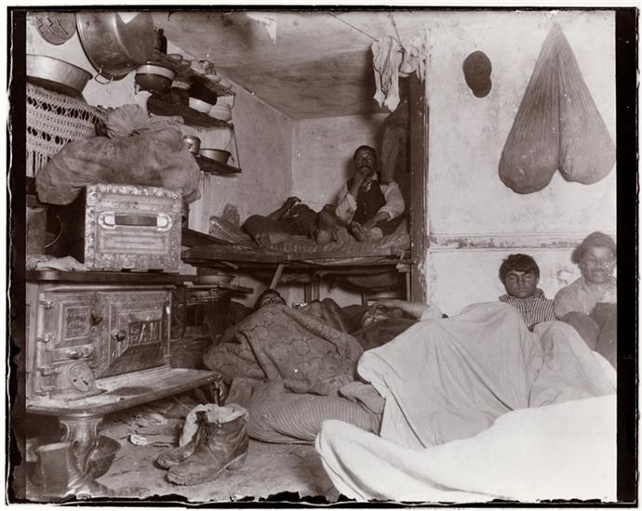
Share
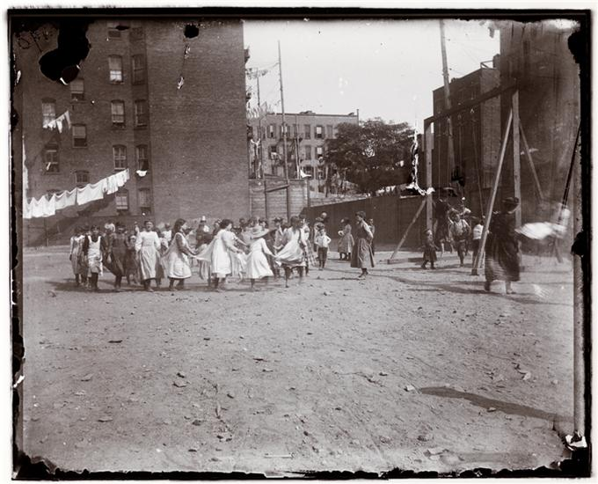
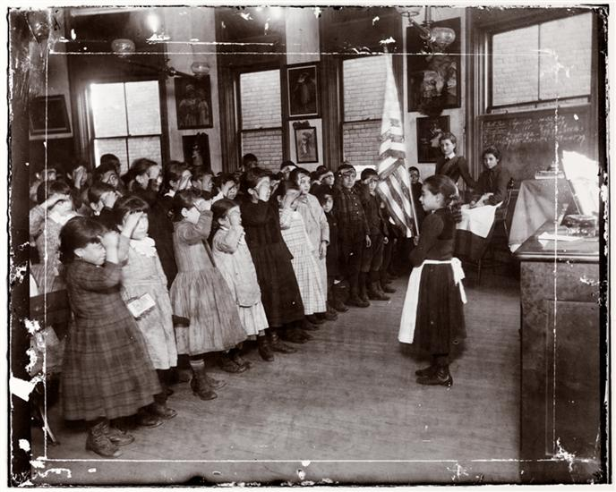
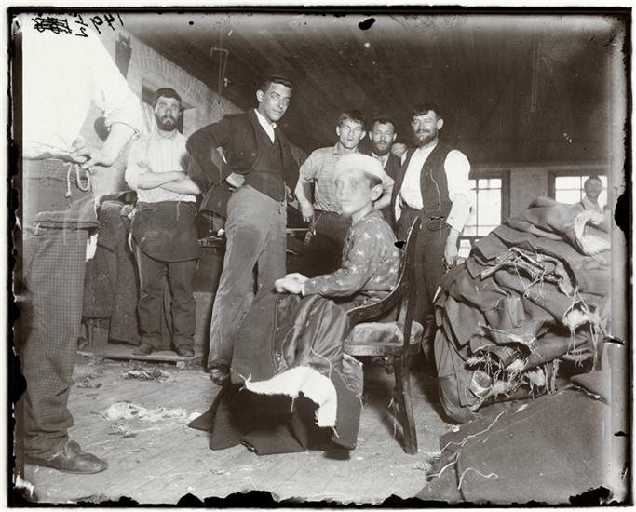
Share
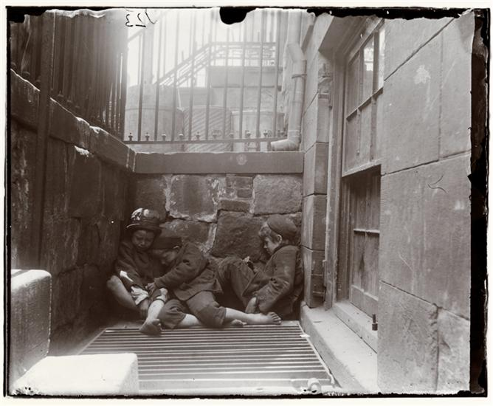
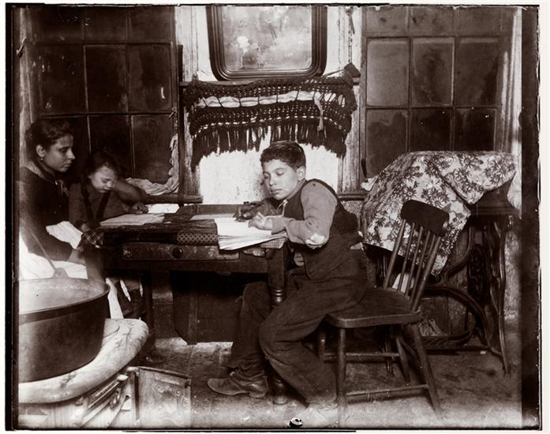
Share
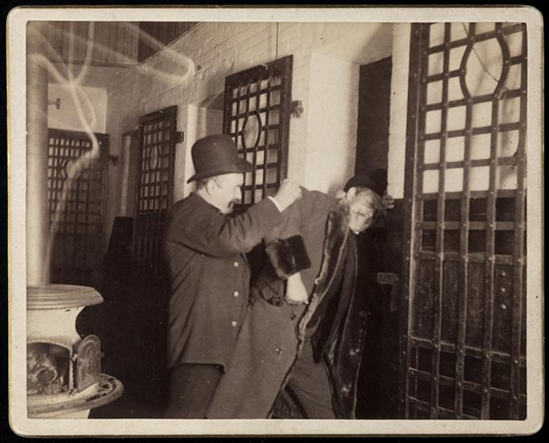

Day 2
Title of Lesson: Immigrant survival and integration.
Course(s): World History or U.S. History
Grade Level: 9-12
Time frame: 1- 1 ½ class periods
Lesson Overview:

This lesson uses a variety of primary sources from the Copper Country to explore how immigrants survived and integrated into their new home in Michigan’s Upper Peninsula.

Students will use a primary source analysis tool from Scholastic to observe, make inferences, explain, and ask questions about the sources. Students will also come together at the end of the activity to share their source and their ideas about it with the rest of the class. The final discussion question will address what they learned about immigrant survival & integration in the Copper Country during the late 1800s and early 1900s.
Objectives:

After completing the lesson, students will be able to:
- Identify ways of how immigrants struggled during the Industrial Revolution and
subsequent urbanization
- Analyze primary sources and relate these struggles to immigration in the Copper Country
Michigan Course Content Expectations:
- World History 6.2.3: 6.2.3 Industrialization : compare and contrast the causes and consequences of industrialization around the world, including social, economic, and environmental impacts
- World History CG1: Population (relationship of the population changes to global interactions, and their impact on different regions of the world)
- U.S. History 6.1.1: Factors in the American Second Industrial Revolution – Analyze the factors that enabled the United States to become a major industrial power, includingU.S. History 6.1.3: Urbanization – Explain the causes and consequences of urbanization
- U.S. History: P1 Reading and Communication – Read and Communicate Effectively
- U.S. History: P2 Inquiry, Research, and Analysis
- U.S. History: P3 Public Discourse and Decision Making
- U.S. History: P4 Citizen Involvement
Materials:
- Computers or chromebooks
- Primary Source Analysis sheet
Activity: Students will analyze and discuss in small groups the primary sources.
Assessment: Students responses in class, student discussion, and the primary source analysis sheets.

The primary source analysis sheet should be scored by effort. Did the student give detailed responses to each section? Did the student fill out the content and context information?
Citations:
“Agate Beach at Freda Park”. Copper Railroad and the Copper Country Historical Page. Retrieved 23 July 2019 from Copper Range Freda

“Central Mine Band.” Keweenaw County Historical Society. Retrieved July 23 2019 from Keweenaw County Historical Society

The Calumet news., December 20, 1909, Section One, Page 8, Image 8. Chronicling America, Historic American Newspapers, LOC. Retrieved 23 July 2019 from Chronicling America with the Library of Congress

“Keweenaw County- Dominico Balagna, Italian Miner.” 1930. MTU Archives and Copper Country Historical Collections, J. Robert Van Pelt Library. Retrieved 23 July 2019 from http://ethnicity.lib.mtu.edu/Documents/NatRecs

“Uusi Vuosi Kuparialueella” (Finnish cartoon). MTU Archives and Copper Country Historical Collections, J. Robert Van Pelt Library. “Copper country church”. MTU Archives and Copper Country Historical Collections, J. Robert Van Pelt Library.

“Cornish American Heritage Society and Kernewek”. 8th Gathering of Cornish Cousins, 1995. MTU Archives and Copper Country Historical Collections, J. Robert Van Pelt Library.

“The Cornish Miner”. I Hear America Singing. Pg. 50. MTU Archives and Copper Country Historical Collections, J. Robert Van Pelt Library.

Procedure for Day 2

- Hand out the “An Interior Ellis Island: Immigrants and Ethnicity in Michigan's Copper Country" article as homework for the night before.
- Begin the lesson by dividing students into small groups of 4-5.
*the teacher should pick the groups so that all of the different student groups are integrated.
3. Hand out four primary source analysis sheets per group.
4. Explain to the students that they will be using these sheets while looking at primary sources from the Copper Country.
5. They are to look at each primary source and answer the primary source sheet for 4 of the documents given.
6. Give each student a chromebook and share a Google doc with links to articles and images that the students will analyze. See example at end of the lesson.
7. The students should be given 30-40 minutes of the hour to discuss and analyze. The teacher should be circulating the room and re-directing when necessary.
8. When there is 15 minutes left to the hour, have each group choose one of their sources to share with the rest of the class. They should explain what their source is, what their ideas were, questions they had, etc…
9. The last discussion question should be, something along the lines of, “how did these documents show how immigrants adapted to their new country?”
10. Exit ticket: Venn diagram of past immigrant experiences vs. today’s immigrant experiences (use homework articles and information from class discussions)

Sample questions from analysis sheet (analysis sheet linked under materials):

What do you observe? Consider the images, people, objects, activities, actions, words, phrases, facts, and numbers. What is the meaning of the objects, words, symbols, etc.?

What sentiment (attitude or feeling) do you think the author is trying to convey through the source? What, based on the source, can you infer about the historical event or time period?

What about the source makes you curious? What questions still remain? What additional
information would you need to know in order to deepen your understanding of the ideas expressed in the source?
An Interior Ellis Island
Immigration, Ethnicity and the Peopling of the Copper Country:
An Interior Ellis Island

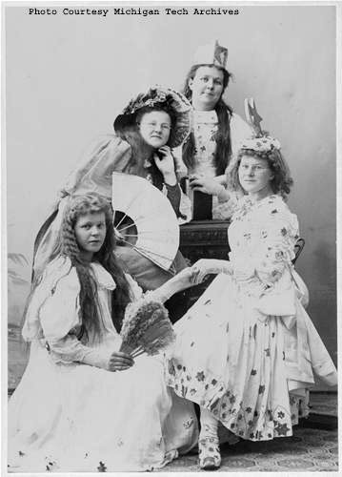
Finnish Dress
Image #: Nara 42-174
The past does not speak for itself, it is spoken for, and there is little in the remains of mineshafts, rock piles or other physical evidence that exists today to tell the story of the peopling of the Michigan’s Copper Country. Nothing remains in the Copper Country to tell us that at the turn of the century, the Keweenaw Peninsula was the most ethnically diverse community in Michigan. Indeed, it was among the most ethnically diverse places in the United States. The 1870 Federal Census reveals that Houghton County, with 57% of its population foreign-born, had the third largest foreign-born population as a percent of the total population in the United States. While in that year 71% percent of Americans had native-born parents, fewer than 5 % of Houghton County residents could make such a claim. Again, for prospective, Houghton County with 96% of its population with at least one parent of foreign birth had the greatest such percentage in the entire United States. According to one child of immigrants, the claim of native-born parentage and Americanization held a negative connation for the residents of the Copper Country:
There ain’t no natives on the [Keweenaw] range. We’re all foreigners up here. Sure I was born here; but my folks came from Ireland and they stayed Irish until the day we buried the two of them. Them Swedes, them Austrians and Polish, they’re all the same way. . . . What I mean, we’re different from those people downstate [Lower Peninsula]. Hell’s fire, half them fellows in Lansing are ashamed their folks come from Europe. Look at the way they changed their names. You don’t see that stuff on the range. . . . We ain’t the same as those stuck-ups downstate. That’s why I say we’re foreigners.
The people of the Copper Country were indeed different from the people of Michigan’s Lower Peninsula as pre-automobile Michigan had very little ethnic diversity. Due to the Erie Canal, New Englanders from western New York, or those migrating directly from New England, mainly settled the state. The agriculture-dominated economy of this “Yankee Michigan,” drew few immigrants and even fewer from eastern and southern Europe. The exception to this nineteenth-century Yankee Michigan was its Upper Peninsula and more specifically its Keweenaw Peninsula. Indeed, in 1900, Houghton County had the largest Chinese, Italian, Finnish, Slovenian and Croatian communities in Michigan. The Calumet public schools claimed to have enrolled children from forty different nationalities from around the world.
The ethnic composition of the Copper Country dramatically changed over time. Initially, the Keweenaw Peninsula drew its labor chiefly from the British Isles, Western Europe and Canada then, after 1890, largely from southern and eastern Europe. In 1870, the Irish were the single largest immigrant group, accounting for nearly a third of the entire foreign-born population in Houghton County, followed by the Cornish, French Canadians and Germans. By 1880, the Cornish were the single largest immigrant group followed by the French Canadians, Irish and Germans. In 1890, the Finns emerged as the single largest immigrant group, a position they would never relinquish, followed by the French Canadians and the Cornish. By the turn of the century, the Finns accounted for a quarter of the entire foreign-born population in Houghton County, followed by the Cornish, French Canadians and the rapidly arriving Croatians and Slovenians, many of who were enumerated as “Austrians.” In 1910, the Finns accounted for a third of the entire foreign-born population, followed by the Cornish, “Austrians,” and Italians.
The peopling of the Copper Country, like all migration, was an economic process driven by “push factors” and “pull factors,” that is, people were pushed out of areas that experienced high levels of surplus labor and pulled to areas that experienced labor shortages. With exception of the Cornish, Irish and some Germans who arrived with previous mining experience, most of those who peopled the Copper Country emigrated from rural parts of Europe that were experiencing and economic upheaval. During the last half of the nineteenth century, most of Europe underwent the capitalist transformation of agriculture. This shift toward market-oriented agriculture demanded greater mechanization and thus capital investment. This process placed tremendous economic pressure on small landholders, who, because they lacked capital, increasingly could not compete in a market with larger landowners. Simultaneously, mechanization reduced the need for their labor as well as the labor of their less fortunate neighbors who were landless peasants. As such, the capitalist transformation of agriculture in Europe produced large numbers of people who either became unemployed or underemployed (surplus units of labor) or small landholders with insufficient land to survive. In search of work, many peasants were forced to migrate to areas with labor shortages in Europe and the United States.
Copper mining, of course, with its great demand for labor was the “pull factor” that drew these emigrants to the Keweenaw. Yet, this begs the question: why were the mine owners unable to attract sufficient native-born labor? During the last half of the nineteenth century and into the twentieth century, there existed a dual labor market in America, that is, a secondary labor market was created by the difficulty or danger of certain industrial occupations that few native-born or English speaking people from the British Isles would fill. Indeed, in 1910 the US Senate Committee on Immigration asked mine owners in the Copper Country why they needed so many foreign workers? Apologetically and remorsefully, they replied: “. . . the employment of these races [from southern and eastern Europe] is due principally to the fact the supply of English-speaking workingmen has not equaled the demand for labor and that it has been necessary, in order to operate the mines, to have recourse to this source of labor supply.”
This remarkable influx of immigrants dramatically impacted the development of the Copper Country, but it also significantly impacted the sending communities from which they emigrated. Brinje, a small town in Croatia of around 5,000 people, sent over 700 young men to work for the Calumet and Hecla Mining Company. Emigration on such levels radically altered the lives of those who remained in Brinje. Excerpts from a 1905 letter from a Croatian schoolteacher offers glimpse in of the lives of those left behind:
Today they are telling in the village that fifteen are going to Fiume tomorrow by the early train, - men, women, and young girls on their way to America. They took leave of the fatherland, our dear Croatia . . She must let them go among strangers in order that those who remain may live, they and their children and their old people. And the old people die in peace because they have hope; the little ones shall fare better than ever they have done.
Toward evening they can be seen hurrying from house to house, taking leave of those that they love. Who can say that there will ever be another meeting for them? It is very late before they have finished these visits, and the family waits for them with impatience. With impatience, how else, when this evening or rather the few hours still left are so short. This is the last supper at home. There is no going to bed, for at three they must start for the station, as the train goes at four. It is so sad to hear them driving through the village singing a song which expresses all the feelings of their sore hearts.
The saddest moment of all is the departure. The train has come, they must get on board. How many tears and sobs and kisses in our little forest and rock-bound station! Friends go with them to Fiume -- all but the children and the old folks, who stay in the village alone. Often the parents buy the betrothal rings for their sons and daughters, who marry in America, and send them to them. Faith and love come from the homeland. Finally, at the ship good-byes must be said, the last
With what anxiety and joy do they wait for the news from the agent that their dear ones have reached New York in safety? There, relatives are already expecting them, and the journey can be peacefully continued in their company. Our people generally go to Michigan. In one town there are so many that our people call it "New Lipa."
Twenty years ago two men went to America from here, the first from our place to go. Now nearly half the village is in America. It is hard to till the fields, for there are no workers to be had. Whoever has strength and youth is at work in America. At home are only the old men and women, and the young wives with their children.
This letter reminds us of the role that immigrants played in supporting their sending communities, the world they behind and the pain of emigration. Such heartbreak, of course, was not limited to Croatia. Many experienced the tears and sobs and kisses in places like Berehaven Ireland, Camborne Cornwall, Jolitte Quebec, Bramberg Germany, Pajala Sweden, Tronhiem Norway, San Gergio Italy, Wasalan Finland and in hundreds of towns and villages throughout the world.
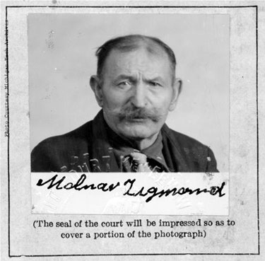
Malnar Zigmond
Image #: No Neg 06-06-23-002
In addition to the exceeding large foreign-born population in the Copper Country, the children and grandchildren of the foreign-born constituted much larger ethnic groups. In her examination of ethnicity among Americans of European descent in the years after the Second World War, sociologist Mary Waters has convincingly argued that their ethnicity has largely transformed itself into choice. That is to say, for present day Americans of European ancestry, their ethnicity is more a matter of consent than descent. This is an important point to our understanding of ethnicity in the United States in the years between 1870-1930; ethnicity was not a choice. This appears to have particularly true in the Copper Country where newspapers listed one’s ethnicity next to one’s name, or, quite frequently, did not bother to list one’s name at all and simply referred to an individual as an “Irishman,” a “Finnish trammer,” or a “Croatian laborer.” Documents such as the Houghton County Jail Records suggest that ethnicity had a pseudo-legal status into the twentieth century, as the ethnicity of inmates, not place of birth, was indicated next to their names. So to was the case with the Calumet and Hecla Mining Company and the Quincy Mining Company as both had their workers identified by ethnicity on their employment records. During the 1913-14 Strike, C & H produced bi-weekly reports that enumerated the ethnic differential of striking and non-striking workers. Even more extraordinary, C & H produced monthly reports on the ethnic composition of their workers into the 1950s. So, for instance, the head of C & H could know the exact number of Italian trammers, French Canadian mill workers or Finnish miners on May 1, 1950 and the increase or decrease of a given ethnic group from last month in a given job category. Needless to say, C & H had the forms specially printed, as these were not standard business forms in the 1950s.
What such forms, and the worldview that they represented, could not account for, of course, was inter-ethnic marriage. There existed no column for someone who was part German and Irish, someone who was past Finnish part Slovenian, or perhaps someone who was part German, Irish, Finnish and Slovenian. Ruby Jo Kennedy, a sociologist who published in 1944 an article “Single or Triple Melting Pot? on intermarriage in New Haven, Connecticut observed a shift beginning in which people were moving away from marring within their ethnic group to marring within a religion, usually in the third generation. This process might have begun earlier in the Copper Country. A small study of 500 households in Calumet found that in 1910 twenty percent of all marriages were interethnic. The Irish (66%) were the most likely marry someone outside their ethnic group, followed by the French Canadians, Swedes and the Cornish. Conversely, the Croatians (4%) were the least likely marry someone outside their ethnic group, followed by Finns, Italians and Slovenes.
The 1913 Copper Strike was the Keweenaw Range’s defining moment. The strike was in many ways an ethnic conflict as much as it was struggle between labor and capital, workers and mine owners. In general, the newly arrived ethnic groups from southern and eastern Europe were more likely to support the strike, while the established ethnic groups from northern and western Europe were less likely to support the strike. Croatian workers were the least likely to go back to work, followed by the Hungarians, Bulgarians and Finns. Conversely, the Cornish were the least likely to strike, followed by the Scots, Germans and Scandinavians. When the Calumet and Hecla Mining Company attempted to resume underground operations in September 1913, an astonishing 94% of Croatians continued to strike, compared to only 40% of the total workforce. Croatians and Finns, with 63%, were the only ethnic groups that had a majority of their workers who refused to return to work. By the middle of December, 86% of C&H’s Croatian workforce still remained on strike, and, as such, they were the only ethnic group that had a majority of their workers out on strike. By the end of February 1914, when the strike was clearly lost, 84% of the Croatians continued to strike; the Finns with 24% were the nearest ethnic group showing such solidarity.
Mining on the Keweenaw, like all extractive industries, declined and ended. Just as the Copper Country saw tremendous immigration it also experienced tremendous out migration. As mining declined so did the need for labor and just as the Keweenaw began to experience high levels of surplus labor, the auto industry began to experience a near insatiable demand for labor. Most anecdotal evidence suggests that Detroit and southeastern Michigan were the main recipient of the Keweenaw’s out migration. Again, the “push-pull” mechanism of labor migration drove this process. The ethnic composition of the Copper Country not only resulted from in migration but out migration as well, as not all ethnic groups out migrated at the same rate. The Finns appeared the least likely to leave the Copper Country, while the Croatians and Italians were the most likely to out migrate. In general, the immigrants (the parents or their children) remained while their children or grandchildren left. Thus, the Keweenaw Peninsula served as an interior Ellis Island, that is, an entry point for tens of thousands immigrants and their children into American society.
Back in the 1990s, an often-heated debate emerged within the pages in the Mining Journal regarding the placement of Finnish names on street signs in Hancock. The issue brought the question of the Copper Country’s ethnic identity into sharp focus as non-Finns wrote and expressed a sense that the Finns were expropriating the Copper Country, pointing out that they were not Finns and that their ancestors had arrive from a certain country at a certain date and worked hard in the mines. Finns often enough responded that such sentiments were anti-Finnish bigotry, which had long history in the Copper Country and generally had that such anti-Finnish bigotry had its origins in other ethnic groups envy over the achievements of the Finns. So whose Copper Country is it? Well, first and foremost, of course, it belongs to those who presently inhabit it, a third of whom are of Finnish ancestry. But secondary, perhaps, it also belongs to those whose roots are on that copper range. Perhaps the Copper Country also belongs on some small ancestral level to the hundreds of thousands of descendents whose ancestors spent a generation or two on that “Interior Ellis Island.”

Source Notes
(Intro 1) Ninth Census of the United States, Vol. I: The Statistics of the Population of the United States, Washington: Government Printing Office, 1872.
Close
(Intro 2) Ninth Census of the United States, Vol. I: The Statistics of the Population of the United States, Washington: Government Printing Office, 1872.
Close
(Intro 3) Ninth Census of the United States, Vol. I: The Statistics of the Population of the United States, Washington: Government Printing Office, 1872.
Close
(Intro 4) Quoted in Angus Murdoch, Boom Copper: The Story of the First U.S. Mining Boom (1943; reprinted Hancock: Book Concern, 1964), 201.
Close
(Intro 5) Twelfth Census of the United States, 1900, Census Reports, Volume I, Part I, Washington, DC: United States Census Office, 1901.
Close
(Intro 6) Ninth Census of the United States, Vol. I: The Statistics of the Population of the United States, Washington: Government Printing Office, 1872.
Close
(Intro 7) Statistics of the Population of the United States at the Tenth Census, (1880) Washington: Government Printing Office, 1883.
Close
(Intro 8) Report on the Population of the United States at the Eleventh Census: 1890, Part I, Washington: Government Printing Office, 1895.
Close
(Intro 9) Twelfth Census of the United States, 1900, Census Reports, Volume I, Part I, Washington, DC: United States Census Office, 1901.
Close
(Intro 10) Thirteenth Census of the United States, Vol. I: Population 1910, Washington: Government Printing Office, 1913.
Close
(Intro 11) Senate Committee on Immigration, Reports of the Immigration Commission: Immigrants in Industry, 61st Cong., 2nd Sess., 1910, S. Document 633, 86.
Close
(Intro 12) Employment Records, Papers of the Calumet and Hecla Mining Company, Copper Country Historical Collection, Michigan Tech University, Houghton Michigan.
Close
(Intro 13) Emily Greene Balch. Our Slavic Fellow-Citizens. New York, Charities Publication Committee, 1910, quoted in Francis E. Clark. “The Croats in Croatia and in America.” in Old Homes of New Americans: The Country and the People of the Austro-Hungarian Monarchy and Their Contribution to the New World. New York: Houghton Mifflin Company, 1913.
Close
(Intro 14) Anna Brock, Chelsea Cole, Erin Klema, Jonathan Pohl, and Jenna Rickmon, “Diversity in Calumet, Michigan, 1910,” research project for Michigan History, Honors Program, Central Michigan University, May 2006, 11.
Close
(Intro 15) Calumet and Hecla Mining Company spreadsheet indicating men working underground by nationality on July 14, 1913 and September 29, 1914, Papers of the Calumet and Hecla Mining Company, box 350, folder 7, Copper Country Historical Collection, Michigan Tech University.
Close
(Intro 16) Calumet and Hecla Mining Company spreadsheet indicating men working underground by nationality on July 14, 1913 and September 29, 1914, Papers of the Calumet and Hecla Mining Company, box 350, folder 7, Copper Country Historical Collection, Michigan Tech University.
Close
(Intro 17) Calumet and Hecla Mining Company spreadsheet indicating men working underground by nationality on July 14, 1913 and September 29, 1914, Papers of the Calumet and Hecla Mining Company, box 350, folder 7, Copper Country Historical Collection, Michigan Tech University.
Close
(Intro 18) Calumet and Hecla Mining Company spreadsheet indicating men working underground by nationality on July 14, 1913 and September 29, 1914, Papers of the Calumet and Hecla Mining Company, box 350, folder 7, Copper Country Historical Collection, Michigan Tech University.
Close
(Intro 19) Thirteenth Census of the United States, Vol. I: Population 1910, Washington: Government Printing Office, 1913; Fourteenth Census of the United States, Vol. III: Population 1920, Washington: Government Printing Office, 1922; and Fifteenth Census of the United States, Vol. III: Population 1930, Washington: Government Printing Office, 1932.
Copper Country Photo’s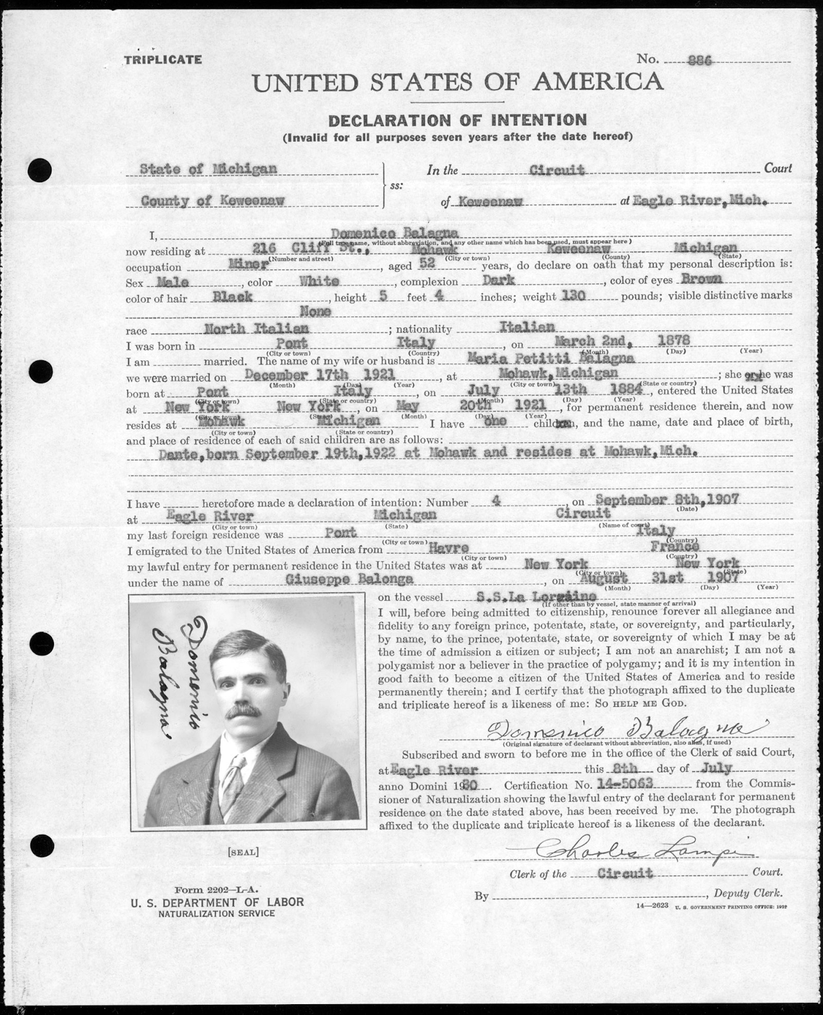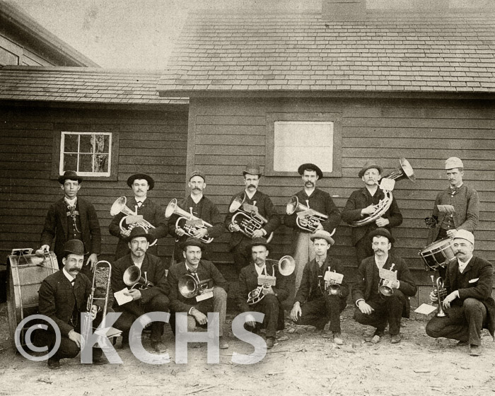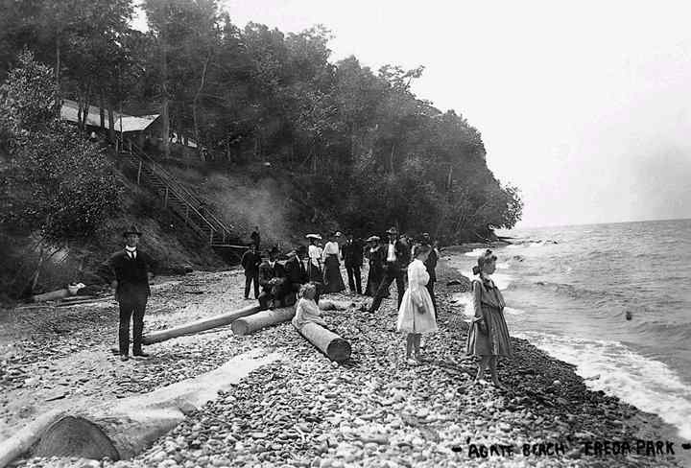
OVERALL ASSESSMENT
Homework Assignment:
Research and Journal Reflection: Immigrants Today

Find three articles on immigration from the past year. These articles need to have:
- Images
- Be from a legitimate print news source
- Can be on immigrants in Europe or the United States
- Need to be cited in MLA format

You will need to:
- Read and summarize what you learned about immigrants today in your journal write as well as answer the following questions:
  - What issues do immigrants deal with today?
  - How do those issues compare to immigrants’ issues in the past (as with Jacob Riis’ photos and what you learned about immigrants in the Copper Country)?
  - How do immigrants today survive and integrate, compared to immigrants in the Copper Country in the late 1800’s/early 1900’s?
  - How can these issues be solved? Who can help solve these issues? The government? Aid groups? Businesses? The immigrants themselves?

Although this is a journal write, you still need to use your chosen news sources to help guide you in your ways of thinking.

