# Coming to America: Social Change in America During the Gilded Age

Cathy Hill [hillc@dollarbay.k12.mi.us](mailto:hillc@dollarbay.k12.mi.us)

**Target Grade level(s):** Grades 9-12. Approximate length of instruction 3 class periods

LESSON OVERVIEW: Students will explore the immigrant experience by investigating problems created by industrialization, urbanization and immigration. They will use a variety of primary and secondary sources to identify different issues that caught the attention of the reformers. Students will explore the role of Jacob Riis and his efforts to increase public awareness of the plight of immigrant conditions in New York City. This lesson will connect with the prior industrialization unit and lead into the progressive movement’

OBJECTIVE: At the end of this lesson students will be able to describe at least three significant problems or issues created by America’s transformation between the 1850 and 1914. Students will be able to describe why people immigrated to the United States and why they stayed and migrated to the cities. Students will also be able to describe problems or issues that immigrants faced in this time period.

BACKGROUND: Jacob Riis (1849-1914) was an American social reformer and writer, born Denmark. Riis came to the U.S. as a carpenter. He spent his early years in the United States as an immigrant and itinerant laborer, barely surviving on his carpentry skills until he landed a job as a muckraking reporter. These early experiences left Riis with empathy for the lives of the immigrants that would shine through his photos. By the late 1880s, he began to photograph the interiors and exteriors of New York slums. Since Riis worked at night and in darkly lit conditions, he utilized a magnesium flash-it contained a highly flammable powder that when lit would create a flash bright enough to light the darkest place. His *How the Other Half Lives* (1890) was one of the earliest popular social documentary books in America, instigating reform legislation in New York City. The book attracted the attention of the then New York City Police commissioner Theodore Roosevelt, (later President) who was later to cooperate with Riis on reform programs. Riis actively sought reforms in tenement housing and schools and was influential in introducing parks and playgrounds in congested neighborhoods.

In the half-century after the Civil War, some 26 million immigrants arrived in the United States.

## **KEY VOCABULARY**

**Tenement:** a crowded apartment building housing immigrants or impoverished people

**Boarder:** A person who pays cash in exchange for meals and a bed

**Immigrant:** A person who comes to live permanently in a foreign country

**The Gilded Age:** The time between the Civil War and World War I during which the U.S. population and economy grew quickly, there was a lot of political corruption and corporate financial misdealings and many wealthy people lived very fancy lives.

**Muckraker:**  reform-minded American journalists who attacked established institutions and leaders as corrupt prior to World War 1. The muckrakers provided detailed, accurate journalist accounts of the political and economic corruption and social hardships caused by the power of big business in a rapidly industrializing United States.

**The Progressive Era:** The period of US history from the 1890s to the 1920s, which was an era of intense social and political reform aimed at making progress toward a better society.

**Social Darwinism:** the theory that individuals, groups, and peoples are subject to the same Darwinian laws of natural selection as plants and animals. This theory held that the strongest and fittest (rich and powerful) showed through their success that they were best adapted to the social and economic climate at the time. The weak and unfit (poor and less powerful) had demonstrated that they could not adapt and should be allowed to die off. Now largely discredited, social Darwinism was advocated by Herbert Spencer and others in the late 19th and early 20th centuries and was used to justify political conservatism, imperialism, and racism and to discourage intervention and reform.

## **BOOKS/SOURCES CONSULTED:**

“Riis, Jacob August.” Discovery Education, Funk & Wagnalls, 2005, app.discoveryeducation.com/learn/player/70a8c95a-3840-4011-a60c-5b3784fea060. Watched July 2019

“An Italian Mother, Jersey Street, NY, 1890.” Discovery Education, IRC, 2005, app.discoveryeducation.com/learn/player/6928ecab-1f38-4016-81e5-37c32d1eb567.

“"Five Cents a Spot" Unauthorized Rental Lodgings.” Discovery Education, IRC, 2005, app.discoveryeducation.com/learn/player/c618c530-2417-457c-9c91-e59fd51ebb14.

“Bohemian Cigarmakers at Work in Their Tenement.” Discovery Education, IRC, 2005, app.discoveryeducation.com/learn/player/8caf62dd-1c10-432c-a97c-6e4cc3c5f333.

[Britannica Jacob Riis](https://www.britannica.com/biography/Jacob-Riis) visited 30 July 2019

[Khan Academy History of the Gilded Age](https://www.khanacademy.org/humanities/us-history/the-gilded-age/gilded-age/v/what-was-the-gilded-age?modal=1) Khan Academy search gilded age

“Immigration and Migration in the Gilded Age” Khan Academy [Khan Academy Immigration and Migration in the Gilded Age](https://www.khanacademy.org/humanities/us-history/the-gilded-age/gilded-age/v/immigration-and-migration-in-the-gilded-age) watched 31July 2019

Hakim, Joy. Freedom: History of US. Oxford University Press. 2003 pages 194-201

Lankton, Larry. Hallowed Ground: copper mining and community building on Lake Superior 1840s-1990s. Wayne State University Press 2010

Lankton, Larry. Cradle to Grave: life, work and death at the Lake Superior copper mines. Oxford University Press.1991

Yochelson, Bonnie and Czitrom, Daniel. Rediscovering Jacob Riis. University of Chicago Press. 2014

Photo Analysis Worksheet [Archives Photo Analysis Worksheet](https://www.archives.gov/files/education/lessons/worksheets/photo_analysis_worksheet.pdf)

## **MDE Social Studies Content Standards Addressed**

World History

WHG 6 .1 .2 Worldwide Migrations and Population Changes – analyze the causes and consequences of shifts in world population and major patterns of long-distance migrations, including the impact of industrialism, imperialism, changing diets, and scientific advances .

WHG 6 .2 .3 Industrialization – compare and contrast the causes and consequences of industrialization around the world, including social, economic, and environmental impacts.

United States History

USHG 6 .1 .3 Urbanization – explain the causes and consequences of urbanization

USHG 6 .1 .4 Growth and Change – explain the social, political, economic, and cultural shifts taking place in the United States at the end of the 19th century and beginning of the 20th century

USHG 6 .3 .1 Describe the extent to which industrialization and urbanization between 1895 and 1930 created the need for progressive reform.

**C6 Citizenship in Action**6.1 Civic Inquiry and Public Discourse Use forms of inquiry and construct reasoned arguments to engage in public discourse around policy and public issues by investigating the question: How can citizens acquire information, solve problems, make decisions, and defend positions about public policy issues?

6.1.1 **Identify and research various viewpoints on significant public policy issues**.

6.1.4 **Address a public issue by suggesting alternative solutions or courses of action, evaluating the consequences of each, and proposing an action to address the issue or resolve the problem.**

**Economics**

1.4.4 Functions of Government – Explain the various functions of government in a market economy including the provision of public goods and services, the creation of currency, the establishment of property rights, the enforcement of contracts, correcting for externalities and market failures, the redistribution of income and wealth, **regulation of labor (e.g., minimum wage, child labor, working conditions),** and the promotion of economic growth and security.

English 9-10

W.9-10.4 Produce clear and coherent writing in which the development, organization and style are appropriate to task, purpose and audience.

## **ASSESSMENT**

Included in supplemental materials: Immigration and the Gilded Age and the Letter Home.

## **CLASSROOM ACTIVITIES**

Activity 1. Prior to the lesson, have students read about the immigrant experience in their textbook and the handout “Arrival”. (with materials)

Start the lesson by writing the word “immigration” on the board have students reflect on their meaning of the word. What is the first word that comes to mind when you hear the word “Immigration”? The teacher or student should write these words on the board. The teacher should lead a classroom discussion about immigration, asking why certain words were chosen. This discussion could include current issues with immigration, the student’s individual ancestry, why people leave an area and decide to settle in a particular place, and the immigration history of the local area.

Activity 2. Preparation: Have the following controversial quotes on printed on poster boards and placed on the walls around the classroom.

Explain to students that the between 1820 and 1924, no less than 36 million people migrated to the United States. The country has been an immigrant destination throughout its history, including today. There were fears over immigration then as there are today. Read the following quotes (some would be considered racist at todays standards). Have students read quotes and stand next to the one that interests them the most. The teacher will then ask each group about their quote and what they think it means and lead a class discussion.

“MacNaughton wanted fresh immigrants from specific locales that he believed provided men who were strong in stature, industrious, and compliant. He preferred Swedes, Germans, Northern Italians and Austrians. These are ‘just the people we want’.” Lankton. *Cradle to Grave*, Social Control at Calumet and Hecla page 211

“Like the Chinese, the Italian is a born gambler. His soul is in the game from the moment the cards are on the table, and very frequently his knife is in it too before the game is ended.” Jacob Riis. *How the Other Half Lives*.

“At the risk of distressing some well-meaning, but, I fear too trustful people, I state in advance as my opinion, bases on the steady observation of years, that all attempts to make an effective Christian of John Chinaman will remain abortive in this generation…”

Jacob Riis. *How the Other Half Lives*.

“Thrift is the watchword of Jewtown….Money is their God. Life itself is of little value compared with even the leanest bank account.” Jacob Riis. *How the Other Half Lives*.

“Especially them Italians around here. They were always sucking around MacNaughton. In fact them, some of them, I know one - every Sunday morning when MacNaughton go to church….this one Italian, he’d go there and same time MacNaughton be coming church…’Good Morning, Mr. MacNaughton’.” Michael Medved (oral history) July 1, 2003

“And they used to say he was partial to the Scotch (Scottish) for hiring. So one man went to see him for a job, and MacNaughton said, “Are you a mechanic?” and the guy said, “No, I’m not a mechanic, I’m a MacDonald.” And he said, “Well come to work in the morning.” John Wilson (oral history) July 12, 2001

“The ‘best families’ at the Champion Mine included the Americans, Englishmen, Cornishmen, Irishmen, Swedes, Scots and Germans, but not the Finns, Austrians, Italians, Armenians, or Lithuanians” F. W. Denton to W. A. Payne. 14 April 1916, Van Pelt Collection, Box 1, MTU (This letter states explicitly that some ethnic groups do not need housing as good as the more favored groups) Lankton. *Hollowed Ground* page 165

**Activity 3.** Assign students to watch “Immigration and Migration in the Gilded Age” Khan Academy [Khan Academy Immigration and Migration in the Gilded Age](https://www.khanacademy.org/humanities/us-history/the-gilded-age/gilded-age/v/immigration-and-migration-in-the-gilded-age) . This video is easily inserted in Google classroom for each student to view. Assign **“Immigration and Migration in the Gilded Age questions** A discussion can be centered on why people leave a place and why they decide to settle in a particular place (push and pull factors of migration) based upon their readings and the Immigration and Migration in the Gilded Age video.

Continue the lesson by having students reflect upon the status of the newly arrived immigrants. What were living conditions like for the new arrivals? If students have difficulty answering the question, have them read the two immigration handouts Instruct students to interact with the text by underlining and circling things that interest them, and to write notes in the margin summarizing what they are reading. Encourage students to consider how bewildering things must have been for many immigrants. Some native born Americans welcomed them, others ignored them, and still others resented and exploited the immigrants. (adapted from Michigan Citizenship Collaborative Curriculum [Michigan Citizenship Curriculum](http://www.micitizenshipcurriculum.org/))

**Activity 4** Analyzing Jacob Riis Photos

Show the students the following videos

NHD Documentary Jacob Riis [NHD Documentary Jacob Riis](https://www.youtube.com/watch?v=HS8Pgbtog9k) 10:00

Tenement Life through the eyes of Jacob Riis [Tenement Life through the Eyes of Jacob Riis](https://www.youtube.com/watch?v=kchN8ZiFGyE) 2:05

Use the Photo Analysis Worksheet (One for each photo) [Archives Photo Analysis Worksheet](https://www.archives.gov/files/education/lessons/worksheets/photo_analysis_worksheet.pdf)

This can be scaffolded by picking one of the photos and complete this together as a class.Copy and print the following Jacob Riis photos and have the students working in groups of 3 analyze each photo using a copy of the Photo Analysis worksheet for each photo. When the students have completed the assignment, the teacher can lead a classroom discussion. Possible questions: What do these photos tell you about urban life in the 1890s? What problems do you see? What are some alternative solutions to these problems? What are consequences of these actions? What, if any, are the consequences if nothing is done to deal with these problems?

**Activity 5** Analyzing Political Cartoons

Analyze these Political Cartoons:

#1 The First Illegal Immigrants

#2A 1921 political cartoon portrays America’s new immigration quotas, influenced by popular anti-immigrant and nativist sentiment stemming from World War I conflict

#3 In this political cartoon, the artist is stressing how negatively the native born citizens looked at Irish immigration. As immigration increased the population of Catholics increased as well because the majority of Irish and Italians were Catholic, In the cartoon, what seems to be alligators are actually Catholic popes symbolizing all the Irish, invading America and destroying society and Christianity.

Use the **Analyzing Political Cartoons** worksheet for each political cartoon.

**Activity 6** Have students pretend they are an immigrant who has recently arrived in the U.S., now writing (or possibly dictating if illiterate) a letter home to their family in the “old country.” What is life like in the U.S.? Is it what they expected? Why or why not? Have students be specific in immigrant identity – for example, 20-year-old Italian man in 1898. If they know of an immigrant ancestor in their own family, they could choose that identity.

Letter Home worksheet and Rubric with materials in supplementary materials.

## **SUPPLEMENTARY MATERIALS**

**Activity 1: Arrivals**

There isn’t one immigrant story: famines, wars, persecution, but also economic opportunity and adventure encouraged individuals to leave their homeland. In Ireland, families fled the Great Famine of 1845-51, Jews escaped the Russian pogroms beginning in 1881, and Southern Italians came hoping to earn enough money to return to Italy and buy land. More recently, Haitians have left due to the political/economic collapse of their country. It should be remembered that Africans were forcibly take from their homelands and enslaved in the United States and the colonies that preceded it.

Those who made the journey were not the poorest of the poor, but the ones who could afford to leave, who often had greater job skills or education than those who remained behind. Whatever the reasons for leaving, immigrants came as part of networks of family and communities, whether Poles settling in Polish Hill in Pittsburgh in the late 19th century or Dominicans moving to Washington Heights today. The networks give people an address – a place to go and a friend or family to take them in for a while.

Immigration reached its peak at the turn of the 20th century and Ellis Island – organized in 1892 to replace Castle Garden in Manhattan – processed the largest number of immigrants. More than 12 million people came through its doors, most having traveled steerage in a not very sanitary ship. On arrival, they faced a physical examination to ensure they carried no communicable diseases and an interview to determine that they were not illegal contract laborers and would not become a public charge. Two percent of immigrants failed and were sent back.

The passage of the National Origins Act in 1924 slashed the number of immigrants, especially those from Southern and Eastern Europe. The Hart-Celler Act of 1965 changed that by allowing entrance from countries earlier excluded, especially in Asia. But the era of the steamship had ended. Immigrants from overseas now arrive in airports – still drawn by a network of family and community connected between the homeland and the United States.

Source: Arrival. A Nation of Immigrants. The City University of New York. 13 February 2009 [CUNY Nation of Immigrants](http://www1.cuny.edu/portal_ur/content/nationofimmigrants/arrival.php)

Michigan Citizenship Collaborative Curriculum [Michigan Citizenship Curriculum](Michttp://www.micitizenshipcurriculum.org/)

**Activity 3: Immigration and Migration in the Gilded Age**

* 1. List reasons caused people to immigrate to the United States(push)

List reasons that caused the immigrants to stay in the cities(pull)

| Push | Pull |
| --- | --- |
|  |  |
|  |  |
|  |  |

* 1. Name 3 differences and 3 similarities between the immigration experiences of Lee Chew and Mary Antin.
  2. Why do you think Lee Chew and Mary Antin immigrated to the United States? Activity 3: Immigration and Migration in the Gilded Age (Answer Key)
  3. List reasons caused people to immigrate or migrate to the United States Cities(push)

List reasons that caused the immigrants or migrants to stay in the cities.(pull)

| Push | Pull |
| --- | --- |
| Mechanisms of Agriculture  Crop failures, famine | Lacked funding to leave the city of arrival |
| Persecution and Discrimination | Jobs were located in the cities |
| Poverty  Job shortages, rising taxes | Communities of support were located in the cities. Immigrants tended to live in areas with the same ethnicity. |
| The United States was perceived as the land of opportunity |  |

* 1. Name 3 differences and 3 similarities between the immigration experiences of Lee Chew and Mary Antin.

Similarities: Both immigrants who did not know English, American food was very different. Both had little job skills.

Differences: Chew immigrated to San Francisco, Antin to Boston. Antin had her name changed. Chew worked and sent most of the money home to his parents in China.

* 1. Why do you think Lee Chew and Mary Anton immigrated to the United States? Student opinion, could include opportunities, to earn money, to have a better life.

**Activity 3: Immigration Handout: Immigration to the United States: 1851 – 1900**

In the late 1800s, people in many parts of the world decided to leave their homes and immigrate to the United States. Fleeing crop failure, land and job shortages, rising taxes, and famine, many came to the U. S. because it was perceived as the land of economic opportunity. Others came seeking personal freedom or relief from political and religious persecution. With hope for a brighter future, nearly 12 million immigrants arrived in the United States between 1870 and 1900. During the 1870s and 1880s, the vast majority of these people were from Germany, Ireland, and England--the principal sources of immigration before the Civil War. That would change drastically in the next three decades.

Immigrants entered the United States through several ports. Those from Europe generally came through East Coast facilities, while those from Asia generally entered through West Coast centers. More than 70 percent of all immigrants, however, entered through New York City, which came to be known as the "Golden Door." Throughout the late 1800s, most immigrants arriving in New York entered at the Castle Garden depot near the tip of Manhattan. In 1892, the federal government opened a new immigration processing center on Ellis Island in New York harbor.

Although immigrants often settled near ports of entry, a large number did find their way inland. Many states, especially those with sparse populations, actively sought to attract immigrants by offering jobs or land for farming. Many immigrants wanted to move to communities established by previous settlers from their homelands.

Once settled, immigrants looked for work. There were never enough jobs, and employers often took advantage of the immigrants. Men were generally paid less than other workers, and women less than men. Social tensions were also part of the immigrant experience. Often stereotyped and discriminated against, many immigrants suffered verbal and physical abuse because they were "different." While large-scale immigration created many social tensions, it also produced a new vitality in the cities and states in which the immigrants settled. The newcomers helped transform American society and culture, demonstrating that diversity, as well as unity, is a source of national strength.

Source: Overview: Immigration to the United States 1851-1900. Rise of Industrial America, 1876-1900. The Learning Page. Library of Congress. 13 February 2009 <http://lcweb2.loc.gov/learn/features/timeline/riseind/immgnts/immgrnts.html

Michigan Citizenship Collaborative Curriculum www.micitizenshipcurriculum.org

**Activity 3: Immigration Handout: The Peopling of America, 1880-1930**

By the 1880's, steam power had shortened the journey to America dramatically. Immigrants poured in from around the world: from the Middle East, the Mediterranean, Southern and Eastern Europe, and down from Canada. The door was wide open for Europeans - In the 1880s alone, 9% of the total population of Norway emigrated to America. After 1892 nearly all immigrants came in through the newly opened Ellis Island. One immigrant recalled arriving at Ellis Island: "The boat anchored at mid-bay and then they tendered us on the ship to Ellis Island… We got off the boat…you got your bag in your hand and went right into the building Ah, that day must have been about five to six thousand people. Jammed, I remember it was August. Hot as a pistol, and I'm wearing my long johns, and my heavy Irish tweed suit." Families often immigrated together during this era, although young men frequently came first to find work. Some of these then sent for their wives, children, and siblings; others returned to their families in Europe with their saved wages.

The experience for Asian immigrants in this period was quite different. In 1882 Congress passed the Chinese Exclusion Act, severely restricting immigration from China. Since earlier laws made it difficult for those Chinese immigrants who were already here to bring over their wives and families, most Chinese communities remained "bachelor societies." The 1907 "Gentlemen's Agreement" with Japan extended the government's hostility towards Asian workers and families. For thousands, the Angel Island Immigration Station in San Francisco Bay would be as close as they would ever get to the American mainland. For Mexicans victimized by the Revolution, Jews fleeing the pogroms in Eastern Europe and Russia, and Armenians escaping the massacres in Turkey, America provided refuge. And for millions of immigrants, New York provided opportunity. In Lower New York, one could find the whole world in a single neighborhood. Between 1880 and 1930 over 27 million people entered the United States - about 20 million through Ellis Island. But after outbreak of World War I in 1914, American attitudes toward immigration began to shift. Nationalism and suspicion of foreigners were on the rise, and immigrants' loyalties were often called into question. Through the early 20s, a series of laws was passed to limit the flow of immigrants.

Source: The Peopling of America. 1880-1930. Ellis Island Foundation, Inc. 13 February 2009 <http://www.ellisislandrecords.org/immexp/wseix_5_3.asp>.

Michigan Citizenship Collaborative Curriculum www.micitizenshipcurriculum.org

**Jacob Riis Photos Activity 4**

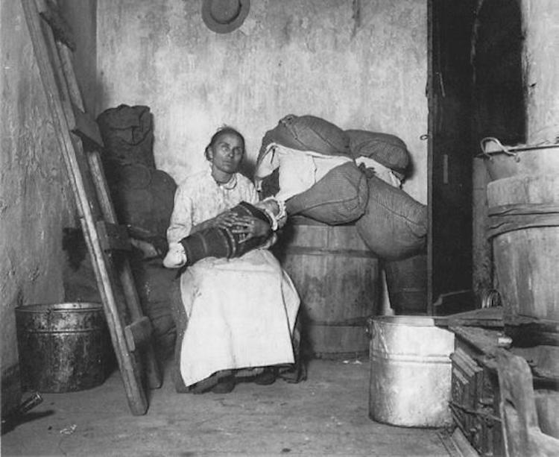

Italian Mother. Photo by Jacob Riis.

An Italian mother and her baby on Jersey Street in New York City about 1890. Many immigrants brought their families, or sent for them as soon as they had earned enough money to buy their passage. For such women from rural backgrounds, the American cities were noisy and confusing worlds, with strange customs and an unfamiliar language. Many clung to the traditional dress and child rearing patterns of their homeland. Crowded living conditions helped to cause high infant mortality.

[[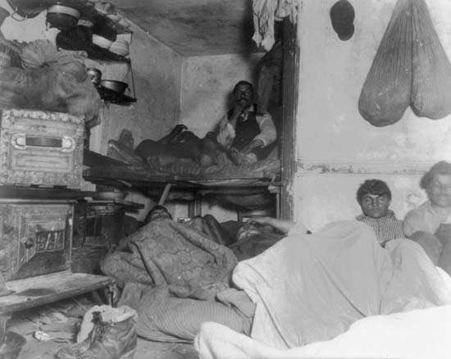](https://www.britannica.com/biography/Jacob-Riis/media/1/503662/122457)](https://www.britannica.com/biography/Jacob-Riis/media/1/503662/122457)

Lodgers in Tenement. “5 cents a spot” Photo by Jacob Riis

[Brittanica Biography Jacob Riis](Bhttps://www.britannica.com/biography/Jacob-Riis)

"Five cents a spot" was the title reforming photographer Jacob Riis (1849-1914) gave to this image of unauthorized rental lodgings in a Bayard Street, New York City, tenement about 1890. The welcome many immigrants received was meagre at best. For "Birds of Passage" (men who came without their families, hoping to earn enough to return to their native countries with sufficient savings to live better lives there), inexpensive lodgings without comfort were endurable if it meant saving money. Tenements such as this one might even rent out beds in eight-hour shifts to get a maximum return.

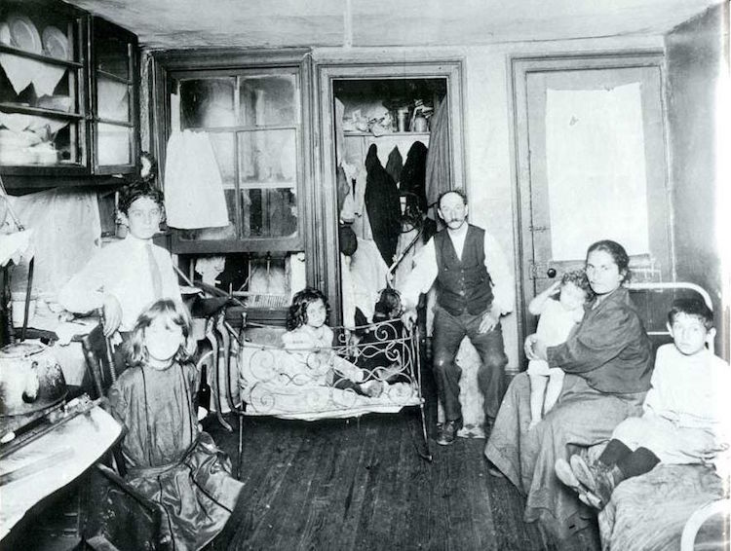

Room in a tenement. Photo by Jacob Riis

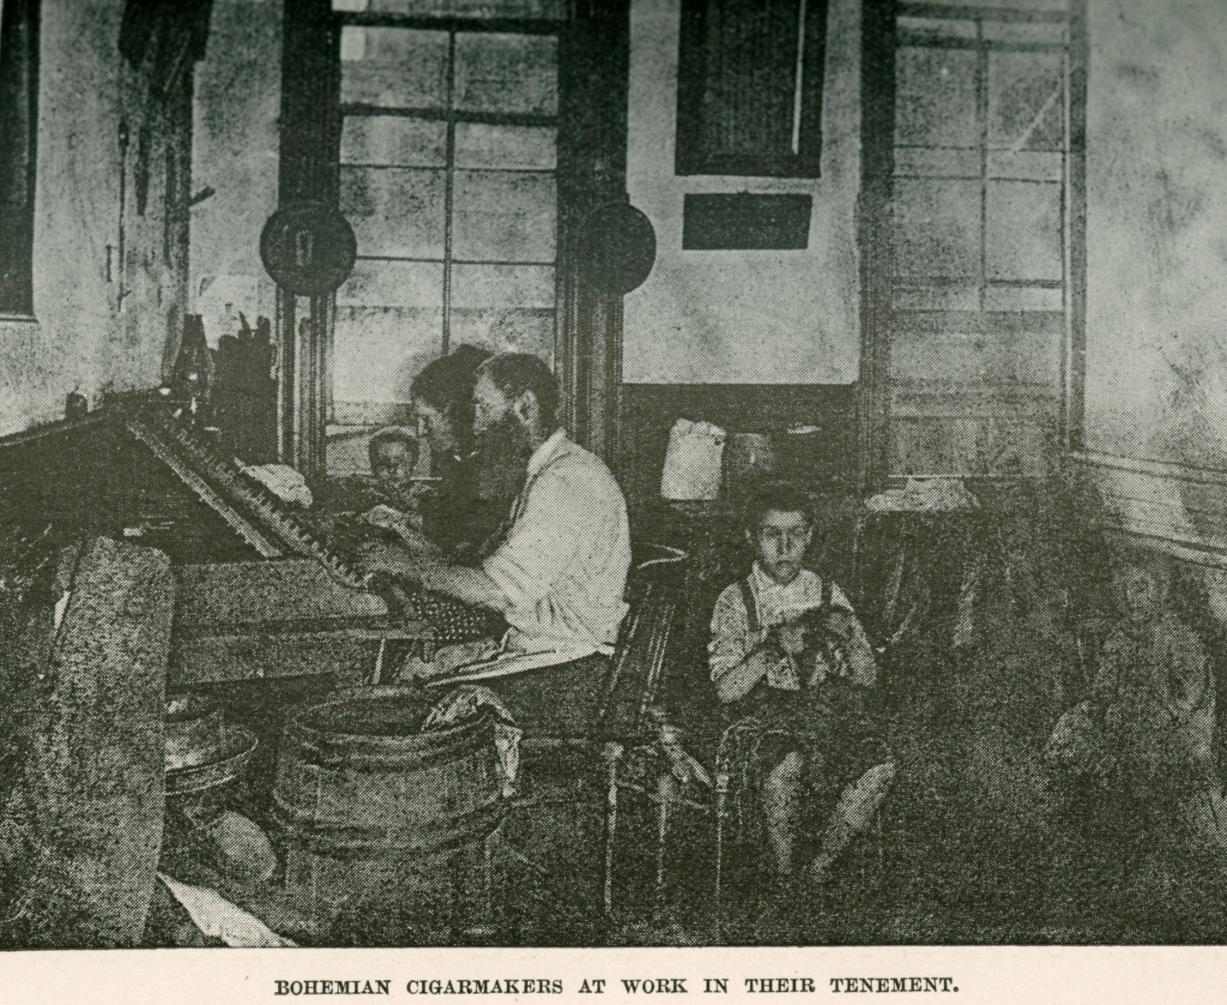

Bohemian cigarmakers at work in their New York City tenement, about 1889. Many immigrants not only lived in the single room in a tenement apartment that served as their lodging, but whole families also worked there, doing piecework for the garment trade, creating artificial flowers for the Victorian ladies' elaborate hats, or rolling cigars. Childrens' labor was a necessary part of the family income. Photo by Jacob Riis.

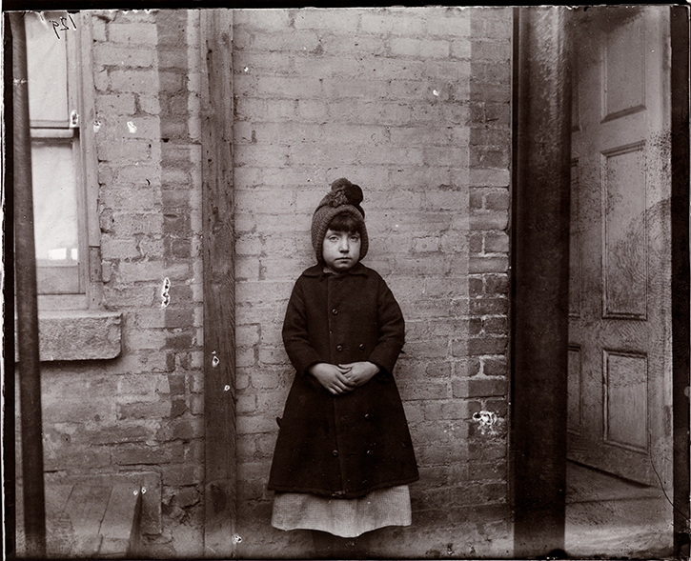

“I Scrubs” photo by Jacob Riis

From 1854 to 1874, the Children’s Aid Society in New York City established twenty-one industrial schools, which offered academic and technical classes, medical care, and recreational programs to children who, because of the conditions of their impoverishment, could not attend public school. Riis met nine-year-old Katie at the West 52nd Street Industrial School, where he interviewed her and took her portrait. Riis asked her what type of work she did, and she answered “I scrubs”. Katie and her three older siblings took their own apartment after their mother died and their father remarried. The older children worked in a hammock family and Katie kept house.

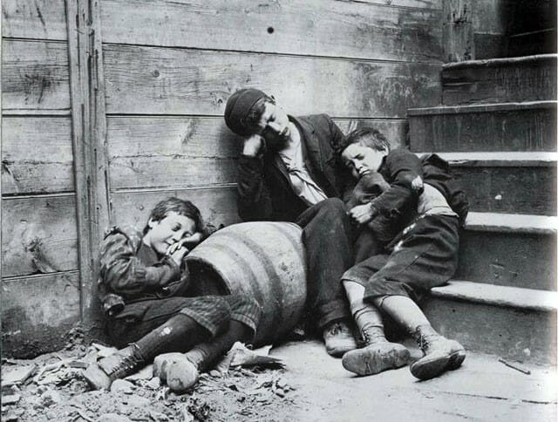

New York City slum children as depicted in the 1890s by social documentary photographer Jacob Riis.

[Jacob Riis How the Other Half Lives](https://mymodernmet.com/jacob-riis-how-the-other-half-lives/) photos

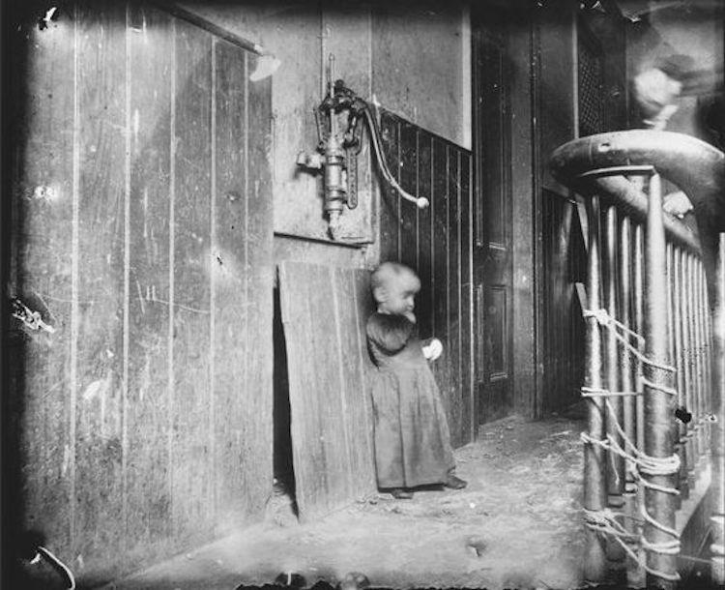

The baby’s playground. Photo by Jacob Riis

A photo of a toddler standing in the filth overflowing from a hall sink at the top of a dark tenement staircase.

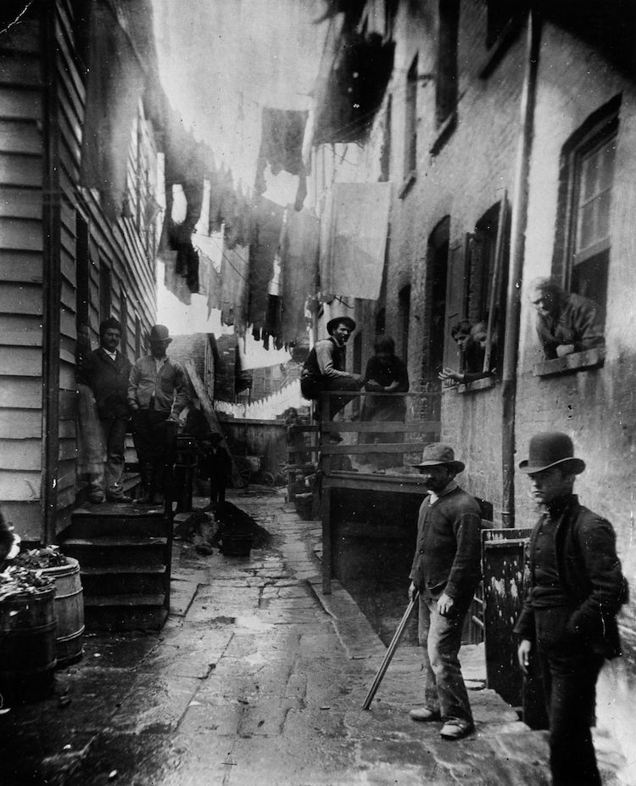

Bandit’s Roost. Jacob Riis Photo

Bandit’s Roost was a nickname for an alley next to 59 Mulberry Street in the heart of Mulberry Bend, a notorious slum not far from Riis’s newspaper office.

Activity 5

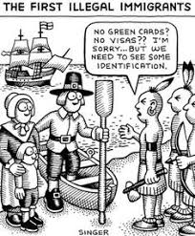

[Political Cartoons](https://politicalcartoons.com/?s=deports)

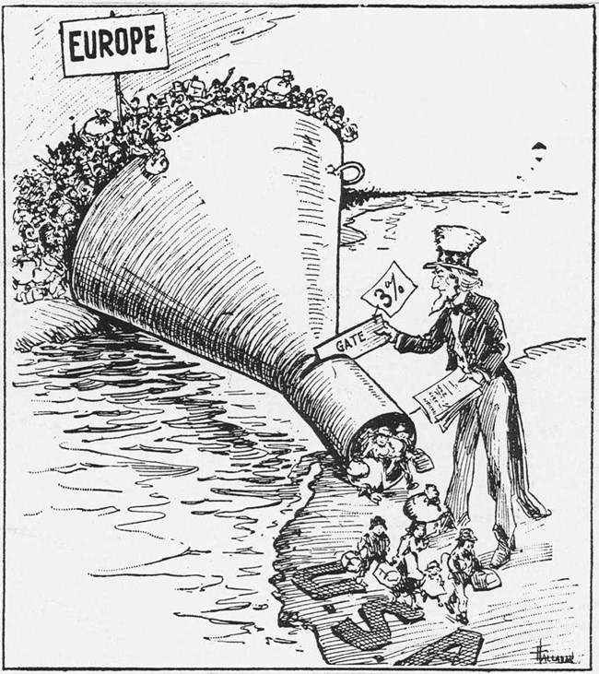

*A 1921 political cartoon portrays America’s new immigration quotas, influenced by popular anti-immigrant and nativist sentiment stemming from World War I conflict.*

*Library of Congress*

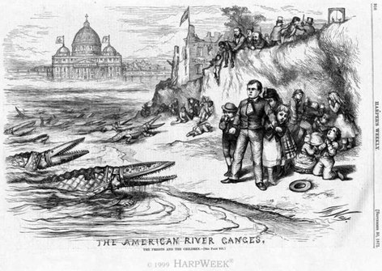

In this political cartoon, the artist is stressing how negatively the native born citizens looked at Irish immigration. As immigration increased the population of Catholics increased as well because the majority of Irish and Italians were Catholic, In the cartoon, what seems to be alligators are actually Catholic popes symbolizing all the Irish, invading America and destroying society and Christianity.

|  |  |  |  |  |  |  |  |  |  |  |  |  |  |  |  |  |
| --- | --- | --- | --- | --- | --- | --- | --- | --- | --- | --- | --- | --- | --- | --- | --- | --- |
| Cartoon Analysis Worksheet  |  |  | | --- | --- | | **Level 1** | | | Visuals | Words (not all cartoons include words) | | 1. List the objects or people you see in the cartoon. | 1. Identify the cartoon caption and/or title. 2. Locate three words or phrases used by the cartoonist to identify objects or people within the cartoon. 3. Record any important dates or numbers that appear in the cartoon. | | **Level 2** | | | Visuals | Words | | 1. Which of the objects on your list are symbols? 2. What do you think each symbol means? | 1. Which words or phrases in the cartoon appear to be the most significant? Why do you think so? 2. List adjectives that describe the emotions portrayed in the cartoon. | | **Level 3** | | | 1. Describe the action taking place in the cartoon. 2. Explain how the words in the cartoon clarify the symbols. 3. Explain the message of the cartoon. 4. What special interest groups would agree/disagree with the cartoon's message? Why? | |   *Cartoon Analysis Worksheet.* National Archives and Records Administration. 6 April 2009 <[Archives Cartoon Worksheet](http://www.archives.gov/education/lessons/worksheets/cartoon.html)>.  Adapted from<www.micitizenshipcurriculum.org> |

**Activity 6 Letter Home**

Pretend you an immigrant who has recently arrived in the United States, now writing a letter home to their family in the “old country”. What was life in the U.S.? Is it what they expected? Why or Why not? You must have a specific immigrant identity. If you know of an immigrant identity in your own family, you can choose that identity. For example, my identity is Frances Catherine Vanderiet from Nieuwpoort, Netherlands and I am 18 years.

**Activity 6 Letter Home Rubric**

|  | 4 | 3 | 2 | 1 | Points |
| --- | --- | --- | --- | --- | --- |
| Immigrant identity, age, name, country of origin incorporated into the letter | Includes Immigrant identity, age, name, country of origin. All are incorporated into the letter , | Includes all 3 identity items but not incorporated into the letter | Includes 2 identity items | Includes only 1 identity item |  |
| Include accurate data of what life was like in the U. S. from 1850-1914 | All facts are accurate and are in the time period | Most facts are accurate and are in the time period | Some facts are accurate and not all in the correct time period | Neither facts or time period are correct | X2 |
| Expectations of immigrant | At least 3 expectations of immigrant were explained and explanation is outstanding | At least 2 expectations of immigrant were explained and explanation is satisfactory | At least 1expectations of immigrant were explained and explanation is okay | No expectation is mentioned |  |
| Letter includes  Date, greeting, 3 paragraph body, complimentary close and signature line | All 5 expectations met within the content of the letter. 3 Paragraphs have at least 5 sentences each. | 4 of the expectations met within the content of the letter. 3 Paragraphs have at least 4 sentences each. | 3 of the expectations met within the content of the letter. 3 Paragraphs have at least 3 sentences each. | 2 or less of the expectations are met | X2 |
| Creativity | Letter is very creative. Outstanding | Letter is somewhat creative | The letter a little creative. | Letter is not  creative |  |
| Total Points |  |  |  |  |  |