Name: Date:
Quincy Timeline Activity

Cut out each of the boxes below to place on your timeline.
Make sure to put them down in the right order!

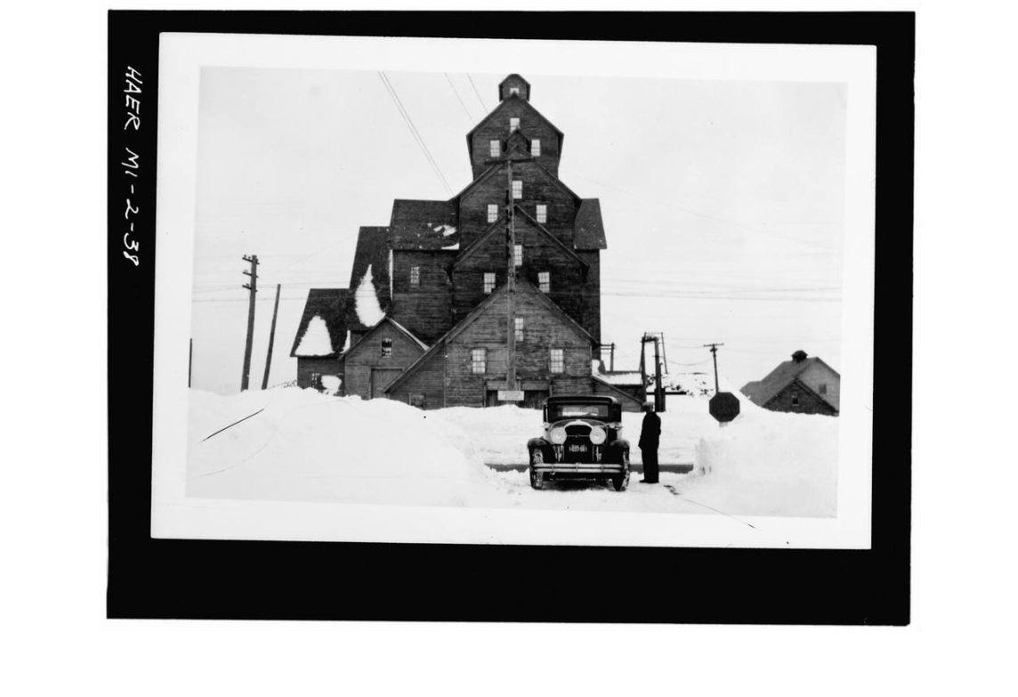
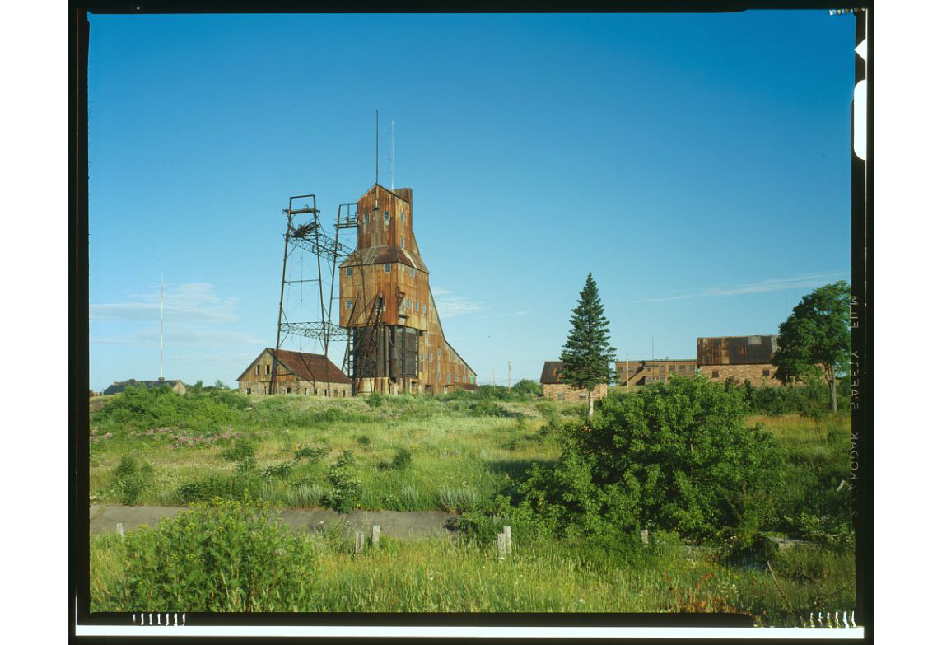
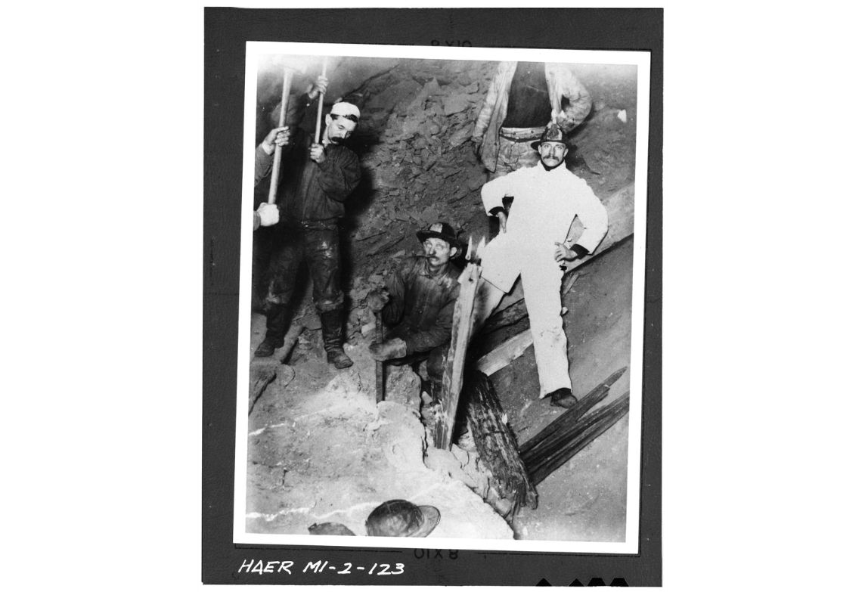

The Great Depression sets in, and copper prices drop. Production comes to a halt, and the Quincy Mine temporarily closes.

Demand for copper goes down quickly after the War. The Quincy Mine is forced to shut down permanently.

The Quincy Mine locates the copper-rich Pewabic Lode. They start extracting copper from it the following year.

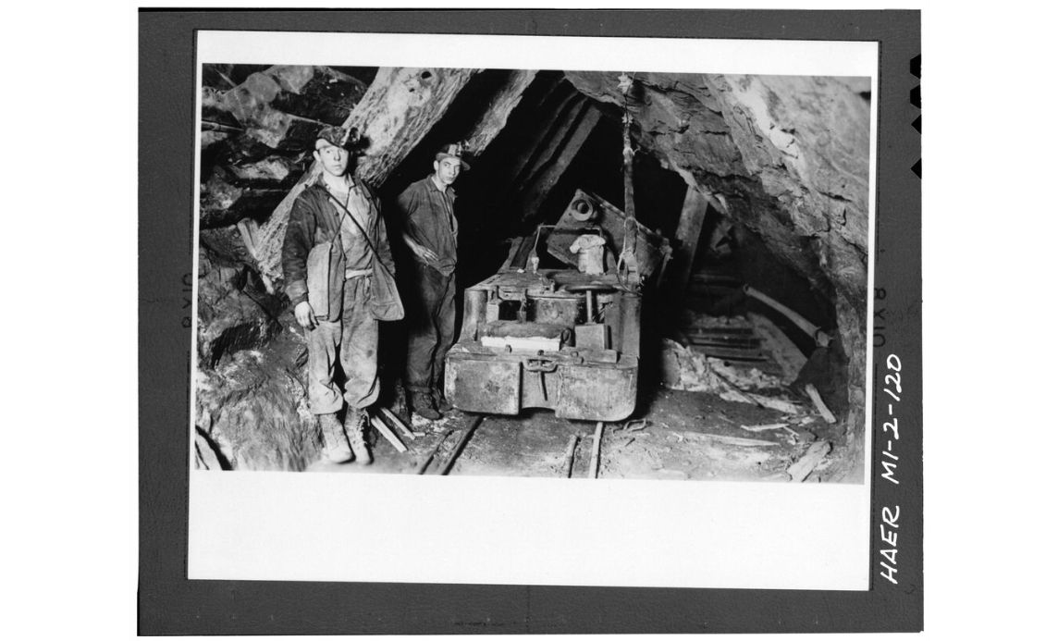
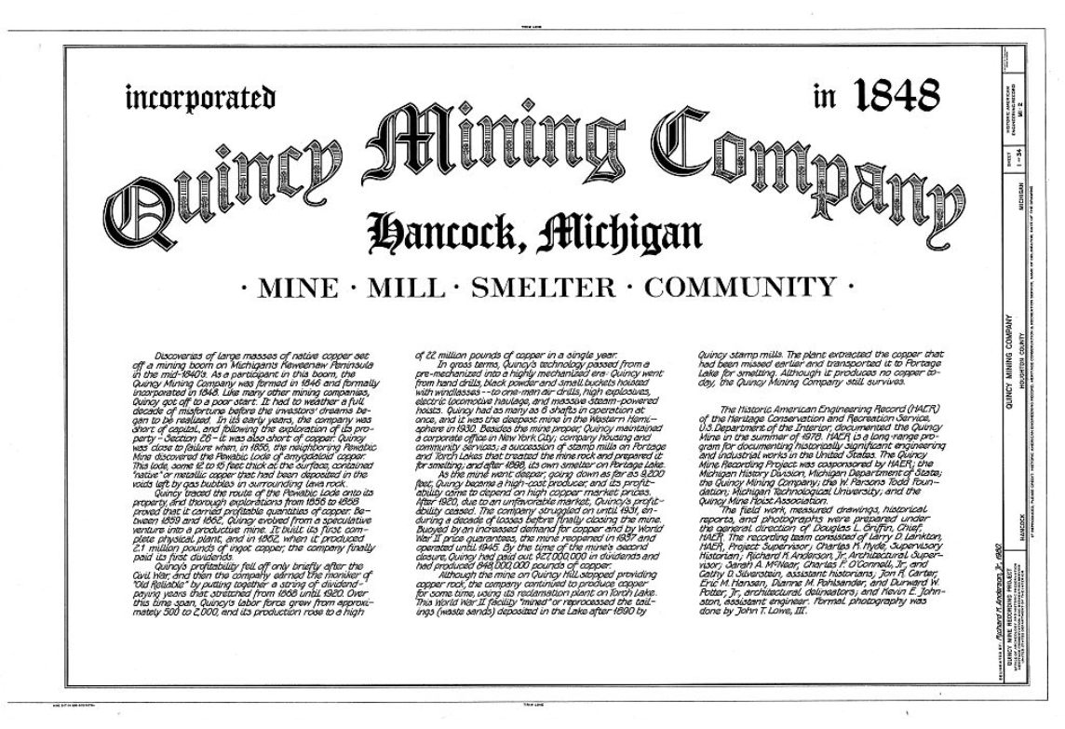
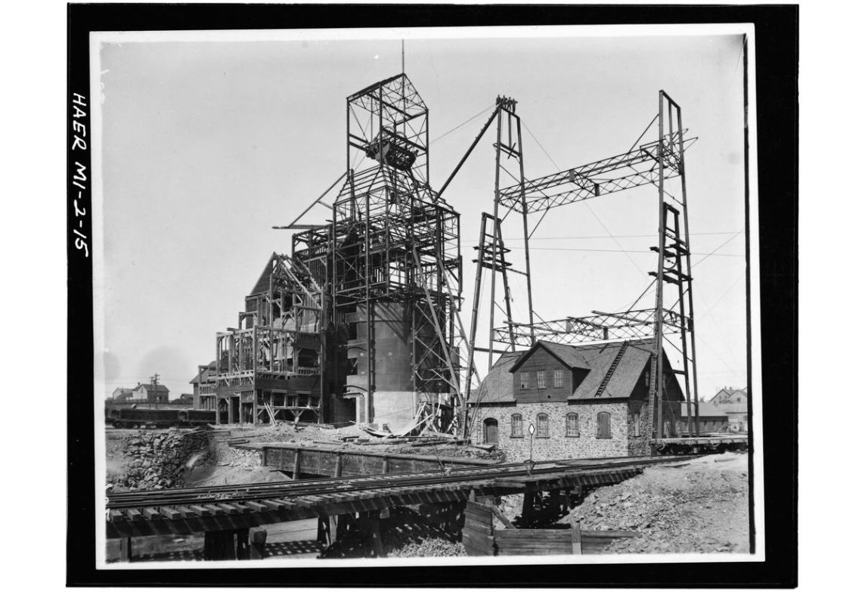

With the U.S. entering World War II, demand for copper rises again, and the Quincy Mine goes back to producing copper.

There’s lots of copper to be mined in the Keweenaw Peninsula, and the Quincy Mining Company is founded to start operations in Hancock.

The Quincy Mine continues to be proﬁtable as copper demand rises.
Mineshafts get deeper, and Shafthouse No. 2, the one that still stands today, ﬁnishes construction.

Images courtesy of the Library of Congress.

