Commissioned Artist 2024: Keweenaw National Historical Park

SUMMARY

The Keweenaw Peninsula has been the site of copper extraction for more than 7,000 years. Visitors come from all over the world to visit what remains of one of the Earth’s most productive mining regions in the world. As people moved on, much of the industrial landscape has given way to the return of nature. Beautiful forests surround historic buildings, grasses and wildflowers reclaim open spaces.
One feature of the mining landscape is not visible to modern visitors – the workers and their families who once crowded Copper Country. The goal of this program is to use art to return the presence of people to these historic landscapes.
The Quincy Dry House represents the transition between the domestic and industrial sides of the miners’ lives. While the mines were in operation, miners changed into their work clothes at a Dry House before walking down to the shafts. After work, they would change out of their work clothes and wash up before heading home.

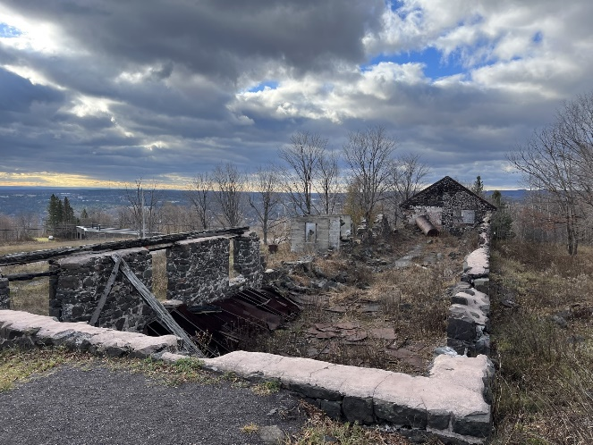
Deadline: February 26, 2024. All submissions must arrive by 11:59 p.m. Electronic submissions are required. You may print and scan this document to send or fill it out electronically. Please use as many pages as necessary. Your completed application and its attachments should be sent to kewe_information@nps.gov.

All applicants will be reviewed by a committee consisting of representatives from Keweenaw National Historical Park, the park’s advisory commission, and Isle Royale and Keweenaw Parks Association (IRKPA). Selections will be made in March, after a round of interviews. The artist will complete their term during a six-week period between July 8th and August 30th.

SECTION A: CONTACT INFORMATION

Name
Street Address
City/Town
Province/Territory/State |  | Postal/ZIP code
Phone Number |  | E-Mail Address

SECTION B: ARTIST’S VISION

A. Describe your vision and what draws you to the project. Include artistic intent, materials/production, interaction with the Keweenaw National Historical Park’s history/landscape, anticipated presentation/exhibition of work, etc.

B. In an attached document, include your work plan. The plan must include:
  - Estimated cost of materials and the artist’s time
  - Draft of work schedule
  - Need for housing.
    - The artist must reside more than a fifty-mile drive away from park headquarters to qualify for housing.
  - Need for workshop space.
    - Include space requirements, and if assistance is required in locating a suitable space.
  - Plan for public engagement. This engagement may take multiple forms, including but not limited to in-person lectures, hands-on workshops, open studio hours, social media posts, or other approved forms. The artist must complete 50 hours’ worth of public outreach during their term. Consider options that:
    - Are accessible to most ages.
    - Consider potential safety concerns.
    - Have no assumption of previous knowledge or skill.
    - Explicitly list safety procedures and gear (Proper PPE, etc.).

SECTION C: OTHER INFORMATION

A. A brief biography (maximum 100 words). This will be used to promote you on our website and in social media posts, should you be selected. Please write the bio as if you are writing for that purpose. Please do not include a photo of yourself at this time.
B. Briefly describe your experience interacting with the public, in person and via media. For example, presenting artist talks or demonstrations, teaching hosting open studios, web site creation and/or use of social media sites, or video to present and promote artistic ideas. Please provide specific examples of how you think these tools might be applied to this project.

C. Please provide the name, phone number, and email address of at least three professional references in the space below.

SECTION D: ATTACHMENTS CHECKLIST

- Your Portfolio of Work (minimum of five images)
- Artist Resume
- Work Plan
*Include these attachments as part of your email.

AGREEMENT AND SIGNATURE

By submitting this application, I affirm that the facts set forth in it are true and complete. Please ensure that you have fulfilled the specific requirements as outlined by this application form; failure to do so will ultimately disqualify you as a candidate for residency.
Name (printed)
Date

Signature [E-signatures are acceptable]

