Park News
National Park Service
U.S. Department of the Interior
Park News
National Park Service
U.S. Department of the Interior

Summary of Park Regulations

Katmai National Park and Preserve Alagnak Wild River
Aniakchak National Monument and Preserve

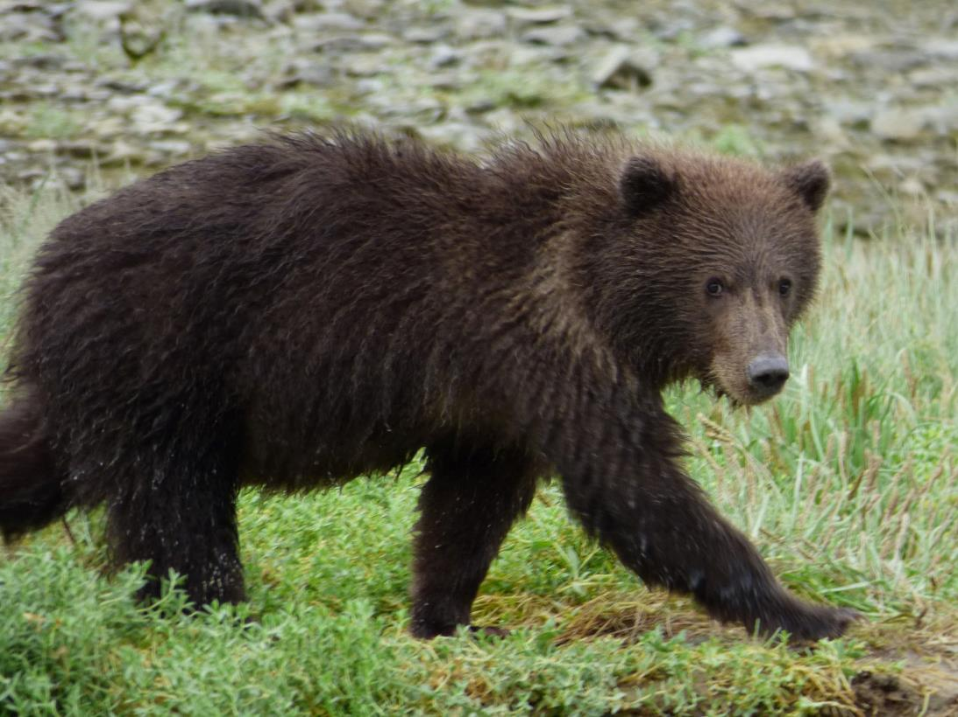

Angler on American Creek

Katmai National Park, Regulations Summary - Vol. 4 February 1, 2018

Katmai Regulations

Katmai, Alagnak, and Aniakchak provide unique opportunities for users of Park areas.
This booklet is designed to help visitors and users understand park regulations as they relate to three National Park Service (NPS) units: Katmai National Park and Preserve, Aniakchak National Monument and Preserve, and Alagnak Wild River, collectively referred to as Katmai.
Contents

Know Before You Go
General Park Definitions
Summary of Katmai Regulations
Activities that Require a Permit
Sport Hunting and other regulations for Preserve areas
Wilderness Travel and Personal Locator Beacons
Brooks Camp Developed Area (BCDA)Map
Brooks Camp Developed Area (BCDA) Regulations
Brooks River Sportfishing Regulations

Other park areas specific regulations:
Geographic Harbor
Hallo Bay Camping Closure
Lake Camp Boundary Map
Lake Camp Regulations
Naknek Lake Area Regulations
Subistence Uses
Alaska Boating Summary
Aircraft Travel
3
4
5
6
7
8
9
10
11

12
12
13
14
15
16
17
18

The following pages provide a general listing of park definitions and regulations, reference maps, and selections of applicable state and federal regulations that are used to manage the park areas. This document is only a summary of park regulations and is not a complete list.

To conserve the scenery and the natural and historic objects and the wildlife therein and to provide for the enjoyment of the same in such manner and
by such means as will leave them unimpaired for the enjoyment of future generations.

~NPS Mission

Note that the park definitions and general regulations apply to all three park areas. Certain areas of Katmai, such as the Preserves and the Brooks Camp Developed Area (BCDA) have additional regulations.

To understand these regulations it is important to know the purpose for the Katmai group of parks and the reasons why these park units were set aside.

Katmai National Park and Preserve’s purpose is to protect, study, and interpret

active volcanism surrounding the Valley of Ten Thousand Smokes, extensive coastal resources, habitats supporting a high concentration of salmon and brown bears, and an ongoing story of humans integrated with a dynamic subarctic ecosystem.

The purpose of Aniakchak National Monument and Preserve is to protect, study and interpret the dynamic geology, ecology, and human use of Aniakchak Caldera and the surrounding landscape.

The Alagnak Wild River is internationally renowned for its scenic beauty, pristine condition, and wide range of outstanding recreational opportunities. It also protects a river system necessary for the perpetuation of the Bristol Bay sockeye salmon fishery.

We care for those special places in Alaska...We serve residents and visitors who seek inspiration, recreation and education, as well as those who come for traditional activities, subsistence and scientific study....to protect the natural and cultural resources...for this and future generations to experience and enjoy.

~NPS Alaska Region Mission
Statement

2 Katmai Regulations Summary

Know Before You Go:
Although the following pages provide many of the regulations that pertain to Katmai, the following list provides some items that we ask you to pay special attention to:

Using a Guide or Business inside of the park:
If you are paying for services where a person or business is receiving compensation of any kind (money, cameras, free trip, etc.) that business is required to first obtain a permit from the National Park Service. That permit is called a Commercial Use Authorization (CUA) permit. For a list of businesses that have a permit please consult the Alaska Region website at: www.nps.gov/locations/alaska/services.htm

Firearms:
As of February 22, 2010, loaded and operable weapons may be carried within Katmai National Park subject to Alaska law. Weapons are prohibited within Federal Facilities which includes but is not limited to the following locations: King Salmon Park Headquarters and maintenance buildings, Brooks Camp and King Salmon Visitor Centers, Brooks Camp Ranger Station and Maintenance Buildings.

No weapon storage will be provided for at Park Facilities.
There is still no authorization for use of firearms in any manner within the National Park which includes:
-Pointing or aiming weapon (such as to use a scope).
-Target practice or demonstration.
-Warning shots.
-Brandishing or other inappropriate handling/ display.

For your safety and the safety of others:
Bear Spray is allowed in all Park areas. However, please note that bear spray should not be transported in the main cabin of an aircraft. Please check with your aircraft transporter for more information on how to transport your bear spray.

Other tips to make your stay more enjoyable:
Know and understand the dangers of camping in bear country. Make loud noise
when travelling through brush and do not

camp near spawning salmon streams. For
more information please visit Bear Safety in Alaska National Parklands found at: https://www.nps.gov/katm/planyourvisit/bear-safety-in-katmai.htm

Electric Fences and Bear Resistant Containers (BRC):
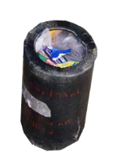
An electric fence is not a substitution for using approved Bear Resistant Containers to store food and odorous items. An electric fence around a standard cooler is prohibited. All food and beverages, food and beverage containers, garbage, harvested fish and equipment used to cook or store food must be stored in a bear resistant container (BRC) or secured—
•Within a hard sided building;
•Within a lockable and hard sided section of a vehicle, vessel, or aircraft; or

BRCs are free for use on a first come first serve basis at the King Salmon and Brooks Camp Visitor Centers.
There are also a number of businesses in the Anchorage area that will rent BRCs.

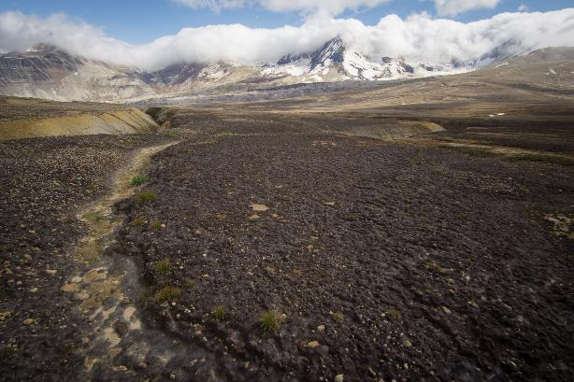

*Most locations within Katmai are covered with low shrubs or in places, such as the Valley of 10,000 smokes, lack vegetation making the use of BRC’s necessary in the backcountry.

General Park Definitions summarized from 36 CFR:

Aircraft means a machine or device that is used or intended to be used to carry persons or objects in flight through the air, including, but not limited to airplanes, float planes, helicopters, and gliders.

ANILCA means the Alaska National Interest Lands Conservation Act. ANILCA provides for some activities to perpetuate the rural Alaskan lifestyle, such as subsistence uses, traditional uses, access, cabins, and hunting and trapping.

Bear Resistant Container (BRC) means an item constructed to prevent access by a bear. BRC’s include items approved by the Department of Interior and Agriculture’s Interagency Grizzly Bear Committee (www.igbconline.org/html/safety.htm). Any additional items listed by the State of Alaska, Department of Fish and Game, Division of Wildlife Conservation must have the concurrence of the Superintendent.

Brooks Camp Developed Area (BCDA) means all park areas within a 1.5 mile radius from the Brooks Falls Platform in Katmai National Park and Preserve. Reference pages 9-11 for more information.

Boundary means the limits of lands or waters administered by the National Park Service and includes waters located within the boundaries of the National Park System, including navigable waters and areas within their ordinary reach (up to the mean high water line in places subject to the ebb and flow of the tide and up to the ordinary high water mark in other places) and without regard to the ownership of submerged lands, tidelands, or lowlands.

Boundaries of the coast of Katmai are lands above the mean high tide line and all islands within five miles of the coast line.

Camping means the erecting of a tent or shelter of natural or synthetic material, preparing a sleeping bag or other bedding material for use, or mooring of a vessel for the apparent purpose of overnight occupancy.

Firearm means a loaded or unloaded pistol, rifle, shotgun or other weapon which is designed to, or may be readily converted to, expel a projectile by the ignition of a propellant.

Fishing means taking or attempting to take fish.

Hunting means taking or attempting to take wildlife, except trapping.

Sportfishing means the taking of or attempting to take for personal use, and not for sale or barter, any fresh water, marine or anadromous fish by hook and line held in the hand, or by hook and line with the line attached to a pole or rod which is held in the hand or closely attended.

Federal Subsistence Uses means the customary and traditional uses by rural Alaska residents (defined under federal subsistence definitions) of wild renewable resources for direct personal or family consumption, as food, shelter, fuel, clothing, tools, or transportation; for the making and selling of handicraft articles and for customary trade and barter.

Off-Road Vehicle means any motor vehicle designed for or capable of cross country travel on or immediately over land, water, sand, snow, ice, marsh, wetland or other natural terrain, except snowmachines or snowmobiles.

Permit means a written authorization to engage in uses or activities that are otherwise prohibited, restricted, or regulated.

Park Areas means lands and waters administered by the National Park Service within the State of Alaska. For the purposes of this brochure, this includes Katmai National Park and Preserve, Alagnak Wild River, and Aniakchak National Monument and Preserve. Collectively these areas are known as “Katmai Park Areas” or simply Katmai.

Picnicking is defined as the consumption or preparation of any food items (other than water).

Snowmachine or snowmobile means a self- propelled vehicle intended for off road travel primarily on snow having a curb weight of not more than 1,000 pounds, driven by a track or tracks in contact with snow and steered by a ski or skis on contact with the snow.

Superintendent means the official in charge of a park area or an authorized representative thereof.

Take or takings as used with respect to fish and wildlife, means to pursue, hunt, harass, harm, shoot, trap, net, capture, collect, kill, wound, or attempt to engage in any such conduct.

Unmanned Aircraft (Drone) means a device that is used or intended to be used for flight in the air without the possibility of direct human intervention from within or on the device, and the associated operational elements and components that are required for the pilot or system operator in command to operate or control the device (such as cameras, sensors, communication links). This term includes all types of devices that meet this definition (e.g., model airplanes, quadcopters, drones) that are used for any purpose, including for recreation or commerce.

Vessel means every description of watercraft, or other artificial contrivance used, or capable of being used, as a means of transportation on the water. This definition does not apply to a seaplane on the water.

Weapon means a firearm, compressed gas or spring-powered pistol or rifle, bow and arrow, crossbow, blowgun, speargun, hand-thrown spear, slingshot, irritant gas device, explosive device, or any other implement designed to discharge missiles, and includes a weapon the possession of which is prohibited under the laws of the State in which the park area or portion thereof is located.

Wilderness Areas are undeveloped Federal lands retaining its primeval character and influence, without permanent improvements or human habitation, which is protected and managed so as to preserve its natural conditions.

Summary of General Park Regulations:

Access: All park lands may be accessed by snowmobiles (with adequate snow cover), motorboats and fixed wing aircraft without a permit. This includes Wilderness Areas.
Note: the use of off road vehicles such as ATVs and hovercraft is prohibited in all park areas. Bicycles are prohibited off of established roadways.
Aircraft Operations: Fixed wing aircraft may be operated within park areas. Landing helicopters is prohibited without a permit. Aircraft may not be operated in a manner that harasses wildlife. Downed aircraft means aircraft that have crashed, wrecked or had a hard landing and cannot fly until the FAA has signed off on it or needs a mechanic’s work. Removal of downed aircraft requires a permit issued by the Superintendent. Launching, landing, or operating an unmanned aircraft (drone) from or on lands and waters administered by the National Park Service is prohibited except as approved in writing by the superintendent.

Bear Spray: May be carried, possessed and used in accordance with applicable federal and non-conflicting state laws. Please note that bear spray should not be carried inside of an aircraft but attached to the outside of the aircraft in case of its accidental discharge.

Boating: All waterways are open to boating in accordance with USCG and Alaska State
regulations. All motor boats must be currently registered and all safety gear carried and used in accordance with size and operations.
Vessels capable of discharge must be able to show that the system has been made inoperable. See page 17 for additional information on boating requirements and
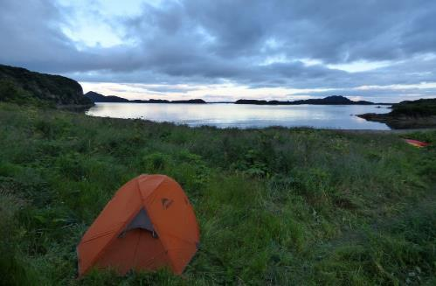
page 10, BCDA, for further restrictions.

Camping and Food Storage: The use of Bear Resistant Containers (BRCs) is mandatory. Food and beverages, food and beverage containers, garbage, harvested fish and equipment used to cook or store food must be stored in a BRC or secured within a hard sided building or within lockable and hard sided section of a vehicle, vessel, or aircraft. Food that is being transported, consumed, or prepared does not need to be in a BRC. BRCs are available free for use on a first come first serve basis at the King Salmon and Brooks Camp Visitor Centers.

Camping is authorized for 14 consecutive days in one location. After 14 days, the campsite location must be moved at least 2 miles away. A camp and associated equipment must be relocated immediately if determined to be interfering with public access or other public interests or adversely impacting park resources.

Note: There are camping restrictions in effect at Hallo Bay, Geographic Harbor and the Brooks Camp Developed Area. Please
read these sections carefully, pages 10 and 12.

Campfires: The lighting and maintaining of personal campfires is allowed; however, they must not be more than 2 feet in diameter. The areas of Lake Camp and the BCDA will remain closed to fires except as provided for in designated receptacles. All campfires must be closely attended and fully extinguished after use.

Collection of Natural Resources: In all park areas, all edible fruits, berries, nuts and
unoccupied seashells may be gathered by hand for personal use or consumption. Dead and downed wood may be collected for use as fuel for campfires. No wood may be collected from historic structures or cabins. This would include the wood used to construct cabins
Property: Except for Lake Camp and the BCDA which have more strict requirements, property may not be left unattended for longer than four months. Identification information is required for all personal property left in park areas. Identification information consists of the owner’s name, home address, telephone number, date that the property was left, and the type of fuel if the property contains fuel. This information must be labeled on the property or provided in writing to the Superintendent. All property must be stored in such a manner that wildlife is unable to access the contents.

or other historic structures such as caches or racks, and wooden furnishings, artifacts or other historic items. Standing timber may not be cut within Katmai National Park.

Commercial Operations: Engaging in or soliciting any business in park areas without a permit is prohibited. Contact 907-644-3644 for more information or visit the website https://www.nps.gov/locations/alaska/do-business-with-us.htm

Fees: An entrance fee is not required for visiting Katmai. There is one developed campground at the Brooks Camp Developed Area (BCDA) that does charge a Campground use fee. Reservations must be made prior to arrival by making a reservation at www.recreation.gov or by calling
877-444-6777.

Pets: Pets are prohibited in the BCDA. In all other park areas pets must be leashed or
physically restrained at all times and may not be left unattended or tied to an object.
Marijuana and Other Controlled Substances:
Although the state of Alaska provides for the regulated possession and use of marijuana, possession and use of marijuana or other controlled substances is prohibited on federal lands. This includes but is not limited to parks, rivers, monuments, and preserves.

Summary of General Park Regulations:

Leaving fuel in more than one location in a park area or leaving more than 30 gallons of fuel is prohibited unless authorized by the Superintendent. Storing fuel within 100 feet of a water source, high water mark of a body of water, or mean high tide is prohibited unless stored in a spill proof overpack container
or authorized by the Superintendent. Note: special conditions exist for commercial business operations.

Permits: For a list of activities that require a permit, please see the box in the right hand corner of the page. Certain permits may require more time to process than others. For questions about how to obtain a permit, please contact Park Headquarters at
907-246-3305.
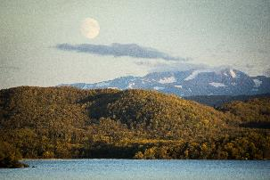
Back away from bears giving them the path or “fishing hole” when practical.

Hunting and Trapping: Sport hunting is in accordance with federal and state law.
Sport hunting is only allowed in Katmai National Preserve, Aniakchak National Preserve, and the Alagnak Wild River. Please consult the Alaska Hunting Regulations for further information on dates, seasons, means, and methods: http://www.wildlife.alaska.gov

Video and Still Photography: The taking or production of any motion picture or sound track, or any still photography that utilizes models, props or sets within park areas for the purposes of commerce or commercial advertising without a written permit from the Superintendent is prohibited. Information on film permit applications can be found on the park website at weeks prior to anticipated filming.
Wildlife Distance Conditions:
- Approaching a bear or any large mammal within 50 yards is prohibited.

- Continuing to occupy a position within 50 yards of a bear that is using a concentrated food source, including, but not limited to, animal carcasses, spawning salmon, and other feeding areas is prohibited.

- Continuing to engage in fishing within 50 yards of a bear is prohibited.

The prohibitions above do not apply to persons:
- Engaged in a legal hunt;
- On a designated bear viewing structure;
- In compliance with a written protocol approved by the Superintendent; or
- Who are otherwise directed by a park employee.

Wildlife Harassment: feeding, touching, teasing, frightening or intentional disturbing of wildlife nesting, breeding or other activities is prohibited.

Public Use Cabins: Fure’s Cabin on Naknek

Lake may be reserved by permit. The cabin
Compilation of Activities Requiring a Permit
is for non-commercial use and has other restrictions. Please call Park Headquarters at 907-246-3305 for further information and to obtain a permit.

Sanitation: All human waste in undeveloped areas must either be removed as trash or deposited in individual, one time use cat-holes dug at least 100 feet from any surface fresh water source and no more than 6 inches deep. All toilet paper and other sanitary products shall be packed out as trash or burned.

Sportfishing: Sportfishing is in accordance with Alaska State regulations and federal law. A valid Alaska State sportfishing license is required and must be in the angler’s possession while fishing. The use or possession of bait and or the practice of chumming is strictly prohibited. Sportfishing in fresh waters is by hook and line, with the rod or line being closely attended. Continuing to engage in fishing within 50 yards of a bear is prohibited. Always yield the right of way to bears.
Scientific research,
Collecting research specimens,
Operating a power saw in developed areas, Operating a portable motor or engine in undeveloped areas,
Operating a public address system, Air delivery,
Using designated fee areas or facilities, Noncommercial soliciting,
Using, possessing, storing, or transporting ex- plosives, blasting agents, or explosive materials, Using or possessing fireworks and firecrackers, Special events, Public assemblies and meetings, Sale and distribution of printed matter, Grazing,
Residing on federal lands,
Installing a monument or other commemorative installation,
Towing a person using a parasail, hang glider, or other airborne device,
Removing sunken, grounded, or disabled vessels,
Operating a submersible vessel,
Motorized use of the Valley of Ten Thousand Smokes Road,
Use of the Lake Camp launching facilities/ roadway by trailers over 20’ in length, Commercial notices or advertisements, Commercial operations,
Commercial photography or filming,
Construction or repair of any building, structure, facility, road, trail, or airstrip on federal lands,
Mining operations (9.9(a)) or an approved Plan of Operations (in lieu of permit)) Cabins on federal lands,
Using aircraft access for subsistence activities in the Monument,
Cutting of live standing timber greater than 3 inches in diameter for non-commercial subsistence uses,
Access to inholdings where access is not made by aircraft, snowmachine, motorboat or non-motorized surface transportation, Salvaging, removing, possessing aircraft, Helicopter landings,
Off-road vehicle (ORV) use,
Temporary access across federal land for survey, geophysical or exploratory work,

Permits may be acquired by contacting Park Headquarters at 907-246-3305. Note: a permit has special stipulations attached that may modify or amend other regulations.
Regulations cannot be modified under a special use permit.

Sport Hunting and Collection of Natural Resources:
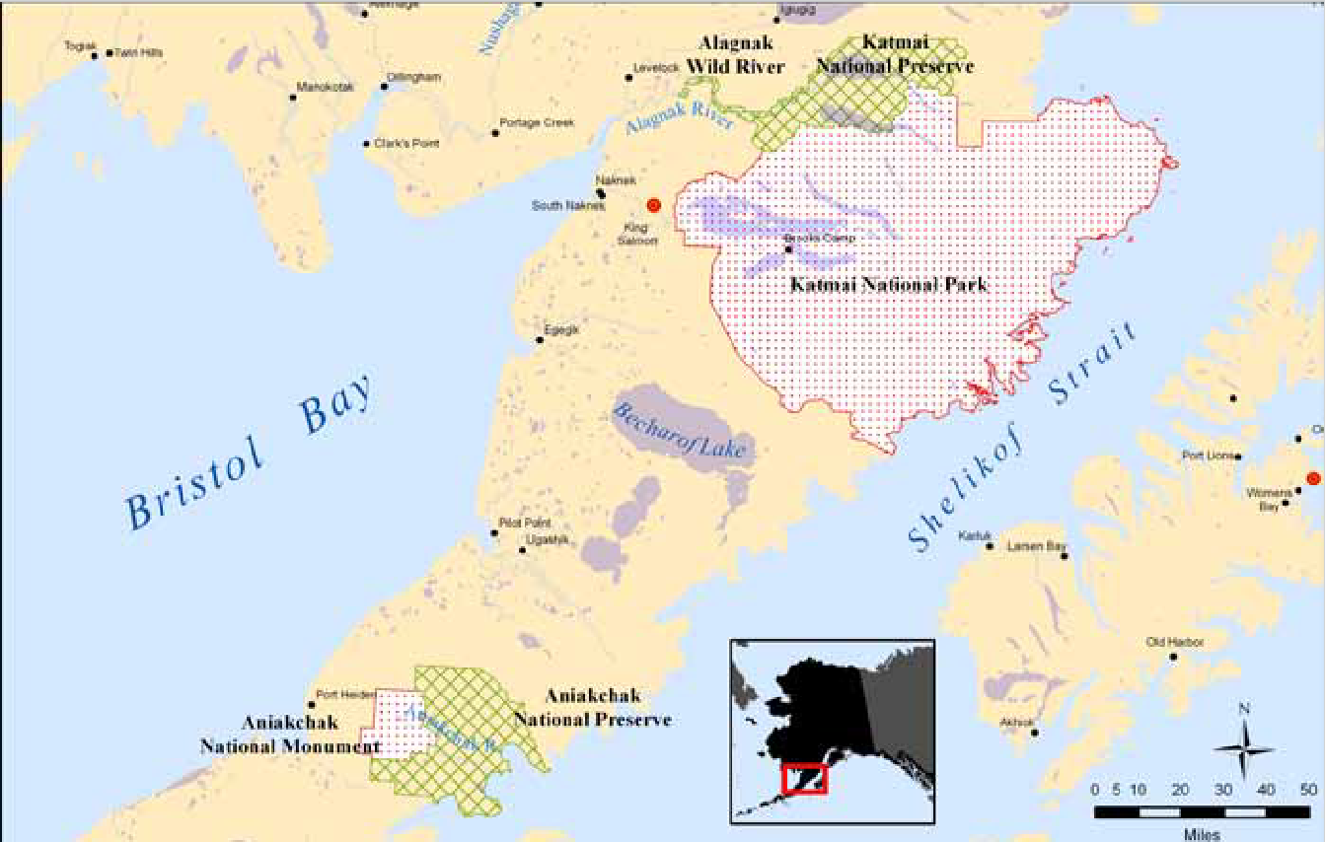
The red shaded area above depicts the former Katmai National Monument boundary as it was in 1969. The collection of natural resources, including some minerals as described on this page, can only occur within the green shaded areas of the current Katmai National Park and Preserve.

Katmai National Preserve, Aniakchak National Preserve and Alagnak Wild River are depicted in green crosshatch on this map and allow for sport hunting activities.

The Alaska National Interest Lands Conservation Act (ANILCA), adopted on December 2, 1980 mandates that some key activities necessary to perpetuate the rural Alaskan lifestyle, such as subsistence uses, traditional uses, access, cabins, and hunting and trapping be allowed to occur. Providing for ANILCA’s mandates and special uses makes management of Alaska parks unique within the National Park System.

Katmai National Preserve, Aniakchak National Preserve, and the Alagnak Wild River are managed to allow for hunting, natural resource collection and other uses as provided for by ANILCA. The following regulations apply to the areas depicted in green crosshatch on the map above.

Sport Hunting and Trapping:
Katmai National Park is closed to all hunting and trapping. Sport hunting and trapping is allowed in Katmai National Preserve, Aniakchak National Preserve, and the Alagnak Wild River. Please consult the Alaska Hunting Regulations for further

information on dates, seasons, means, and methods: http:// www.wildlife.alaska.gov

Guide Services:
Big game sport hunting for caribou, moose, and brown bear are all managed by the Alaska Department of Fish and Game in conjunction with the National Park Service. Guide services are only available from exclusively permitted guides by the National Park Service.

Collection of Natural Resources:
Gathering or collecting, by hand and for personal use only, of the following renewable resources is only allowed outside the boundaries of the former Katmai National Monument.* (see page 16 for a map of the former monument boundary)

- Natural plant food items, including fruits, berries and mushrooms, but not including threatened or endangered species.

- Driftwood and uninhabited seashells.

Surface collection, by hand (including hand- held gold pans) and for personal recreation- al use only, of rocks and minerals is allowed, with the following exceptions:
- Collection of silver, platinum, gemstones and fossils is prohibited; and
- Collection methods that may result in disturbance of the ground surface, such as the use of shovels, pickaxes, sluice boxes, and dredges, are prohibited.
* The “...former Katmai National Monument” language is taken from 36 CFR 13.35 and refers to the Katmai National Monument boundary as it was in 1969, which at the time did not include some of the northern park lands.

The collection of dead standing wood re- quires a permit from the Chief Ranger at Katmai National Park and Preserve 907-246- 3305.

Wilderness Travel:
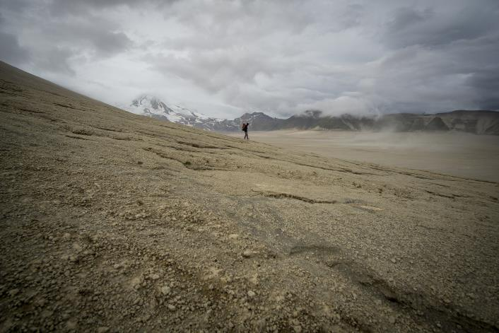
Katmai is over 90% trail-less Wilderness. Wilderness travel can be by foot, kayak, canoe, raft, boat or airplane. Most wilderness users find that they need skills beyond basic camping to have a safe and successful experience.

Carrying emergency equipment is very important. At a minimum, you should carry a satellite phone since cell phone coverage does not exist in the Katmai Wilderness. Rental satellite phones are available over the internet.

Personal Locator Beacons (PLBs) and personnel satellite communicators have become popular for travelers of all types. It’s a good idea to carry one, however, there are limitations of these devices in the Alaska environment.

Although satellite technology has improved greatly, there may be times/places when your device may not get a clear satellite signal – cloudy days, narrow canyons, thick forests.

Are you prepared if an emergency arises? Are you dressed for the environment, have the safety gear, and know how to get yourself out of a difficult situation before activating a PLB?

Even if you activate your personal locator beacon, help may be hours or days away, especially during weather events such as high wind or limited visibility. Searchers may not go out into weather situations that may endanger their own lives or equipment such as airplanes or boats.
Modern technology is great, but being mentally and physically prepared for wilderness travel at Katmai can add more value and security to your trip.
For more information please visit our :

https://www.nps.gov/katm/planyourvisit/backcountry-regulations-and-suggested-best-practices.htm
Before undertaking any wilderness trip, leave your travel plans with a responsible party. Make sure they have the information to give to responders; such as group member’s names, ages, special medical conditions, and level of experience in wilderness travel. Also make sure they know your tent colors and the companies you are travelling with. Finally, make sure they are familiar with your emergency equipment and your needs if a PLB is activated.

The park has responded to several instances of accidental emergency activations due to the PLB buttons being hit while carried in a pack. Understand how to safely and effectively carry and use your specific device before you enter the field.

Accidental activations cause unnecessary searches and can cost thousands of dollars in flights, personnel, resource and overtime costs. Money, resources, and time are borne by the NPS and other agencies and can make these rescue resources unavailable for other true emergency calls.
Leave No Trace Principles

Plan ahead and prepare
Know the area and what to expect – contact the park for specific information.

Select appropriate equipment -- weather and environmental conditions at Katmai can vary from hour to hour.

Camp and travel on durable surfaces
In popular areas - concentrate use; in remote areas - spread use.

Pack it in, Pack it out
Dispose of trash properly – pack it out! Do not burn it in campfires.

Bears may be present anywhere. Be extra clean in Bear country! Do not keep or store food in your tent. You are required to use a Bear Resistant Container to store all food and odorous items.

Keep tents, sleeping bags and personal gear free of food odors. Place the kitchen area at least 100 yards away from and downwind of sleeping sites.

Dispose of human waste properly. All human waste must be deposited 100 feet from any surface fresh water source and no more than 6 inches deep.

Deposit fish guts in deep water. In popular fishing locations consider “catch and re- lease” to minimize resource depletion.

Leave what you find. Leave natural objects and cultural artifacts where you find them.

Avoid disturbing wildlife.

Minimize use and impact from fire. Make a fire only if necessary – use camp stoves to cook your food. If a campfire is necessary, use only dead and downed wood and ensure it is attended to and completely extinguished when finished.

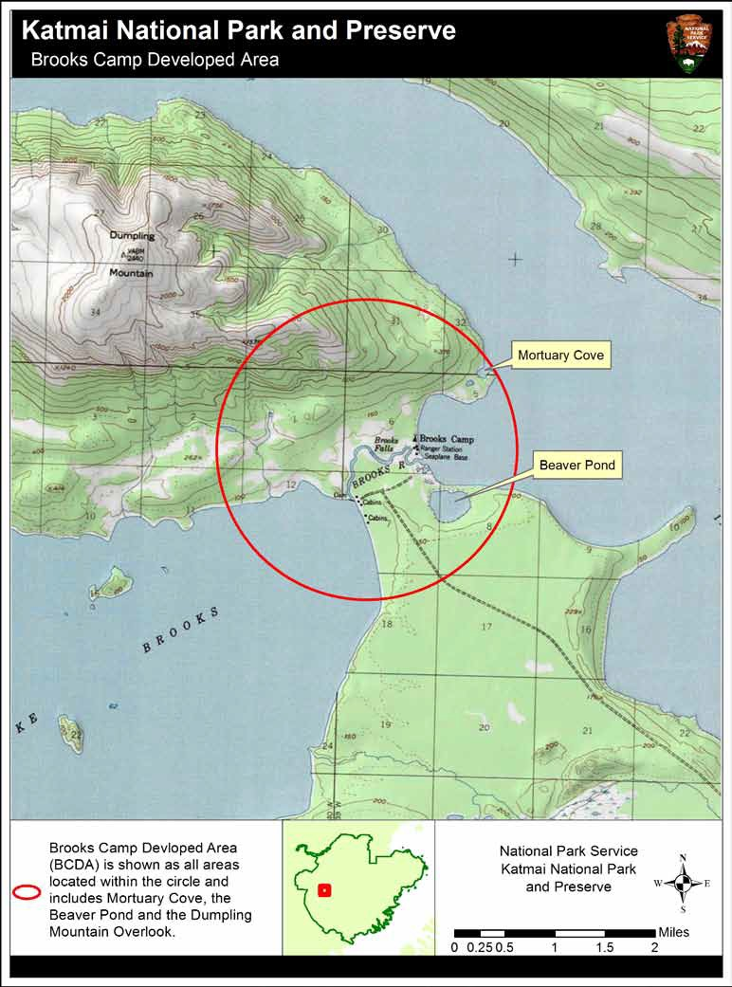

9 Katmai Regulations Summary

Brooks Camp Developed Area (BCDA)

Visiting the BCDA requires some preparation before arrival. Please review these regulations to have a safe and pleasant visit.

Brooks Camp Developed Area: The Brooks Camp Developed Area (BCDA) means all park areas within a 1.5 mile radius from the Brooks Falls Platform and is depicted on the map on page 9.

Aircraft: Surface operations are limited to idle maneuvers within 200 yards of Brooks Camp Beach on Naknek Lake. Step taxi operations, initiation of takeoffs and landing within this zone is prohibited. Buoys mark the no-wake area.

Bear Orientation: All persons visiting the BCDA must receive an NPS-approved Bear Orientation. Failure to receive an NPS- approved Bear Orientation is prohibited. [This orientation is mandatory immediately upon arrival to Brooks Camp.]

Brooks Falls Area: the area within 50 yards of the ordinary high water mark of the Brooks River from the Riffles Bear Viewing Platform to a point 100 yards above Brooks Falls is closed to entry from June 15 through August 15, unless authorized by the Superintendent. [For those on the Brooks River, an alternate route around this closure is marked with orange flagging and a map is provided at the Visitor Center.]
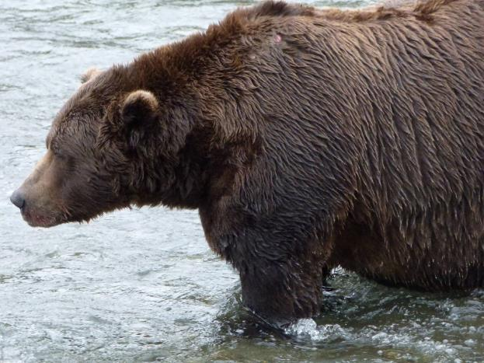

Visiting Hours:
The Falls and Riffles bear viewing platforms and boardwalks are closed from 10 pm to 7 am from June 15 through August 15. Entering or going upon these platforms and boardwalks during these hours is prohibited.
[Many non-habituated bears use Brooks Falls area at night after humans have left. They will not fish during the day because humans are too disturbing.]

Tripods:
Tripods and rail-mounted cameras are prohibited on the Brooks Falls platform between June 15th and August 15th.
Camping:
Camping is prohibited in all areas of the BCDA except within the Brooks Camp- ground. The following prohibitions apply to camping within the BCDA:

- Camping in Brooks Campground for more than a total of 7 nights during the month of July.

- Exceeding a group size limit of 6
persons per site in the Brooks Camp Campground from June 1-Sept. 17.

- Using specialized sites, facilities, equipment or services without paying the required
fees and possessing the applicable permits. [Note: you must make reservations at www.rec- reation.gov or calling 877-444-6777 for Brooks Campground prior to arrival at Brooks Camp. Checkout time is 12:00pm].

Campfires:
Lighting or maintaining a fire is prohibited except in established receptacles in the BCDA. [There are three fire rings established in the Brooks Campground near the picnic shelters.] All campfires must be closely attended and fully extinguished when finished.

Sanitation: Within the BCDA, washing dishes or cooking utensils at locations other than the water spigot near the food cache in the Brooks Campground is prohibited.

Property:
Leaving property, other than motorboats and planes, unattended for any length of time within the BCDA is prohibited, except at the Brooks Lodge Porch, Brooks Campground, or designated equipment caches as posted at the Brooks Camp Visitor Center. This regulation applies to gear left in open boats and gear
left hanging on airplanes. [Store all gear you are not willing/able to keep in your immediate control in the gear caches.]

Pets
Possessing a pet, including assistance animals in the BCDA is prohibited.

Picnicking and Possession of Food Items Within the BCDA, picnicking is only allowed at the Brooks Camp Visitor Center Picnic Area, Brooks Campground, and Brooks Lake Picnic Area. Food consumption or possession while at the Brooks River is prohibited. Picnicking is defined as the consumption or preparation of any food items (other than water). Food items include any substance intended for human consumption.

Brooks River Fishing Regulations
Katmai is one of the premier brown bear viewing areas in the world. It is also famous for its world-class angling experiences. Just as previous anglers to Katmai helped preserve this unique experience for you, it is your responsibility to future visitors to follow these regulations and keep bears out of trouble.

Fishing at Brooks River Always do your best to keep the fish in the water and release it as quickly and gently as you can to ensure its survival. Fish in Katmai may be caught many times by many different anglers throughout their life, give them the best chance at life by practicing good catch and release techniques. “Letting Go: The Art of Catch and Release” is a short video available at the Brooks Camp Visitor

Distance Requirements Continuing to engage in any fishing activity within 50 yards of a bear is prohibited. Persons engaged in fishing are required to immediately terminate fishing activity by
releasing any fish from the line and removing the line and hook from the water.

Reminders Alaska State Sportfishing License is required.

Only unbaited, single-hook, artificial flies may be used on the entire stretch of the Brooks River including lake waters within 1/4 mile of the river inlet and outlet. Hooks must be 1/2” or less.

Fish hooked elsewhere than in the mouth
Center demonstrating ideal catch & release techniques.

Another great responsibility of anglers is to ensure that bears do not form an association between anglers and food. Never let a bear obtain a fish from you! In past years, Brooks River has been closed to fishing when bears began to associate anglers with fish as a food source.

Yield the right of way to bears when practical. Back away from bears giving them the path.
Avoid trying to move a bear by yelling at it or throwing things at the bear as this may provoke an aggressive response.

must be released immediately.
“Snag” or foul hooked means to hook a fish elsewhere than in its mouth.

Chumming or placing preserved or fresh fish eggs, fish roe, food, fish parts, chemicals, or other foreign substances in fresh waters for the purpose of feeding or attracting fish in order that they may be taken is prohibited.

Fish Retention/ Fish Cleaning
Only one fish per person/day may be retained on Brooks River, and only downstream of the floating Bridge, except for Rainbow Trout. All rainbow trout are catch and release only.

No cleaning of fish is allowed within the Brooks Camp Developed Area.

Fish that are kept must be immediately placed whole in a plastic bag [available at the Visitor
Center] and immediately transported to the Fish Freezing Building to be frozen. Each bagged fish must be labeled with the angler’s first/last name, date caught, and date you will be removing your fish from Brooks Camp.

5 fish per day (except rainbow trout) may be retained beyond 200 yards of inlets and outlets of the Brooks River.

Closures
Brooks Falls Area Closure (June 15 through August 15): The area within 50 yards of either side of the bank (ordinary high water mark of the Brooks River) from 100 yards downstream (the Riffles Bear Viewing Platform) to a point 100 yards above Brooks Falls is closed to entry.
Use the designated route to transit around the closed area marked by the orange flags.

Fishing from the floating bridge is prohibited.

Fishing within 300 feet of the fish ladder is prohibited.

11 Katmai Regulations Summary

Specific Regulations for Geographic and Hallo Bay:
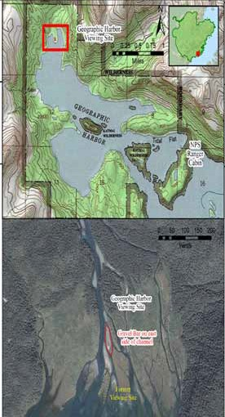
Geographic Harbor:

Geographic Harbor is located on the Katmai Coast approximately 70 air miles

southeast of King Salmon.

Within the designated area at the outlet of Geographic Creek, wildlife viewing within 50 yards of a bear using a concentrated food source may only occur under the limits of the following protocol:

- All viewers must utilize the same identified site. (see map to the right)
- No food is allowed at the viewing site (except water).
- No camping is allowed at the viewing site.

Wildlife viewing outside of the designated viewing area must follow standard park regulations concerning proximity to concentrated food sources and fishing.
The viewing area subject to the special viewing protocol is identified in the two photos at right.

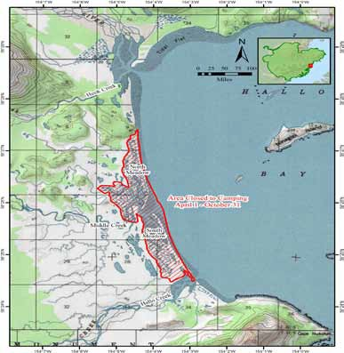
Hallo Bay Camping Closure:

Hallo Bay is a popular bear viewing and camping area found on the Katmai Coast.

To protect bear habitat and to allow for bear viewing opportunities, camping is prohibited in the core meadow areas April 1 to October 31.

Camping longer than 14 days in one lo- cation is prohibited and a new campsite must be moved at least 2 miles away from the original campsite. (applicable park- wide)

This restriction is intended to prevent conflicts with bears and visitors at prime feeding sites and to protect vital meadow resources while providing for overnight camping on the periphery of the closure.

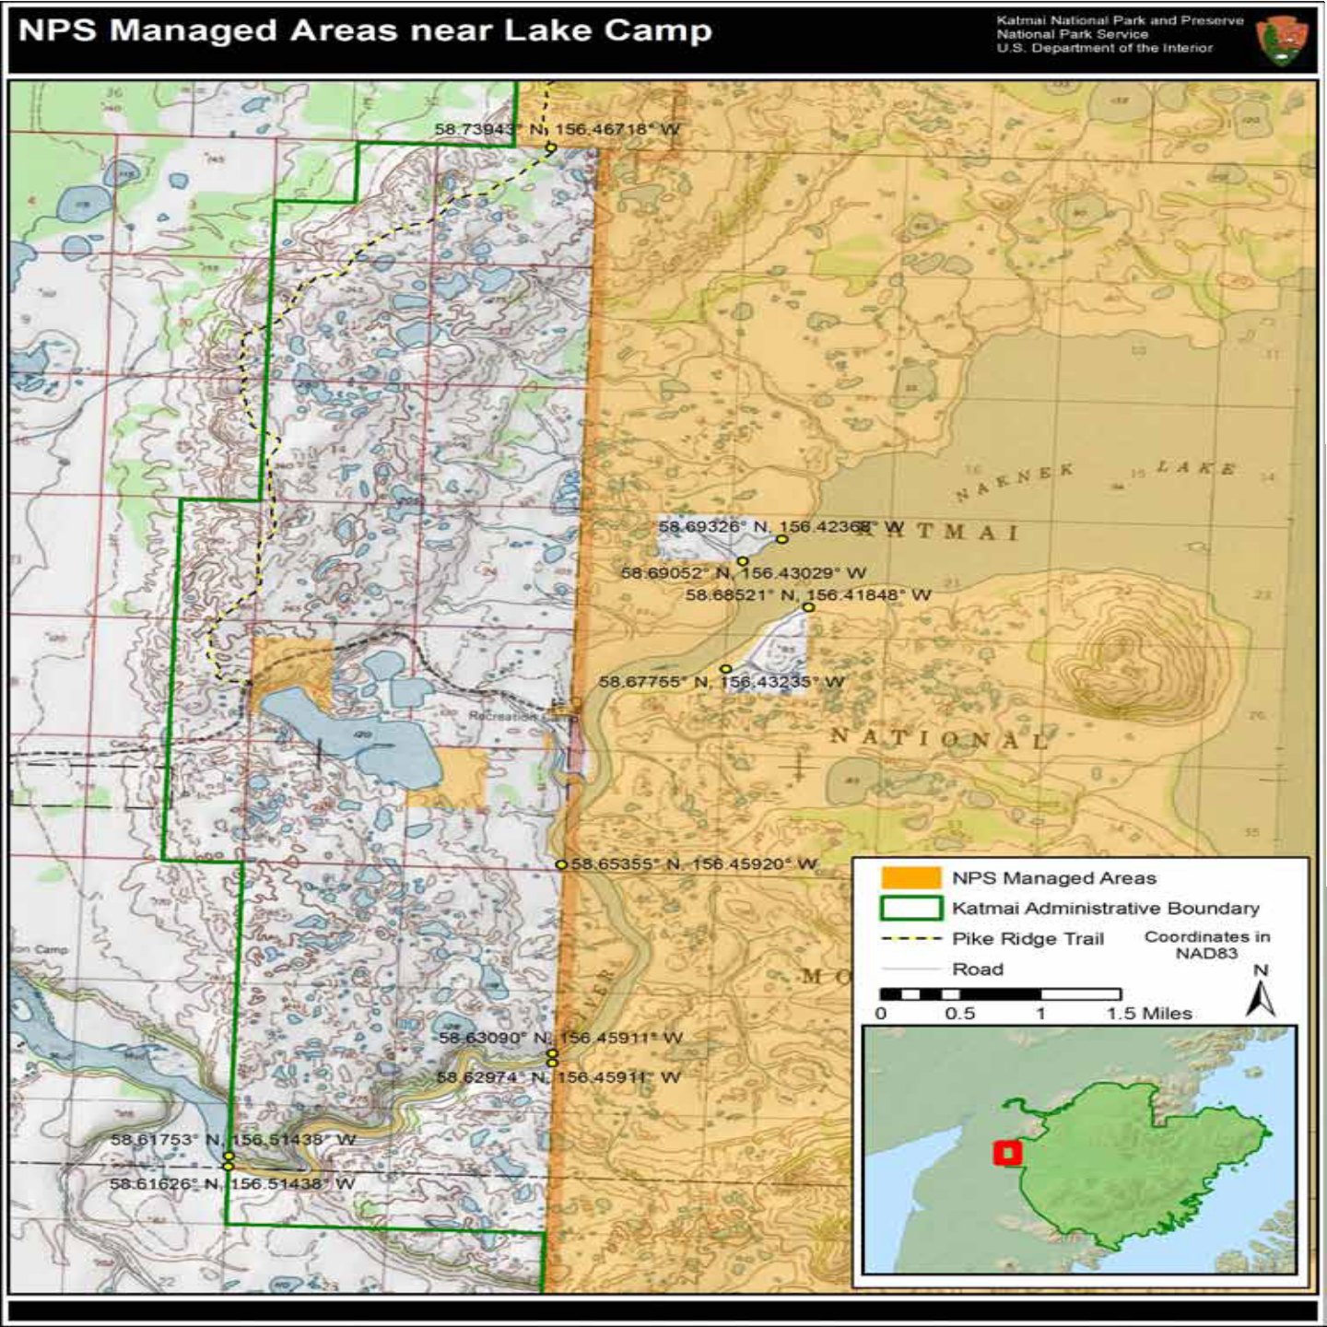
Lake Camp Boundary Map

13 Katmai Regulations Summary

Lake Camp Boat Launching Facilities:

Lake Camp is located 9 miles east of King Salmon and is accessed via the Lake Camp Road or from other portions of the Naknek River via boat.

Boundary:
The map on page 13 references the boundaries of Katmai National Park and Preserve. Note that the boundary of the park (green line) encompasses Naknek Lake and extends down on the Naknek River to a portion below the Alaska Fish and Game “fish counter”.

The NPS recognizes jurisdiction on the waters from Naknek Lake to the end of the orange color highlight at the park’s legislative boundary (green line). This jurisdiction includes the enforcement of fishing, commercial business operations, hunting and trapping, boating, and public use regulations within the highlighted areas.

Prohibitions:
Along this stretch of the Naknek River contiuing into Naknek Lake the following acts are prohibited:

- Hunting and trapping while on Park owned lands or in/upon waters within the boundaries of Katmai National Park. Non-federal, private or Native Lands within the Park boundary are not subject to these prohibitions.

- Commercial operations including guided fishing and boating trips without a Commercial Use Authorization permit issued by the National Park Service. For information on how to obtain a permit see page 5.

- Commercial fishing in or on the waters within the boundaries of Katmai National Park.

- Subsistence fishing, hunting and gathering is prohibited on all lands and waters of Katmai National Park (see page 15 for information on Traditional Red Fishery).

Sportfishing:
Sportfishing is in accordance with Alaska State regulations and also federal law. The following sportfishing regulations apply:

A valid Alaska State issued sportfishing license is required and must be in the angler’s possession while fishing. The use or possession of bait and or the practice of chumming is strictly prohibited. Sportfishing in fresh waters is by hook and line, with the rod or line being closely attended. Continuing to engage in fishing within 50 yards of a bear is prohibited. Yield the right of way to bears when practical.

In all flowing waters upstream from an ADF&G regulatory marker located 1/2 mile upstream of Rapids Camp, including all waters within 1/4 mile of all lake inlet and outlet streams, only unbaited, single hook, artificial lures may be used year-round.

Closures: Naknek River from ADF & G markers located 1/2 mile above Rapids Camp, upstream to ADF&G markers at Trefon’s Cab- in at the outlet of Naknek Lake. This section is closed to all sport fishing April 10-June 7.

From ½ mile upstream above Rapids Camp to Trefon’s Cabin at the outlet of Naknek Lake: Only unbaited, single-hook, artificial lures with a gap between the point and shank of 1/2 inch or less are allowed from March 1-April 9 and from June 8-July 31. For the remainder of the year, only unbaited single- hook artificial lures may be u s e d .

Be sure to check the Alaska Sportfishing Regulations Summary for the most updated information on bag limits, means, and methods.

You may fish from the dock at Lake Camp however, you may not fish from nor trespass upon any boats that are not yours. Do not bleed, gut or fillet fish on the docks or boats.
Lake Camp Boat Launching and Parking: Leaving a boat, trailer, or vehicle unattended for more than 72 hours at the facilities associated with the Lake Camp launching ramp is prohibited without authorization from the Superintendent. Leaving a boat unattended at the Lake Camp dock is prohibited.

Operating a vessel above a flat wake speed within 100’ of the launch facilities and docks at Lake Camp is prohibited.

Fires are permitted only within the designated receptacles (the grills located near the out- house). All fires must be closely attended to and fully extinguished after use.

A permit is required for the use of any passenger vehicle with an 11-foot wheel base and trailer of more than 20-feet, or vehicle/ trailer combination when the vehicle has over a 12-foot wheelbase at the Lake Camp facility.

The Lake Camp access road and ramp were designed for a passenger vehicle with maximum 11-foot wheel base and trailer of no more than 20-feet. Any vehicle with a wheel base of over 12-feet will reportedly have trouble making the turn. Requiring permits for vehicles and/or trailers exceeding the stated measurements allow the park to control the time, place and manner of use while ensuring resource protection, personal safety, and full public access to the boat launching facility. Permits may be obtained by contacing the Chief Ranger at 907-246-3305 at least two weeks prior to needing the permit.

Boating Regulations:
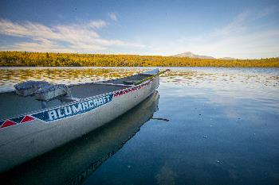
For boating regulations, please see page 17 for more information on requirements and required safety gear.

Specific Regulations for Naknek Lake:

Naknek Lake is the Alaska Peninsula’s third largest lake next to Lake Iliamna and Becharof Lake. It is accessible via the Lake Camp Boat Launch or by boating up the Naknek River from King Salmon. Float planes also access this area. During the winter months, when the lake is frozen and there is sufficient snow cover, visitors may access this area via snowmachines, snowshoeing, skiing, hiking, or dogsledding.

The Naknek Lake area provides an abundance of sportfishing opportunities, wilderness camping, and winter recreation opportunities.

Sportfishing is in accordance with regulations.

Hunting and subsistence uses are prohibited in the Naknek Lake and Naknek River areas within the park boundary. This includes gull egg collecting, waterfowl hunting, and subistence fishing.

Bear Resistant Containers: the use of Bear Resistant Containers (BRCs) is mandatory. Food and beverages, food and beverage containers, garbage, harvested fish and equipment used to cook or store food must be stored in a (BRC) or secured within a hard sided building; within lockable and hard sided section of a vehicle, vessel, or aircraft. Food that is being transported, consumed, or prepared does not need to be in a BRC.
BRCs are available free for use on a first come first serve basis at the King Salmon and Brooks Camp Visitor Centers.

Fure’s Cabin is located in the northeast corner of Naknek Lake in the Bay of Islands and is a public use cabin. Reservations are required and are made by contacting Park headquarters. The use of this cabin is for non-commercial purposes only.
Water skiing is prohibited on all park waters. Wildlife harassment and feeding:
Do not feed any wildlife. If you find wildlife that has been fed or cubs that are by themselves please report it to park headquarters at 907-246-3305 and you should leave the area to find another place to camp.

Be aware that bears frequent the areas including beaches and swim in the lakes from island to island. Keep your distance from them, at least 50 yards. Sows with cubs will often leave their cubs on shore while they fish in the lake. Stay aware of your surroundings.

Motorboats are allowed in the wilderness; however, generators and chainsaws are not allowed in areas that are managed as Wilderness. This includes the Bay of Islands area.

Keep a clean camp. Several different users utilize the beaches and island areas.
Ensure that you are disposing of human waste properly (remove as trash or bury in individual one time use cat-holes dug at least 100 feet from any water source and no more than 6 inches deep. All toilet paper and other sanitary products must be removed. ) If possible, bring in a portable toilet or container/bag to use and pack it and its waste out.

Boating and Safety:
See page 17 for Boating requirements. Boating under the influence (BUI) is strictly enforced on Naknek Lake. For the safety of you and passengers, do not operate a vessel under the influence of drugs or alcohol.

The lighting and maintaining of personal campfires is allowed; however, they must not be more than 2 feet in diameter. All campfires must be closely attended to and fully extinguished after use.

Only dead and downed wood may be collected for campfire use.

Before departing, make sure your camp is clean or cleaner than when you arrived. Do not leave anything behind such as chairs, shovels, boats, plywood, etc. Dirty sites endanger wildlife and other visitors, discouraging public use.

Please help us keep the area pristine for future visitors.

Traditional Red Fishery in the Naknek Lake Area:

Katmai National Park is closed to subsistence hunting and gathering. The traditional red fish harvest that is congressionally mandated to allow local residents who are descendants of Katmai residents who lived in the Naknek Lake and River Drainage will continue based upon established seasons, methods, and means. This fishery is not a Title VIII subsistence activity pursuant to ANILCA.

Seasons for the take of redfish by other than hook and line are set by the Alaska Department of Fish and Game as posted in the Subsistence and Personal Use
Statewide Fishing Regulations booklet. Qualified persons must obtain authorization directly from Katmai National Park in coordination with local village councils to partake in redfish collection under this regulation. This activity is not open to all Alaska residents who qualify under state subsistence laws.

The 2012 Katmai National Park Compendium established a protocol by which the local village councils of King Salmon, Naknek, and South Naknek will assist the Superintendent
in the identification of authorized persons. Persons interested in partaking in the traditional harvest of redfish should consult directly with their native council and the Chief Ranger for Katmai National Park, available by phone at 907-246-3305.

- Katmai Regulations Summary

Subsistence Uses:
The Alaska National Interest Lands Conservation Act (ANILCA), adopted on December 2, 1980 mandates that some key activities necessary to perpetuate the rural Alaskan lifestyle, such as subsistence uses, traditional uses, access, cabins, and hunting and trapping be allowed to occur. Providing for ANILCA’s mandates and special uses makes management of Alaska parks unique within the National Park System.
Katmai National Preserve, Aniakchak National Monument and Preserve, and the Alagnak Wild River are all managed and may allow for subsistence uses, hunting, natural re- source collection and other uses as provided for by ANILCA.

The use of aircraft and ATV/UTV’s for subsistence hunting is prohibited.

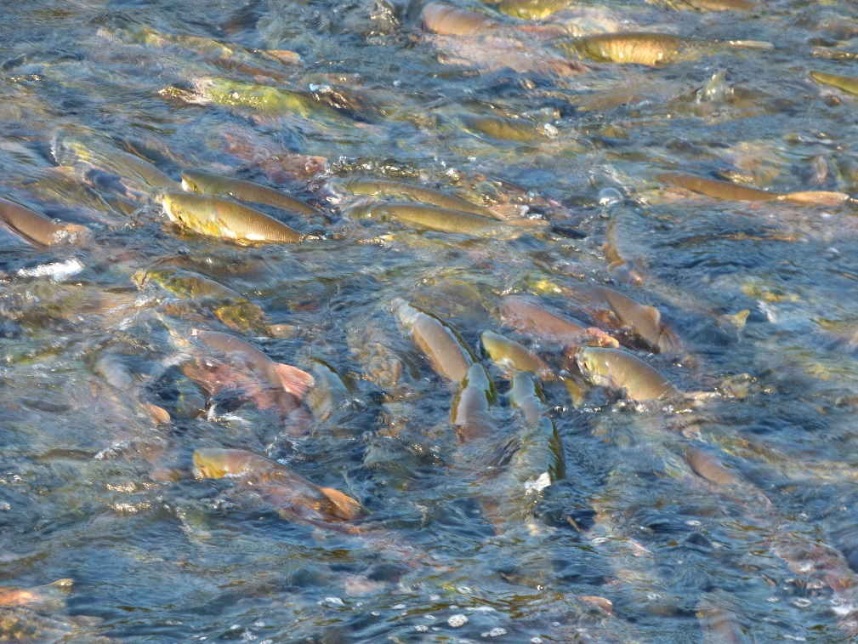
For the authorized federal subsistence brown bear hunt in Game Unit 9C, a permit is required and can be obtained online at http://alaska.fws.gov/asm/fsps.cfml

Please consult the Subsistence Management Regulations for the Harvest of Wildlife on Federal Public Lands in Alaska and the Subsistence Management Regulations for the Harvest of Fish and Shellfish on Federal Public Lands and Waters in Alaska for further information on dates, seasons, means
and methods, and permit requirements.

Spotlight: Drone Use

There has been dramatic growth throughout the United States in the numbers and use of unmanned aircraft during recent years. “Unmanned aircraft” is defined as a device that is used or intended to be used for flight in the air without the possibility of direct human intervention from within or on the device. This term includes all types of devices that meet this definition (e.g., model airplanes, quadcopters, drones) that are used for any purpose, including for recreation or commerce. In some cases, their use has resulted in noise and nuisance complaints from park visitors, park visitor safety concerns, and one documented incident in which park wildlife were harassed. Small drones have crashed in geysers in Yellowstone National Park, attempted to land on the features of Mount Rushmore National Memorial, been lost over the edge of the Grand Canyon, and been stopped from flying in Prohibited Airspace over the Mall in Washington DC. Policy Memorandum 14-05, released by the National Park Service (NPS) director in June 2014, directed each superintendent to use the authority under 36 CFR 1.5 to prohibit the launching, landing, or operation of unmanned aircraft, subject to the certain conditions and exceptions set forth in the memo. This is still in force with very few exceptions. This action applies to the launching, landing, and operation of unmanned aircraft on lands and waters administered by the NPS. Jurisdiction by the NPS ends at the park boundary. The policy memorandum does not modify any requirement imposed by the Federal Aviation Administration (FAA) on the use or operation of unmanned aircraft in the National Airspace System.

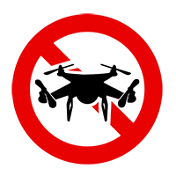

Why did the NPS restrict unmanned aircraft?
The National Park Service embraces many activities in national parks because they enhance visitor experiences with the iconic natural, historic and cultural landscapes in our care. However, due to serious concerns about the negative impact that flying unmanned aircraft can have for safety of visitors, staff, and wildlife, they have been restricted in all but a few parks.

- Katmai Regulations Summary

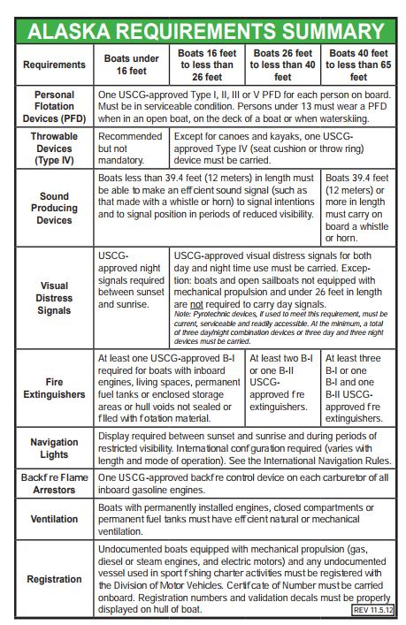
Boating Information:
Vessels operating in waters within the boundaries of Katmai must be in accordance with United States Coast Guard (USCG) and Alaska State regulations. All motor boats must be currently registered and all safety gear carried and used in accordance with size and operations. Vessels capable of discharge must be able to show that the system has been made inoperable.

If you are involved in a boating accident with injuries or spills of any kind, you must immediately report that incident to the Katmai Chief Ranger at Katmai National Park at 907- 246-3305 after taking any life saving measures.

Before you go boating, file a float plan with someone you trust who can be your contact person when you return. If you are overdue, that contact person should know the following information to give to searchers: departure time and expected return time, type and description of vessel and number and age of occupants, boating experience and knowledge of waters that they are boating in.

Before boating, ensure your vessel is fully operational and verify you have all of the required safety devices.

If you are planning to travel by boat to Brooks Camp, be sure to prepare your personal items in advance. Items such as coolers, PFD’s, packs, and other loose items may not be left unattended in boats along the beach. Please make plans to have secure storage for these items or utilize the equipment and food caches provided to the public at Brooks Camp to prevent violations of the unattended property regulations.

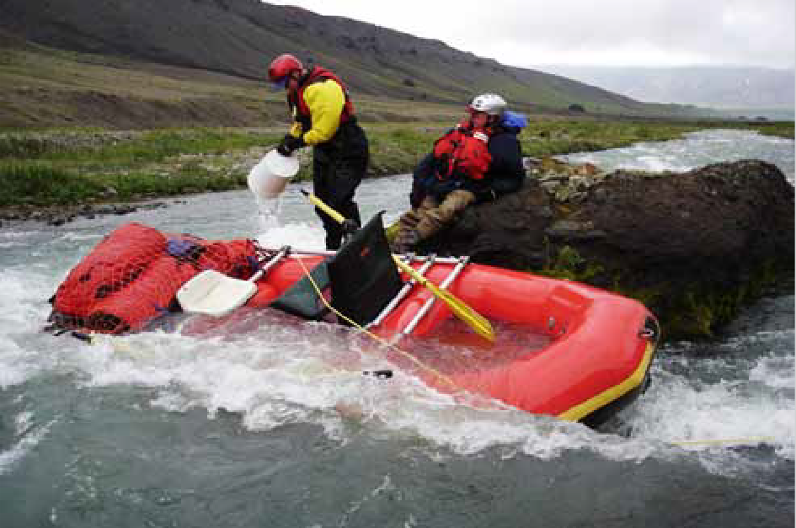

Boating and Cold Water Survival

Note: if you are a commercial business operator, additional regulations and certifications apply please contact Katmai Headquarters for more information.

Information for this page has been provided by: http://dnr.alaska.gov/parks/boating/

It has us surrounded! Alaska has over 33,000 miles of coastline and an abundance of lakes and rivers. For many of us in Alaska, the water is our highway, our playground, our work site, and our food supply.

Unfortunately, Alaska also has one of the highest non-commercial boating fatality rates in the nation. In Alaska drowning is the second leading cause of accidental death.

Accident statistics reveal that 3 out of 4 boating fatalities were the result of capsizing or falling overboard into cold water, where the boater was not wearing a life jacket.

Accidents don’t just happen. They are predictable and, therefore, avoidable. It just takes a moment to fall in the water. Without a PFD, you can quickly get into an emergency situation. Wear your PFD!

Katmai Regulations Summary 17

National Park Service
U.S. Department of the Interior

Katmai National Park and Preserve Alagnak Wild River
Aniakchak National Monument and Preserve
Post Office Box 7
King Salmon, AK 99613

EXPERIENCE YOUR AMERICA™

Wilderness Travel in Aircraft

This publication and its associated maps are to be used as a reference only, and is not complete in its entirety. This edition is dated February 1, 2018.

Editor
Jordan Neumann

Chief Ranger
Jason Lux

NPS Photographers
Anela Ramos
Jordan Neumann

Comments? Write to:
Chief Ranger
Katmai National Park and Preserve PO Box 7
King Salmon, AK 99613

Katmai Regulations Summary 18
Emergency Locator Transmitters or ELTs are devices located in aircraft that may be activated in the event of an aircraft accident or incident. Once activated, ELTs send out a signal to request an emergency response from Search and Rescue (SAR) agencies. In essence, this is like dialing “911”.

There are two types of frequencies used in these devices; the new standard of 406 MHz (megahertz) and the older standard of 121.5 MHz that transmit information to satellites in the event of an emergency. The devices that use the 406 MHz frequency are much more reliable and provide for almost an instantaneous response from SAR agencies.

As of February 1, 2009, the federal government no longer monitors the 121.5 MHz frequency with satellites because of the large number of 121.5 MHz ELT false alerts and the lack of a quick means of verifying the
actual status of an activated 121.5 MHz.

If you are travelling in small aircraft, the Federal Aviation Administration (FAA) and the National Park Service have not required but highly recommend that aircraft switch over to the new standard of ELTs, the 406 MHz frequency.

We recommend you check with the company you are flying with prior to travel and ensure that they have the new 406 MHz ELT installed on the aircraft. The old 121.5 MHz ELTs will provide extremely limited assistance if an aircraft crashes, especially in a remote location.

