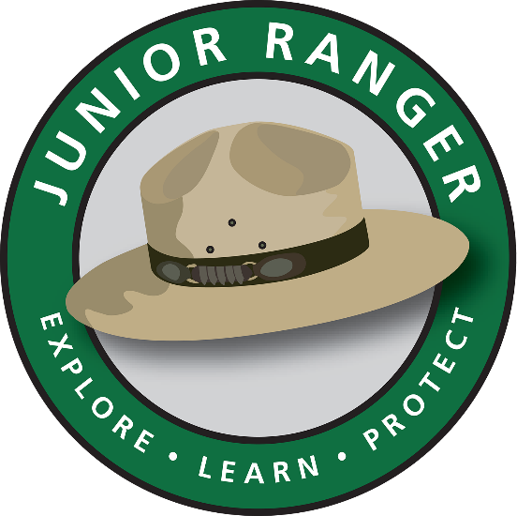
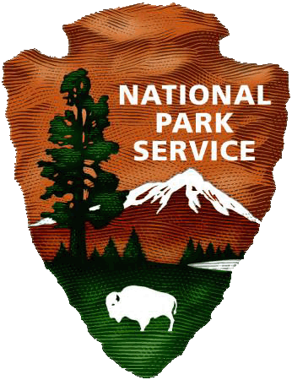
THIS CERTIFIES THAT

(your name)
HAS BECOME A
KALAUPAPA NATIONAL HISTORIC PARK JUNIOR RANGER
Date:________________
Junior Ranger Signature:__________________________________
Ka ‘ōlelo ho‘ohiki o ke kia‘i ‘ōpio:
- E kōkua mai e mālama i nā mea o Kalaupapa
i ka ‘āhiu a me ka nani.
Lōkahi
- E mahalo nō i nā lā‘au a me nā
holoholona.
Mālama ‘Āina
- E ha‘i ma ka hoaloha a me ka ‘ohana i nā
mea i a‘o ‘ia.
Alu like mai
- E a‘o i nā mea maoli i kokoke ma ko‘u hale
a me ke kia‘i ‘ana i nā mea.
Laulima
- E lilo me kekahi papakuhikuhi kia‘i ‘ōpio.

I pledge to:
- Help keep Kalaupapa wild and beautiful.
Lōkahi
- Respect the plants and animals.
Mālama ‘Aina
- Tell my friends and family what I learned.
Alu like mai
- Learn about native species near my home and help protect them.
Laulima
- Get involved in other Junior Ranger programs.

