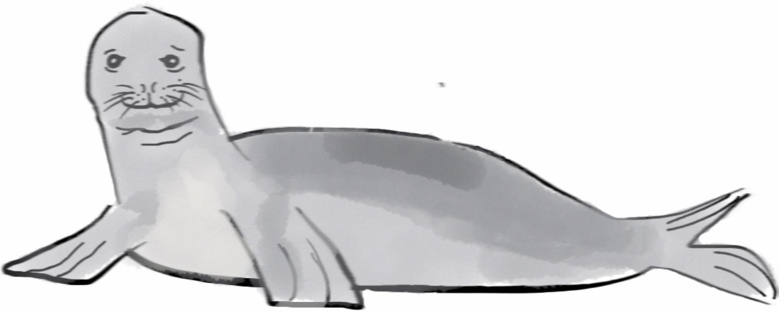

2.
Add a circle above the body for a head.

4.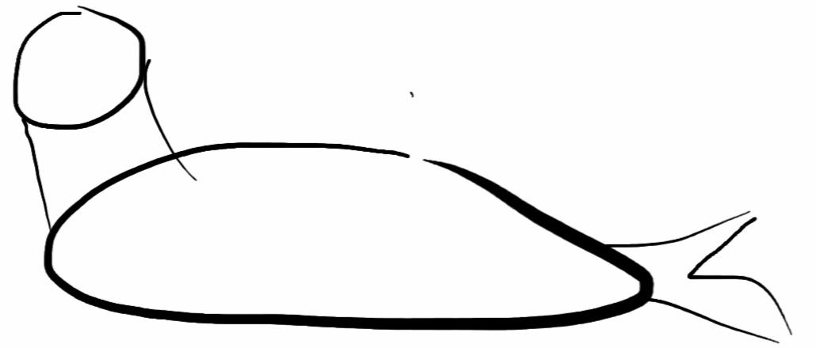
Connect the head to the body.

6.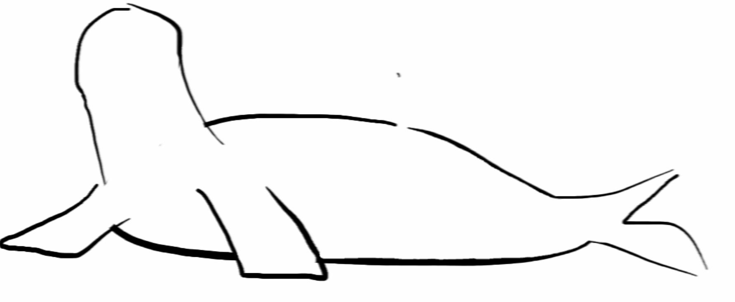
Now erase extra lines inside the body.

8.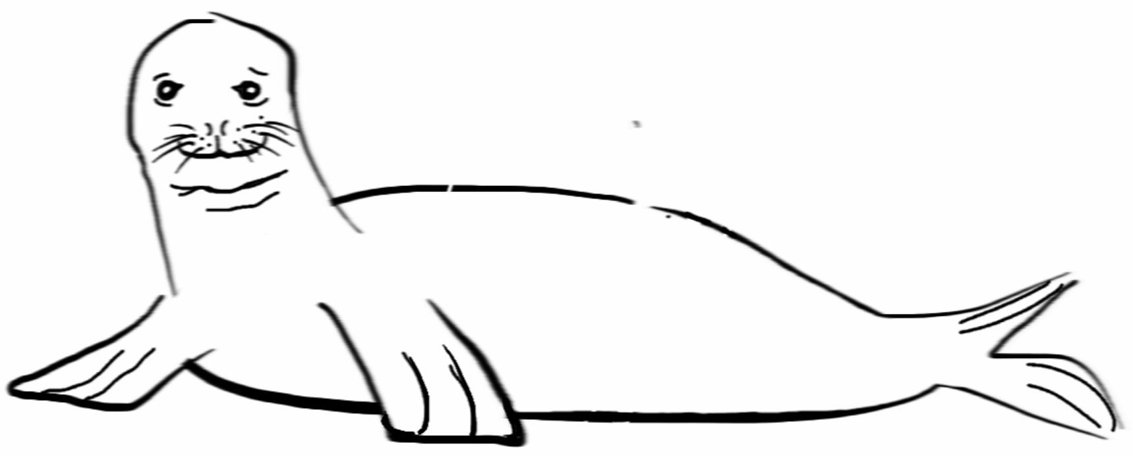
Draw in some extra lines on the flippers and tail. And add some skin under the chin.

1.
Start by drawing a long oval. Draw lightly
or with pencil so you can erase later!

3. 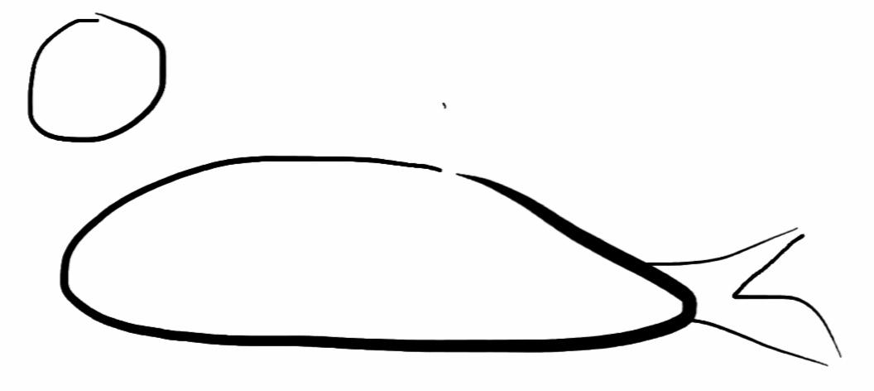
Draw a sideways “M” shape for the tail.

5.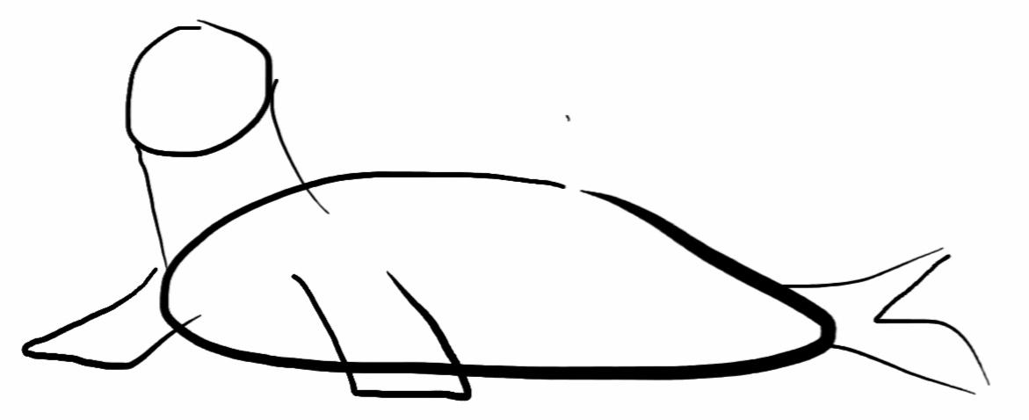
Add two rectangular shapes for flippers.

7.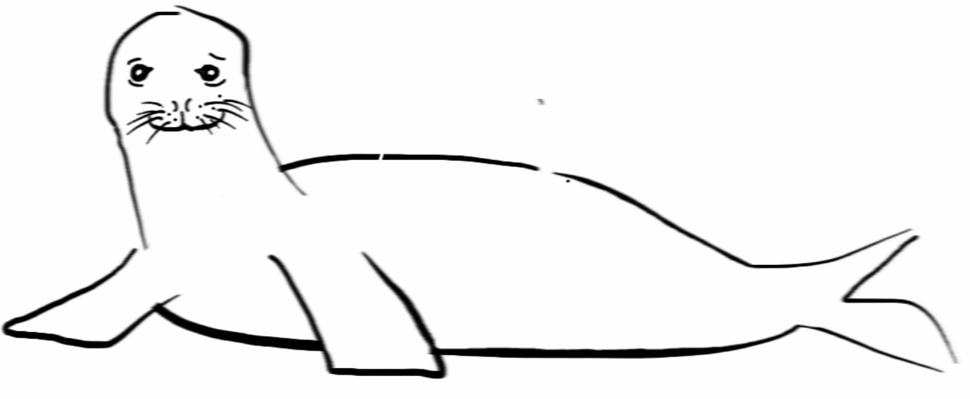
Add some details for the face. Draw eyes,
whiskers and a mouth!

9.
Now have fun adding color. Don’t forget to
give it a name!

