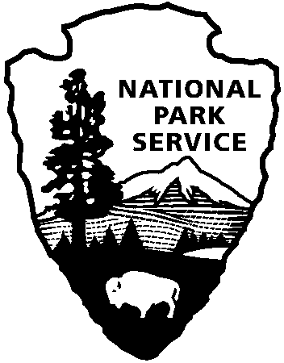
National Park Service
U.S. Department of the Interior
Joshua Tree National Park
Education Office
9800 Black Rock Canyon Rd.
Yucca Valley, CA 92284

760-367-3012
jotr_education@nps.gov

Virtual Field Trip Request Form
How to use this form:
- Download the request form
- Fill out the form by clicking on each fillable box or use the drop-down arrow
*please request time in Pacific Time zone*
- Use Save-As to save document with new name
- Email document to jotr_education@nps.gov

Contact Information
Contact Name: Teacher/Contact Name(s)
Email: Email Address
Location: Location (City/State/Country)
Time Zone: Your Time Zone (i.e. Eastern, Central, Pacific, Mountain, Hawaiian, Alaskan)
Preferred Virtual Platform: i.e. Zoom, Google Meet, Microsoft Teams, Skype, etc.

Date & Time Options
1st choice | 2nd choice | 3rd choice
preferred date #1 | preferred date #2 | preferred date #3
*time option #1 in pacific time | *time option #2 in pacific time | *time option #3 in pacific time

*pacific time (PT) is 3 hours behind eastern time, 2 hours behind central time, and 1 hour behind mountain time, 3 hours ahead Hawaii time, and varies with Alaskan time*
We follow daylight savings from mid-March – mid-November.
*International: UTC -7[PDT] mid-March – early November or UTC -8[PST] early November – mid March*

Student Information
Student Grade: student grade
Number of Participants: number of participants

Program Request
Program choices | Other: please specify other | How did you find us? Other: please specify
Comments
Accessibility: | ex: Do your students need specific accommodations?
Comments: | ex: Would like more than one program? Teacher’s goals?

