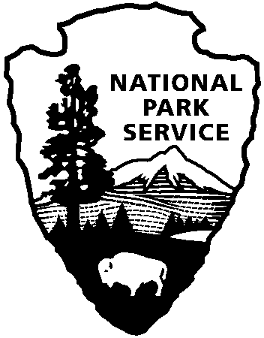
9800 Black Rock Canyon Rd.
Yucca Valley, CA 92284

For questions:
760-367-3012
jotr_education@nps.gov
Joshua Tree National Park
Education Office
National Park Service
U.S. Department of the Interior

Field Trip Reservation Request

Directions:

download document, complete and save, email the completed copy to: jotr_education@nps.gov

Teacher Contact: teacher name Email: teacher email Cell phone: teacher cell

School Name: school name

School Address: school address School Phone: phone number
Participating Teachers: names of participating teachers

*Most program locations can accommodate one school bus (two classes per bus). If you plan on bringing two busses, you may need two days for your field trip. Park staff will work with you to schedule that extra day from the dates you provide below.
*Keys to the Past at Keys Ranch is limited to one class per day (25-30 participants total)

Date: 1st Choice: mm/dd/yy 2nd Choice: mm/dd/yy 3rd Choice: mm/dd/yy

Program Requested: Program Title, select from updated list on website
Grade: grade level Number of Classes: total # Number of Students: total #
Number of Chaperones: 10:1 ratio requested

Arrival Time at Park: time
Special Accommodations Needed: comments

OFFICIAL USE ONLY
Date Received
Added to Calendar
Confirmation Created
Confirmation Emailed
Notified Staff
*Transportation subsidies are available. Please complete a “Transportation Funding Request” and submit it with this form. Bus funding is NOT GUARANTEED and will not be provided without an accompanying Transportation Funding Request. Subsidies are dispersed on a first come-first served basis until all funds are exhausted.

