Jefferson National
Expansion Memorial
11 North 4th Street
St. Louis MO 63102
www.nps.gov/jeff

314-655-1600 phone
314-655-1641 fax
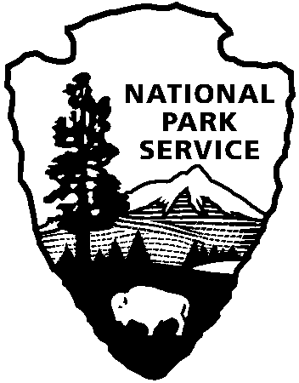
National Park Service
U.S. Department of the Interior
Press Release

Release date:

Contact(s):
Phone number:
Date:

Immediate

Ann Honious
314 655-1634
7-1-2011
National Park Commemorates Westward Expansion from St. Louis

Jefferson National Expansion Memorial in downtown St. Louis, Missouri, is a 90.96-acre unit of the National Park Service, consisting of the Gateway Arch, the Old Courthouse, and landscaped grounds surrounding both buildings. The Memorial marks St. Louis’ role in the westward expansion of the United States during the nineteenth century. It commemorates Thomas Jefferson, whose vision opened the West; the inhabitants of the West who helped shape its history; and Dred and Harriet Scott who sued for their freedom in the Old Courthouse.

Under the terms of the 1916 Organic Act, the National Park Service preserves and presents the following resources at this park:
- The Gateway Arch—an inspirational, transcendent symbol of national identity—and its designed landscape, which together are exemplars of mid-20th-century Modern design.
- The Old Courthouse, site of the Dred Scott case; testament to the value of civil rights, citizenship, and freedom; and exemplar of mid-19th-century civic architecture.
- The museum objects and archival records in the park’s collection, which demonstrate the history of United States westward expansion to a worldwide audience.

Jefferson National Expansion Memorial was established in 1935 by executive order of President Franklin D. Roosevelt. He directed the Department of the Interior to acquire and develop property along the riverfront in St. Louis. Between 1939 and 1942, 40 square blocks of condemned buildings

page 2
were razed to make way for the Memorial. In 1940, the City of St. Louis deeded the Old Courthouse to the National Park Service and it was incorporated into the Memorial.

During a nationwide competition in 1947-48, architect Eero Saarinen's inspired design for a 630-foot stainless steel arch was chosen as a fitting monument to the spirit of the western pioneers. Groundbreaking for the Gateway Arch occurred in June 1959, and the structure was completed in October 1965 at a total cost of $15 million. The designed landscape and the underground Museum of Westward Expansion were completed during the following 25 years. Legislation in 1984 and 1992 authorized the acquisition of 100 acres of land on the east bank of the Mississippi River, in East St. Louis, Illinois, for which the boundary has yet to be determined and property has yet to be acquired.

In 2009, the National Park Service—in collaboration with local, state, and federal partners— invited public ideas for improving the Memorial. The resulting General Management Plan authorized an international design competition. The winning design proposal, by Michael Van Valkenburgh Associates of New York, lays out changes to the memorial and to adjacent city streets and property that will revitalize downtown St. Louis. A final design is currently being developed, incorporating information from the various government entities, stakeholders and historic preservationists. The plan also encompasses land on the east bank of the river. The improvements are scheduled for completion in October 2015.
# # #

