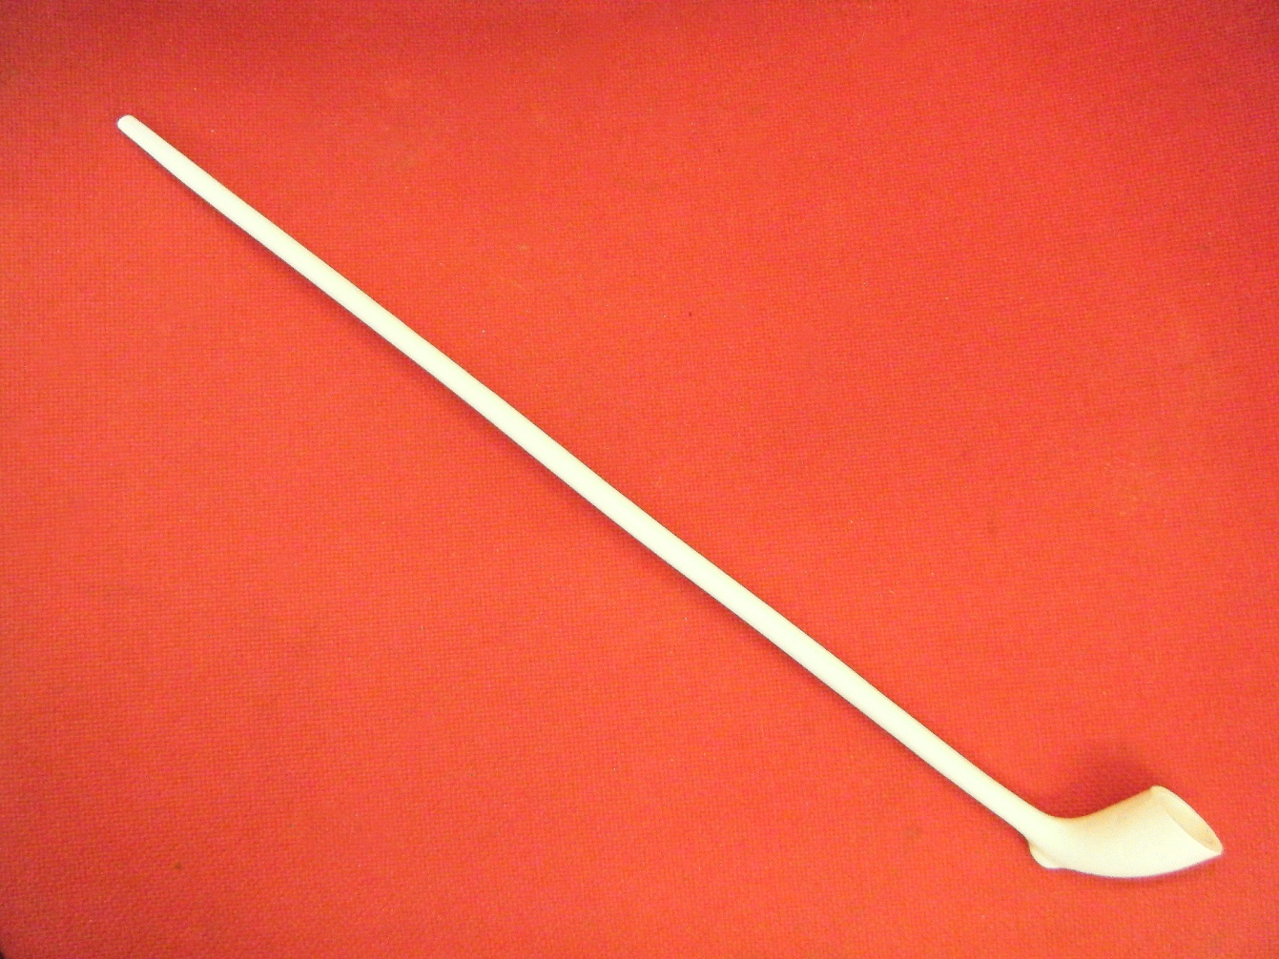
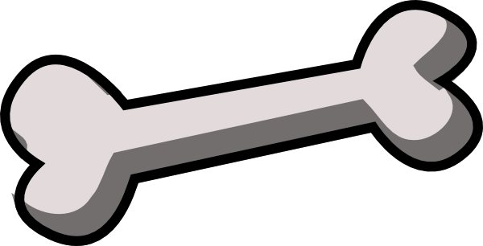
Pipe

Chicken Bone
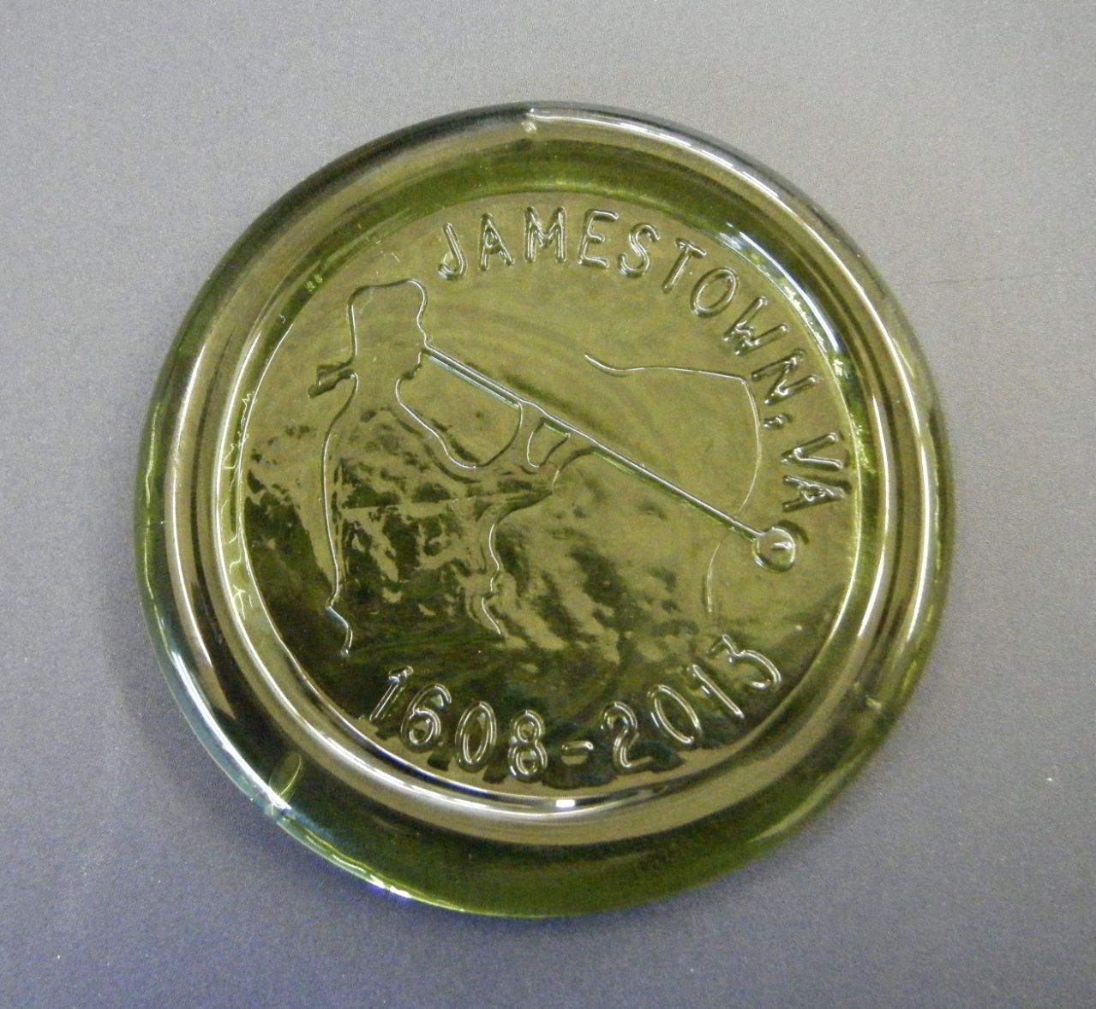
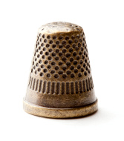
Glass Piece

Thimble
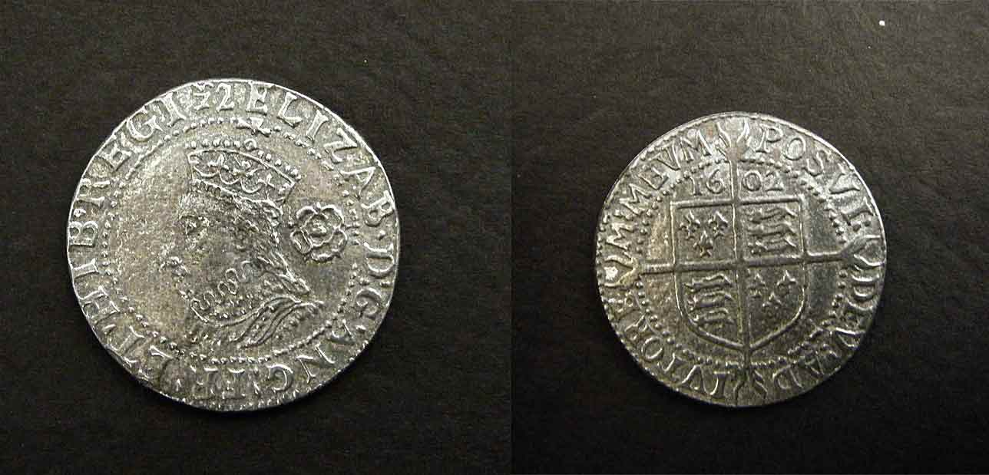
Coin (Six Pence)

Dice
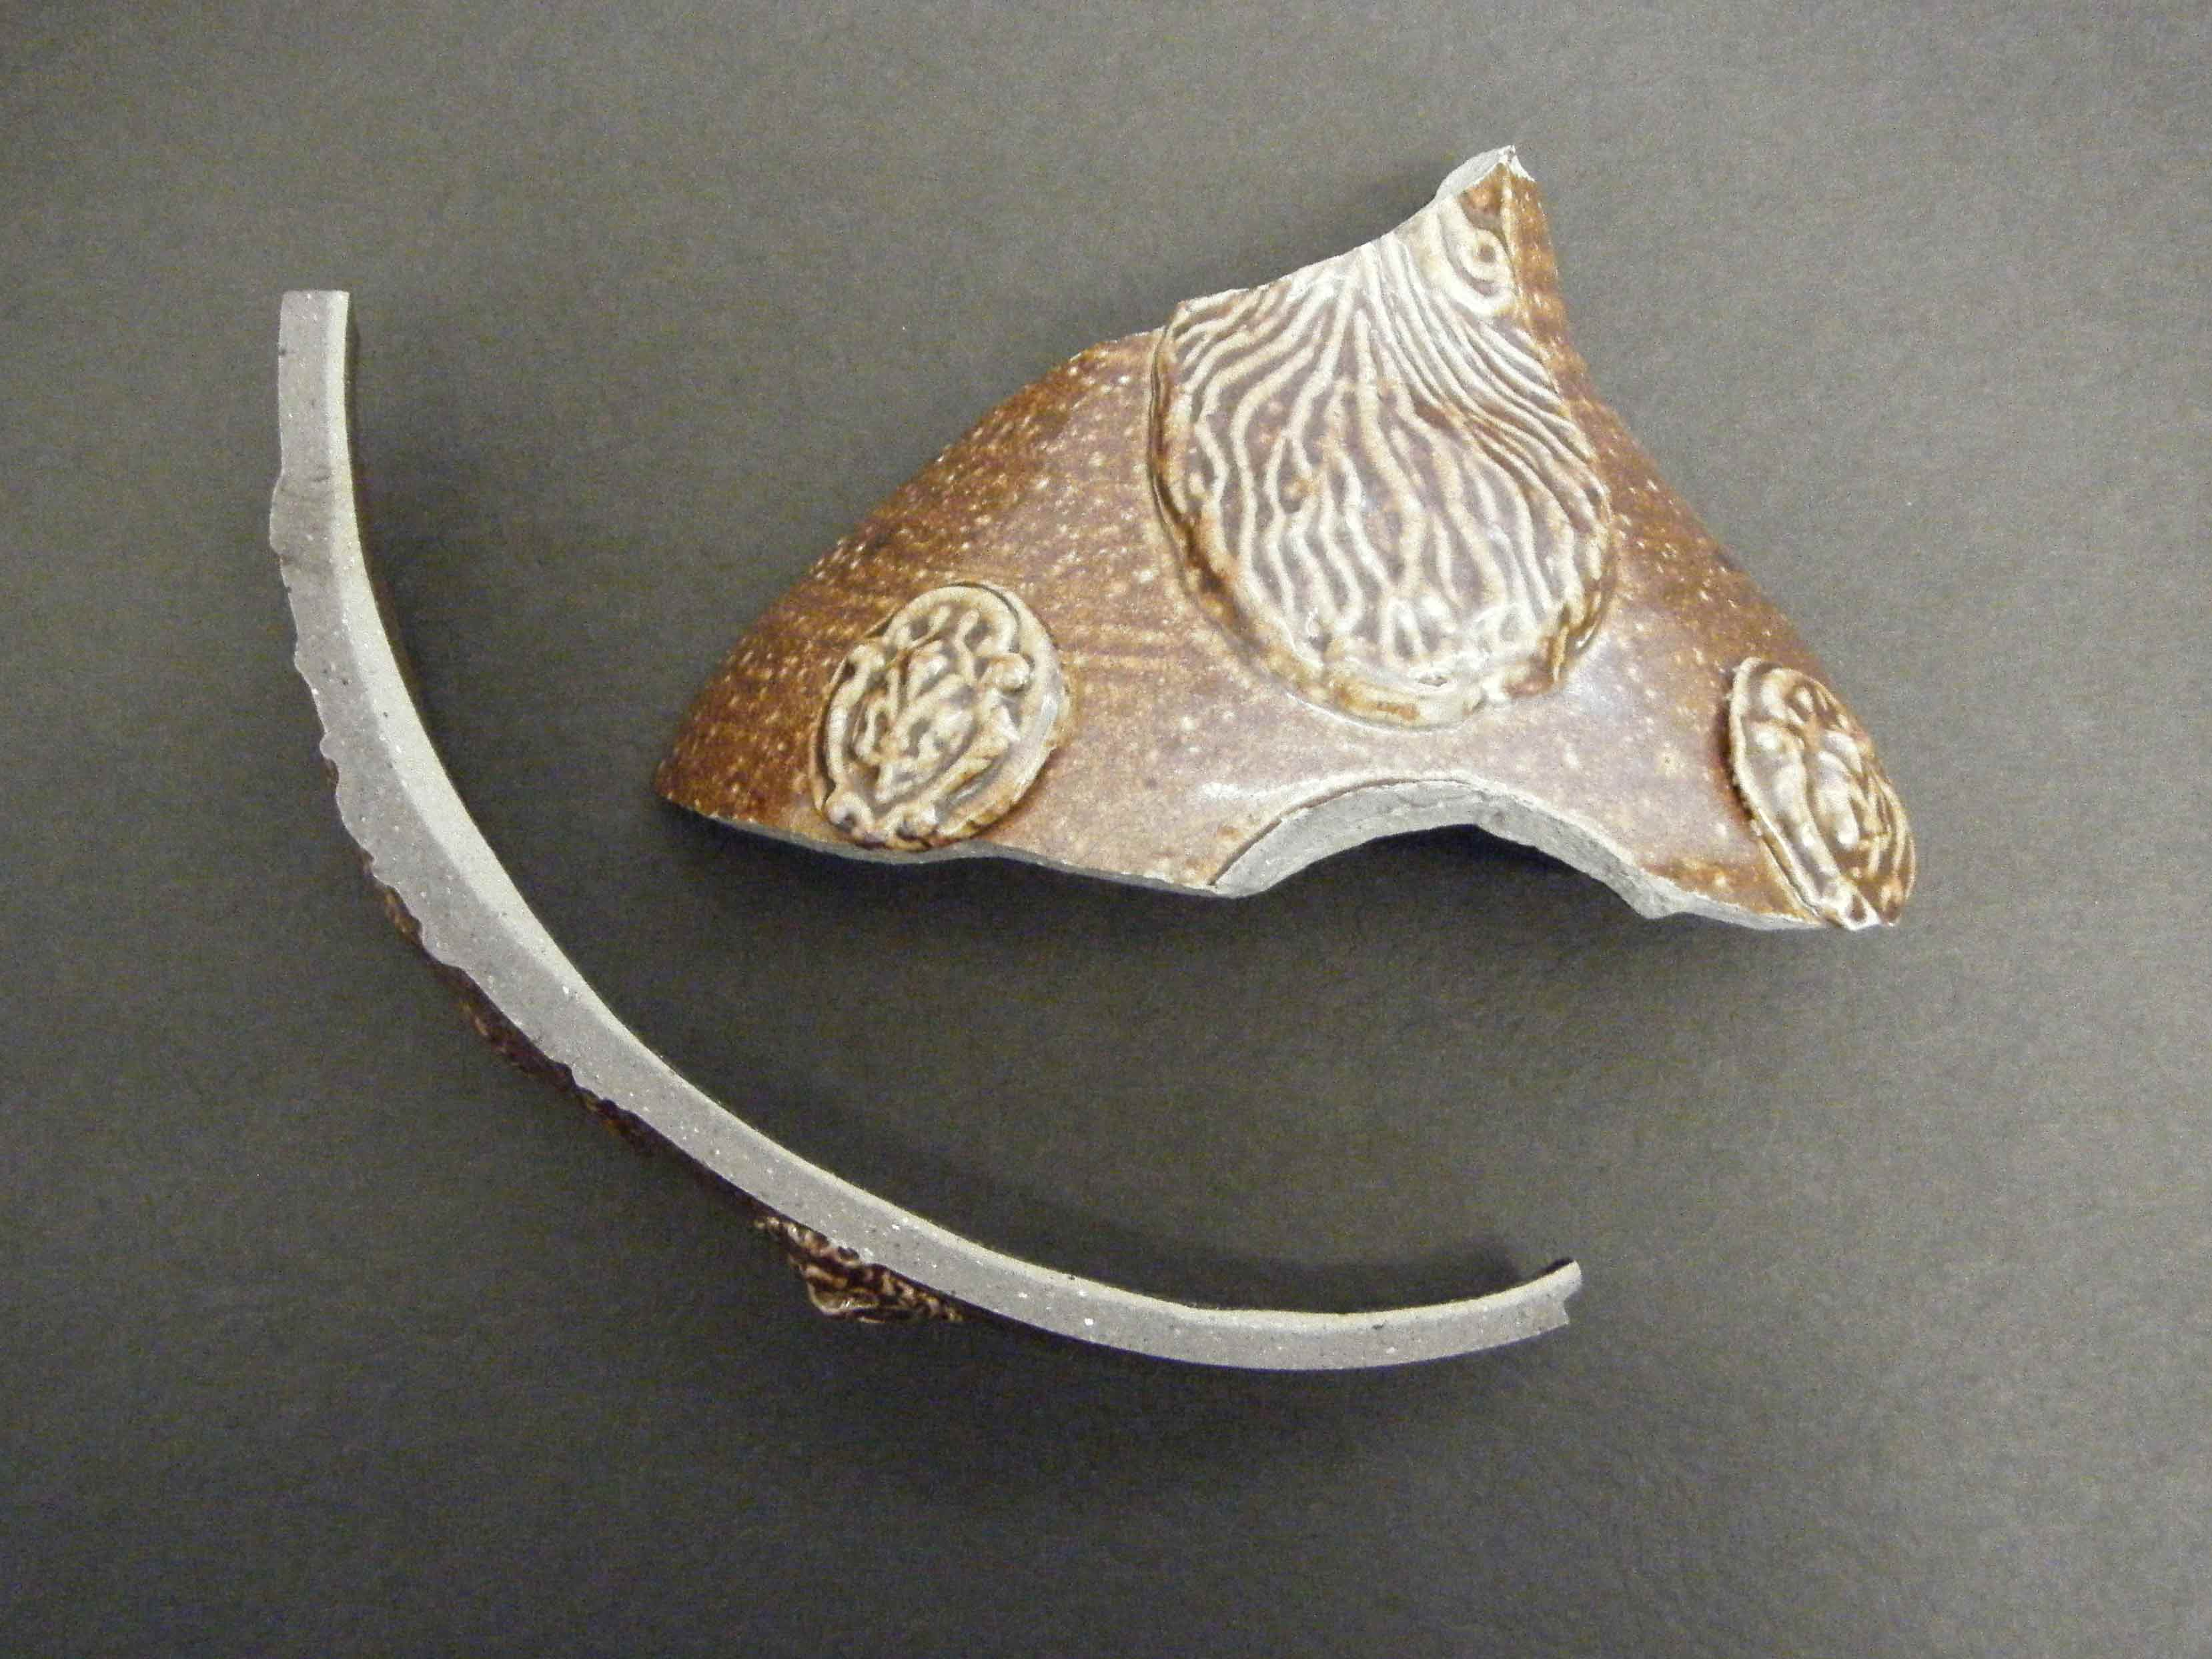
English Pottery Shards

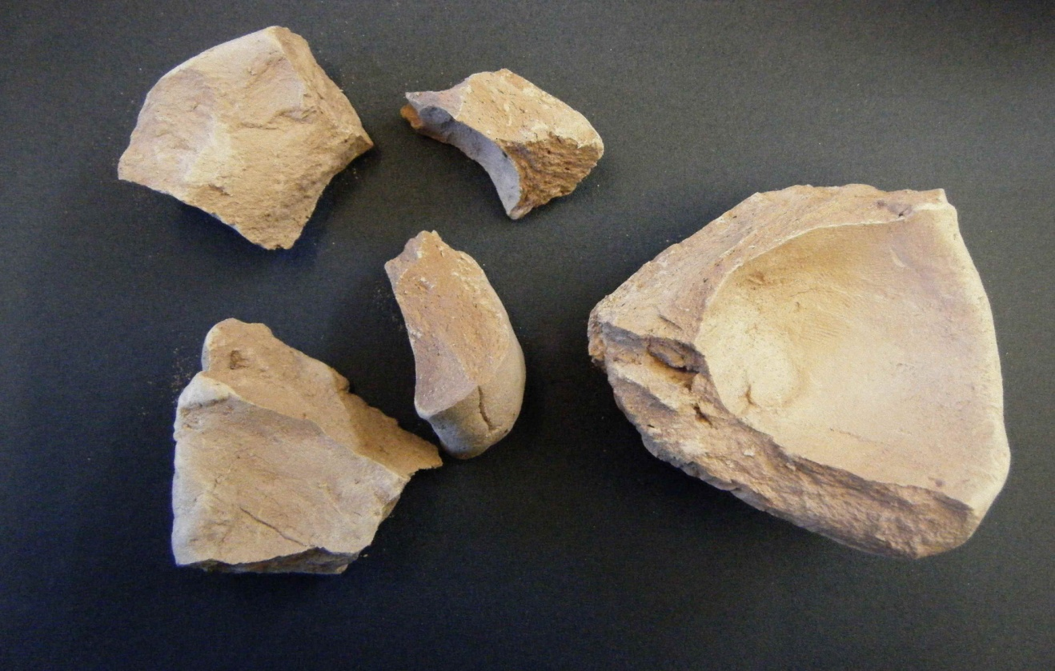
Native American Pottery Shards
Most items are available for purchase at:
Preservation of Virginia
Historic Jamestowne Museum Store
(757)- 856- 1272
http://www.preservationvirgnia.org
(Teachers receive 10% discount with valid ID)

