Introduction to the Asian Carp Traveling Trunk
Creators: Craig Garzella, Anna Jones, & Taylor Livingston
(Thanks for checking me out!)

What’s in the Asian Carp Traveling Trunk?
“Understanding the Threat”
- Important background information to answer the most basic questions about Asian Carp.
- Recommended to read first before starting to engage in the activities.
- 17 pages (p3-19)

Great Lakes Interactive Food Web
- Organisms to place on a wall around the classroom
- 11 Arrows to connect things
- Commence Discussion
- Provide talking points
  - Native fish
  - Invasive fish
  - Limited resources, competition
- If the invasive talk occurs over a week, then start each lesson by adding a bit of the food web to the room. Get the kids brains working.

Bighead and Silver Carp Watch Cards (42)

Bighead and Silver Carp 2D vinyl replicas (rolled)

Biodiversity Word Search & Crossword
The wordsearch and crossword puzzles contain vocab words that will be helpful to know for the rest of the activities in the trunk. Go over these words and give the students the word search before beginning some of the other activities.
These vocab words include:
- Indiana - Home of the Hoosiers and the Indiana Dunes National Lakeshore
- Fishing - A common hobby that is also a way to supply food
- Sand - Ground up rocks on the shores of beaches
- Asian Carp - An invasive species which originated in Asia that could be very harmful to the Great Lakes ecosystems; they were transported here to clean aquaculture and sewage treatment plants
- Water level - Can change based on rainfall
- Bighead - A type of Asian Carp that is highly destructive
- Silver - Type of Asian Carp that jump out of the water when boats pass through
- Huron - The second largest Great Lake, which also contains 30,000 islands
- Lake Michigan - The only Great Lake entirely in the USA
- Ontario - The smallest and easternmost Great Lake that connects to the St. Lawrence Seaway
- Superior - This Great Lake is the largest body of freshwater on Earth
- Biodiversity - The variety of life in the world or in a particular habitat or ecosystem
- Erie - The warmest Great Lake because of its southernmost position
- Vernal Pool - Temporary pools of water that provide habitat for certain plants and animals
- Marram Grass - Stabilizes the dunes so that the sand does not move
- Wetlands - Land consisting of marshes or swamps; saturated land
- Water - You jump into this at the beach; makes up more than 75% of Planet Earth!
- Ecosystem - A biological community of interacting organisms and their physical environment
- Climate - Long term weather that directly influences life
- Dunes - Mounds of sand created by wind and prehistoric glacial activity
- Beaver - Wetland engineer that is responsible for lodges and dams
- Watershed - An area of land whose water sources all collect in the same lake, stream or river
***Here are examples of the wordsearch and crossword puzzles, there is a large green poster with the crossword on it and smaller laminated versions too.
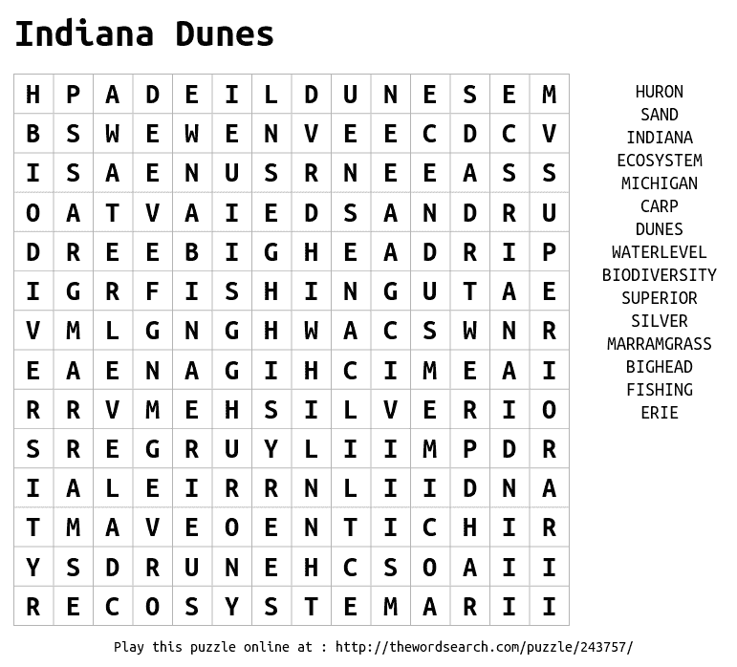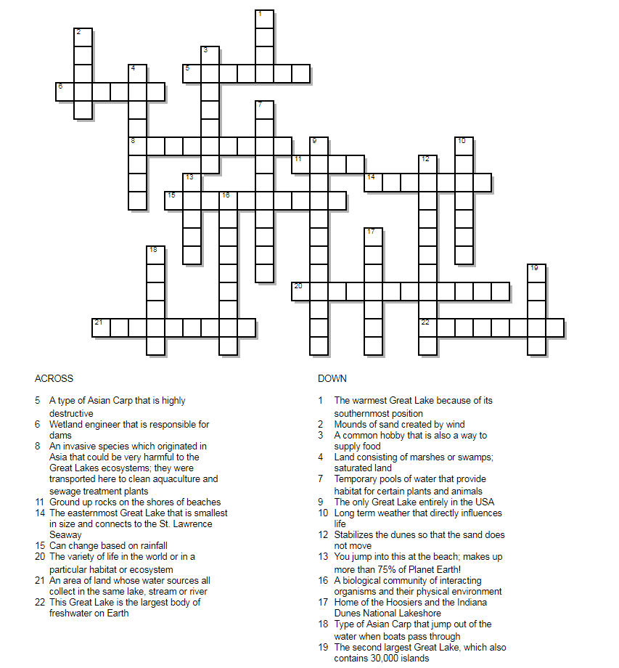
State of the Great Lakes
- Great Lakes & Saint Lawrence Seaway folded poster w/ information
- Great Lakes & Saint Lawrence Seaway flat poster w/ discussion questions
- “State of the Great Lakes 2017 Highlights Report”
  - Everything that impacts this area from industry to invasive species
- Two paper copies of Areas of Concern
- http://www.ijc.org/rel/boards/annex2/aoc_map.html
  - Link to Interactive AOC map above

Hubbs, C. L., Lagler, K. F., & Smith, G. R. (2004). Fishes of the Great Lakes region. Ann Arbor: University of Michigan.
- Book differentiating the native species of the Great Lakes.
- Helpful to understand what exactly invasive species are disrupting.
- Discusses:
  - Important differing anatomical characteristics like scales, fins, coloring, jaw/eye/head morphology etc.
  - Location found within the Great Lakes
  - Excellent speciation/description of phylogenies

Carp VS. Fisherman Game
The parts provided in the trunk for this game include: 2 creative minds fishing sets
Need: Straws
How to Play:
- Use tape to create a line along the length of the table or surface. One side represents where the fish already are and the other represents where they are trying to invade.
- Spread the fish on one side of the dividing line, this will represent the side that they have already inhabited. On the other side of the table place the fishing poles, this is the side that the fish are trying to invade.
- Assign or let the students choose if they want to be a fish or a fisherman.
  - Fish role - blow the fish across the line in the middle of the table over to the side that they are trying to invade. The tool they use for this is straws.
  - Fisherman role - once the fish have been blown over to their side of the table, the fisherman must use the fishing poles to pick up the fish. Once the fish have been picked up, they can be removed from the game.
4. Once the game begins, if the fish get all the fish over to the fisherman’s side of the table before they are all caught and removed, then the fish win. If the fishermen can remove all of the fish before the last fish is blown over, then the fishermen are victorious!!

Carp VS. Plankton Game
This game is a direct reflection of the game sharks and minnows, just with a name change! The rules are the exact same.
Materials included in the trunk: name tags (carp or plankton). Or just have them remember what they are.
How to Play:
- Have students choose if they would like to be plankton or carp. (The game is more successful/fun if you start out with more plankton than carp)
- In a fairly open room, have the carp stand in the middle and the plankton on one wall of the room.
- Have the carp spin around in two circles covering their eyes while the plankton begin to run to the opposite side of the room. After the two circles, the carp may open their eyes and attempt to tag the plankton. If the plankton are tagged, they turn into carp and join them in the middle during the next round.
- The game becomes increasingly harder as there are more carp and less plankton to catch. The last plankton is the winner of the game!
- This game is also fun to play outside, just create two clear “walls” or “sides” to run between.

Asian Carp Invasion Game
Game Introduction:
This game explores how aquatic invaders (such as Asian Carp) can enter an ecosystem and begin to take over. This is more of a story than the other games in a sense that there is not a winner and you rather just ask questions along the way. There are several example questions in the How to Play section.
About the Spinners:
The examples in this game come about by the increased chance of a wet or dry season as a result of climate change. In the game there are two spinners. One represents a year with extreme weather and the other represents a typical year. In each case, there are chances of a normal, wet or dry year. However, the percentage of each chance changes depending on if it is extreme or typical (see spinners for a visual representation).
How to Play:
- Assign each player an organism (Asian Carp, Spring Peepers, Minnows, Tadpoles, Turtles, Algae, Aquatic Sedge, Crawdad). This can be narrowed down if there is a small group to fewer species and fewer of each species. If there is a large group you can have multiples of everything. The only species in this mix that cannot be eliminated for a smaller group size is the Asian Carp. There should also be about a 1:3 ratio of Asian Carp to other species.
- Lay out rope in circles to create a bullseye effect with three layers. Adjust the sizes depending on the amount of players. (Center circle represents a drought. Middle ring represents a “normal” year. The outside ring represents a flood.)
- Have the “native” players (all accept the Asian Carp) stand within the middle ring. Have the “invasive” players stand to the side. The game will commence in a normal year.
- Choose one of the spinners randomly. One of the players will then spin the spinner to determine if the next year is dry, normal or wet. The spinners show the randomness and chance that weather patterns have.
- In the scenario of a normal year: In a normal year, the middle ring would be filled with native species and the water level would be normal.
  - Some questions to ask while playing:
    - What do you think about this scenario?
    - How do you think the water level is influencing the aquatic life?
- In the scenario of a wet year: In a wet year there will be flooding. All native species can spread out into the outside ring. But wait! Then the flooding allows the Asian Carp to come over from a nearby river into our water! The Asian Carp come into play now and eat the native species (only algae/aquatic sedge) and overtake the pond. The native species that do survive do not have any more food to eat so they die too. At the end of this scenario all of the Asian Carp should be in the water all the way to the outside ring. Only one or two natives should be present now in the water.
  - Some questions to ask while playing:
    - What do you think about this scenario?
    - Do you think this a good year for the native species?
    - Do you think this is a good year for the invasive species?
    - How is this different from the previous scenario?
- In the scenario of a dry year: In a dry year, remove all of the Asian Carp if they are present, and all of the natives except a few. Move the few remaining natives into the center circle. This represents a year of drought where the Asian Carp couldn’t get back into the water and there is not even enough water to keep all of the native species alive.
  - Some questions to ask while playing:
    - What do you think about this scenario?
    - Where do you think the other native species went?
    - Do you think this is a healthy pattern?
- Questions to ask as a wrap up:
  - Which year do you think was best for the native plants and animals?
  - Which year do you think was the best year for the pollution levels?
  - How would the aquatic life be influenced by an increase of human population in the area?
    - Consider: Pollution, development, introduction of more invasive species.
  - Ask each individual aquatic species: How could things change? How could it have gone better? What could you do to help your local environment.

Educational Posters
Rolled:
- Forest Fires Catch Fish Too (1)
- Lake Michigan - Ecosystems of Indiana Coastal Regions (2)
- Fishes, Tails, and Scales - Learning about Great Lakes Fish - Sea Grant Michigan (1)
- Great Lakes Most Unwanted Aquatic Invasive Species (1)
- Bighead and Silver Carp Watch (2)
- Be a Hero Release Zero (1)
- Be a Hero Transport Zero(1)
- Bluegill… A Creature of Clean Water - Native to Great Lakes (1)
- Map of the Great Lakes (1)
- Water Supply and Uses - How Everything is Connected (1)
- Don’t Let the Invaders Hijack your Boat! (1)
Unrolled:
- Biodiversity Crossword (1)
- Clyde “the Big Smack” Silver Carp Sea Grant IL/IN (1)
- Don’t Dump Bait Stickers (2)
- “Ask Me About Asian Carp”
- “Let’s Talk Asian Carp”
- Invasive Species: Bighead, Silver, Black, and Grass Carps in the Midwest (U.S. Fish & Wildlife Service) *** really helpful

Background Information Binder
- A History of Asian Carp in the United States
- Asian Carp a Brief Timeline
- What to Do If You Think You Have Found an Asian Carp
- Keeping out the Carp - Updating the Electric Barriers
- Chicago Sanitary and Ship Canal Electric Fish Barrier (US Army Corps of Engineers)
- Success Story: Unified Fishing Method to Reduce Asian Carp Populations
- Preventing the Establishment of Asian Carp in the Great Lakes: The Wabash/Maumee River Connection
- Overview of Asian Carp - courtesy of Craig Garzella (6 pages)
- Protecting the Great Lakes from Asian Carp
- The Great Lakes Restoration Initiative - Invasive Species Focus Area
- Carp Cartoons
- The Journal of Great Lakes Research - Assessment of phytoplankton resources suitable for bighead carps in Lake Michigan derived from remote sensing and bioenergetics (10 pages)
- What Scientists are Really Saying about Asian Carp Surviving in the Great Lakes
- Bighead and Silver Carp eDNA Early Detection Results: 2016 Chicago Area Waterway System (chart, map)
- July 2017 Response - Operation Silver Bullet
- Lake Michigan Food Web (2 pages)
- Education and Outreach on Asian Carp - Great Lakes Sea Grant Network (p1-56; see “understand the threat” for pages 3-19)
- A Field Guide to Fish Invaders of the Great Lakes Region
- A Field Guide to Aquatic Exotic Plants and Animals
- How’s the Water - Citizen’s Report Form for Water Pollution
- Ballast Water - a source of invasion
- Great Lakes Wetlands
- Eating Lake Michigan Fish
- Lake Trout Rehabilitation in the Great Lakes
- RIP Currents!
- Lake Sturgeon - Giant of the Great Lakes
- Sea Lamprey - The Battle Continues
- Two New Fish Aliens to the Great Lakes - Round Goby/Tubenose Goby (c. 1990)
- Great Lakes Regional Environmental Information System
- Sea Lamprey Management Program
- Freshwater FISHES of the Great Lakes
- Indiana Dunes National Lakeshore Map
- Indiana Dunes Country Fishing Guide
- Indiana Fishing Regulation Guide (2016-2017)
- Indiana Fishing Regulation Guide (2017-2018)
- Grab this Fish Tale - newsprint comic book
- Great Lakes Most Unwanted Aquatic Invasive Species - Asian Carp
- Don’t Let it Loose - Dispose of Classroom Plants and Animals Properly
- A Small Fish Can Ruin a Big Pond Sticker (5)
- Be a Hero Transport Zero Sticker (5)
- Great lakes in my world invasive table

Carp Lesson Plans/Activity Binder (For copy and distribution)
- Fish or Famine
- Asian Carp Research
- Aquatic Exotic Invaders (Coloring Book)
- Ecosystem Analysis Worksheet
- A Puzzling fish WorkSheet
- Assorted Coloring Pages
- Origami
- Lake Michigan alive word search
- You can Draw a fish Worksheet
- Invader Species of the Great Lakes
- Great Lakes Grief
- But I was here first!
- Wanted! (Asian Carp Centered)
- Ecosystem Analysis
- Adaptation Stories Invasive Species Informational list
- Fish Observation Journal Activity
- Invasive Issues
- Biodiversity: Non-indigenous Species
- What’s new? Great Lakes Game
- Race for Survival - Aquatic Adaptation

Carp Example Crafts
*provided: a completed example, list of materials to get and instructions for each craft
- accordion carp
  - Need: construction paper (squares), googly eyes or small in. diameter construction paper circles, triangle tails, scissors, glue sticks, tape
  - Instructions: Square of construction paper, fold in half diagonally, leave head space but begin making cuts along the spine of the fish; take two consecutive/perpendicular sides beneath the cut spine and tape together to form a type of cone; glue the triangular tail onto the point of the cone; glue eyes onto head
- carp clothespin, eating plankton
  - Need: large clothespin, construction paper or foam board, googly eyes, hot glue gun, scissors, string, beads
  - Instructions: Cut out fish shape of the construction paper/foam board. String a couple beads on the string and attach to the back side of the clothespin. Arrange the googly eyes in a face. Hot glue the fish cut out and eyes on to the clothespin.
- paper plate fish bowl ecosystem
  - Need: paper plates, sequins, glue sticks or hot glue, construction paper, beads, pipe cleaners, markers, glitter, sand etc.
  - Instructions: Take two paper plates. Cut a circle out of one in order to leave a one to two inch ring of plate left. Color or glue blue construction paper onto the other of the two paper plates. Cut out various paper fish and color them as you like. Bend the pipe cleaners into fish shapes of different sizes. Bend more pipe cleaner into “seaweed” or “coral”. Randomly glue beads, sequins, paper fish, pipe cleaner fish, and pipe cleaner plants to make your own aquarium. Attach the paper plate onto the front in order to
- handprint native fish puppets
  - Need: popsicle sticks, construction paper, glitter glue, markers
  - Instructions: Trace hand on the construction paper. Cut out and glue to the popsicle stick, sideways (look at the example). Decorate.
- tissue paper ‘’stained glass’ native fish
  - Need: tissue paper of all colors, tape or glue, construction paper, scissors, pencils
  - Instructions: Take the construction paper and trace fish outlines, cut out the inside of the fish. Layer cut out pieces of tissue paper to make a collage stained glass effect. Tape or glue the pieces together and then attach to the back of the cut out fish construction paper (refer to the example for help).
- native fish windchimes
  - Need: string, construction paper, markers/paint/crayons, hole punch, tissue paper, glitter glue, scissors, glue
  - Instructions: Draw or paint scales and eyes onto a horizontal flat piece of construction paper. Let dry. Attach tissue paper streamers to the bottom. Roll the decorated paper and glue the ends together. Then hole punch where you want the string to hang the fish, opposite end from the tissue paper streamers.

Additional Resources Added Past 11/26/2017:

