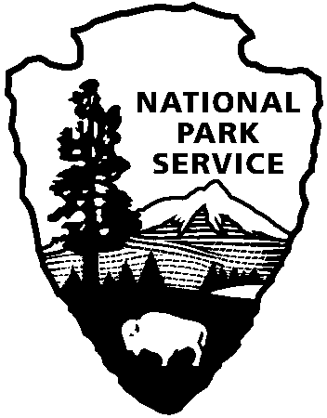
Product Submission Form
Interpretive Development Certification Program

Third line of address

National Park Service
U.S. Department of the Interior

Please include this form with your submission

Name: Park/Site:

Module #: Date mailed:

This is my _______ submission attempt for certification in this module (1st, 2nd, etc.)

I have reviewed the enclosed product against the submission requirements AND rubric for this certification:
- Yes □ No
Has supervisor reviewed product?
- Yes □ No (Optional) Supervisor’s name:_______________________
Career Position (Please select one from the following):
- GS-0025: Park Ranger □ GS-0090: Park Guide
- GS-1702: Educational Specialist □ SCA/Student Intern
- GS-0303: Visitor Use Assistant □ Volunteer
- Cooperating Association Employee □ Other _______________________

Career Status:
- Permanent □ Term □ Seasonal □ Intake (Year _______ )
Product Format (Please indicate number of copies sent):
- Video ( ______ copies) □ Hard Copy ( ______ copies)
- Floppy Disk □ ccmail/Email

Product Topic/Emphasis is primarily:
□ Natural □ Cultural □ Natural and cultural □ Other___________________

If you have attended a training course in this module, please indicate the training venue.
□ TEL satellite broadcast □ In-park training □ Regional course □ Other________________

If your submission meets the certification standards, may we use it for training other interpreters in the elements of effective interpretation? (If yes, we may keep one copy on file at Mather and duplicate as needed for training in this module.)

□ Yes □ No □ Yes, but please remove my name from the product

Park’s FedEx mailing address and phone:

E-mail address and/or phone number where you can be reached if there are questions about your submission:

