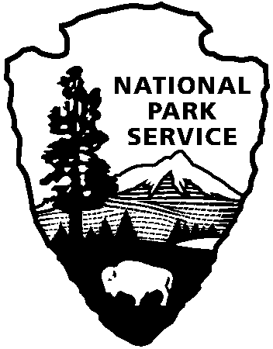
National Park Service
U.S. Department of the Interior

Interpretive Development Program

Essay Questions
Submission for Planning Park Interpretation

Please provide descriptions and answer the bold-faced questions in an essay format. Suggestions on what to include are in parentheses below each question.

- Describe the park planning effort to which you contributed.

(What relationship did interpretation have to the specific plan? What were the goals of the planning effort? What was the scope of the project?)

- How was teamwork important in your planning process?

(What roles did each member have? Were there problems reaching consensus? What were they? If consensus was reached, how did it occur? What role did the facilitator play? How did the team achieve "teamwork?" Were multiple perspectives included and respected?)

- How did your planning effort contribute to the goals in established park and interpretive planning documents?

(Are there established purpose, significance, and goals [CIP, GMP, RMP, Media Plan, SFI, etc.] for this park that relate to this planning effort? How did your planning effort support the purpose, significance, and goals for the park? How might it have more effectively addressed these?)

- Did your planning team develop an implementation strategy?

(Were potential funding sources identified? Was there a timetable for implementation? Who is responsible for the plan’s implementation? How were implementation priorities established? )

Last update: April, 2001
http://www.nps.gov/idp/interp/310/submit.htm

