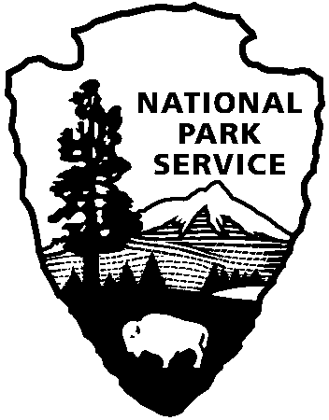
National Park Service
U.S. Department of the Interior

Interpretive Development Program

Module 270 – Presenting Curriculum-based Programs
Required Supplemental Questionnaire

Please complete this form and submit with your submission videos. This information provides program context for the certification review and serves to assure that you have included these elements in your program planning and preparation.

Describe your group: (i.e., group name/age/grade/special circumstances)

Describe how your program was curriculum-based and identify or list the group's pre-
determined learning and/or educational objectives. (Be specific -- the reviewers cannot assess your submission without this information. List only those learning objectives that were relevant to your presentation on the video. See "Key Submission Points" in the Submission Guidelines.)

Briefly describe what pre-visit preparation was completed by the group to prepare them for the site visit/presentation and begin the sequence of learning? (i.e., introductory reading material, worksheets, briefings, activities, goal-setting)*

Briefly describe what post-visit activity or follow-up was planned and/or accomplished by the group after this visit/presentation to affirm learning or extend the learning experience? (i.e. follow-up activities, reports, role-plays, tests, integration with additional learning units)*

*It is not necessary to send/attach program materials, such as teacher guides, student activity handouts, etc, as these will not be considered in the review. Your description of the sequence of learning activities is sufficient to provide program context for the reviewers.

Last module update: August, 2003
Editor: STMA Training Manager Interpretation

