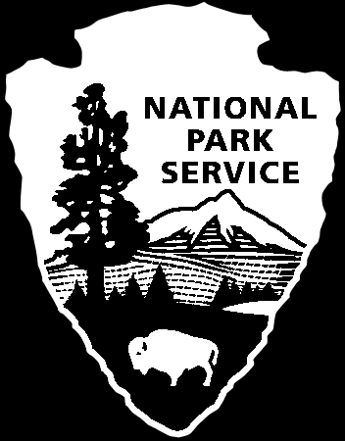
National Park Service
U.S. Department of the Interior

Interpretive Development Program
Module 101
Developmental Worksheet
Using TIU’s* and the Interpretive “So What”

This exercise can be used to develop broad interpretive program/product goals, or specific outcome-oriented program/product objectives. It can also be helpful in formulating or generating theme ideas, or in keeping objectives theme-focused. Before beginning this exercise, participants should be well grounded in the definitions and philosophies presented in the Interpretive Development Curriculum, Module 101 and its components.

Step 1 - Identify and list the tangible or physical natural/cultural resources that will become, be used, or be referred to as a part of an interpretive program or project. This could be in the form of resources along a walk or tour route, props that represent park resources that might be used for programs or exhibits, a list of resources that might be used as subject matter reference for an AV program, or in general, a list of resources that represent the park story.

Step 2 - On a piece of paper or flip chart, diagram the linkages between each identified tangible resource and the intangible ideas/meanings/significance that it represents.

Step 3 - Carry the linkage activity farther by identifying those intangibles that are also universal concepts – meanings that many audience members will likely identify with in some way. These are sometimes also referred to as the interpretive “so what.” You can play “devil’s advocate” to get at the meanings in the resource by role-playing a visitor who is difficult to impress and/or not easily moved to care about the resource. For each tangible on the list ask “So what? What does this mean to me? Why should I care?” Continue to ask the “so what?” questions until you identify the meaning or universal concept that most audience members, even a hard-to-impress visitor, could likely relate to intellectually and/or emotionally – or at least not easily dismiss its significance – OR until you exhaust the possibilities or can’t realistically or logically ask “so what?” any more.

Step 4 - From the “so what” linkage list you generate, write program or product objectives that reflect the highest levels of meanings identified. The objectives should identify desired interpretive outcomes. Choose which objectives to use for the program/project based on the relevance of meanings/outcomes identified, and the potential to tie the objectives together thematically. What theme possibilities emerge from the connections generated by this exercise?

*For more information on tangibles, intangibles and universal concepts (TIU’s), see the Module 101 component entitled “What Interpretation Is.”

Tangible to Intangible Graph
INTANGIBLES
Relevance, Meanings, Ideas, Concepts

TANGIBLES
Information, Facts, Chronology, Narrative

Analyze an interpretive program or product for its tangible/intangible linkages, and use the graph above to plot or chart the progression of those linkages as they occur in the course of a presentation, or the sequence of other types of products (i.e. brochure, exhibit, AV program). Is there a progression, or direction of thought, toward higher level meanings, concepts or significance? Does the level of presentation focus heavily on tangibles, facts and chronology, creating a graph line that stays close to the horizontal axis? Is the product heavily weighted in emotional impact, but light on supporting tangible/informational structure, causing the graph line to stay close to the vertical axis? Practice graphing several different interpretive products/programs. Use the graph the next time you are beginning development of a new product, to map out one or more possible courses for the interpretive direction of your project.

