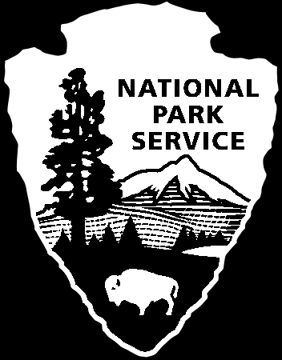
National Park Service
U.S. Department of the Interior

Interpretive Development Program
Module 101
Developmental Worksheet

NPS Tenets of Interpretation

Resources possess meanings and have relevance.
- resources act as icons for meanings

Visitors are seeking something special —something of value for themselves.
- individuals find different value/meanings in the same resource

Interpretation facilitates a connection between the

interests of the visitor and the meanings of the resource.
- primary objective is to provide access to meanings

connections involve moments of intellectual and/or emotional revelation, perception, insight or discovery related to the meanings of the resource
- connections are the bridge between information and meanings

Role of Interpretation in Preservation

- Audiences must care about a resource before they value the preservation of the resource.

- The primary goal of interpretation is not to preach preservation but to facilitate an attitude of care on the part of the audience.

- Preservation depends on audience access and personal connection to the meanings of the resource.

APPLYING THE TENETS

- Resources:
Possess meanings and have relevance.

- Visitor/Audience:
Is seeking something of value for themselves—an environment, an experience, understanding, personal relevance, solitude, community...

- Interpretation:
Facilitates a connection between the interests of the visitor and the meanings of
the resource.

My topic (resource) is:

What are the meanings associated with this topic, subject or resource? |  | What are the interests of the visitor regarding this resource or topic?

What will you do, as an interpreter…
to connect the above?

