Gift Book

The giving of a gift book was a Christmas tradition that gained popularity in the 19th century. Gift books usually contained inspirational short stories and poetry, and often had religious themes, and often contained elaborate illustrations. There are multiple gift books that were given to the children of the Ridgley family in the museum collections. So, join in on the holiday tradition of gift books by making one on your own! You can either keep it for yourself or pass on this tradition to others by gifting your handmade gift book to someone else for the holidays.

Supplies Needed
Writing utensil, Construction paper (4-5 sheets), String, Hole Puncher

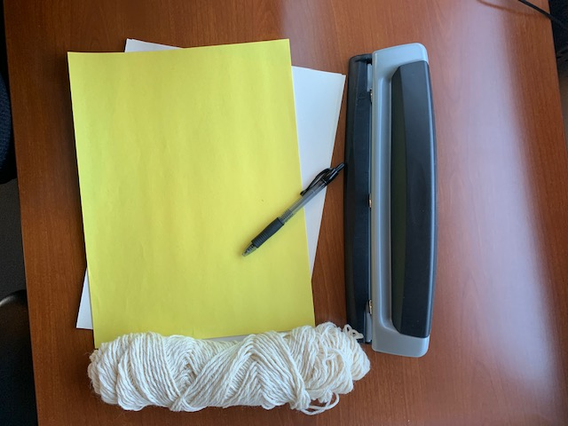

Step 1

Stack the pieces of construction paper on top of each other evenly then fold the pieces in half, making sure that the halves are even. This will create the look of a book.

Step 2

Use the hole puncher to create holes through each of the pieces of paper along the ‘spine’ of the book. Once you have punched holes along the spine of each page, line up the holes of each page by placing the pages one inside the other.

Step 3

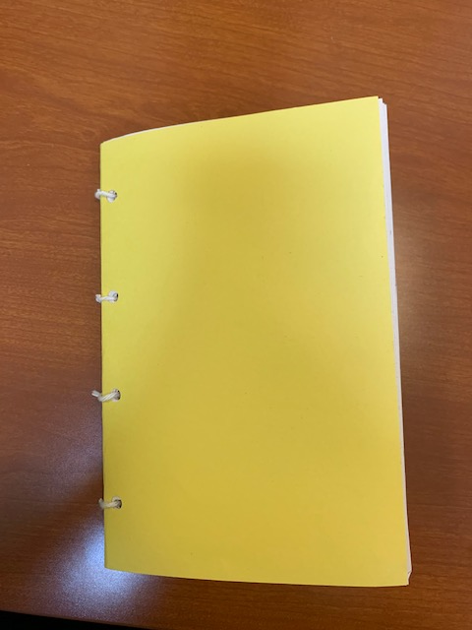

Once all the holes are lined up, take a small piece of string, and tie it through each of the holes along the spine of the book. (Note: make sure not to tie the string too tightly or you will not be able to open the book.) Once you tie strings along the spine of the book your book should be bound together and should not come apart.

Now that the basic form of the book is complete you can unleash your creativity!

Step 4

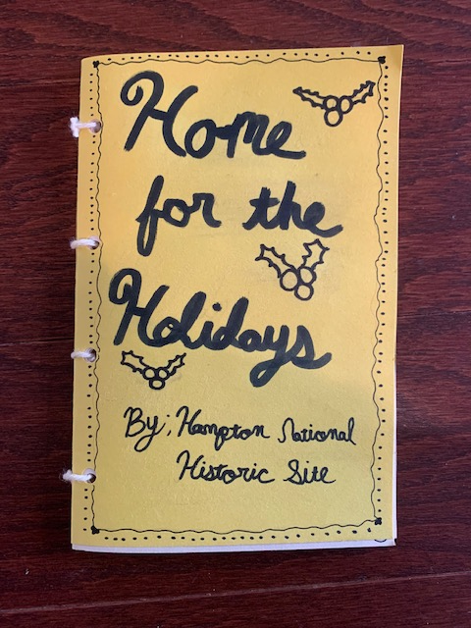

First create a title (and possibly draw a picture) to put on the cover of your book.

Step 5

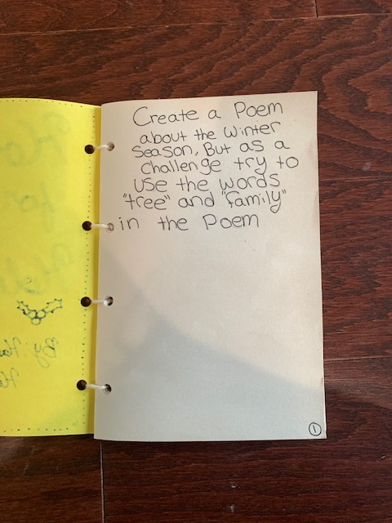

Then open the book to the first page, create a short poem, as an added challenge try to use the words “tree” and “family” in the poem somewhere.

Step 6

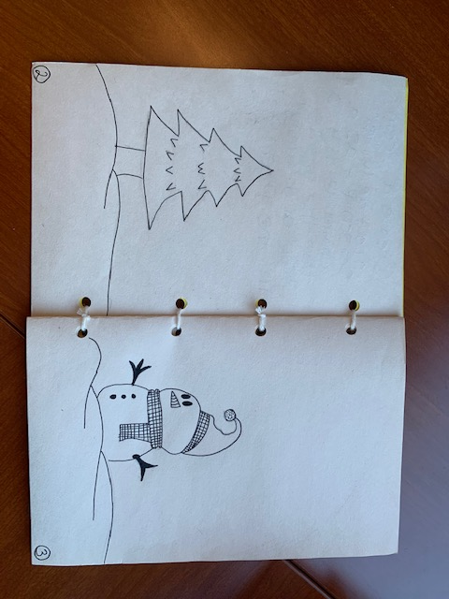

Use the next two pages to draw a big picture of what the winter season reminds you of.

Step 7

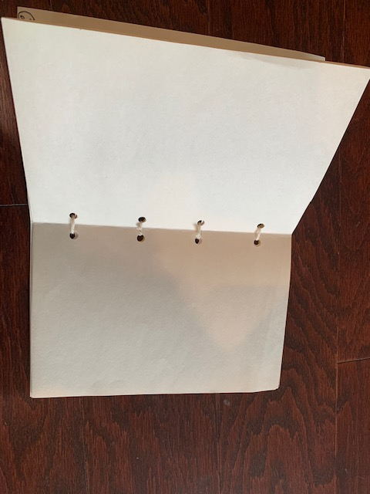

On the next page begin writing a short story about the holiday season, you can make this story only a couple of pages or you can make it take up the rest of the pages in the book.

Step 8
If you still have pages left over in your gift book, use your creativity! You can draw some pictures, write more poems, or write another short story!

Congratulations your gift book is complete!

