,



National Park Service
U.S. Department of the Interior
www.nps.gov/hagr

Hamilton Grange National Memorial Restoration Update – March 2011

Interior restoration work is continuing at Hamilton Grange National Memorial. Teams have recently begun work on the historic fireplaces, replacing damaged bricks and preparing the fireplaces to receive their facings. Another team is working on the door frames for the dining room. A mock-up of one of the massive doors will be used during this phase of the restoration, while the historic doors remain in Lowell, MA to be fitted with mirrors and replicated hardware for reinstallation into the dining room. The home’s mirrored dining room walls, a signature feature of Hamilton's "Sweet Project," reflected the view from the room’s triple hung windows and were designed to make guests feel as if they eating in an outdoor gazebo.
We are very excited about the progress and pleased with the great care our staff and contractors are taking to make the ‘Grange’ look as much as it did when Alexander Hamilton stepped through its doors for the first time in 1802. As of now we do not have a date set for the reopening of the home, but we are hopeful for the middle of this summer. As a subscriber to this list you’ll be among the first to know.
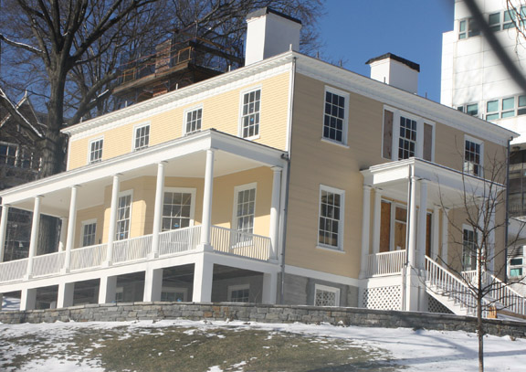
Exterior view of the Grange from the northwest corner of St. Nicholas Park on W. 141st Street.
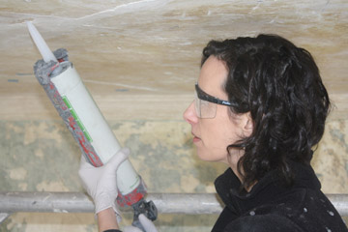
National Park Service conservators are working to restore the home’s historic plaster using a technique that injects a special adhesive behind the plaster that creates a bond between the plaster and the lath supporting it.
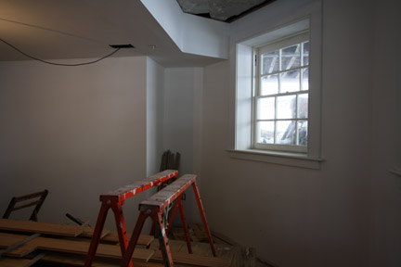
The visitor center, located on the ground floor of the Grange, is beginning to take on its final appearance. The drywall is up, taped and finished. Outlets for electricity and the state-of-the-art multimedia exhibits have been roughed in.
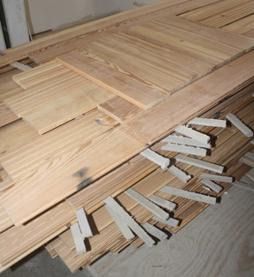
The visitor center will have a hardwood floor made from reclaimed lumber. The use of historic boards is not only environmentally friendly; it also ties the new ground level portion of the Grange to the historic levels.
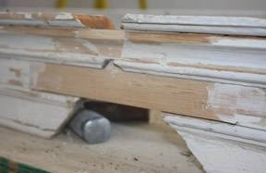
Reclaimed lumber is also being used where applicable to replace damaged or missing sections of wooden trim throughout the home. The reclaimed wood is of a similar type to the home’s historic fabric and it has already fully “aged”, making it ideal for this type of application.

